You are familiar with many objects that oscillate -- a tuning fork, a pendulum, the strings of a guitar, or the beating of a heart. At the microscopic level, you have probably observed the flagellum of microbes. Even at the nanoscopic level, molecules oscillate, as do their constituent atoms. All of these objects are subjected to forces that change with position. Springs are a common example of objects that exert this type of force.

In this lab you will study oscillatory motion caused by springs exerting a force on an object. You will use different methods to determine the strength of the force exerted by different spring configurations, and investigate what quantities determine the oscillation frequency of systems.

Objectives:
After successfully completing this laboratory, you should be able to:
• Provide a qualitative explanation of the behavior of oscillating systems using the concepts of restoring force and equilibrium position.
• Identify the physical quantities that influence the period (or frequency) of the oscillatory motion and describe this influence quantitatively.
• Demonstrate a working knowledge of the mathematical description of an oscillator's motion.
• Describe qualitatively the effect of additional forces on an oscillator's motion.

Preparation:
Read Serway and Jewett chapter 2 (section 4), chapter 4, chapter 12 (sections 1-4 and 6-8). It is likely that you will be doing some of these laboratory problems before your lecturer addresses this material. It is very important that you read the text before coming to lab.
Before coming to lab you should be able to:
• Describe the similarities and differences in the behavior of the sine and cosine functions.
• Recognized the difference between amplitude, frequency, and period for repetitive motion.
• Determine the force on an object exerted by a spring.
• Be able to use Newton’s second law for accelerating objects.

Problem #1:
Measuring spring constants

Your research group is studying the properties of a virus that attaches to the outside of a healthy cell and injects its RNA into that cell. The injection process relies on a single large molecule in the virus that provides the force for the injection process. This biopolymer is coiled up like a spring and pushes the RNA through the cell wall. Your group needs to determine the maximum force the molecule can exert when it uncoils like a spring. You know you can determine the “spring constant” of the polymer by measuring its extension in response to a known force. However, it is much easier to disturb the molecule and observe its oscillation. This should give you the result you need since the oscillation period of a system also depends on the spring constant. To compare the two methods of determining the spring constant, you decide to try them both in the lab. First you need to calculate the spring constant as a function of the forces on the system and the properties of the system that you can measure using each method.

Equipment

You will have a spring, clamps, a vertical support, a meter stick, a stopwatch, a balance, a set of weights, and a computer with a video analysis application written in LabVIEW™. | 

Predictions

Restate the problem in terms of quantities you know or can measure. Beginning with basic physics principles, show how you get an equation that gives the solution to the problem for each method. Make sure that you state any approximations or assumptions that you are making. Do you expect the two methods to yield similar results?

Warm-up Questions

Read Serway & Jewett: section 2.4, Chapter 4, sections 12.1 and 12.2.
Method #1:
1. Make a sketch of an object suspended from a spring, as shown in the equipment section. Draw and label the forces acting on the object when it is in equilibrium. Use Newton’s second law to write an equation that relates the forces acting on the object. Solve your equation for the spring constant.
2. Sketch a graph of the weight of the object versus the extension of the spring. What does the slope of the graph tell you?

Method #2:
1. Draw a picture of the object hanging on the spring at a time when the object is below its equilibrium position. Identify and label this position on a coordinate axis with an origin at the equilibrium position of the object.
2. Label the forces acting on the object at this position Next to the diagram draw a vector representing the acceleration of the object.
3. Write down an equation relating the forces on the object to its acceleration. Write down an equation that relates the force exerted by the spring on the object to the displacement of the object from its equilibrium position.
4. Solve your equation for the acceleration of the object as a function of the mass of the suspended object, the spring constant, and the displacement of the object from its equilibrium position.
5. Write down the definition of the acceleration of an object, in terms of the rate of change of its position using calculus notation. Re-write your equation from the previous question, so that position including its derivatives is the only variable.
6. Solve that equation for the position as a function of time by guessing a reasonable solution and trying it. How do you justify your guess? Determine the values of constants necessary to satisfy the equation. Which of these constants is related to the period of the system? Why? Show how the period depends on the spring constant.

Exploration

Method #1: Select a series of masses that give a usable range of displacements. The largest mass should not pull the spring past its elastic limit (about 60 cm). Beyond that point you will damage the spring. Decide on a procedure that allows you to measure the extension of the spring in a consistent manner. Decide how many masses ou will need to use to make a reliable measurement of the spring constant.

Method #2: Select a range of object masses that give a regular oscillation without excessive wobbling to the hanging end of the spring. Make sure that the largest mass does not pull the spring past its elastic limit while oscillating. Practice starting the mass so that it oscillates vertically in a smooth and consistent manner. Using a stopwatch, decide whether or not the oscillation amplitude affects its period, for a particular mass.

Practice making a video to record the motion of the object. Decide how to measure the period of oscillation of the spring-object system both by video and by using a stopwatch. How can you minimize the uncertainty introduced by your reaction time in starting and stopping the stopwatch? How many times should you measure the period to get a reliable value? How will you determine the uncertainty in the period?

Write down your measurement plan.

Measurement

Method #1: Make the measurements necessary to determine the equilibrium spring extension for different masses.

Method #2: Make a video of the motion of the hanging object to find its oscillation period. Compare the stopwatch measurements with the video measurements. Repeat for objects with different masses.

Analyze your data as you go along so you can decide how many measurements you need to make to determine the spring constant accurately and reliably.

Analysis

Method #1: Make a graph of the weight of the hanging object as a function of spring extension. From the slope of this graph, calculate the value of the spring constant, including the measurement uncertainty.

Method #2: Determine the period of the motion of the object from the graph of position as a function of time. Make a graph of the period of the oscillation as a function of mass for the object. If this graph is not a straight line, make another graph with the period as a function of mass raised to some power such that the graph is a straight line. From the slope of the straight-line graph, calculate the value of the spring constant, including the uncertainty.

Conclusion

How do the two values of the spring constant compare? Which method of measuring the spring constant is more efficient? Which method do you feel is the most reliable? Justify your answers.

Does the oscillation period depend on the oscillation amplitude? Defend your response with data from the exploration, and with arguments based on the prediction equation.

What is the spring constant of a polymer extended to 2 nanometers with a force of 0.2 x10⁻¹² Newton? What would be its oscillation period?

problem #2:
oscillation frequency with two springs

You have a job with a group practicing industrial medicine. Your group is advising employees on how to avoid repetitive stress syndrome. As part of a demonstration, you have been asked to build a simple mechanical system that repeats its motion. You decide to place a low friction cart between two springs. To be able to adjust the period in a predictable manner, you calculate the oscillation period of the system as a function of the cart mass and the two spring constants. You then decide to check your calculation in the lab.

Equipment

You will have an aluminum track, two adjustable end stops, two springs, a meter stick, a stopwatch, a cart, cart masses, and the video analysis equipment.

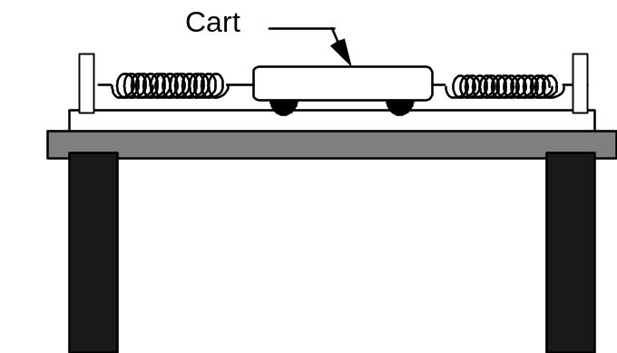

Prediction

Restate the problem in terms of quantities you know or can measure. Beginning with basic physics principles, show how you get an equation that gives the solution to the problem. Make sure that you state any approximations or assumptions that you are making. Make a graph of period of the system as a function of the cart’s mass for a given set of springs.

Warm-up Questions

Read Serway & Jewett: section 2.4, Chapter 4, sections 12.1 and 12.2.
1. Make two pictures of the oscillating cart, one at its equilibrium position, and one at some other position and time while it is oscillating. On each of your sketches, show the direction of the velocity and acceleration of the cart. Identify and label the relevant forces and positions.
2. Decide on a coordinate system and draw a free-body diagram of the cart at a position other than its equilibrium position. Label the forces and define the symbols you are using. Draw the acceleration vector near the diagram.
3. Write down the equation relating the forces on the cart to its acceleration. Write down an equation that relates the force exerted by each spring on the object to the displacement of the object from its equilibrium position.
4. Solve your equation for the acceleration of the cart as a function of its mass, the spring constants, and the displacement of the cart from its equilibrium position.
5. Write down the definition of the acceleration of the cart, in terms of the rate of change of its position using calculus notation. Re-write your equation from the previous question, so that position including its derivatives is the only variable.
6. Solve that equation for the position as a function of time by guessing a reasonable solution and trying it. How do you justify your guess? Determine the values of constants necessary to satisfy the equation. Which of these constants is related to the period of the system? Why? Show how the period depends on the spring constants and the mass of the cart.

Exploration

Decide on the best method to determine each spring constant based on the results of a previous lab problem. DO NOT STRETCH THE SPRINGS PAST THEIR ELASTIC LIMIT (ABOUT 60 CM) OR YOU WILL DAMAGE THEM.

Find the best place for the adjustable end stop on the track. Do not stretch the springs past 60 cm, but stretch them enough so they oscillate the cart smoothly. Practice releasing the cart smoothly. Use a stopwatch to roughly determine the period of oscillation. Use this to set up the time axis in LabVIEW. Determine if the period depends appreciably on the starting amplitude of the oscillation. Decide on the best starting amplitude to use for your measurements.

You will notice that the amplitude of the oscillation decreases as time goes by. What causes it? Check if this seems to affect the period of oscillation.

Try changing the mass of the cart and observe how that qualitatively changes its period of oscillation. How much of a mass change is too little to see an effect? How much of a mass change is too much? Write down your measurement plan.

Measurement

Determine the spring constant for each spring. Record these values. What is the uncertainty in these measurements?

Use the video equipment to record the motion of the cart. Record a sufficient number of complete cycles to reliably measure the oscillation period and to determine how it changes with amplitude. Repeat for different cart masses.

Analyze your data as you go along in order to determine the magnitude and number of different cart masses you need to use. Collect enough data to convince yourself and others of your conclusions.

Analysis

Analyze your video to find the period of oscillation. Make a graph of period vs. cart mass, showing the estimated uncertainty.

Using your prediction, calculate the predicted period for these springs and each cart mass you used. Record these points on your graph, with estimated uncertainty.

Conclusion

Did your measurements agree with your predictions? Explain any discrepancies. What are the limitations on the accuracy of your measurements and analysis?

If you decided that your first attempt produced an oscillation frequency too fast for effective demonstration, what kinds of changes could you make to increase the period?
problem #3:
oscillation frequency of an extended system

A male cricket produces sound by oscillating its wings. This sound has a specific frequency distribution that attracts females of the same species. You are interested in the sensitivity of the females – will they respond to slightly different frequencies? The frequency of the sound is the same as the frequency of the oscillating wing. To change the frequency you will add a very small mass to the males’ wings. To model this, you decide to attach one end of a low friction cart to a spring. The other end you attach to a string that goes over a pulley and is connected to an object hanging straight down. As the cart moves back and forth, it raises and lowers the object. First you need to be able to calculate how the frequency of the system depends on the amount of mass hanging from the string. After that, you will check your calculations in the lab.

Equipment

You have an aluminum track with an adjustable end stop, a pulley, a pulley clamp, a spring, a cart, some strings, a mass hanger, a mass set, cart masses, a meter stick, a stopwatch and the video analysis equipment.

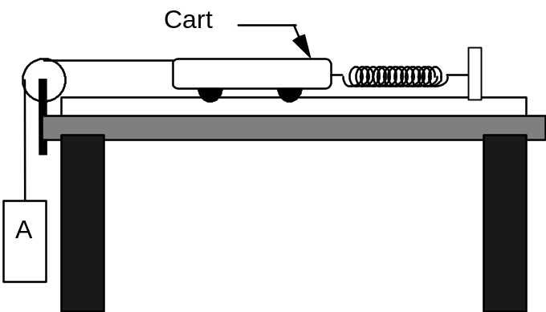

Prediction

Restate the problem in terms of quantities you know or can measure. Beginning with basic physics principles, show how you get an equation that gives the solution to the problem. Make sure that you state any approximations or assumptions that you are making.

Make a graph of frequency of the system as a function of mass of the hanging object for a given cart mass and spring constant. Will the frequency increase, decrease or stay the same as the hanging mass increases?

Warm-up Questions

Read Serway & Jewett: section 2.4, Chapter 4, sections 12.1 and 12.2.
1. Make two pictures, one when the cart and hanging object are at their equilibrium position and one at some other position. On your pictures, show the direction of the acceleration of the cart and hanging object. Identify and label the known (measurable) and unknown quantities.
2. Decide on a coordinate system and draw separate force diagrams of the cart and the hanging object. Label the forces acting on each object. Draw the appropriate acceleration vector next to each force diagram.
3. Independently apply Newton's laws to the cart and to the hanging object. Is the magnitude of the acceleration of the cart always equal to that of the hanging object? Is the force the string exerts on the cart always equal to the weight of the hanging object? Explain.
4. Solve your equations for the acceleration of the cart in terms of quantities you know or can measure. Write the acceleration as the second derivative of position with respect to time.
5. Solve that equation for the position as a function of time by guessing a reasonable solution and trying it. How do you justify your guess? Determine the values of constants necessary to satisfy the equation. Which of these constants is related to the period of the system? Why? Show how the frequency depends on the spring constant and the masses of the cart and the hanging object. Sketch a graph of frequency vs. mass of hanging object for constant cart mass and spring constant.

Exploration

Find the best place for the adjustable end stop on the track. DO NOT STRETCH THE SPRING PAST 60 CM OR YOU WILL DAMAGE IT, but stretch it enough so the cart and hanging mass oscillate smoothly.

Determine the best range of masses for the hanging object. Use a stopwatch to roughly determine the period of oscillation. Use this to set up the time axis in LabVIEW. Determine if the period depends appreciably on the starting amplitude of the oscillation. Decide on the best starting amplitude to use for your measurements. Try adding some mass to the cart to see how it affects the motion.

Practice releasing the cart and hanging object smoothly and consistently. You want to make sure that the hanging object moves straight up and down and does not swing from side to side. You may notice the amplitude of oscillation decreases. Explain the cause. Does this affect the period of oscillation?

Measurement

If necessary, determine the spring constant of your spring. What is the uncertainty in your measurement?

Use the video to record the motion of the cart. Record a sufficient number of complete cycles to reliably measure the oscillation period and to determine how it changes with amplitude. Repeat for enough different hanging object masses to make a graph of frequency as a function of mass. Analyze your data as you go in order to determine the magnitude and number of different hanging masses you need to use.

Collect enough data to convince yourself and others of your conclusion regarding the dependence of the oscillation frequency on the mass of the hanging object.

Analysis

Analyze your video to find the period of oscillation. Calculate the frequency (with uncertainty) of the oscillations from your measured period. Make a graph of frequency as a function of hanging object mass.

Calculate your predicted frequency for each value of the hanging object’s mass and plot those predicted values on your graph.

Conclusion

What are the limitations on the accuracy of your measurements and analysis? Over what range of values does the measured graph match the predicted graph best? Do the two curves start to diverge from one another? If so, where? What does this tell you about the system?

If you were to use this device on the surface of the moon, where the gravitational field is much weaker than on the earth’s surface, would you expect the frequency to be any different? Use physics arguments and your prediction equation to justify your explanation.

problem #4:
driven oscillations

You are working a consultant to a medical school that wants to introduce future doctors to Magnetic Resonance Imaging (MRI) machines. You are asked to design a device that illustrates the principle of resonance. You decide to use a low friction cart connected between two springs. One spring is connected to a device that mechanically pulses the spring at a frequency which can be varied while the other spring is connected to an end stop. The amplitude of the mechanical oscillator’s movement is only a few millimeters. Make an educated guess, justified by your experience, about what frequency of the mechanical oscillator will cause the maximum oscillation of the cart. How big do you think the amplitude of this oscillation will be?

Equipment

You will have an aluminum track, an adjustable end stop, two springs, a clamp, a meter stick, a stopwatch, a cart, a mechanical oscillator, two cables with banana plugs, and a function generator. The mechanical oscillator has a rod that goes back and forth with an adjustable frequency that can be read out from a display on the function generator.
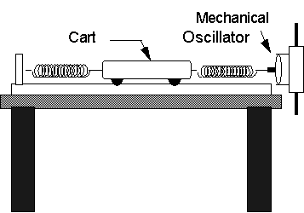

Prediction

Restate the problem in terms of quantities you know or can measure. Calculate the oscillation frequency of the cart when the mechanical oscillator is turned off. This is called the system’s natural frequency.

Sketch a graph illustrating, qualitatively, how you expect the amplitude of the cart’s oscillation to vary with the frequency of the mechanical oscillator. Will the maximum amplitude occur at a frequency less than, equal to, or greater than the natural frequency of the cart and the springs?

Warm-up Questions

Read Serway & Jewett: sections 12.1 and 12.2
1. If you have not already calculated the oscillation frequency of the cart and two springs without the mechanical oscillator, follow the Warm-up Questions of problem 2.
2. To qualitatively decide on the behavior of the system with the mechanical oscillator attached and turned on, think about an experience you have had putting energy into an oscillating system. For example, think about pushing someone on a swing. When is the best time to push to get the maximum height for the person on the swing? How does the frequency of your push compare to the natural frequency of the person on the swing? How does the maximum height of the swinger compare to the size of your push?

Exploration

Examine the mechanical oscillator. Mount it at the end of the aluminum track, using the clamp and metal rod so its shaft is aligned with the cart's motion. Connect it to the function generator, using the output marked Lo (for “low impedance”). Use between middle and maximum amplitude to observe the oscillation of the cart at the lowest frequency possible.

Determine the accuracy of the digital display on the frequency generator by using the stopwatch to measure one of the lower frequencies.

Devise a scheme to accurately determine the amplitude of a cart on the track, and practice the technique.

What happens to the cart when you change frequencies? Determine how long you should stay at one frequency in order to determine an effect. Try changing frequencies. For each new frequency you try, does it matter whether or not you restart the cart from rest?

Try setting the driver frequency to the natural frequency of the cart-spring system. Determine the response sensitivity by making very small changes in the frequency and watching the result. Plan a strategy to find the frequency for maximum amplitude oscillation.

If you guessed that some other pushing frequencies would be effective, try them to see their effect.

Measurement

Collect enough cart amplitude and oscillator frequency data to test your prediction. Be sure to collect several data points near the natural frequency of the system.

When the mechanical oscillator is at or near the natural frequency of the cart-spring system, try to simultaneously observe the motion of the cart and the shaft of the mechanical oscillator. Describe what you see. What happens when the oscillator’s frequency is twice as large as the natural frequency?

Analysis

Make a graph of the oscillation amplitude of the cart as a function of the oscillator frequency.

Conclusion

Was your prediction correct? How does it differ from the results? Explain. What is the limitation on the accuracy of your measurements and analysis?

How does the maximum kinetic energy of the cart compare with the energy input to the system by each stroke of the mechanical oscillator? Describe, qualitatively, how conservation of energy can be applied to this system.
problem #5:
simple pendulum

You work for a NASA team investigating the effects of a reduced gravity environment, such as in a space station or the Martian surface, on human biological cycles. One theory is that the body has many mechanical oscillators within it and it is the effect of the gravitational force on these oscillators that changes biological cycles. Although you do not believe this theory, you decide to test it. As a first step, you decide to study a simple cyclical physical system that you know depends on the gravitational force, the pendulum. First you calculate an expression relating the period of the pendulum to the gravitational acceleration and properties of the pendulum. To make your calculation easier, you only consider small oscillations. You will then test your calculations in the laboratory.

Equipment

The pendulum consists of a small object, called a bob, connected to one end of a string which is suspended by the other end. You will also have a meter stick, a stopwatch, a set of different mass bobs, and a stand from which to hang the pendulum.

Prediction

Restate the problem in terms of quantities you know or can measure. Beginning with basic physics principles, show how you get an equation that gives the solution to the problem. Make sure that you state any approximations or assumptions that you are making.

Warm-up Questions

Read Serway & Jewett: section 12.4

There are two ways to solve this problem, one using forces and acceleration and the other using conservation of energy. The main features of both are given below. After trying both, decide which you like better. Both should give the same answer.

Method #1 (Force and acceleration)
1. Draw a picture of the pendulum at some typical time in its swing. Label all the forces acting on the bob, all relevant lengths, and the angle of the pendulum. Draw a free-body diagram of the forces on the bob.
2. Choose a coordinate system with one axis along the direction of the bob’s motion. Transfer your forces to that coordinate system and relate any angles to the pendulum angle. Write down Newton’s second law to express the component of acceleration in the direction the bob moves. The bob moves on the circumference of a circle. What is the radius of that circle?
3. How is the distance that the pendulum bob swings along that circle (its arclength) related to the pendulum angle measured in radians? The acceleration of the bob along its path is the time derivative of how that distance changes with time. Use the arclength relationship to write down the acceleration of the bob along its circular path in terms of the pendulum angle and the length of the pendulum. Use this acceleration in the Newton’s law equation from 2.
4. Use the small angle approximation, that the sine of an angle is approximately equal to the angle in radians, to modify your equation so that the only variable is the angle.
5. Solve that equation for the angle of the pendulum as a function of time by guessing a reasonable solution and trying it. How do you justify your guess? Determine the values of constants necessary to satisfy the equation. Which of these constants is related to the period of the system? Why? Show how the period depends on the gravitational acceleration and the length of the pendulum. Sketch a graph of period vs. gravitational acceleration for a constant length pendulum.

Method #2 (Conservation of energy)
1. Define your system. Be sure to indicate all external forces that can transfer energy to or from the system. Write an energy conservation equation for the system.
2. Use geometry to change terms that involve the height of the pendulum bob into terms involving the pendulum angle.
3. Use the definition of the angle in radians to write the velocity of the pendulum bob in terms of a time derivative of the pendulum angle.
4. Take the time derivative of the resulting conservation of energy equation. Don’t forget the Chain Rule. Then use the small angle approximation, that the sine of an angle is approximately equal to the angle in radians, to modify your equation so that the only variable is the angle.
5. Solve that equation for the angle of the pendulum as a function of time by guessing a reasonable solution and trying it. How do you justify your guess? Determine the values of constants necessary to satisfy the equation. Which of these constants is related to the period of the system? Why? Show how the period depends on the gravitational acceleration and the length of the pendulum. Sketch a graph of period vs. gravitational acceleration for a constant length pendulum.

Exploration

Try different masses for the pendulum bob. According to your prediction, should this change the oscillation frequency? Does it?

Try releasing the pendulum bob at different heights. Does the period vary when the pendulum is released at different heights? What range of angles appears to be small enough for the small angle approximation to be good?

Try different lengths for the pendulum. Determine a range of lengths for which you can reliably measure the oscillation frequency, and for which the frequency will vary enough to test your prediction.

Determine an efficient way to vary the length of the pendulum, to measure that length, and to measure the oscillation frequency. Write down your measurement plan.

Measurement

Follow your measurement plan. Be sure to take more than one measurement for each length, and to estimate the uncertainties in the measurements.

Analysis

As you take each measurement, create a graph of the oscillation period versus the length of the pendulum (with uncertainties). Is the relationship linear? Did you predict a linear relationship? Plot the prediction equation on the same graph as the data.

Use your prediction to decide on a set of axes that will linearize the data (give a linear relationship). Graph your prediction equation and your measurements on these axes.

As a check of your data, use the slope of the line to determine the gravitational acceleration. Compare it to the expected value.

Conclusion

Did the measured period follow your predictions? If not, explain why.

How close is your calculated value for the gravitational acceleration to the accepted value? Based on the uncertainties of your measurements, how close should it be? If it is not close enough, explain why.

If the pendulum were moved from the earth’s surface to the surface of the moon, where the gravitational acceleration is approximately one-sixth the value we are accustomed to, what effect should that have on the pendulum’s period?

1. The diagram below shows an oscillating mass/spring system at times 0, T/4, T/2, 3T/4, and T, where T is the period of oscillation. For each of these times, write an expression for the displacement (x), the velocity (v), the acceleration (a), the kinetic energy (KE), and the potential energy (PE) in terms of the amplitude of the oscillations (A), the angular frequency (w), and the spring constant (k).

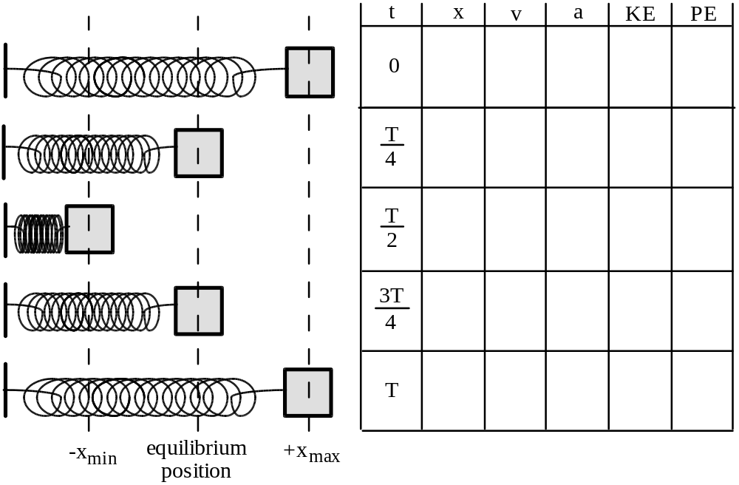

2. Identical masses are attached to identical springs which hang vertically. The masses are pulled down and released, but mass B is pulled further down than mass A, as shown at right.  a. Which mass will take a longer time to reach the equilibrium position? Explain.  b. Which mass will have the greater acceleration at the instant of release, or will they have the same acceleration? Explain.  c. Which mass will be going faster as it passes through equilibrium, or will they have the same speed? Explain. | 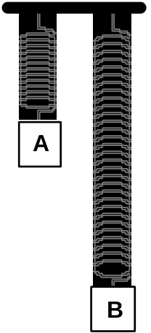

d. Which mass will have the greater acceleration at the equilibrium point, or will they have the same acceleration? Explain.

3. Two different masses are attached to different springs which hang vertically. Mass A is larger, but the period of simple harmonic motion is the same for both systems. They are pulled the same distance below their equilibrium positions and released from rest. | 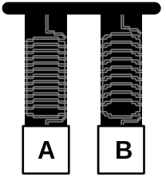

a. Which spring has the greater spring constant? Explain.

b. Which spring is stretched more at its equilibrium position? Explain.

c. The instant after release, which mass has the greater acceleration? Explain.

d. If potential energy is defined to be zero at the equilibrium position for each mass, which system has the greater total energy of motion? Explain.

e. Which mass will have the greater kinetic energy as it passes through its equilibrium position? Explain

f. Which mass will have the greater speed as it passes through equilibrium? Explain.

4. Five identical springs and three identical masses are arranged as shown at right.  a. Compare the stretches of the springs at equilibrium in the three cases. Explain.  b. Which case would execute simple harmonic motion with the greatest period? With the least period? Explain. | 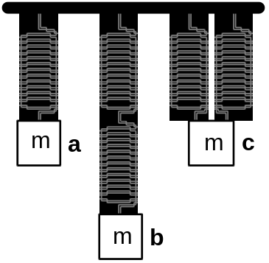

PHYSICS 1201 LABORATORY REPORT

Laboratory IV

Name and ID#:
Date performed: Day/Time section meets:
Lab Partners' Names:
Problem # and Title:
Lab Instructor's Initials:
Grading Checklist | Points*
LABORATORY JOURNAL:
PREDICTIONS
(individual predictions and warm-up questions completed in journal before each lab session)
LAB PROCEDURE
(measurement plan recorded in journal, tables and graphs made in journal as data is collected, observations written in journal)
PROBLEM REPORT:
ORGANIZATION
(clear and readable; logical progression from problem statement through conclusions; pictures provided where necessary; correct grammar and spelling; section headings provided; physics stated correctly)
DATA AND DATA TABLES
(clear and readable; units and assigned uncertainties clearly stated)
RESULTS
(results clearly indicated; correct, logical, and well-organized calculations with uncertainties indicated; scales, labels and uncertainties on graphs; physics stated correctly)
CONCLUSIONS
(comparison to prediction & theory discussed with physics stated correctly ; possible sources of uncertainties identified; attention called to experimental problems)
TOTAL(incorrect or missing statement of physics will result in a maximum of 60% of the total points achieved; incorrect grammar or spelling will result in a maximum of 70% of the total points achieved)
BONUS POINTS FOR TEAMWORK
(as specified by course policy)

* An "R" in the points column means to rewrite that section only and return it to your lab instructor within two days of the return of the report to you.

