Analyzing Force Concept Inventory Questions

Group Task:
The top of each attached page shows a question from the Force Concept Inventory. The "Pre" and "Post" columns show the percentage of students in the calculus-based course that selected each of the possible answers on the pretest (given at the beginning of the term) and the posttest (at the end of ten weeks of instruction).

1. Individually read all the questions.

2. For each question assigned to your group:
a. Describe briefly how a student might be thinking who selected each incorrect answer. (Hint: Review the alternative conceptions from the McDermott and Wandersee et. al., articles.)
b. Which of the possible "alternative conceptions" were successfully addressed by instruction? Which were not?

3. For one question assigned to your group, imagine you were tutoring a student with the indicated alternative conception. Discuss what example situation, reference to a common experience the student is likely to have, or set of questions that you think might help move this student away from their alternative conception. Write your answer on the back of this page.

Group Roles
Skeptic: Ask what other possibilities there are, keep the group from superficial analysis by not allowing the group to agree too quickly; ask questions that lead to a deeper analysis; agree when satisfied that the group has explored all possibilities. (earliest birthday in year)
Manager: Suggest a plan for answering the questions; make sure everyone participates and stays on task; watch the time. (next later birthday in year)
Checker/Recorder: Ask others to explain their reasoning process so it is clear to all that their suggestions can be discussed; paraphrase, write down, and edit your group's answers to the questions. (next later birthday in year)

TIME: 25 minutes.
One member from each group will be randomly called on to contribute answers to the questions.

Group Product:
Activity #2 Answer Sheets.
2.
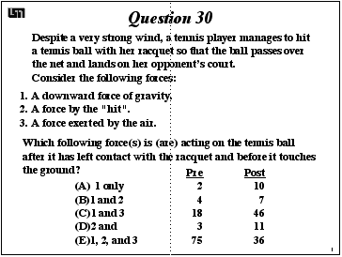

a. Describe briefly how a student might be thinking who gives each incorrect answer.

b. Which of these “alternative conceptions” were successfully addressed by instruction? Which were not?

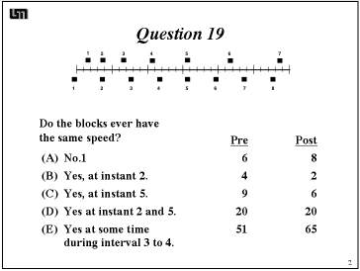

a. Describe briefly how a student might be thinking who gives each incorrect answer.

b. Which of these “alternative conceptions” were successfully addressed by instruction? Which were not?

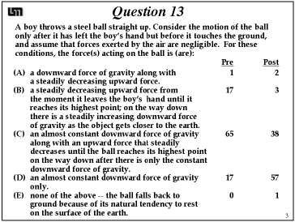

a. Describe briefly how a student might be thinking who gives each incorrect answer.

b. Which of these “alternative conceptions” were successfully addressed by instruction? Which were not?

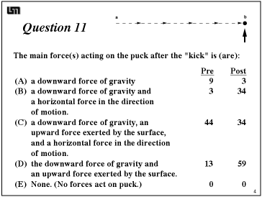

a. Describe briefly how a student might be thinking who gives each incorrect answer.

b. Which of these “alternative conceptions” were successfully addressed by instruction? Which were not?

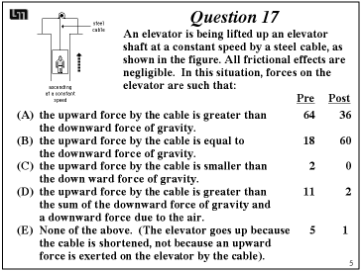

a. Describe briefly how a student might be thinking who gives each incorrect answer.

b. Which of these “alternative conceptions” were successfully addressed by instruction? Which were not?

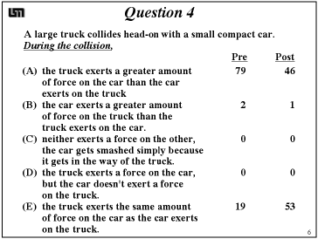

a. Describe briefly how a student might be thinking who gives each incorrect answer.

b. Which of these “alternative conceptions” were successfully addressed by instruction? Which were not?

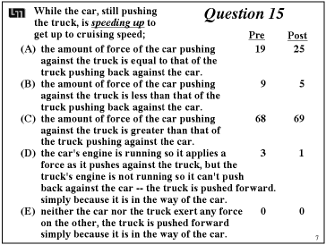

a. Describe briefly how a student might be thinking who gives each incorrect answer.

b. Which of these “alternative conceptions” were successfully addressed by instruction? Which were not?

3. Imagine you are tutoring a student who has an "alternative conception" similar to that of Question # ______. What example situation, reference to a common experience the student is likely to have, or set of questions do you think might help move this student away from their alternative conception?

