Below is a problem from an exam in Physics 1101 (algebra-based introductory course). Solve this problem as quickly as you can.

Cowboy Bob Problem: Because parents are concerned that children are taught incorrect science in cartoon shows, you have been hired as a technical advisor for the Cowboy Bob show. In this episode, Cowboy Bob, hero of the Old West, happens to be camped on the top of Table Rock in the Badlands. Table Rock has a flat horizontal top, vertical sides, and is 500 meters high. Cowboy Bob sees a band of outlaws at the base of Table Rock 100 meters from the side wall. The nasty outlaws are waiting to rob the Dodge City stagecoach. Cowboy Bob decides to roll a large boulder over the edge and onto the outlaws. Your boss asks you if it is possible to hit the outlaws with the boulder. Determine how fast Bob will have to roll the boulder to reach the outlaws.

Notes:

Differences in Expert-Novice Problem Solving

Group Tasks:
1. Make a list or flow chart of all the steps (major decision points and/or actions) that you took to solve a "real problem" (the Graduate Written Exam Problem).
2. Make a list or flow chart of all the steps (major decision points and/or actions) that you took to solve an "exercise" (the Cowboy Bob Problem).
3 Make a list of all the ways an expert problem solver (e.g., you, a professor) solves a "real problem" differently than an "exercise."
4. What does Larkin recommend be done to help students become better problem solvers? How should this be done? What do you think of this idea?

Cooperative Group Roles:
Skeptic: Ask what other possibilities there are, keep the group from superficial analysis by not allowing the group to agree too quickly; ask questions that lead to a deeper analysis; agree when satisfied that the group has explored all possibilities.
Manager: Suggest a plan for answering the questions; make sure everyone participates and stays on task; watch the time.
Checker/Recorder: Ask others to explain their reasoning process so it is clear to all that their suggestions can be discussed; paraphrase, write down, and edit your group's answers to the questions.

Time: 25 minutes.
One member from your group will be randomly selected to present your group's answers to Questions #1 and #2.

Product:
Activity #6b Answer Sheet.
Answer Sheet for Activity 6b

1. Examine your group solution to the Graduate Written Exam Problem. Make a flow chart of the major steps (decisions and/or actions) you took to solve the problem.

2. Now compare and contrast your group solution to the Graduate Written Exam (GWE) Problem and your individual solutions to the Cowboy Bob Problem. For you, as expert problem solvers, the GWE problem was a "real problem" -- one you did not know how to solve immediately -- and the Cowboy Bob Problem was probably more like an "exercise" -- a type of problem you have solved so many times before that you immediately knew how to approach the problem.

(a) Make a flow chart of the steps (major decisions and/or actions) you took to solve the Cowboy Bob Problem.

(b) How were your solution steps different for the real problem and the exercise?
3. For students in an introductory physics class (novice problem solvers), the Cowboy Bob Problem IS A REAL PROBLEM. Compare and contrast the attached novice solution to the Cowboy Bob Problem with your group solution to the GWE Problem.

Based on (a) your comparison of the solutions, and (b) the reading of Larkin (1979), make a list of all the ways that experts solve real problems (e.g., the GWE problem) differently than novices solve what is, for them, a real problem (e.g., the Cowboy Bob Problem).

Expert Solving Real Problem | Novice Solving a Real Problem

"Novice" Solution to Cowboy Bob Problem

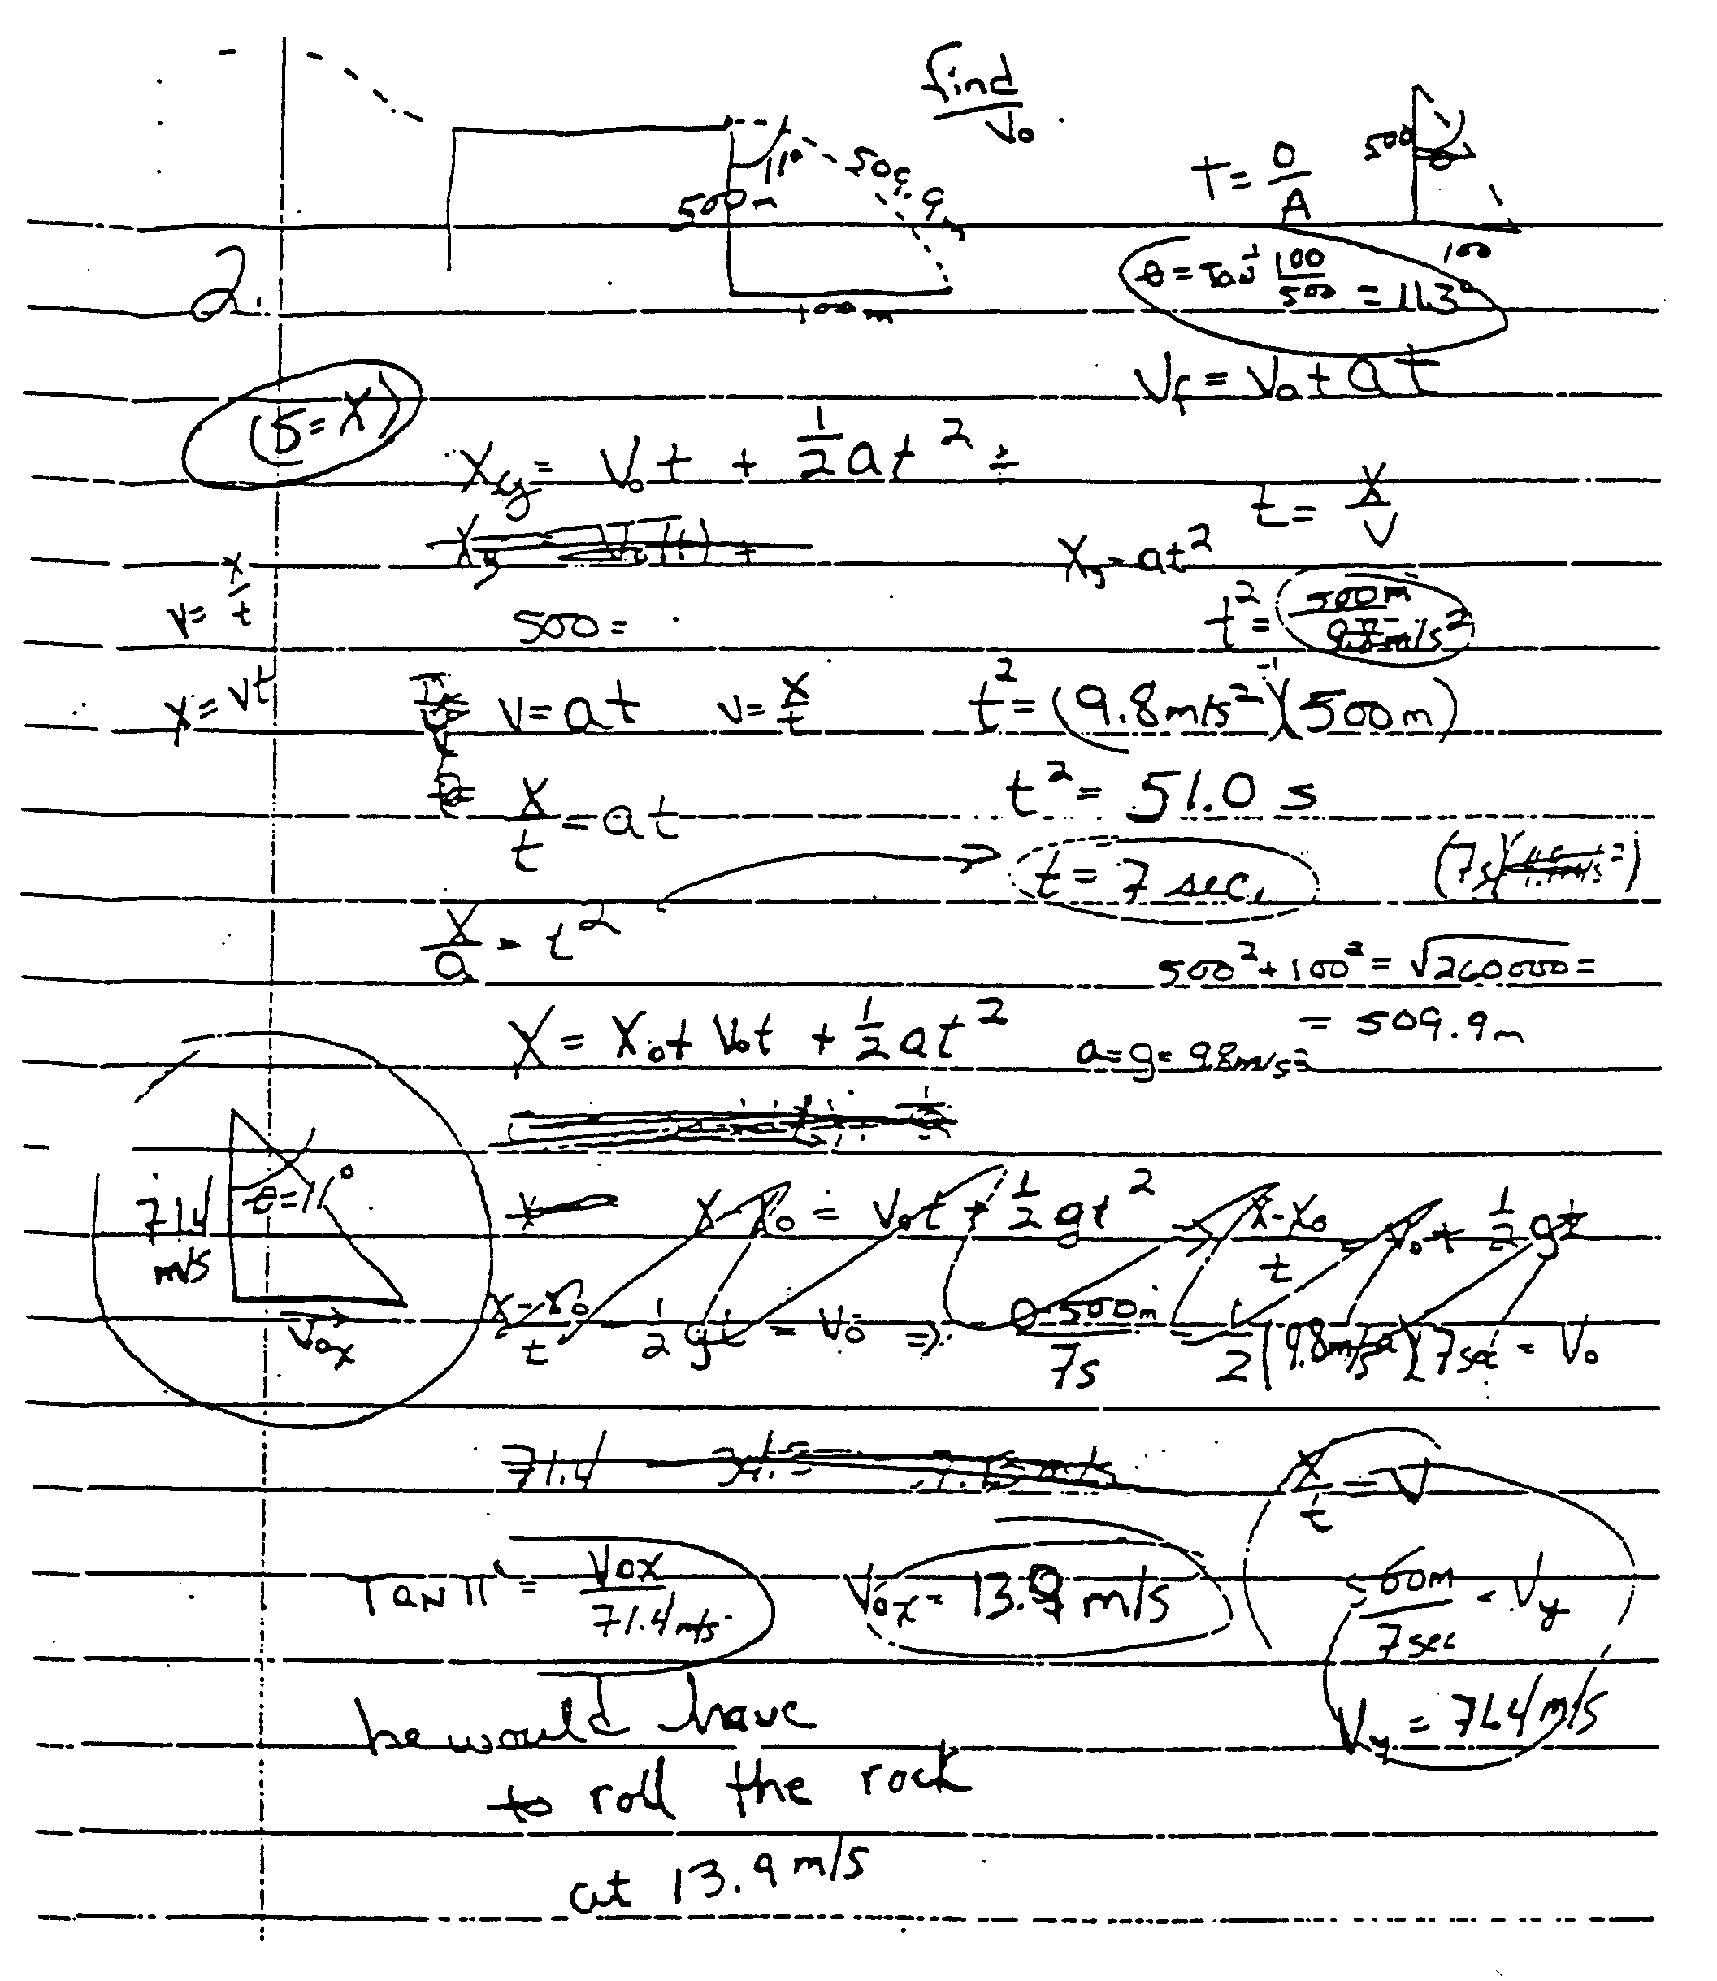

4. Optional: Shown below is a standard textbook solution to the Cowboy Bob problem. Discuss why this solution promotes continued use of a novice strategy (i.e., discourages the use of a more expert-like strategy).

"Choose a coordinate system with its origin at the point where the boulder goes off the cliff, with the x axis pointing horizontally to the right and the y axis vertically downward. The horizontal component of the initial velocity is:

Since the fastest athletes run at about this speed, it is unlikely that Cowboy Bob would be able to push a big boulder this fast."

