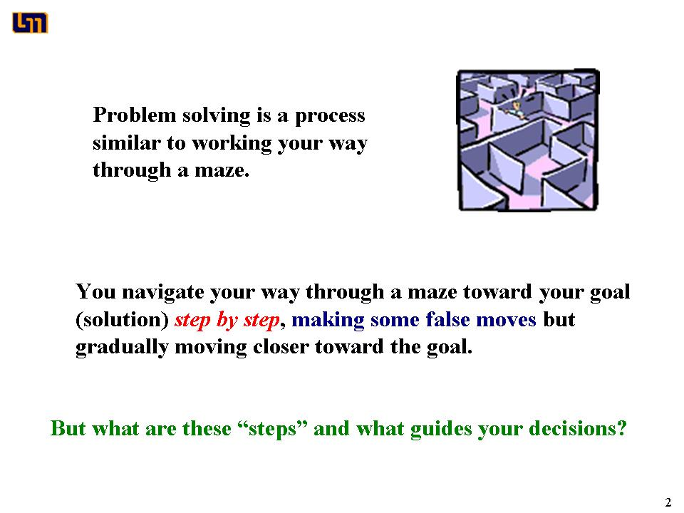

Using Methods Questions for Coaching

Individual and Group Tasks:
1. Individually read the passage below. Participate in a class discussion about this passage
The procedure is actually quite simple. First, you arrange them into different groups. Of course, one pile may be sufficient depending on how much there is to do. If you have to go somewhere else due to lack of facilities that is the next step; otherwise, you are pretty well set.
It is important not to overdo things. That is, it is better to do too few things than too many. In the short run, this may not seem important, but complications can easily arise. A mistake can be expensive as well. At first, the whole procedure will seem complicated. Soon, however, it will become just another fact of life. It is difficult to foresee any end of the necessity of the task in the immediate future, but then, one can never tell.
After the procedure is completed, one arranges the materials into different groups again. Then they can be put into their appropriate places. Eventually they will be used once more and the whole cycle will then have to be repeated. However, that is a part of life.

2. You will be given directions for a group discussion with specific questions about using Methods Questions for coaching.

Cooperative Group Roles:
Skeptic: Ask what other possibilities there are, keep the group from superficial analysis by not allowing the group to agree too quickly; ask questions that lead to a deeper analysis; agree when satisfied that the group has explored all possibilities.
Manager: Suggest a plan for answering the questions; make sure everyone participates and stays on task; watch the time.
Checker/Recorder: Ask others to explain their reasoning process so it is clear to all that their suggestions can be discussed; paraphrase, write down, and edit your group's answers to the questions.

Time: 20 minutes.
One member from your group will be randomly selected to present your group's answers.

Product:
Overhead of group answers. One member from your group will be randomly selected to present your group's answers.

