Homework



Solve the following problems like you, as an instructor, would like see freshman solutions. That is, draw diagrams with a clear definition of symbols, clearly represent the symbolic forms of the fundamental concepts and principles you use, and show a logical, organized progression of steps in your solution.

1. Traffic Accident Problem: You have a summer job with an insurance company and are helping to investigate a tragic "accident." At the scene, you see a road running straight down a hill that is at 10° to the horizontal. At the bottom of the hill, the road widens into a small, level parking lot overlooking a cliff. The cliff has a vertical drop of 400 feet to the horizontal ground below where a car is wrecked 30 feet from the base of the cliff. A witness claims that the car was parked on the hill and began coasting down the road taking about 3 seconds to get down the hill. Your boss drops a stone from the edge of the cliff and, from the sound of it hitting the ground below, determines that it takes 5.0 seconds to fall to the bottom. You are told to calculate the car's average acceleration coming down the hill based on the statement of the witness and the other facts in the case. Obviously, your boss suspects foul play. (Remember you can only use the fundamental concepts listed below.)
Fundamental Concepts: ,
Under Certain Conditions: ,

2. Ice Skating Problem: You are taking care of two small children, Sarah and Rachel, who are twins. On a nice cold, clear day you decide to take them ice skating on Lake of the Isles. To travel across the frozen lake you have Sarah hold your hand and Rachel's hand. The three of you form a straight line as you skate, and the two children just glide. Sarah must reach up at an angle of 60 degrees to grasp your hand, but she grabs Rachel's hand horizontally. Since the children are twins, they are the same height and the same weight, 50 lbs. To get started you accelerate at 2.0 m/s2. You are concerned about the force on the children's arms which might cause shoulder damage. So you calculate the force Sarah exerts on Rachel's arm, and the force you exert on Sarah's other arm. You assume that the frictional forces of the ice surface on the skates are negligible. (Remember you can only use the fundamental concepts listed below.)

Fundamental Concepts: , , , , , F12 = F21
Under Certain Conditions: , ,

3. Safe Ride Problem: A neighbor's child wants to go to a neighborhood carnival to experience the wild rides. The neighbor is worried about safety because one of the rides looks dangerous. She knows that you have taken physics and so asks your advice. The ride in question has a 10-lb. chair which hangs freely from a 30-ft long chain attached to a pivot on the top of a tall tower. When a child enters the ride, the chain is hanging straight down. The child is then attached to the chair with a seat belt and shoulder harness. When the ride starts up the chain rotates about the tower. Soon the chain reaches its maximum speed and remains rotating at that speed. It rotates about the tower once every 3.0 seconds. When you ask the operator, he says that the ride is perfectly safe. He demonstrates this by sitting in the stationary chair. The chain creaks but holds and he weighs 200 lbs. Has the operator shown that this ride safe for a 50-lb. child? (Remember you can only use the fundamental concepts listed below.)
Fundamental Concepts: , , , , , F12 = F21
Under Certain Conditions: , , , ,

4. Fusion Problem: You have a great summer job in a research laboratory with a group investigating the possibility of producing power from fusion. The device being designed confines a hot gas of positively charged ions, called plasma, in a very long cylinder with a radius of 2.0 cm. The charge density of the plasma in the cylinder is 6.0 x 10-5 C/m3. Positively charged Tritium ions are to be injected into the plasma perpendicular to the axis of the cylinder in a direction toward the center of the cylinder. Your job is to determine the speed that a Tritium ion should have when it enters the plasma cylinder so that its velocity is zero when it reaches the axis of the cylinder. Tritium is an isotope of Hydrogen with one proton and two neutrons. You look up the charge of a proton and mass of the tritium in your trusty Physics text to be 1.6 x 10-19 C and 5.0 x 10-27 Kg.

Fundamental Concepts:

 |  |  |  | $$\sum{\vec{F}}=m\vec{a}$$
 | $$W=\int_{\text{path}}{\vec{F}⋅d\vec{ℓ}}$$ | $$\text{KE}=\frac{1}{2}{\text{mv}}^{2}$$ | $$E_{f}−E_{i}={ΔE}_{\text{transfer}}$$

Under Certain Conditions:

Initial Evaluation of Example Student Laboratory Reports

Before you start this homework, read the article by S. Allie, A. Buffler, L. Kunda, and M. Inglis, Writing Intensive Physics Laboratory Reports: Tasks and Assessment (Selected Readings). In this homework you will you will go through 2 examples of student laboratory reports and evaluate their quality.

Homework Tasks:

- Come up with words and characteristics that describe what you consider to be “good” and “bad” writing.

- Using the descriptions that you came up with in step 1, evaluate the following 2 example student laboratory reports.

- Mark down any and all comments on the example student laboratory reports, and indicate whether it is “good” or “bad” based on your description.

Note: This homework is to elicit your initial ideas on how to evaluate student laboratory reports. In class we will discuss, model, and coach grading lab reports.

Defining “Good” & “Bad” Writing

What words or characteristics come to mind when trying to define “good” writing?

What words or characteristics come to mind when trying to define “bad” writing?

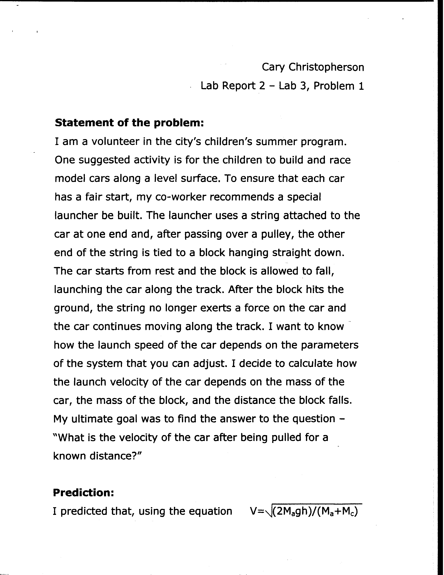

Example #1

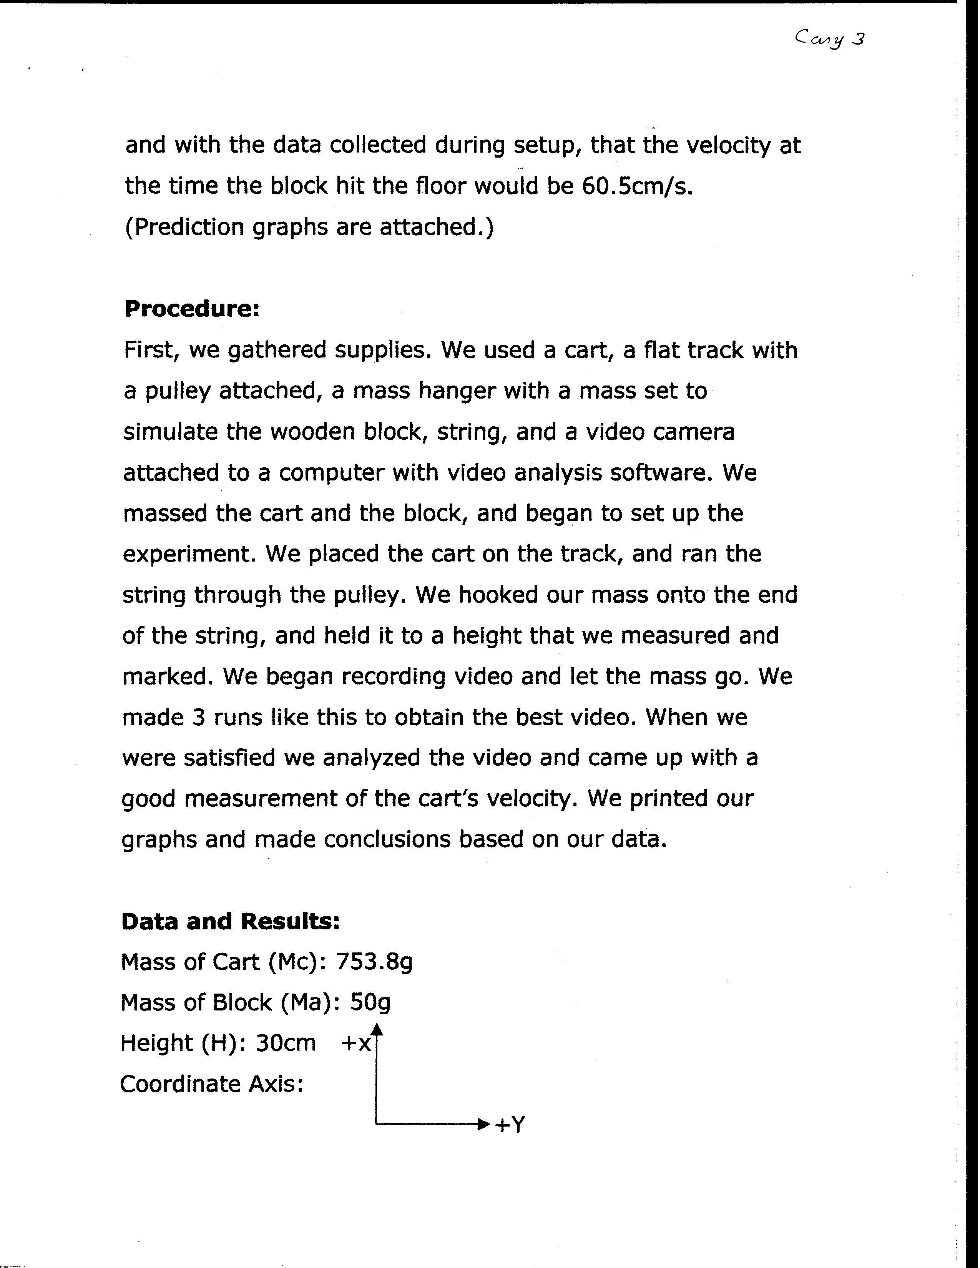
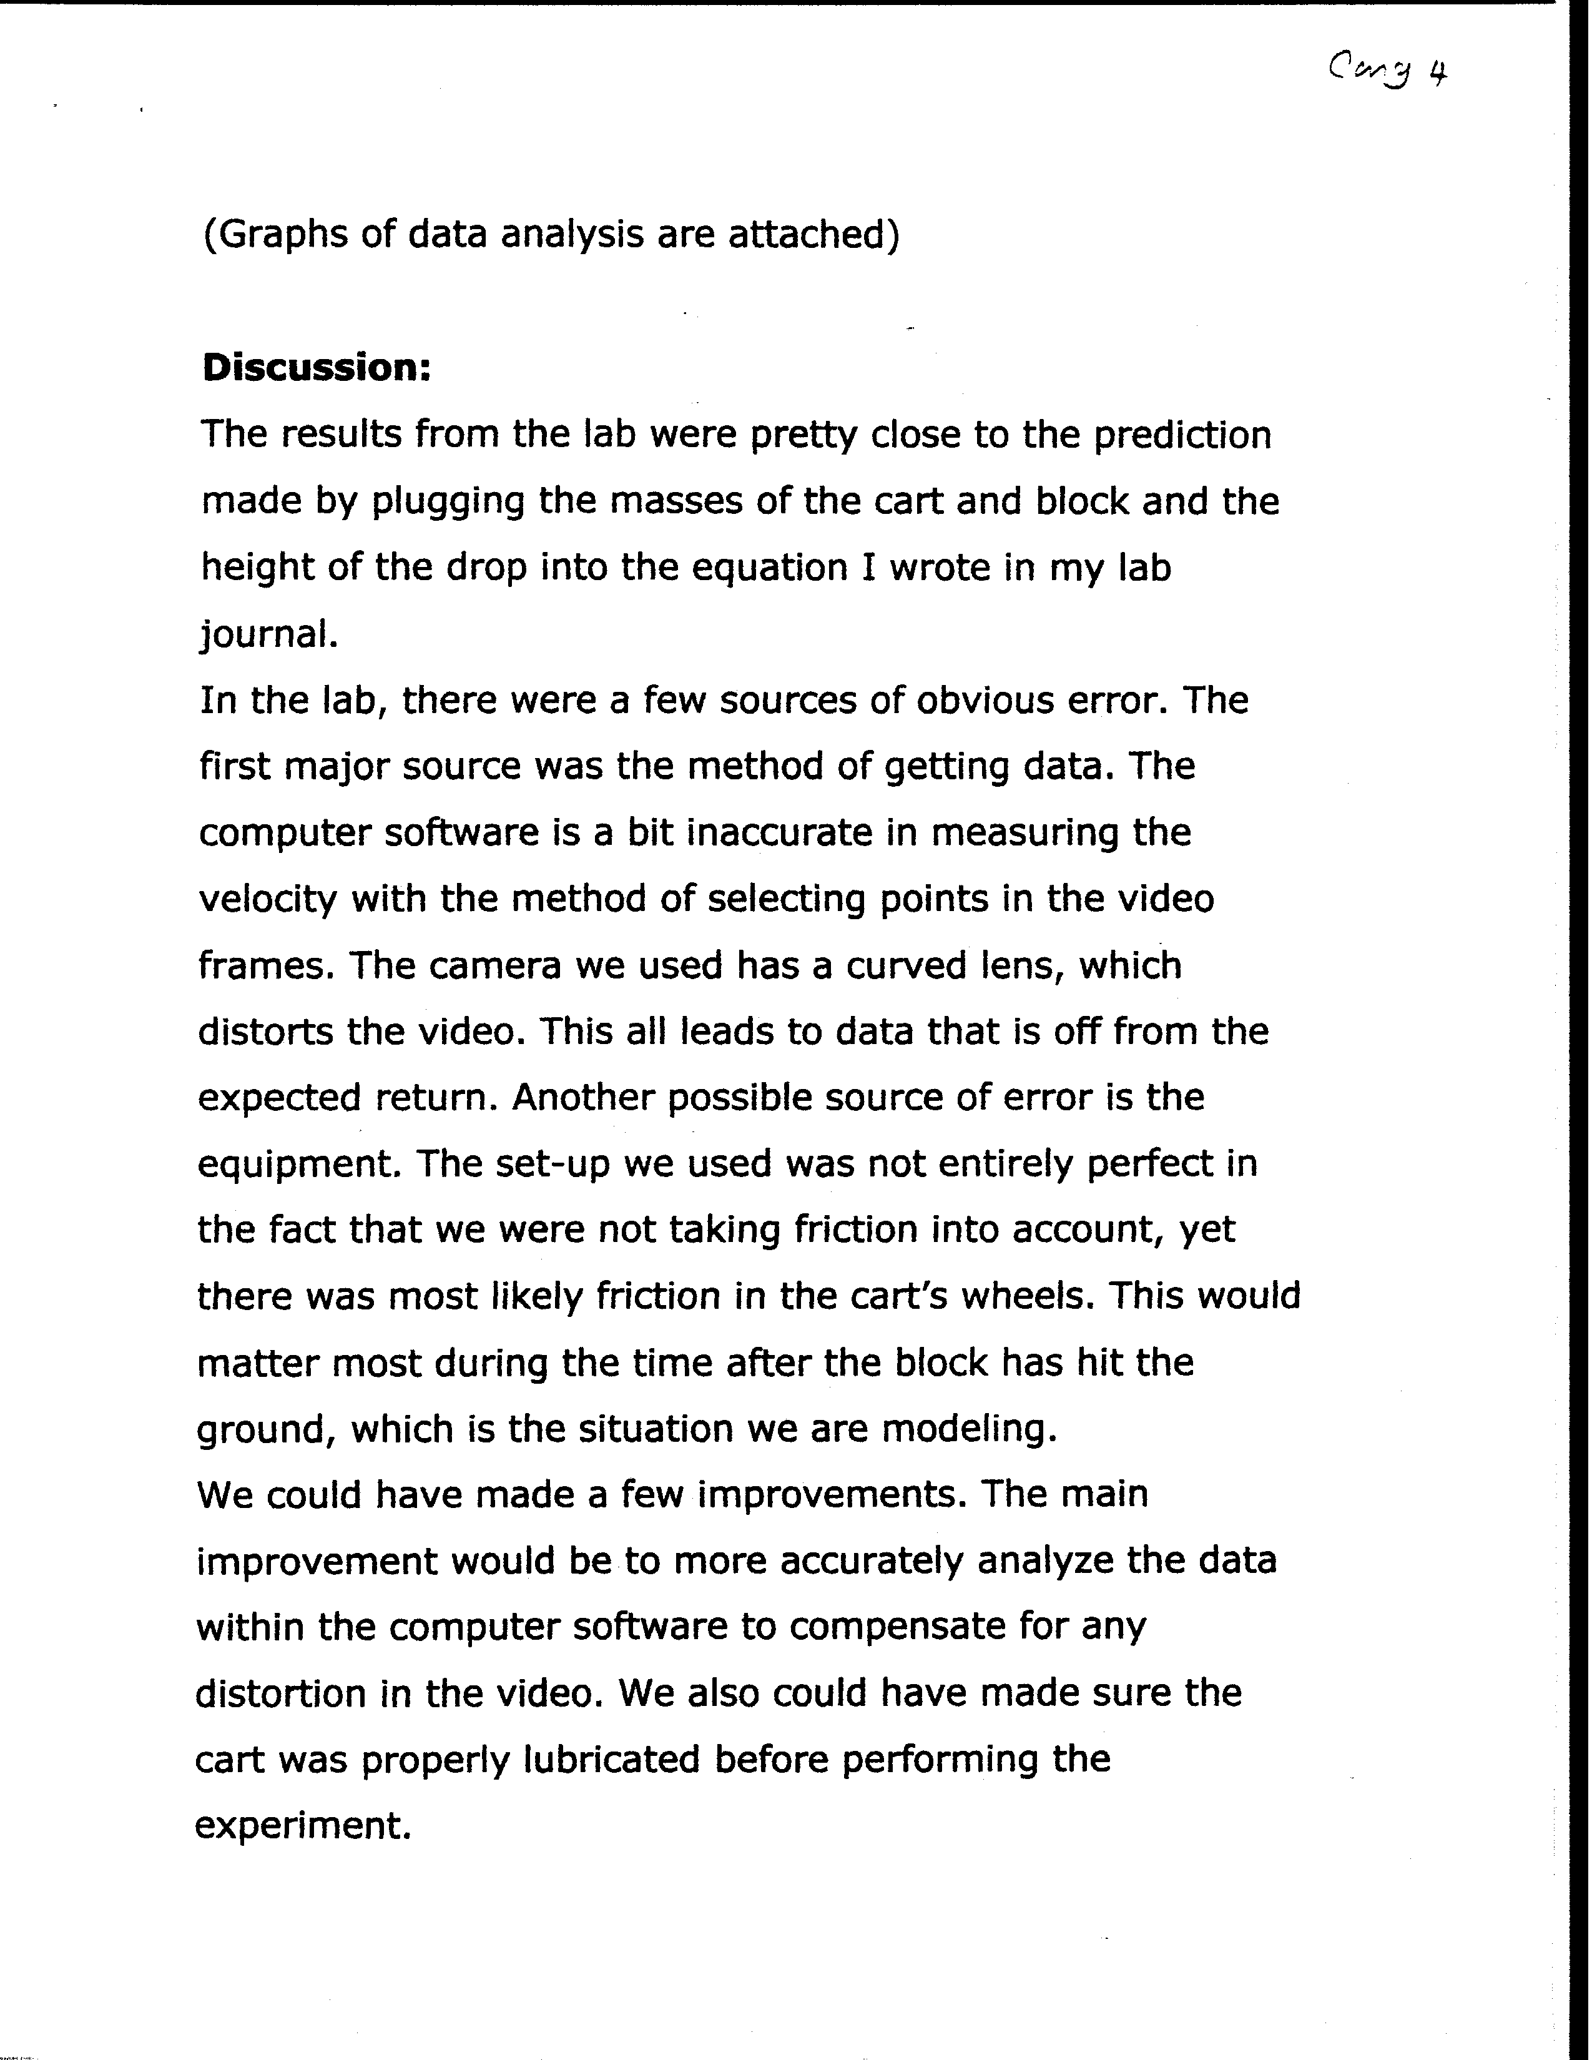
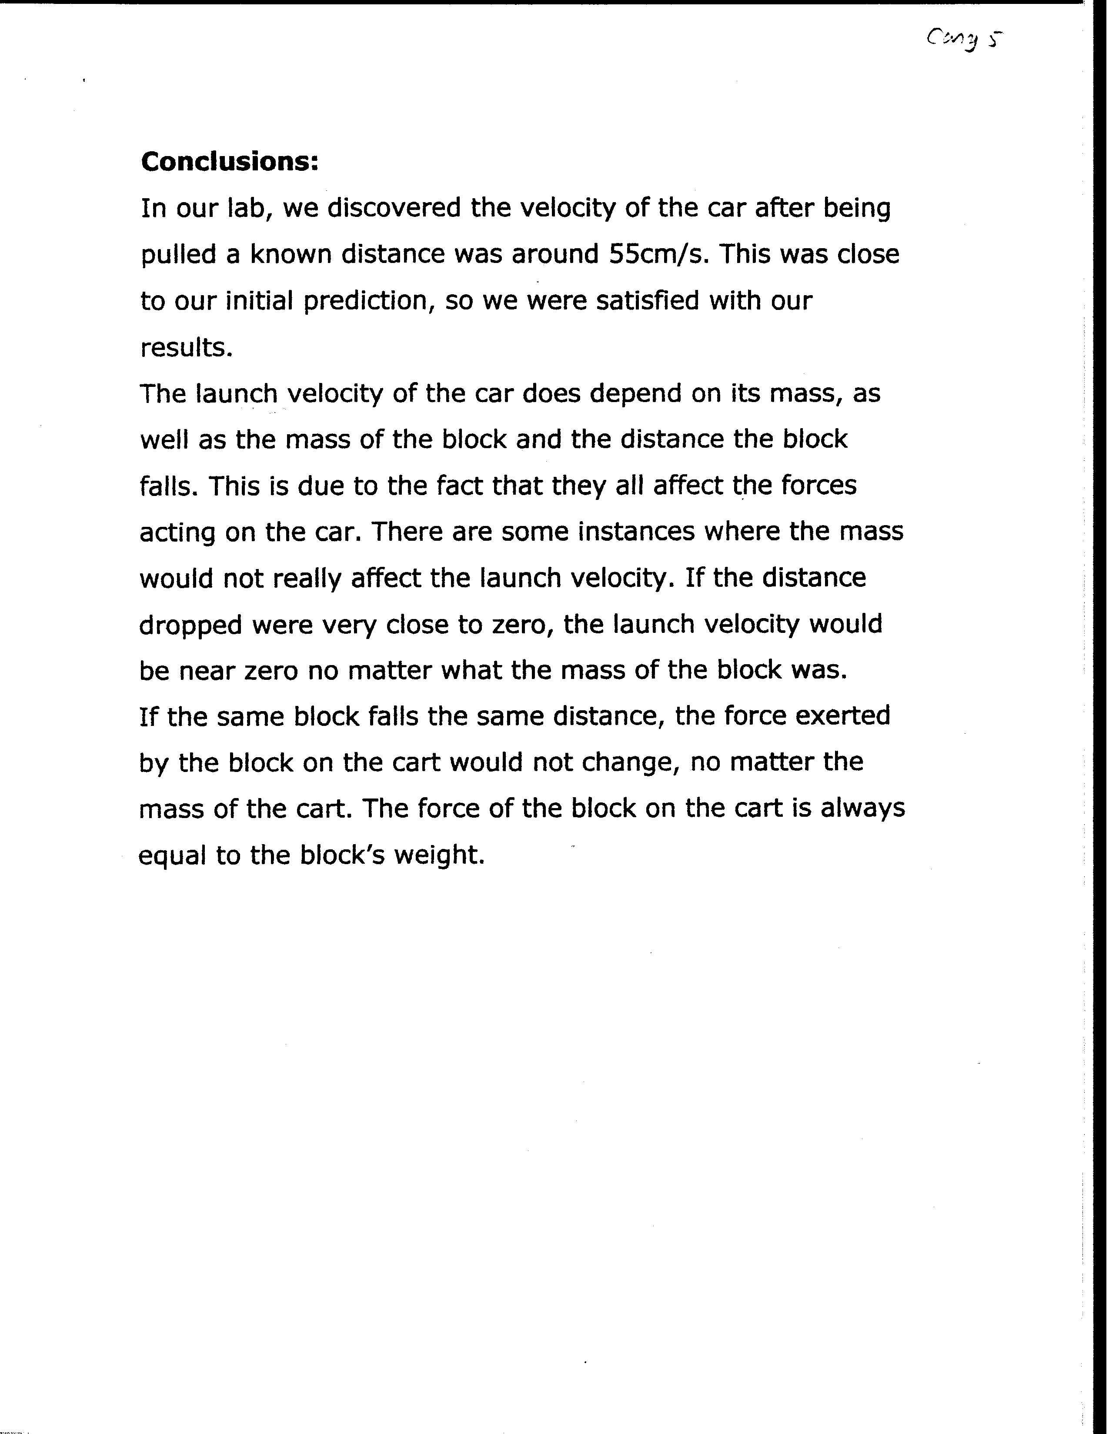

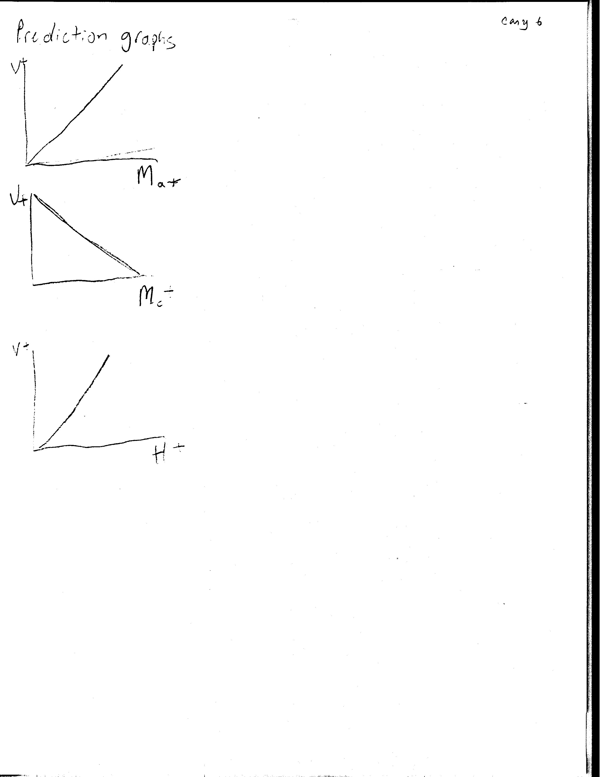

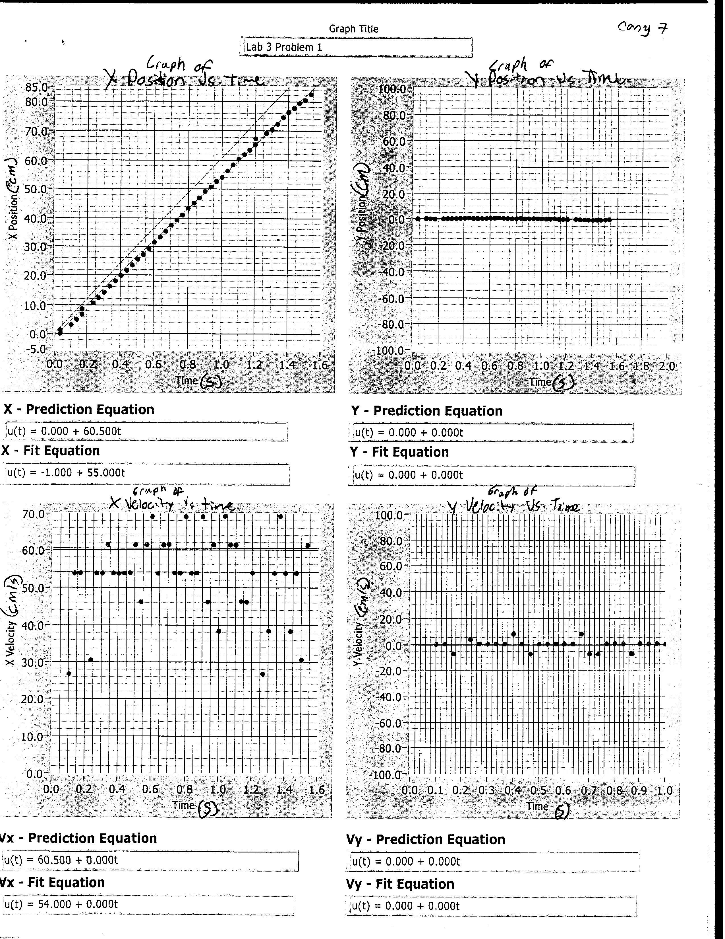
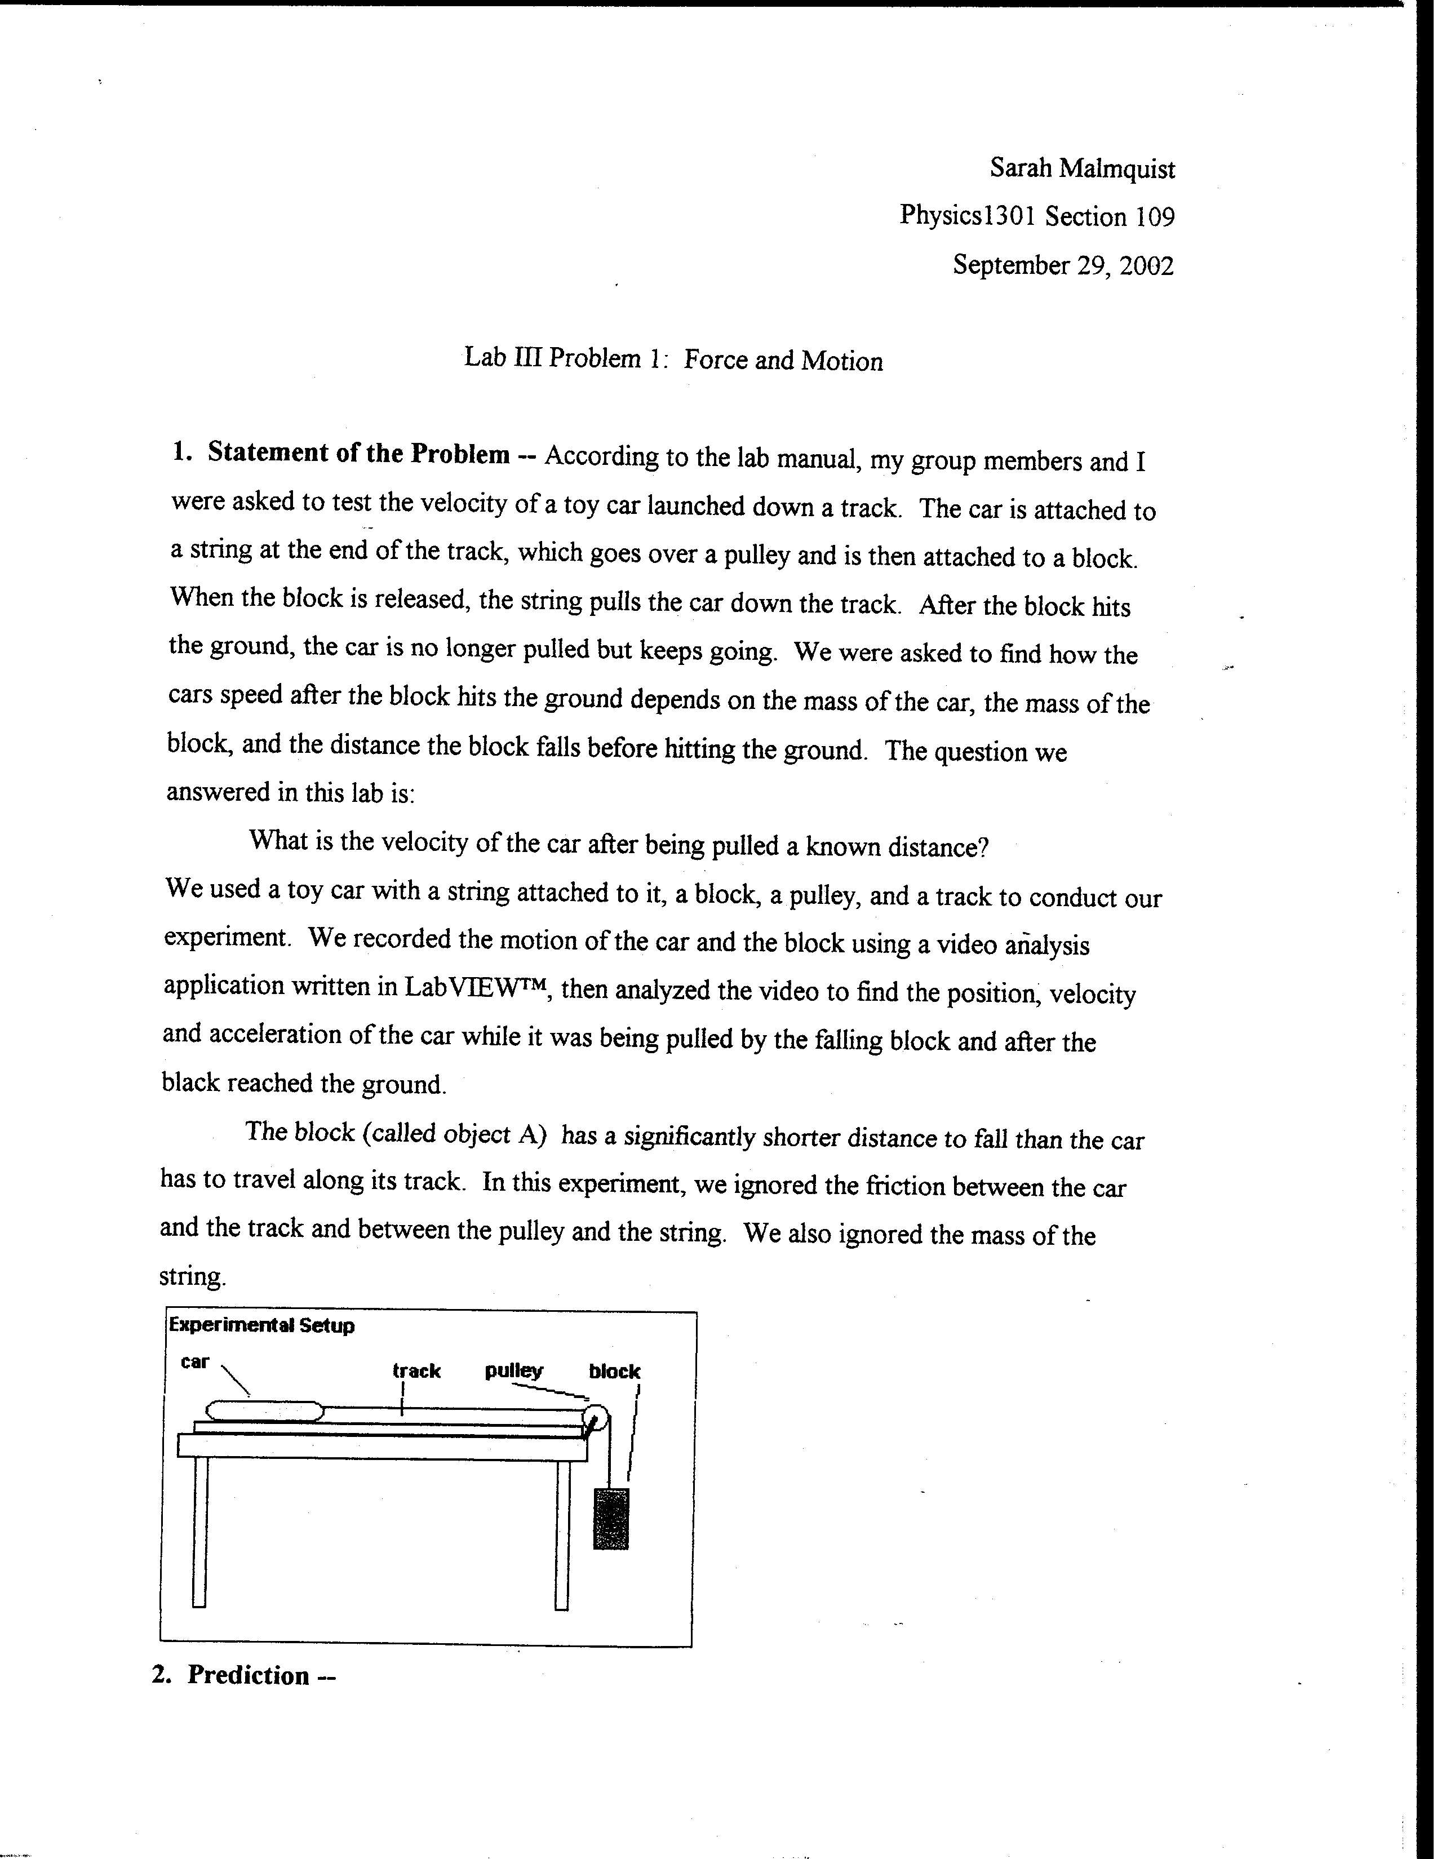

Example #2
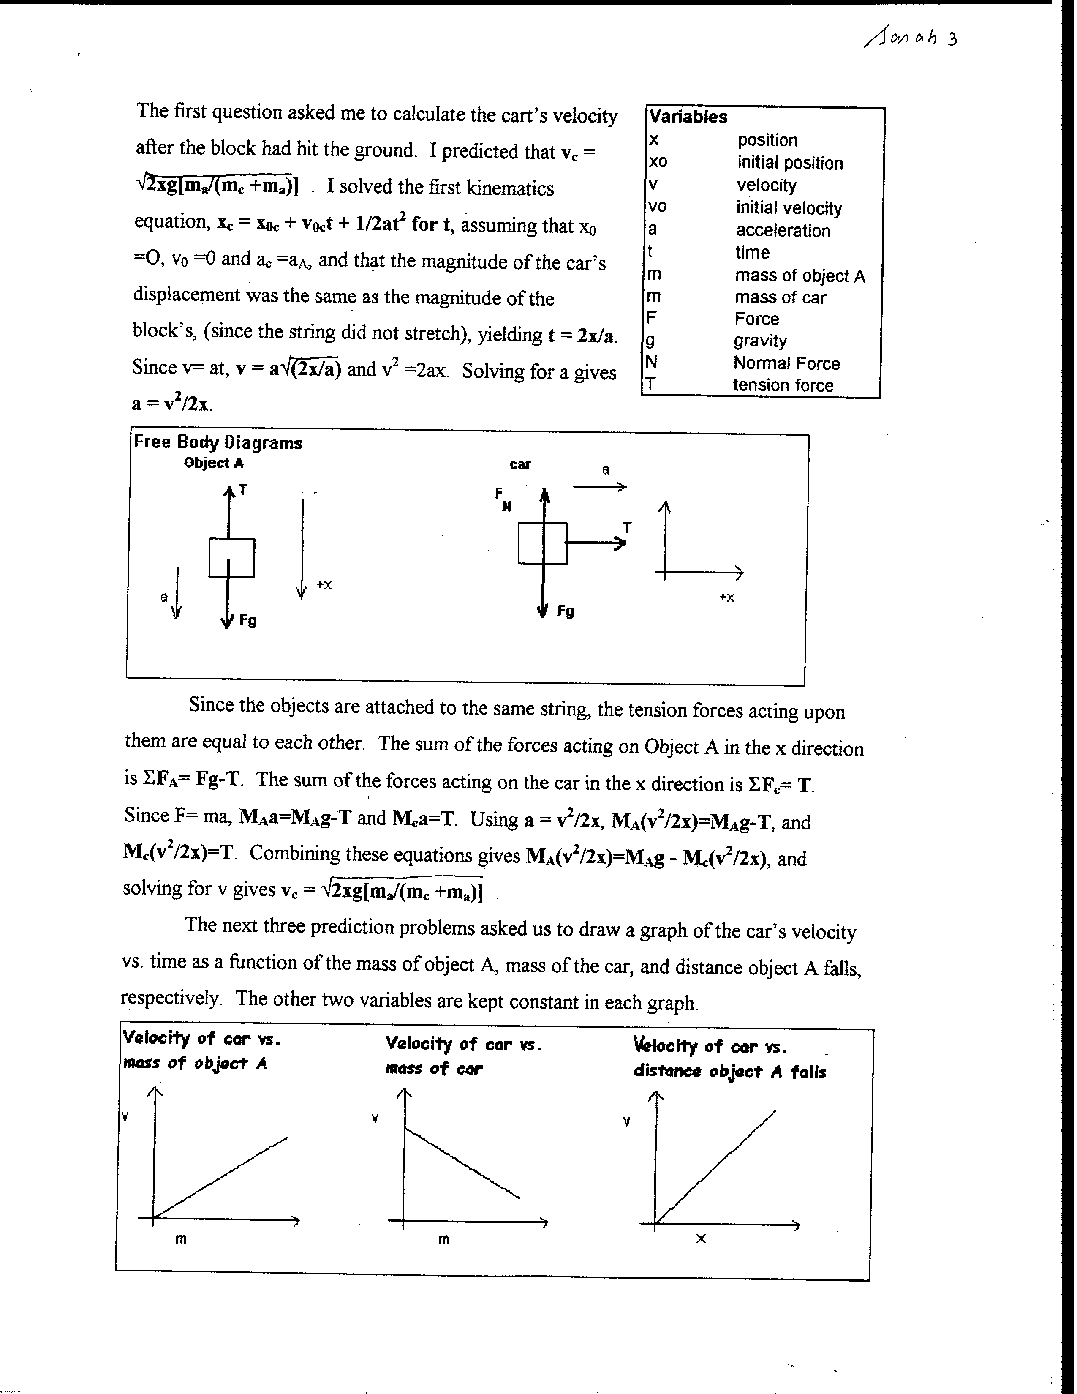

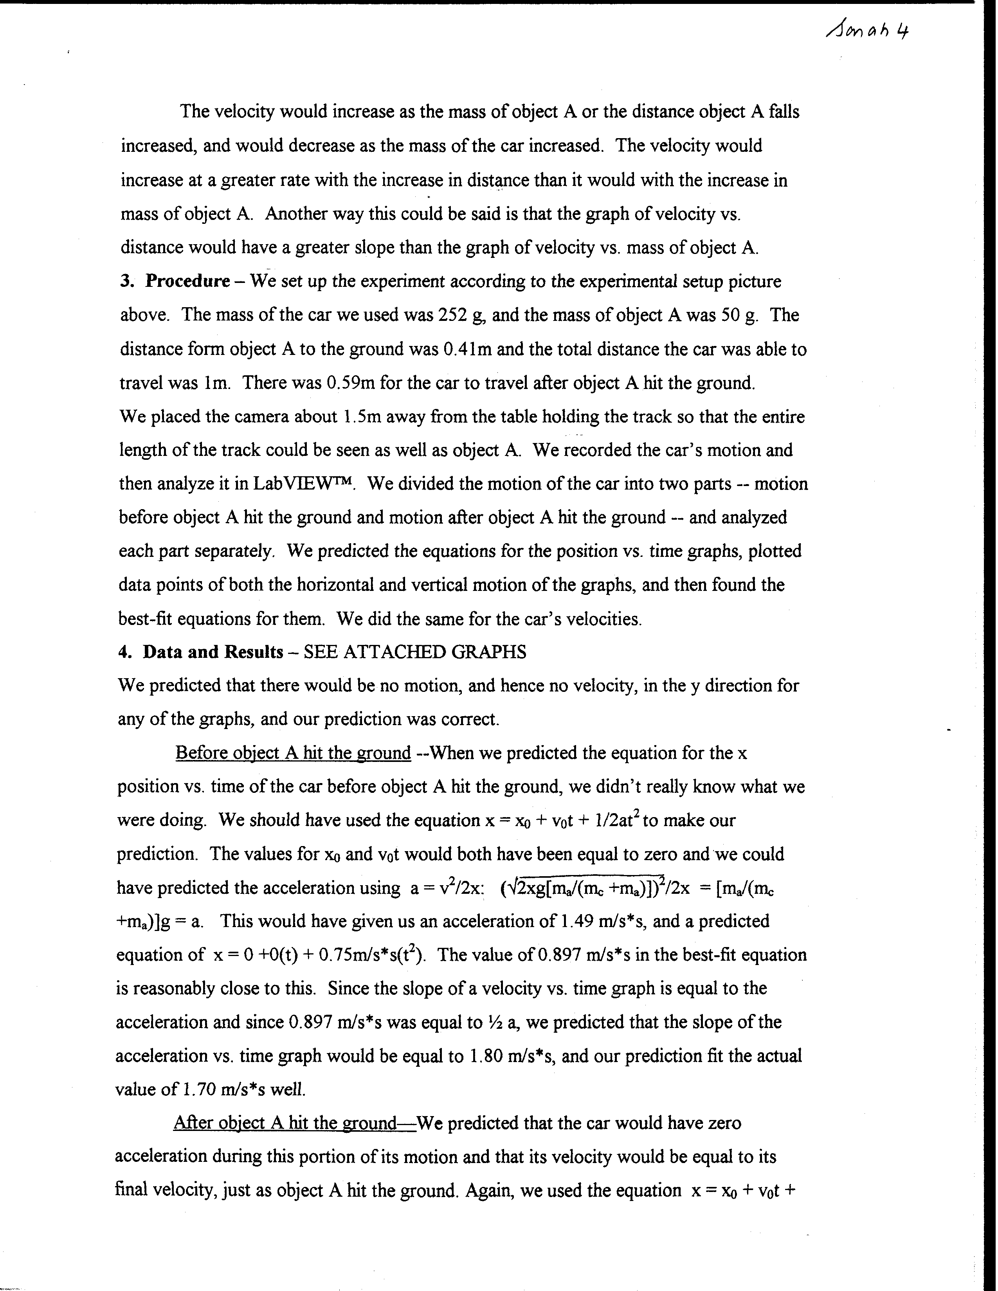
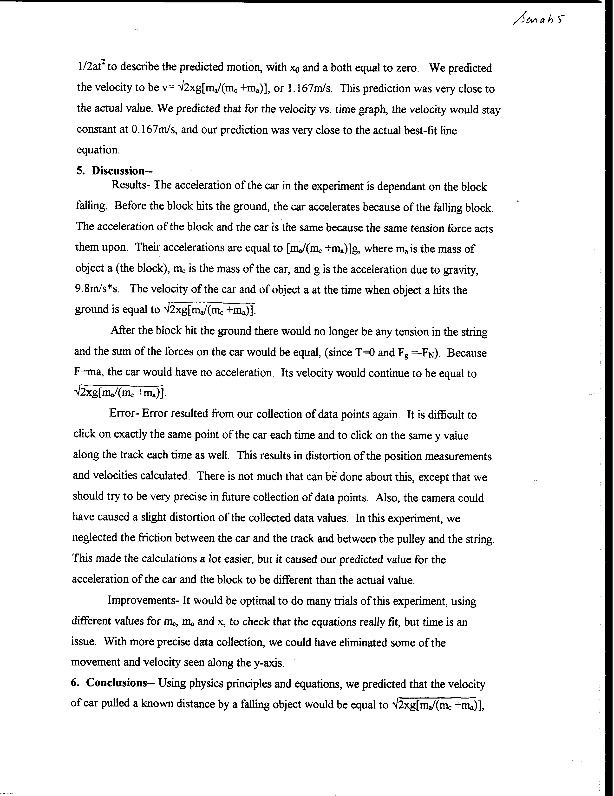
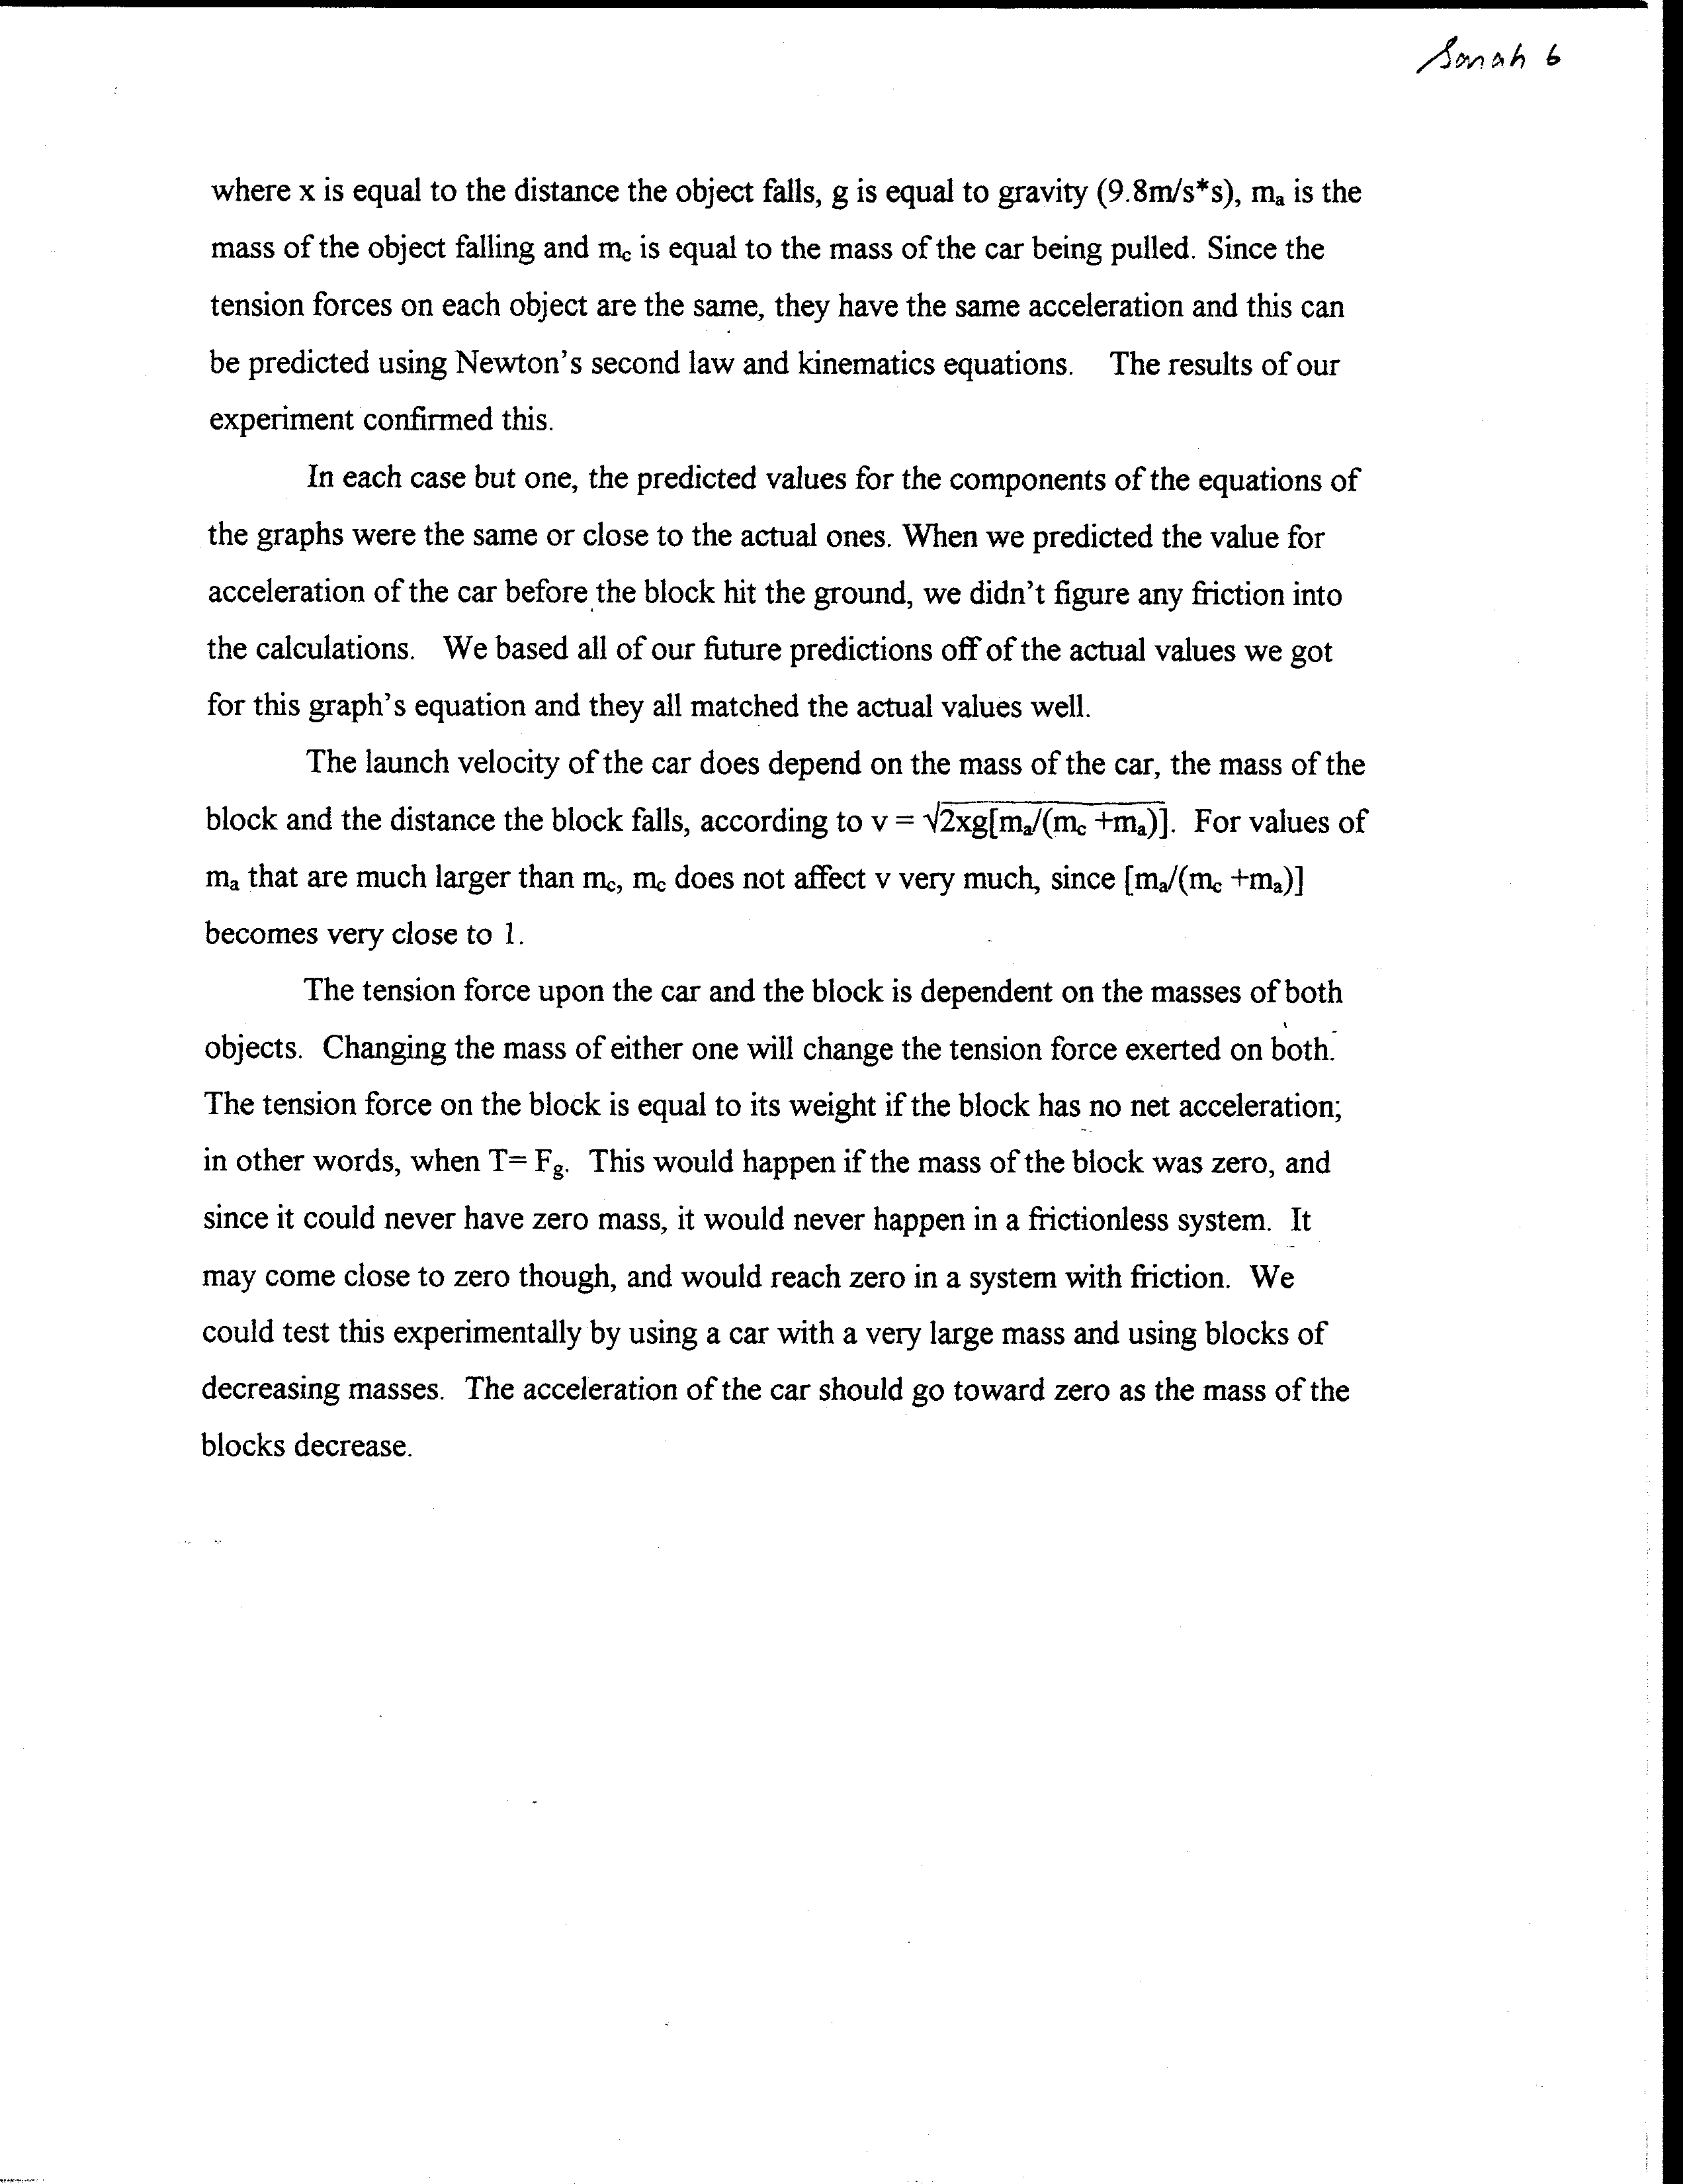
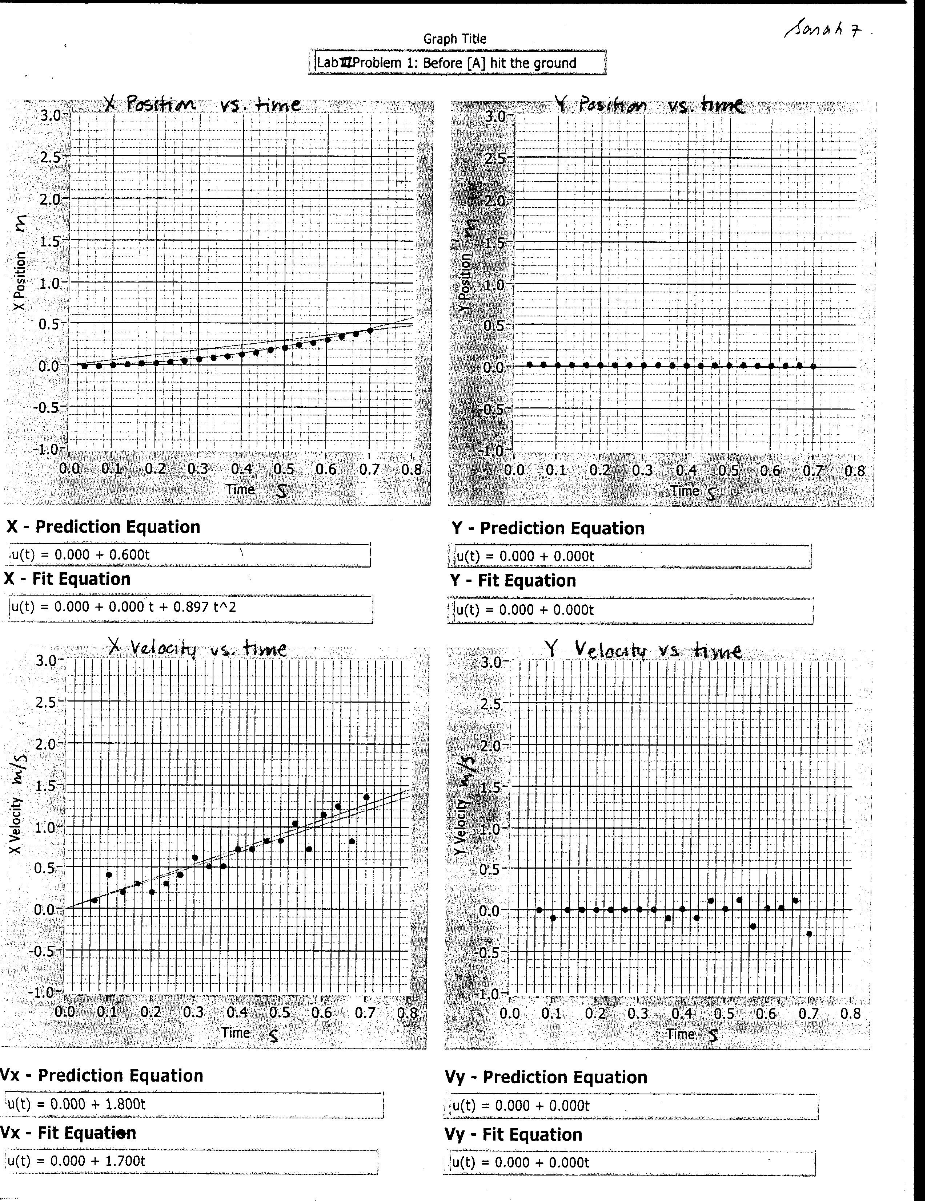
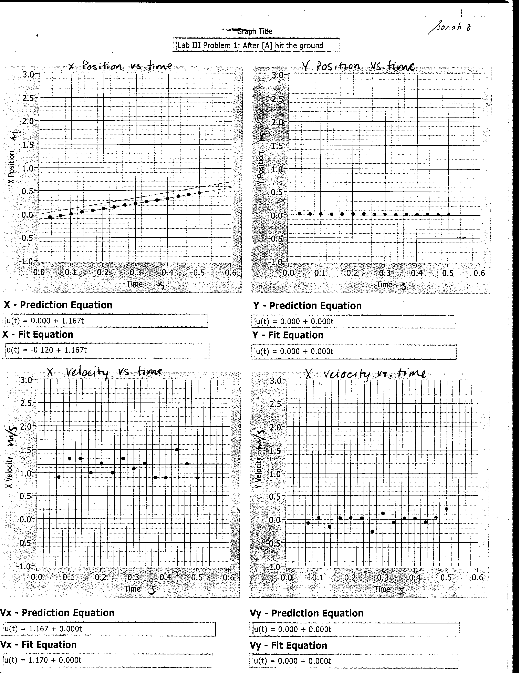

Judging Problems

1. Read/Review the criteria for judging whether a problem would be a good group practice problem (20 - 25 minutes), a good graded group problem (45 - 50 minutes), and/or a good (easy, medium, difficult) individual problem (see pages 39 to59 in the Instructor’s Handbook). There is considerable overlap in the criteria, so most problems can be judged to be both a good group practice or graded problem and a good easy, medium-difficult, or difficult individual problem.

2. Check the items in the right column that apply to each problem you solved in Homework #3. Then use the decision strategy to decide whether you think each problem is a good individual problem, group practice problem, or graded group problem [check your decision(s) in the right column]. Finally, explain your reasoning for each decision.

1. Oil Tanker Problem: Assume students have just started their study of linear kinematics (i.e., they only have the definition of average velocity and average acceleration).  Reject if:  ___ one-step problem  ___ tedious math, little physics  ___ problem needs "trick"  Reasons: |  | Decision:  ___ group practice problem (20 - 25 minutes);  ___ group test problem (45 - 50 minutes); and/or  ___ easy medium difficult individual problem (circle one)
Approach | Analysis |  | Mathematical Solution
- Cues Lacking  ___ A. No target variable  ___ B. Unfamiliar context  - Agility with Principles  ___ A. Choice of principle  ___ B. Two principles  ___ C. Abstract principle  - Non-Standard Application  ___ A. Atypical situation  ___ B. Unusual target | - Excess or Missing Info.  ___ A. Excess data  ___ B. Numbers required  ___ C. Assumptions  - Seemingly Missing Info.  ___ A. Vague statement  ___ B. Special constraints  ___ C. Diagrams  - Additional Complexity  ___ A. >2 subparts  ___ B. 5+ terms  ___ C. Vectors |  | - Algebra required  ___ A. No numbers  ___ B. Unknown(s) cancel  ___ C. Simultaneous eqns.  - Targets Math Difficulty  ___ A. Calc/vector algebra  ___ B. Lengthy algebra

2. Ice Skating Problem: Assume students have just finished their study of the application of Newton's Laws of Motion.  Reject if:  ___ one-step problem  ___ tedious math, little physics  ___ problem needs "trick"  Reasons: |  | Decision:  ___ group practice problem (20 - 25 minutes);  ___ group test problem (45 - 50 minutes); and/or  ___ easy medium difficult individual problem (circle one)
Approach | Analysis |  | Mathematical Solution
- Cues Lacking  ___ A. No target variable  ___ B. Unfamiliar context  - Agility with Principles  ___ A. Choice of principle  ___ B. Two principles  ___ C. Abstract principle  - Non-Standard Application  ___ A. Atypical situation  ___ B. Unusual target | - Excess or Missing Info.  ___ A. Excess data  ___ B. Numbers required  ___ C. Assumptions  - Seemingly Missing Info.  ___ A. Vague statement  ___ B. Special constraints  ___ C. Diagrams  - Additional Complexity  ___ A. >2 subparts  ___ B. 5+ terms  ___ C. Vectors |  | - Algebra required  ___ A. No numbers  ___ B. Unknown(s) cancel  ___ C. Simultaneous eqns.  - Targets Math Difficulty  ___ A. Calc/vector algebra  ___ B. Lengthy algebra

3. Safe Ride Problem: Assume that students have just finished their study of forces and uniform circular motion.  Reject if:  ___ one-step problem  ___ tedious math, little physics  ___ problem needs "trick"  Reasons: |  | Decision:  ___ group practice problem (20 - 25 minutes);  ___ group test problem (45 - 50 minutes); and/or  ___ easy medium difficult individual problem (circle one)
Approach | Analysis |  | Mathematical Solution
- Cues Lacking  ___ A. No target variable  ___ B. Unfamiliar context  - Agility with Principles  ___ A. Choice of principle  ___ B. Two principles  ___ C. Abstract principle  - Non-Standard Application  ___ A. Atypical situation  ___ B. Unusual target | - Excess or Missing Info.  ___ A. Excess data  ___ B. Numbers required  ___ C. Assumptions  - Seemingly Missing Info.  ___ A. Vague statement  ___ B. Special constraints  ___ C. Diagrams  - Additional Complexity  ___ A. >2 subparts  ___ B. 5+ terms  ___ C. Vectors |  | - Algebra required  ___ A. No numbers  ___ B. Unknown(s) cancel  ___ C. Simultaneous eqns.  - Targets Math Difficulty  ___ A. Calc/vector algebra  ___ B. Lengthy algebra

4. Fusion Problem: Assume students have just finished their study of the electricity.  Reject if:  ___ one-step problem  ___ tedious math, little physics  ___ problem needs "trick"  Reasons: |  | Decision:  ___ group practice problem (20 - 25 minutes);  ___ group test problem (45 - 50 minutes); and/or  ___ easy medium difficult individual problem (circle one)
Approach | Analysis |  | Mathematical Solution
- Cues Lacking  ___ A. No target variable  ___ B. Unfamiliar context  - Agility with Principles  ___ A. Choice of principle  ___ B. Two principles  ___ C. Abstract principle  - Non-Standard Application  ___ A. Atypical situation  ___ B. Unusual target | - Excess or Missing Info.  ___ A. Excess data  ___ B. Numbers required  ___ C. Assumptions  - Seemingly Missing Info.  ___ A. Vague statement  ___ B. Special constraints  ___ C. Diagrams  - Additional Complexity  ___ A. >2 subparts  ___ B. 5+ terms  ___ C. Vectors |  | - Algebra required  ___ A. No numbers  ___ B. Unknown(s) cancel  ___ C. Simultaneous eqns.  - Targets Math Difficulty  ___ A. Calc/vector algebra  ___ B. Lengthy algebra

