Teaching Lab Sessions at UMn

Today, a mentor TA will demonstrate how to teach a problem-solving laboratory session at the University of Minnesota. The goals of this activity are for you to learn:
• the structure of the problem-solving labs you will be teaching;
• the rationale for each teaching action in the lab sessions.

During the demonstration, another mentor TA will observe the teacher. At the end of the demonstration, the teacher will be mentored by the observer. Compare your impressions with those of the mentor.

Individual and Group Tasks:
1. Participate in the laboratory demonstration as undergraduates might.
2. Periodically, we will stop the demonstration. Discuss the reasons for each part of the lesson plan with your group. Then individually write the reasons under “Rationale” on the attached lesson plan. These reasons will then be shared and expanded upon by the class and instructors.
3. Work on the assigned laboratory problem and be prepared to discuss your results.

Cooperative Group Roles:
Skeptic: Ask what other possibilities there are, keep the group from superficial analysis by not allowing the group to agree too quickly; ask questions that lead to a deeper analysis; agree when satisfied that the group has explored all possibilities.
Manager: Suggest a plan for discussing the reasons for each part of the lesson plan; make sure everyone participates and stays on task; watch the time.
Checker/Recorder: Ask others to explain their reasoning process so it is clear to all that their suggestions can be discussed; paraphrase, your group’s rationale.

Time: 2 hours.

Product:
We will randomly collect the answer sheet of one group member to grade. Every group member will receive this grade.

Time | Opening Moves | Rationale
10 min.  ~1 min.  5 min  2 min  5-10 min  1 min | 0 Get there early and lock door.  - Collect one piece of equipment needed for lab problems  - Write new groups/roles on board (when appropriate)  - Write which methods questions groups should write on board  - Open Door  1. Prepare students for group work by showing group/role assignments.  2. Prepare students for lab.  a) Focus on what students should learn. Tell students which Methods Question(s) they should discuss and put on the board.  b) Diagnose student difficulties. While groups discuss Methods Questions, circulate around the class, observe/listen to each group, and diagnose difficulties.  c) Post Group Answers. Select (randomly) one person from each group to write/draw on board answers to the Methods Questions.  d) Lead a class discussion. Give students a few minutes to read all the answers on the board. Ask the representatives of each group to give their reasons for each of their answers.  e) How much time. Tell class time they need to stop (usually about 30 – 40 minutes) and remind Managers to keep track of the time.

NOTES:

Time | Middle Game | Rationale
5 min  ~5 min.  variable | 3. Coach groups in problem solving (making decisions) by:  a) Diagnose initial difficulties with the problem or group functioning.  - Return equipment to groups  - Watch class from front of room:  Don’t answer questions.  Is class able to proceed?  Stop class and discuss difficulty if everyone is off task.  b) Monitor groups and intervene to coach when necessary.  Monitor and diagnose :  - Establish a circulation pattern around room. Listen to each group (without them knowing) at least one before answering questions.  Diagnose difficulties with physics;  Diagnose difficulties with group functioning.  Prioritize who needs the most help.  Is entire class confused on the same thing? If so, stop the class and discuss the difficulty.  Coach Groups with the Most Need.  - coach first with the group that needs the most help, and so on  - Always join a group at eye level.  - If you spend a long time with group, circulate around class again, listening briefly to each group and diagnose difficulties, before intervening again.  - Be sure groups are completing all parts of the problem  - If a group finishes early, have them start the next problem.

Time | Middle Game (continued) | Rationale
10 min  5 min | - Start grading lab procedures (journals).  5. Prepare Students for class discussion by  a) Ten-Minute Warning. Ten minutes before you want the groups to stop, tell them to find a good stopping place and clean up their area. (Make sure you are done grading journals). (If groups are new, you may want to pass out the group functioning forms.)  - Posting Corrected Methods Questions and/or Results. Tell one person in each group, who is not the Recorder/Checker, to write their corrected answers (if necessary) to the methods questions on the board (and/or their results).

NOTES:

Time | End Game | Rationale
~10 min  5 -10 minutes  5 min | - Lead a class discussion. Usually, focus the discussion on the qualitative analysis of problem.  7. Optional: Discuss group functioning. Call on one group for “good” response, another group for a “problem,” and a third group for a “specific action.” Repeat until every group has spoken twice.  8. Start next problem. If there is time, have students start the next assigned lab problem. Repeat Steps 1 through 7.  9. End of Lab Session.  a) Tell students what lab problem(s) to do Methods Questions for next week.  b) Assign students problems to write up (if last session of lab). In each group, randomly assign each student in the group a different problem for a lab report.  c) Leaving the Lab. Leave a neat lab room for the next class.

NOTES:
Preparation for Peer Teaching of Labs and Discussion Session

Individual and Team Tasks:
1. Individually read through the next four pages. These pages describe how the four afternoon peer-teaching sessions are structured and graded. Be prepared to ask questions in a class discussion.

2. Lab Preparation: It is assumed that each team member has already done the Method Questions for your assigned lab problems.
(a) Discuss with your team the answers to the Methods Questions.
(b) Work through the assigned lab problems (as a team), collect data, and analyze your results (3 points). What is the conclusion for this lab problem? Your team will be the “expert” on this lab, and should be able to answer questions from other Tas. If you need help with anything, ask the mentor TA working with you.
© When you have finished (b), ask your mentor TA for the Lab Instructor’s Guide for these problems. This manual was written by former Tas to help you prepare for and teach each lab problem.
(d) Discuss the following questions with your team. How does the data you collected and analyzed compare with the example data in the Instructor’s Guide? What other information is included in the Instructor’s Guide? How will this information help you prepare to teach these lab problems?
(e) Photocopy your results and analysis for each lab problem (one per “student”). These will be handed out to your “students” at the end of each lab practice teaching session.

3. Discussion Session Preparation: It is assumed that each team member has already solved the assigned group problem in a logical, organized manner.
(a) Discuss with your team your individual solutions to the discussion problem.
(b) As a team, write a good solution for this problem. A good solution must be helpful to undergraduate students who do not know how to solve the problem. A good solution includes:
• Detailed diagram(s)
• Definition of all variables
• Logical progression and complete steps in the solution (working backwards from target variable).
• Symbolic representation of all equations (both fundamental principles and relationships that apply in certain situations) should be written before substitution of defined variables.
• Solve the problem mathematically before the substitution of quantities (numbers) into the final equation for the target variable.
- ©Photocopy your solution (one per “student”). This will be handed out to your “students” at the end of the discussion practice teaching session.

Structure of Peer Teaching

As a way of preparing to teach the University of Minnesota’s problem-solving labs and discussions sessions, you will have the opportunity to practice-teach either one lab problem or one discussion session to your peers. You have already been assigned to a 3-member team, and your team has been assigned two lab problems and one discussion session to prepare. For four afternoons in the next week, the mentor Tas will supervise the practice teaching of the labs and discussion sessions.

There are two goals for this peer teaching. One is for you to get practice “running through” a lab problem or discussion session, so that you have a sense of what it feels like to keep track of time, supervise a room full of people solving a problem, and lead a discussion. The other goal is for you to become familiar and comfortable with the equipment and typical results for the problem-solving labs.

Each afternoon will be structured as follows:
• The mentor Tas may need to make some brief announcements.
• The “practice teachers” for one afternoon will teach, and the practice teachers for the other three afternoons will act like undergraduate students. This means that you must come to morning class with the Methods Questions completed, and be ready to participate in discussions and take data in the afternoon (see Homework #4, #5, #7 and #9 in the Syllabus).
• On the day your team practice teaches:
- Your team will receive your “students” (peers acting as undergraduates) answers to the Methods Questions during the morning. This will allow you to look over the answers and decide which Method Question(s) you will have your “students” discuss put on the board.
- Just before lunch, your Mentor TA will tell each team member whether they will teach the assigned discussion session or a lab problem (and which assigned lab problem). So each team member has to be prepared to teach all three.
• Each practice teacher will have about 60 minutes to teach one lab problem, or about 30 minutes to teach a discussion session. The practice teachers for lab will then pass out the data and results that THEY had previously prepared for their lab problem (3 points). The practice teachers for discussion will hand out the solution to the problem (3 points).
• The “students” for this lab or discussion session will give each practice teacher written feedback.
• After all the Tas have practice-taught on a day, they will stay and be mentored by the mentor TA.

These afternoon sessions should run between 3 and 4 hours for the first three days, and about 2 hours for the fourth day.

Each TA will select one free afternoon!

Grading Sheet for Homework #4, #5, #7 or #9

When You Are the Practice Teacher: LAB

What the TA Does | TA Initials:
Opening Moves: | ⓪ Be at the classroom early
Opening Moves: | ① Prepare students for group work by showing group/role assignments.
Opening Moves: | ② Prepare students for lab by:  a) diagnosing difficulties while groups discuss and come to consensus on Methods Questions.
Opening Moves: | b) selecting one person from each group to write/draw on board answers to the Methods Questions.
Opening Moves: | c) leading a class discussion about the group answers.
Opening Moves: | d) telling students how much time they have to check their predictions; reminding Manager to keep track of time
Middle Game | ③ Coach groups in problem solving (making decisions) by:  a) monitoring (diagnosing) progress of all groups
Middle Game | b) helping (coaching) groups with the most need, using group roles.
Middle Game | ④ Grade Lab Procedure (journal).
Middle Game | ⑤ Prepare students for class discussion by:  a) giving students a “10-minute warning.” Pass out Group Evaluation Form (if necessary)
Middle Game | b) selecting one person from each group to put corrected methods questions and results on board.
End Game | ⑥ Lead a class discussion focusing on what you wanted students to learn from solving the problem.
End Game | ⑦ Discuss group functioning (optional) | na | na | na | na
End Game | ⑧ Start next lab problem (repeat Steps 1 – 7) if time | na | na | na | na
End Game | ⑨ End of Lab  a) Tell students what lab problems to do Methods Question for next week; if last session, assign students problems for lab report.
End Game | b) Leave a neat lab room for the next class. Do NOT let the next group of students into the classroom. Write down the comments about equipment that did not work on the lab-room sheet .
Total:
Grade:
Total Steps Performed Grade Total Steps Performed Grade
13 – 14 3 points 9 – 10 1 points
11 -12 2points 0 – 8 0 points

Grading Sheet for Homework #4, #5, #7 or #9

When You Are the Practice Teacher: DISCUSSION SESSION

What the TA Does | TA Initials:
Opening Moves: | ⓪ Be at the classroom early
Opening Moves: | ① Introduce the problem by telling students:  a) what they should learn from solving problem;
Opening Moves: | b) the part(s) of the solution you want groups to put on board
Opening Moves: | ② Prepare students for group work by:  a) showing group/role assignments and classroom seating map (if necessary);
Opening Moves: | b) passing out Problem (& Useful Information) and one Answer Sheet.
Opening Moves: | c) Tell class the time they need to stop and remind Managers to keep track of the time.
Middle Game | ③ Coach groups in problem solving by:  a) Monitoring (diagnosing) progress of all groups. Establish a circulation pattern for periodically listening to groups and diagnosing difficulties.
Middle Game | b) helping (coaching) groups with the most need. Using group roles.
Middle Game | ④ Prepare students for class discussion by:  a) giving students a “five-minute warning”
Middle Game | b) selecting one person from each group to put specified part of solution on the board.
Middle Game | c) passing out Group Evaluation Sheet (optional) | na | na | na | na
End Game | ⑤ Lead a class discussion focusing on what you wanted students to learn from solving the problem.
End Game | ⑥ Discuss group functioning (optional) | na | na | na | na
End Game | ⑦ Pass out the problem solution as students walk out the door.
Total:
Grade:

Total Steps Performed Grade Total Steps Performed Grade
11-12 3 points 7-8 1 points
9-10 2 points 0 – 6 0 points
Teaching Discussion Sessions at UMn

The purpose of this activity is to introduce you to your role as instructors in the discussion section.

Part A: Demonstration of a Discussion Session (~50 minutes)
A Mentor TA will demonstrate how to teach a typical discussion session, with you as the students! Focus on the process of collaborative problem solving.

Group Task:
Follow the directions of the Mentor TA.

Group Product:
Your group’s problem solution.

Grading Rubric:
The solution will not be graded for a correct answer. Instead, the solution will be graded for organization and logical progression.

Part B: Class Discussion About Teaching Discussion Sessions
- On the following pages is the Outline for Teaching a Discussion Session. Read through this outline and think about the experience you had solving the problem in a group. Write down questions and comments.

- The Mentor TA will lead a class discussion about your questions. Write important answers/notes in the space provided.

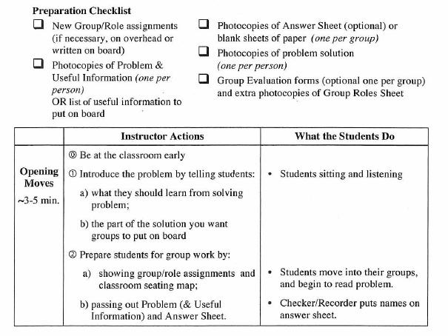

QUESTIONS/NOTES:

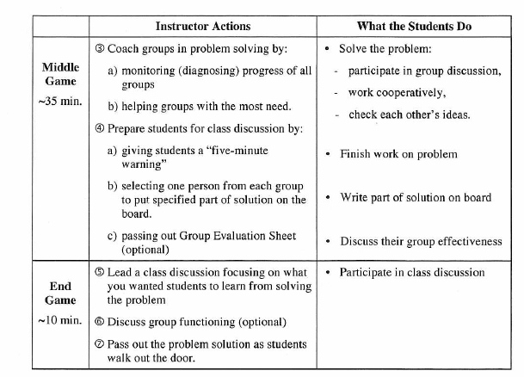

QUESTIONS/NOTES:

Revising an Inappropriate Group Practice Problem

Group Task:
- Solve the inappropriate group practice problem assigned to your group. Explain why the problem is inappropriate, using the criteria on pages 111-115 of the Instructor’s Handbook.
- Follow the steps on page 120 to revise the problem so it is an acceptable group practice problem. Complete the Answer Sheet for Activity #13.
- Solve the revised problem on the student answer sheet provided.
- Write your revised problem on a sheet of butcher paper. Post in room 157.

Cooperative Group Roles:
Skeptic: Ask what other possibilities there are, keep the group from superficial analysis by not allowing the group to agree too quickly; ask questions that lead to a deeper analysis; agree when satisfied that the group has explored all possibilities.
Manager: Suggest a plan for answering the questions; make sure everyone participates and stays on task; watch the time.
Checker/Recorder: Ask others to explain their reasoning process so it is clear to all that their suggestions can be discussed; paraphrase, write down, and edit your group’s answers to the questions.

Time: 45 minutes

Products:
- Revised problem on butcher paper.
- Activity #13 Answer Sheet (revised problem, difficulty characteristics, and your decision.
- Solution to problem written on student answer sheet.

Assume that students are just finishing studying the concepts needed to solve the inappropriate group practice problem below.

Original Problem: A merry-go-round has a circular platform which turns at a rate of one full rotation every 10 seconds. A passenger holds himself on the surface with a pair of very sticky shoes with a coefficient of static friction of 0.4. Determine how far away from the center he can go before falling down to the platform.

- Solve the problem. Explain why the problem is an inappropriate group practice problem. Refer to the Characteristics of a Good Group Problem (Instructor’s Handbook pages 111 to 115).

- Revised Problem:
Analysis
_____ 1. Choice of principle
_____ 2. Two principles
_____ 3. Excess data
_____ 4. Numbers required
_____ 5. Assumptions
_____ 6. Special constraints
_____ 7. Diagrams
_____ 8. Vectors
Mathematical Solution
_____ 9. No numbers
_____ 10. Unknown(s) cancel
_____ 11. Simultaneous eqns.
_____ 12. Calc/vector algebra
_____ 13. Lengthy algebra

Check difficulty characteristics at right.

- Explain why you think that your revised problem is now an appropriate group practice problem. Use the Decision Table (IH page 117) and the Characteristics of a Good Group Problem (IH pages 111 to 115).

Assume that students are just finishing studying the concepts needed to solve the inappropriate group practice problem below.

Original Problem: A ball starts from rest and accelerates at 0.500 m/s² while moving down an inclined plane 9.00 m long. When it reaches the bottom, the ball rolls up another plane, where, after moving 15.0 m, it comes to rest.
- What is the speed of the ball at the bottom of the first plane?
- How long does it take to roll down the first plane?
- What is the acceleration along the second plane?
- What is the ball’s speed 8.00 m along the second plane?

- Solve the problem. Explain why the problem is an inappropriate group practice problem. Refer to the Characteristics of a Good Group Problem (Instructor’s Handbook pages 111 to 115).

- Revised Problem:
Analysis
_____ 1. Choice of principle
_____ 2. Two principles
_____ 3. Excess data
_____ 4. Numbers required
_____ 5. Assumptions
_____ 6. Special constraints
_____ 7. Diagrams
_____ 8. Vectors
Mathematical Solution
_____ 9. No numbers
_____ 10. Unknown(s) cancel
_____ 11. Simultaneous eqns.
_____ 12. Calc/vector algebra
_____ 13. Lengthy algebra

Check difficulty characteristics at right.

- Explain why you think that your revised problem is now an appropriate group practice problem. Use the Decision Table (IH page 117) and the Characteristics of a Good Group Problem (IH pages 111 to 115).

Assume that students are just finishing studying the concepts needed to solve the inappropriate group practice problem below.
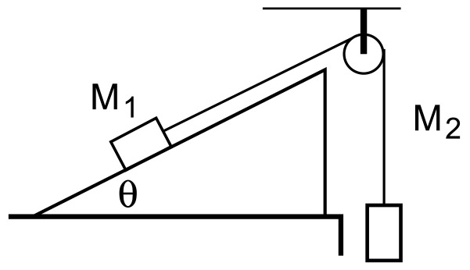
Original Problem: As shown on the diagram, mass M₁ rests on an inclined plane with a rope tied to it. The rope goes through a frictionless, massless pulley, and is connected to another mass, M₂, which hangs off the edge of the table. There is a coefficient of friction, µ_{k}, between the mass M₁ and the inclined plane. The angle of the inclined plane is θ.
- Draw a free body diagram showing all forces (solid lines) and the acceleration (dotted line).
- Write a general solution for the acceleration of the masses in terms of the variables given plus any other that you need to define.
- What is the expression for the acceleration if µ_{k} goes to zero?
- What is the expression for the acceleration if θ = 0?
- What is the acceleration if M₁ = 10 kg, M₂ = 4 kg, µ_{k} = 0.2, and θ = 30 degrees?

  - Solve the problem. Explain why the problem is an inappropriate group practice problem. Refer to the Characteristics of a Good Group Problem (Instructor’s Handbook pages 111 to 115).

  - Revised Problem:
Analysis
_____ 1. Choice of principle
_____ 2. Two principles
_____ 3. Excess data
_____ 4. Numbers required
_____ 5. Assumptions
_____ 6. Special constraints
_____ 7. Diagrams
_____ 8. Vectors
Mathematical Solution
_____ 9. No numbers
_____ 10. Unknown(s) cancel
_____ 11. Simultaneous eqns.
_____ 12. Calc/vector algebra
_____ 13. Lengthy algebra

Check difficulty characteristics at right.

  - Explain why you think that your revised problem is now an appropriate group practice problem. Use the Decision Table (IH page 117) and the Characteristics of a Good Group Problem (IH pages 111 to 115).

