Laboratory Problems

TA Orientation

School of Physics and Astronomy
Fall 2005

Laboratory Problems

Lab Problem Page

Lab 2 Problem #2 (1201) 3
Objects in Free Fall

Lab 2 Problem #3 (1201) 7
Motion Down an Incline

Lab 1 Problem #3 (1301) 11
Motion Up and Down an Incline

Lab 2 Problem #2: (1301) 15
Initial conditions

Lab 2 Problem #3 (1301) 21
Projectile motion and velocity

Lab 2 Problem #5 (1301) 27
Acceleration and Circular Motion

Lab 3 Problem #2 (1301) 31
Forces in Equilibrium

Lab 3 Problem #3 (1301) 35
Frictional Force

Appendix D: Software
LabVIEW™ 39
Ultr@ VNC 49
Digital Projector 52

Lab 2 Problem #2 (1201)
Objects in Free Fall

You and a friend watch a cat at play. You wonder about the cat’s biomechanics. A person, with stronger bones and muscles than a cat, would be injured by jumps from heights that pose no problem for a cat. Your friend observes that humans are heavier than cats. You know that any object’s “heaviness” is a measure of the earth’s gravitational pull on the object; you deduce that the earth exerts a larger gravitational force on a falling human than on a falling cat. Your friend continues the thought, saying that a larger force imparts a larger acceleration, and if a human and a cat jumped from the same height the human would be moving faster than the cat just before each one landed. You are not totally convinced; you decide to test this idea by measuring the speed of falling objects with different masses dropped from the same height.

Draw a graph of the relationship between the velocity of a falling object and the time since its fall began. Determine the relationship between the velocity of the object just before hitting the ground and the height from which it was released. Determine the influence of the object’s mass on these relationships. Assume that the object is always dropped from rest.

Equipment

For this problem, you will have a collection of balls (tennis ball, baseball, Styrofoam ball and so on), each with approximately the same diameter, but different mass. You will also have a stopwatch, a meter stick, a video camera and a computer with a video analysis application written in LabVIEW™.

Prediction

Draw a graph of the relationship between the velocity of a falling object and the elapsed time since being released from rest. Determine the relationship between the velocity of an object and the height at which it was released. Determine the dependence of the velocity on the mass or weight of the falling object.

Method Questions

The following questions should help you formulate your prediction, and decide if it makes sense. See Figure 2.1 (p.42) and sections 4.4, 4.5, and 6.5 in your text.

- Draw a diagram of a ball in midair and establish a convenient coordinate system. Identify all the forces acting on the ball. State any simplifying assumptions you make.
- (Qualitative solution) Make a qualitative plot of the velocity of a falling ball versus time. What is the speed of the ball just after release? What is the shape of the graph? How is a position vs. time graph related to a velocity vs. time graph? Sketch a qualitative graph of position versus time just below the first graph, using the same scale for time. What does this pair of graphs tell you about the quantitative solution to the problem?
- (Energy and work solution) Relate the ball’s kinetic energy at all times during its fall to its velocity. Relate the kinetic energy of a ball to the energy input, or work done by the sum of all forces acting on it, after the ball has fallen a certain distance. Is this solution consistent with your qualitative solution?
- (Newton’s Second Law solution ** optional, see section 2.7 in your text **) Write down the relationship between the sum of forces acting on the ball and the rate at which the velocity changes (increases or decreases) with time. Use this relationship and calculus to write an expression for the ball’s velocity as a function of time. Use the velocity function and calculus to write an expression for the ball’s position as a function of time. Solve the equations to produce an expression of velocity as a function of position. Is this solution consistent with the other two?

Exploration

Position the camera and adjust it for optimal performance. Make sure everyone in your group gets the chance to operate the camera and the computer.

Practice dropping one of the balls until you can get the ball's motion to fill the least distorted part of the screen. Determine how much time it takes for the ball to fall and estimate the number of video points you will get in that time. Are there enough points to make the measurement? Adjust the camera position and screen size to give you enough data points. Take a test video and step through it to determine the quality. Sometimes the data bus on the computer drops a video frame. See if you can tell if this happens by what you see when you step through the video.

Although the ball is the best item to use to calibrate the video, the image quality due to its motion might make this difficult. If you cannot clearly determine the edges of your ball in the first frame of the video you want to use, you can place an object of known length in the plane of motion of the ball, near the center of the ball’s trajectory, for calibration purposes.
Step through the video and determine which part of the ball is easiest to consistently mark. When the ball moves rapidly the image may blur because of the shutter speed of the camera. It is also possible that the image is too dark or too light to see a good edge.

Measure the distance the ball travels with a meter stick and the time for the fall to determine the maximum value for each axis (as well as to check that the numbers the computer will give you make sense) before taking data.

Run through the LabVIEW program once very quickly just to see if you have everything you need before taking careful measurements. Check that you know the origin of the coordinate system used for the graph. Check whether up or down is positive.

Write down your measurement plan.

Measurement

Measure the mass of a ball and make a video of its falling according to the plan you devised in the exploration section. Make sure you can see the ball in every frame of the video.

Measure the position of the ball in enough frames of the video so that you have sufficient data to accomplish your analysis. Make sure you set the scale for the axes of your graph so that you can see the data points as you take them.

Complete your data analysis as you go along (before making the next video), so you can determine how many different videos you need to make. Don’t waste time in collecting data you don't need or, even worse, collecting incorrect data. Collect enough data to convince yourself and others of your conclusion.

Repeat this procedure for different balls.

Analysis

Choose a function to represent the position-versus-time graph. Estimate the values of the constants of the function from the points on the graph. Use the concepts of calculus. You can waste a lot of time if you just try to guess the constants. What kinematic quantities do these constants represent?

Choose a function to represent the velocity-versus-time graph. Calculate the values of the constants of this function from the function representing the position-versus-time graph using calculus. Check how well this works. You can also estimate the values of the constants from the graph. Just trying to guess the constants can waste a lot of your time. What kinematic quantities do these constants represent?

From the velocity-versus-time graph determine the rate at which the velocity increases (or decreases) with time.

Compare the information contained in the graphs of balls with different masses.

Conclusion

What do your measurements say about the variation of the velocity of a freefalling object with time? What do your measurements say about the variation of velocity with the height at which the object is dropped? Did the data support your predictions? If not, what assumptions did you make that were incorrect? Explain your reasoning.

What are the limitations on the precision of your measurements and analysis?

Do your results hold regardless of the masses of the balls? Would the character of the motion of a falling Styrofoam ball be the same as that of a falling baseball? Do the size and shape of the object matter? Is air resistance significant?

Will the velocity (and acceleration) of a falling cat be larger than that of a falling person? State your results in the most general terms supported by your analysis. Compare the kinetic energy of a cat and that of a person just before each strikes the ground. Where does this energy go after each makes a hard landing?

Lab 2 Problem #3 (1201)
Motion Down an Incline

You are part of a group designing experiments to study the effects of a reduced gravity environment on living organisms. Since it will be months before your group will know if your proposal to operate your experiments in the Space station is approved, you decide to use the downtime to study freefalling objects in a ground-based laboratory. You are also aware from previous experience that freefalling objects move too fast, and that the cameras and other detectors can’t respond to them quickly. A colleague suggests that you study objects moving down an inclined track. By changing the inclination, you can slow down the objects, but the motion is still similar in many ways to freefall. You start to experiment with releasing a cart at the top of an incline and measuring its speed after traveling a certain distance down the track.

Determine the speed of the cart after traveling a given distance down an inclined track. Determine the dependence of the speed on the inclination.

Equipment

For this problem you will have a cart, a track with an end stop, a stopwatch, a meter stick, blocks, a video camera and a computer with a video analysis application written in LabVIEW™.

Prediction

Given the angle of inclination, calculate the speed of a cart after being released from rest and traveling a know distance down the inclined track.

Method Questions

- Draw a free-body diagram for the cart moving down the sloped track. Show all forces acting on the cart. Explain which forces you can neglect.
- Draw a coordinate system with two perpendicular axes for the analysis of the forces. Choose the directions of these two axes to make the calculation as easy as possible. Is there a component of the cart’s motion that can be considered as in equilibrium?
- If some forces are not along the axes, find their components along the axes. If any angles are involved, write down how they are related to the angle of the track.
- Write down the work done by the forces as the carts moves down the track a given distance. Relate this work or energy input (or output) to the increase (or decrease) in the kinetic energy of the cart.

Exploration

What is the best way to change the angle of the incline in a reproducible way? How can you use trigonometry to measure this angle with respect to the table?

Start with a small angle and with the cart at rest near the top of the track. Observe the cart as it moves down the inclined track. Explore a range of angles and roughly measure the time it takes to get to the bottom. BE SURE TO CATCH THE CART BEFORE IT HITS THE END STOP! If the time is too short, you may not get enough video frames, and thus enough position and time measurements. Select the best angle for this measurement.

Where is the best place to put the camera? Is it important to have most of the motion in the center of the picture? Which part of the motion do you wish to capture? Explore different camera positions.

Where is the best place to release the cart so it does not damage the equipment but has enough of its motion captured on video? Be sure to catch the cart before it collides with the end stop. Take a few practice videos and play them back to make sure you have captured the motion you want.

What is the total distance through which the cart rolls? How much time does it take? These measurements will help you set up the graphs for your computer data taking.

Write down your measurement plan.

Measurement

Make a video of the cart moving down the track at a given angle. Don't forget to measure and record the angle (with estimated uncertainty).

Choose an object in your picture for calibration. Choose your coordinate system. Is a rotated coordinate system the easiest to use in this case? Try the measurement with and without a rotated coordinate system.

Why is it important to click on the same point on the cart’s image to record its position? Estimate your accuracy in doing so.
Make sure you set the scale for the axes of your graph so that you can see the data points as you take them. Use your measurements of total distance the cart travels and total time to determine the maximum and minimum value for each axis before taking data.

Are any points missing from the position versus time graph? Missing points result from more data being transmitted from the camera than the computer can write to its memory. If too many points are missing, make sure that the size of your video frame is optimal. It may also be that your background is too ‘busy’. Try positioning your apparatus so that the background has fewer visual features.

Change the angle of the track and then repeat the measurement. Determine how many different angles and distances you need to test your prediction.

Analysis

Choose a function to represent the position-versus-time graph. Use your knowledge of functions and calculus to estimate the values of the constants of the function from the graph. You can waste a lot of time if you just try to guess the constants. What kinematic quantities do these constants represent?

Choose a function to represent the velocity-versus-time graph. Why do you have less data points for the velocity-versus-time graph than the position-versus-time graph? How can you calculate the values of the constants of this function from the function representing the position-versus-time graph? Check how well this works. You can also estimate the values of the constants from the graph. Just trying to guess the constants can waste a lot of your time. What kinematic quantities do these constants represent?

As you analyze your video, make sure everyone in your group gets the chance to operate the computer.

For each different angle, you should do the above analysis once.

Conclusion

How do the graphs of your measurements compare to your predictions? How does velocity vary with the distance the cart travels and the angle of the incline? In what sense is the motion similar to freefall? Extrapolate your results to the case of a vertically inclined track and compare with that of freefall.

Lab 1 Problem #3 (1301)
Motion up and down an Incline

A proposed ride at the Valley Fair amusement park launches a roller coaster car up an inclined track. Near the top of the track, the car reverses direction and rolls backwards into the station. As a member of the safety committee, you have been asked to describe the acceleration of the car throughout the ride. (The launching mechanism has been well tested. You are only concerned with the roller coaster’s trip up and back down.) To test your expectations, you decide to build a laboratory model of the ride.

Equipment

For this problem you will have a stopwatch, a meter stick, an end stop, a wood block, a video camera and a computer with a video analysis application written in LabVIEW™ (VideoRECORDER and VideoTOOL applications). You will also have a cart to roll up an inclined track.

Prediction

Make a rough sketch of how you expect the acceleration vs. time graph to look for a cart with the conditions discussed in the problem. The graph should be for the entire motion of going up the track, reaching the highest point, and then coming down the track.

Do you think the acceleration of the cart moving up an inclined track will be greater than, less than, or the same as the acceleration of the cart moving down the track? What is the acceleration of the cart at its highest point? Explain your reasoning.

Method Questions

The following questions should help you examine the consequences of your prediction. Read: Fishbane Chapter 2. Sections 2.1-2.4

1. Sketch a graph of the instantaneous acceleration vs. time graph you expect for the cart as it rolls up and then back down the track after an initial push. Sketch a second instantaneous acceleration vs. time graph for a cart moving up and then down the track with the direction of a constant acceleration always down along the track after an initial push. On each graph, label the instant where the cart reverses its motion near the top of the track. Explain your reasoning for each graph. Write down the equation(s) that best represents each graph. If there are constants in your equations, what kinematic quantities do they represent? How would you determine these constants from your graphs?
2. Write down the relationship between the acceleration and the velocity of the cart. Use that relationship to construct an instantaneous velocity vs. time graph just below each of acceleration vs. time graph from question 1, with the same scale for each time axis. (The connection between the derivative of a function and the slope of its graph will be useful.) On each graph, label the instant where the cart reverses its motion near the top of the track. Write an equation for each graph. If there are constants in your equations, what kinematic quantities do they represent? How would you determine these constants from your graphs? Can any of the constants be determined from the constants in the equation representing the acceleration vs. time graphs?
3. Write down the relationship between the velocity and the position of the cart. Use that relationship to construct an instantaneous position vs. time graph just below each of your velocity vs. time graphs from question 2, with the same scale for each time axis. (The connection between the derivative of a function and the slope of its graph will be useful.) On each graph, label the instant where the cart reverses its motion near the top of the track. Write down an equation for each graph. If there are constants in your equations, what kinematic quantities do they represent? How would you determine these constants from your graphs? Can any of the constants be determined from the constants in the equations representing velocity vs. time graphs?
4. Which graph do you think best represents how position of the cart will change with time? Adjust your prediction if necessary and explain your reasoning.

Exploration

What is the best way to change the angle of the inclined track in a reproducible way? How are you going to measure this angle with respect to the table? (Think about trigonometry.)

Start the cart up the track with a gentle push. BE SURE TO CATCH THE CART BEFORE IT HITS THE END STOP ON ITS WAY DOWN! Observe the cart as it moves up the inclined track. At the instant the cart reverses direction, what is its velocity? Its acceleration? Observe the cart as it moves down the inclined track. Do your observations agree with your prediction? If not, discuss it with your group.

Where is the best place to put the camera? Which part of the motion do you wish to capture?

Try different angles. Be sure to catch the cart before it collides with the end stop at the bottom of the track. If the angle is too large, the cart may not go up very far and will give you too few video frames for the measurement. If the angle is too small it will be difficult to measure the acceleration. Take a practice video and play it back to make sure you have captured the motion you want (see the “Exploration” section in Problem 1, and appendix D, for hints about using the camera and VideoRECORDER / VideoTOOL). Hint: To analyze motion in only one dimension (like in the previous problem) rather than two dimensions, it could be useful to rotate the camera!

What is the total distance through which the cart rolls? How much time does it take? These measurements will help you set up the graphs for your computer data taking, and can provide for a check on your video analysis of the cart’s motion.

Write down your measurement plan.

Measurement

Follow your measurement plan to make a video of the cart moving up and then down the track at your chosen angle. Record the time duration of the cart’s trip, and the distance traveled. Make sure you get enough points for each part of the motion to determine the behavior of the acceleration. Don't forget to measure and record the angle (with estimated uncertainty).

Work through the complete set of calibration, prediction equations, and fit equations for a single (good) video before making another video. Make sure everyone in your group gets the chance to operate the computer.

Analysis

From the time given by the stopwatch and the distance traveled by the cart, calculate its average acceleration. Estimate the uncertainty.

Look at your graphs and rewrite all of the equations in a table but now matching the dummy letters with the appropriate kinetic quantities. If you have constant values, assign them the correct units, and explain their meaning.

Can you tell from your graph where the cart reaches its highest point?

From the velocity vs. time graph determine if the acceleration changes as the cart goes up and then down the ramp. Use the function representing the velocity vs. time graph to calculate the acceleration of the cart as a function of time. Make a graph of that function. Can you tell from this instantaneous acceleration vs. time graph where the cart reaches its highest point? Is the average acceleration of the cart equal to its instantaneous acceleration in this case?

Compare the acceleration function you just graphed with the average acceleration you calculated from the time on the stopwatch and the distance the cart traveled.

Conclusion

How do your position vs. time, velocity vs. time graphs compare with your answers to the method questions and the prediction? What are the limitations on the accuracy of your measurements and analysis?

Did the cart have the same acceleration throughout its motion? Did the acceleration change direction? Was the acceleration zero at the top of its motion? Describe the acceleration of the cart through its entire motion after the initial push. Justify your answer with kinematic arguments and experimental results. If there are any differences between your predictions and your experimental results, describe them and explain why they occurred.

SIMULATION
If your data did not match your expectations, you may use the simulation to explore what could have happened. A scheme for doing so is outlined at the end of Problem 2 in this lab.
Lab 2 Problem #2: (1301)
Initial Conditions

You have designed an apparatus to measure air quality in your city. To quickly force air through the apparatus, you will launch it straight downward from the top of a tall building. A very large acceleration may destroy sensitive components in the device; the launch system’s design ensures that the apparatus is protected during its launch. You wonder what the acceleration of the apparatus will be once it exits the launcher. Does the object’s acceleration after it has left the launcher depend on its velocity when it leaves the launcher? You decide to model the situation by throwing balls straight down.

Equipment

You will have a ball, a stopwatch, a meter stick, a video camera and a computer with a video analysis application written in LabVIEW™ (VideoRECORDER and VideoTOOL applications). The launcher is your hand.

Prediction

Sketch a graph of a ball’s acceleration as a function of time after it is launched in the manner described above. State how your graph will change if the object's initial velocity increases or decreases.

Do you think that the acceleration increases, decreases, or stays the same as the initial velocity of the object changes? Make your best guess and explain your reasoning.

Method Questions

The following questions will help you examine three possible scenarios. They should help you to understand your prediction and analyze your data.
Read: Fishbane Chapter 2, section 2.5.

- How would you expect an acceleration vs. time graph to look for a ball moving downward with a constant acceleration? With a uniformly increasing acceleration? With a uniformly decreasing acceleration? Sketch the graph for each scenario and explain your reasoning. To make the comparison easier, draw these graphs next to each other. Write down the equation that best represents each graph. If there are constants in your equations, what kinematic quantities do they represent? How would you determine these constants from your graph?
- Write down the relationships between the acceleration and the velocity and the velocity and the position of the ball. Use these relationships to construct the graphs for velocity vs. time and position vs. time just below each acceleration graph from question 1. Use the same scale for each time axis. Write down the equation that best represents each graph. If there are constants in your equations, what kinematic quantities do they represent? How would you determine these constants from your graphs? Can any of the constants be determined from the equations representing the acceleration and velocity graphs?
- Does your prediction agree with one of the scenarios you just explored? Explain why or why not.
- Write down an outline of how you will determine the acceleration of the object from the video data.

Exploration

Review your lab journal from Lab 1. Position the camera and adjust it for optimal performance. Make sure everyone in your group gets the chance to operate the camera and the computer.

Practice throwing the ball straight downward until you can get the ball's motion to fill most of the video screen after it leaves your hand. Determine how much time it takes for the ball to fall and estimate the number of video points you will get in that time. Is it sufficient to make the measurement? Adjust the camera position to get enough data points.

Although the ball is the best item to use to calibrate the video, the image quality due to its motion might make this difficult. Instead, you might hold an object of known length in the plane of motion of the ball, near the center of the ball’s trajectory, for calibration purposes. Where you place your reference object does make a difference in your results. Check your video image when you put the reference object close to the camera and then further away. What do you notice about the size of the reference object in the video image? The best place to put the reference object to determine the distance scale is at the position of the falling ball.

Step through the video and determine which part of the ball is easiest to consistently determine. When the ball moves rapidly you may see a blurred image due to the camera’s finite shutter speed. If you cannot make the shutter speed faster, devise a plan to measure the position of the same part of the “blur” in each video frame.

Write down your measurement plan.

Measurement

Make a video of the ball being tossed downwards. Repeat this procedure for different initial velocities.

Digitize the position of the ball in enough frames of the video so that you have sufficient data to accomplish your analysis. Make sure you set the scale for the axes of your graph so that you can see the data points as you take them. Use your measurements of total distance the ball travels and total time to determine the maximum and minimum value for each axis before taking data.

Graph your data as you go along (before making the next video), so you can determine how many different videos you need to make and how you should change the ball's initial velocity for each video. Don’t waste time collecting data you don't need or, even worse, incorrect data. Collect enough data to convince yourself and others of your conclusion.

Repeat this procedure for different launch velocities.

Analysis

Choose a function to represent the position vs. time graph. How can you estimate the values of the constants of the function from the graph? You can waste a lot of time if you just try to guess the constants. What kinematic quantities do these constants represent?

Choose a function to represent the velocity vs. time graph. How can you calculate the values of the constants of this function from the function representing the position vs. time graph? Check how well this works. You can also estimate the values of the constants from the graph. Just trying to guess the constants can waste a lot of your time. What kinematic quantities do these constants represent? Determine the launch velocity of the ball from this graph. Is this value reasonable?

If you cannot get one function to describe your velocity graph in a consistent way, you can try using one function for the first half of the motion and another for the last half. To do this you must go through the video analysis process twice and record your results each time. (How can you avoid repeating some work with the “Save Session” and “Open Session” commands?)

From the velocity vs. time graph(s) determine the acceleration of the ball. Use the function representing the velocity vs. time graph to calculate the acceleration of the ball as a function of time. Is the average acceleration different for the beginning of the video (just after launch) and the end of the video?

Determine the acceleration of the ball just after launch and at the end of the video. How do they compare with the gravitational acceleration? Do you have enough data to convince others of your conclusions about your predictions?

Repeat the analysis for another launch velocity and compare the results.

Conclusion

Did the data support your predicted relationship between acceleration and initial velocity? (Make sure you carefully review Appendix C to determine if your data really supports this relationship.) If not, what assumptions did you make that were incorrect. Explain your reasoning.

What are the limitations on the accuracy of your measurements and analysis?

Will the survival of your apparatus depend on its launch velocity? State your results in the most general terms supported by your analysis.

SIMULATION
If your results did not completely match your expectations, you may use the simulation “Lab2Sim” (See Appendix F for a brief explanation of how to use the simulations) to explore what might have happened. First, set the simulation to approximate the conditions of your experiment. Can you get the behavior, and the graphs of position and velocity, that you expect?

(The initial position of the ball should be well off the table, and the initial speed should be downward. Note that the initial position and velocity parameters in Lab2Sim are specified as vectors of the form <x₀, y₀, z₀> and <v_{x0}, v_{y0}, v_{z0}>. The x-axis is along the Right/Left direction, the y-axis is Up/Down, and the z-axis is Front/Back.)

If you believe air resistance may have affected your results, explore the effects of each with the simulation. Does it affect the behavior, and the graphs of position and velocity, in the ways you expect?

If you believe that uncertainty in position measurements may have affected your results, use the simulation to compare the results with and without error. Can you more easily see the effect in the position vs. time graph or in the velocity vs. time graph? Did you see the effects of measurement uncertainty in your VideoTOOL measurements?

Lab 2 Problem #3 (1301)
Projectile motion and velocity

A toy company has hired you to produce an instructional videotape for would-be jugglers. To plan the videotape, you decide to separately determine how the horizontal and vertical components of a ball’s velocity change as it flies through the air. To catch the ball, a juggler must be able to predict its position, so you decide to calculate functions to represent the horizontal and vertical positions of a ball after it is tossed. To check your analysis, you decide to analyze a video of a ball thrown in a manner appropriate to juggling.

Equipment

For this problem, you will have a ball, a stopwatch, a meter stick, a video camera and a computer with a video analysis application written in LabVIEW™ (VideoRECORDER and VideoTOOL).

Prediction

Note: for this problem, you should complete the Method Questions to help formulate a prediction.

1. Write down equations to describe the horizontal and vertical velocity components of the ball as a function of time. Sketch a graph to represent each equation.

Do you think the horizontal component of the object's velocity changes during its flight? If so, how does it change? Or do you think it is constant (does not change)? Make your best guess and explain your reasoning. What about the vertical component of its velocity?

2. Write down the equations that describe the horizontal and vertical position of the ball as a function of time. Sketch a graph to represent each equation.

Method Questions

Read: Fishbane Chapter 3. Sections 3.1-3.4.

The following questions will help you calculate the details of your prediction and analyze your data.
- Make a large (about one-half page) sketch of the trajectory of the ball on a coordinate system. Label the horizontal and vertical axes of your coordinate system.
- On your sketch, draw acceleration vectors for the ball (show directions and relative magnitudes) at five different positions: two when the ball is going up, two when it is going down, and one at its maximum height. Explain your reasoning. Decompose each acceleration vector into its vertical and horizontal components.
- On your sketch, draw velocity vectors for the ball at the same positions as your acceleration vectors (use a different color). Decompose each velocity vector into vertical and horizontal components. Check that the change of the velocity vector is consistent with the acceleration vector. Explain your reasoning.
- On your sketch, how does the horizontal acceleration change with time? How does it compare to the gravitational acceleration? Write an equation giving the ball’s horizontal acceleration as a function of time. Graph this equation. If there are constants in your equation, what kinematic quantities do they represent? How would you determine these constants from your graph?
- On your sketch, how does the ball's horizontal velocity change with time? Is this consistent with your statements about the ball’s acceleration from the previous question? Write an equation for the ball’s horizontal velocity as a function of time. Graph this equation. If there are constants in your equation, what kinematic quantities do they represent? How would you determine these constants from your graph?
- Based on the equation of the ball’s horizontal velocity, write an equation for the ball’s horizontal position as a function of time. Graph this equation. If there are constants in your equation, what kinematic quantities do they represent? How would you determine these constants from your graph?
- On your sketch, how does the ball's vertical acceleration change with time? How does it compare to the gravitational acceleration? Write an equation giving the ball’s vertical acceleration as a function of time. Graph this equation. If there are constants in your equation, what kinematic quantities do they represent? How would you determine these constants from your graph?
- On your sketch, how does the ball's vertical velocity change with time? Is this consistent with your statements about the ball’s acceleration questioning the previous question? Write an equation for the ball’s vertical velocity as a function of time. Graph this equation. If there are constants in your equation, what kinematic quantities do they represent? How would you determine these constants from your graph?
- Based on the equation describing the ball’s vertical velocity, write an equation for the ball’s vertical position as a function of time. Graph this equation. If there are constants in your equation, what kinematic quantities do they represent? How would you determine these constants from your graph?

Exploration

Review your lab journal from the problems in Lab 1.

Position the camera and adjust it for optimal performance. Make sure everyone in your group gets the chance to operate the camera and the computer.

Practice throwing the ball until you can get the ball's motion after it leaves your hand to reliably fill the video screen . Determine how much time it takes for the ball to travel and estimate the number of video points you will get in that time. Do you have enough points to make the measurement? Adjust the camera position to get enough data points.

Although the ball is the best item to use to calibrate the video, the image quality due to its motion might make this difficult. Instead, you might need to place an object of known length on the plane of motion of the ball, near the center of the ball’s trajectory, for calibration purposes. Where you place your reference object does make a difference in your results. Check your video image when you put the reference object close to the camera and then further away. What do you notice about the size of the reference object? Determine the best place to put the reference object for calibration.

Step through the video and determine which part of the ball is easiest to consistently determine. When the ball moves rapidly you may see a blurred image due to the camera’s finite shutter speed. If you cannot make the shutter speed faster, devise a plan to measure the position of the same part of the “blur” in each video frame.

Write down your measurement plan.

Measurement

Make a video of the ball being tossed. Make sure you have enough useful frames for your analysis.

Digitize the position of the ball in enough frames of the video so that you have the sufficient data to accomplish your analysis. Make sure you set the scale for the axes of your graph so that you can see the data points as you take them. Use your measurements of total distance the ball travels and total time to determine the maximum and minimum value for each axis before taking data.

Analysis

Choose a function to represent the horizontal position vs. time graph and another for the vertical position graph. How can you estimate the values of the constants of the functions from the graph? You can waste a lot of time if you just try to guess the constants. What kinematic quantities do these constants represent?

Choose a function to represent the velocity vs. time graph for each component of the velocity. How can you calculate the values of the constants of these functions from the functions representing the position vs. time graphs? Check how well this works. You can also estimate the values of the constants from the graph. Just trying to guess the constants can waste a lot of your time. What kinematic quantities do these constants represent? Determine the launch velocity of the ball from this graph. Is this value reasonable? Determine the velocity of the ball at its highest point. Is this value reasonable?

From the velocity vs. time graphs determine the acceleration of the ball independently for each component of the motion. Use the functions representing the velocity vs. time graph for each component to calculate each component of the ball’s acceleration as a function of time. Is the acceleration constant from just after launch to just before the ball is caught? What is its direction? Determine the magnitude of the ball’s acceleration at its highest point. Is this value reasonable?

Conclusion

Did your measurements agree with your initial predictions? Why or why not? Did your measurements agree with those taken by other groups? Why or why not? What are the limitations on the accuracy of your measurements and analysis?

How do the horizontal components of a juggled ball's velocity and position depend on time? How do the vertical components of a juggled ball's velocity and position depend on time? State your results in the most general terms supported by your analysis. At what position does the ball have the minimum velocity? Maximum velocity?

SIMULATION
If your results did not completely match your expectations, you may use the simulation “Lab2Sim” See Appendix F for a brief explanation of how to use the simulations, and see Problem 2 in this laboratory for suggestions of how you could use the simulation here. Note that in this case the initial velocity should have non-zero horizontal and vertical components.

Lab 2 Problem #5 (1301)
Acceleration and Circular Motion

You have been appointed to a Citizen Committee investigating the safety of a proposed new ride called "The Spinner" at the Mall of America's Camp Snoopy. The ride consists of seats mounted on each end of a steel beam. For most of the ride, the beam rotates about its center in a horizontal circle at a constant speed. Several Committee members insist that a person moving in a circle at constant speed is not accelerating, so there is no need to be concerned about the ride’s safety. You disagree and sketch a diagram showing that each component of the velocity of a person on the ride changes as a function of time even though the speed is constant. Then you calculate the magnitude of a person’s acceleration. The committee is still skeptical, so you build a model to show that your calculations are correct.

Equipment

You will be using a set of rotational apparatus that spins a horizontal beam on a stand. A top view of the device is shown to the right. You will have a stopwatch, a meter stick and the video analysis equipment.

Prediction

Calculate the time dependence of the velocity components of an object moving like the ride’s seats. Use this to calculate the object’s acceleration.

Method Questions

Read: Fishbane Chapter 3, section 3.5.

The following questions will help with your prediction and data analysis.
- Draw the trajectory of an object moving in a horizontal circle with a constant speed. Choose a convenient origin and coordinate axes. Draw the vector that represents the position of the object at some time when it is not along an axis.
- Write an equation for one component of the position vector as a function of the radius of the circle and the angle the vector makes with one axis of your coordinate system. Calculate how that angle depends on time and the constant angular speed of the object moving in a circle (Hint: integrate both sides of equation 3-46 with respect to time). You now have an equation that gives a component of the position as a function of time. Repeat for the component perpendicular to the first component. Make a graph of each equation. If there are constants in the equations, what do they represent? How would you determine the constants from your graph?
- From your equations for the components of the position of the object and the definition of velocity, use calculus to write an equation for each component of the object’s velocity. Graph each equation. If there are constants in your equations, what do they represent? How would you determine these constants? Compare these graphs to those for the components of the object’s position.
- From your equations for the components of the object’s velocity, calculate its speed. Does the speed change with time or is it constant?
- From your equations for the components of the object’s velocity and the definition of acceleration, use calculus to write down the equation for each component of the object’s acceleration. Graph each equation. If there are constants in your equations, what do they represent? How would you determine these constants from your graphs? Compare these graphs to those for the components of the object’s position.
- From your equations for the components of the acceleration of the object, calculate the magnitude of the object’s acceleration. Is it a function of time or is it constant?

Exploration

Practice spinning the beam at different speeds. How many rotations does the beam make before it slows down appreciably? Use the stopwatch to determine which spin gives the closest approximation to constant speed. At that speed, how many video frames will you get for one rotation? Will this be enough to determine the motion?
Check to see if the spinning beam is level?

Move the apparatus to the floor and adjust the camera tripod so that the camera is directly above the middle of the spinning beam. Practice taking some videos. How will you make sure that you always click on the same position on the beam?

Decide how to calibrate your video.

Measurement

Digitize the position of a fixed point on the beam in enough frames of the video so that you have sufficient data to accomplish your analysis -- at least two complete rotations. Set the scale for the axes of your graph so that you can see the data points as you take them. Use your measurements of total distance the object travels and total time to determine the maximum and minimum value for each axis before taking data.

Analysis

Analyze your video by digitizing a single point on the beam for at least two complete revolutions.

Choose a function to represent the graph of horizontal position vs. time and another for the graph of vertical position vs. time. How can you estimate the values of the constants in the functions? You can waste a lot of time if you just try to guess the constants. What kinematic quantities do these constants represent? Which are the same for both components? How can you tell when a complete rotation occurred from each graph?

Choose a function to represent the velocity vs. time graph for each component of the velocity. How can you calculate the values of the constants of these functions from the functions representing the position vs. time graphs? Check how well this works. You can also estimate the values of the constants from the graph. Just trying to guess the constants can waste a lot of your time. What kinematic quantities do these constants represent? Which are the same for both components? How can you tell when a complete rotation occurred from each graph?

Use the equations for the velocity components to calculate the speed of the object. Is the speed a constant? How does it compare with your measurements using a stopwatch and meter stick?

Use the equations for the velocity components to calculate the equations that represent the components of the acceleration of the object. Use these components to calculate the magnitude of the total acceleration of the object as a function of time. Is the magnitude of the acceleration a constant? What is the relationship between the acceleration and the speed?

Conclusion

How do your graphs compare to your predictions and method questions? What are the limitations on the accuracy of your measurements and analysis?

Is it true that the velocity of the object changes with time while the speed remains constant?

Is the instantaneous speed of the object that you calculate from your measurements the same as its average speed that you measure with a stopwatch and meter stick?

Have you shown that an object moving in a circle with a constant speed is always accelerating? Explain.

Compare the magnitude of the acceleration of the object that you calculate from your measurements to the “centripetal acceleration” that you can calculate from the speed and the radius of the object.
Lab 3 Problem #2 (1301)
Forces in Equilibrium

You have a summer job with a research group studying the ecology of a rain forest in South America. To avoid walking on the delicate rain forest floor, the team members walk along a rope walkway that the local inhabitants have strung from tree to tree through the forest canopy. Your supervisor is concerned about the maximum amount of equipment each team member should carry to safely walk from tree to tree. If the walkway sags too much, the team member could be in danger, not to mention possible damage to the rain forest floor. You are assigned to set the load standards.

Each end of the rope supporting the walkway goes over a branch and then is attached to a large weight hanging down. You need to determine how the sag of the walkway is related to the mass of a team member plus equipment when they are at the center of the walkway between two trees. To check your calculation, you decide to model the situation using the equipment shown below.

Equipment

The system consists of a central object, B, suspended halfway between two pulleys by a string. The whole system is in equilibrium. The picture below is similar to the situation with which you will work. The objects A and C, which have the same mass (m), allow you to determine the force exerted on the central object by the string.
You need to make some assumptions about what you can neglect. For this investigation, you will need a meter stick, two pulley clamps, three mass hangers and a mass set to vary the mass of objects.

Prediction

Predict the vertical displacement of the central object B in terms of quantities that you can directly control in the experiment. Use your equation to make a graph of the vertical displacement of object B as a function of its mass (M).

Method Questions

Read: Fishbane Chapter 4. Read carefully Section 4-6 and Example 4-12.

To solve this problem it is useful to have an organized problem-solving strategy such as the one outlined in the following questions. You should use a technique similar to that used in Problem 1 (where a more detailed set of Method Questions is provided) to solve this problem.

- Draw a sketch similar to the one in the Equipment section. Draw vectors that represent the forces on objects A, B, C, and point P. Use trigonometry to show how the vertical displacement of object B is related to the horizontal distance between the two pulleys and the angle that the string between the two pulleys sags below the horizontal.
- The "known" (measurable) quantities in this problem are L, m and M; the unknown quantity is the vertical displacement of object B.
- Write down the acceleration for each object. Draw separate force diagrams for objects A, B, C and for point P (if you need help, see your text). Use Newton’s third law to identify pairs of forces with equal magnitude. What assumptions are you making?
  - Which angles between your force vectors and your horizontal coordinate axis are the same as the angle between the strings and the horizontal?
- For each force diagram, write Newton's second law along each coordinate axis.
- Solve your equations to predict how the vertical displacement of object B depends on its mass (M), the mass (m) of objects A and C, and the horizontal distance between the two pulleys (L). Use this resulting equation to make a graph of how the vertical displacement changes as a function of the mass of object B.
- From your resulting equation, analyze what is the limit of mass (M) of object B corresponding to the fixed mass (m) of object A and C. What will happen if M>2m?

Exploration

Start with just the string suspended between the pulleys (no central object), so that the string looks horizontal. Attach a central object and observe how the string sags. Decide on the origin from which you will measure the vertical position of the object.
Try changing the mass of objects A and C (keep them equal for the measurements but you will want to explore the case where they are not equal).

Do the pulleys behave in a frictionless way for the entire range of weights you will use? How can you determine if the assumption of frictionless pulleys is a good one?

Add mass to the central object to decide what increments of mass will give a good range of values for the measurement. Decide how measurements you will need to make.

Measurement

Measure the vertical position of the central object as you increase its mass. Make a table and record your measurements with uncertainties.

Analysis

Graph the measured vertical displacement of the central object as a function of its mass. On the same graph, plot the predicted vertical displacement.

Where do the two curves match? Are there places where the two curves start to diverge from one another? What does this tell you about the system?

What are the limitations on the accuracy of your measurements and analysis?

Conclusion

What will you report to your supervisor? How does the vertical displacement of an object suspended on a string between two pulleys depend on the mass of that object? Did your measurements of the vertical displacement of object B agree with your predictions? If not, why? State your result in the most general terms supported by your analysis.

What information would you need to apply your calculation to the walkway through the rain forest?

Estimate reasonable values for the information you need, and solve the problem for the walkway over the rain forest.
Lab 3 Problem #3 (1301)
Frictional Force

You have joined a team trying to win the next solar powered car race and have been asked to investigate the effect of friction on the strategy of the race. In any race, sometimes the car coasts and sometimes it speeds up. One of your team has suggested that the frictional force is larger when a force causes an object to speed up than when it coasts and slows down “naturally” because of friction. Do you agree? You suggest making a laboratory model to measure the frictional force when it is speeding up and when it is coasting. You can’t measure force directly; to make the model useful you must calculate how measurable quantities will be affected by the friction force. Your model consists of a cart pulled along a level track by a light string. The string passes over a pulley and is tied to some weights hanging down. After the weights hit the ground, the cart continues to coast along the track. A pad between the cart and the track provides a variable friction force.

Equipment

A cart is pulled along a level track by a hanging object as shown below:

You can change the mass of Object A and the Cart. You will use the friction cart (with pad). You will have a meter stick, a mass hanger, a stopwatch, a mass set, a pulley clamp, cart masses, a string, and video analysis equipment.

Prediction

Express the frictional force on the cart in terms of quantities that you can measure in the experiment. Make an educated guess about the relationship between the frictional forces in the two situations.

Method Questions

Read: Fishbane Chapter 5. Read carefully Section 5-1 and Examples 5-3 and 5-6.

It is useful to have an organized problem-solving strategy such as the one outlined in the following questions. You should use a technique similar to that used in Problem 1 (where a more detailed set of Method Questions are given) to solve this problem.
- Make a drawing of the problem situation while the cart’s speed is increasing, and another one while the cart’s speed is decreasing. Draw vectors for each drawing to represent all quantities that describe the motions of the block and the cart and the forces acting on them. Assign appropriate symbols to each quantity. If two quantities have the same magnitude, use the same symbol. Choose a coordinate system and draw it.
- List the "known" (controlled by you)_ and "unknown" (to be measured or calculated) quantities in this problem.
- Write down what principles of Physics you will use to solve the problem. Will you need any of the principles of kinematics? Write down any assumptions you have made that are necessary to solve the problem and are justified by the physical situation.
- Start with the time interval in which the string exerts a force on the cart (before object A hits the floor). Draw separate free-body and force diagrams for object A and for the cart after they start accelerating. Check to see if any force pairs are related by Newton’s 3rd Law. For each force diagram (one for the car and one for object A), write down Newton's 2nd law along each axis of the coordinate system. Be sure all signs are correct.
- Write down an equation, from those you have collected in step 4 above, that relates what you want to know (the frictional force on the cart) to a quantity you either know or can find out (the acceleration of the cart). Is the force the string exerts on the cart equal to, greater than, or less than the gravitational pull on object A? Explain. Solve your equations for the frictional force on the cart in terms of the masses of the cart, the mass of object A, and the acceleration of the cart.
- Now deal with the time interval in which the string does not exert a force on the cart (after object A hits the floor). Draw a free-body and force diagram for the cart. Write down Newton's 2nd law along each axis of the coordinate system. Be sure your signs are correct. Solve your equation for the frictional force on the cart in terms of the masses of the cart, the mass of object A, and the acceleration of the cart.

You can now determine the frictional force on the cart for each case by measuring the acceleration of the cart.

Exploration

Adjust the length of the string such that object A hits the floor well before the cart runs out of track. You will be analyzing a video of the cart both before and after object A has hit the floor. Consider how to distinguish these two cases in the same video. Adjust the string length to give you a video that is long enough to allow you to analyze enough of the motion to measure the cart’s acceleration.

Choose a mass for the cart and find a mass for object A that allows you to reliably measure the cart’s acceleration both before and after object A hits the floor. Because you are comparing the case of the string pulling on the cart with the case of the string not pulling on the cart, make sure the force of the string on the cart is as large as possible. Practice catching the cart before it hits the end stop on the track. Make sure the assumptions for your prediction are good for the situation in which you make the measurement. Use your prediction to determine if your choice of masses will allow you to measure the effect you are looking for. If not, choose different masses.

Write down your measurement plan. (Do you need video of the cart? Do you need video of object A?)

Measurement

Carry out the measurement plan you determined in the Exploration section.

Measure and record the mass of the cart and object A (with uncertainties). Record the height through which object A (the mass hanger) falls and the time it takes to fall.

Make enough measurements to convince yourself and others of your conclusion.

Analysis

Using the height and time of object A’s fall for each trial, calculate the cart’s accelration before object A hits the floor. Use the video to determine the cart's acceleration before and after object A. Is the “before” acceleration from the video consistent with the one you calculate based on time and height of fall?

Use the acceleration to determine the friction force before and after object A hits the floor.

What are the limitations on the accuracy of your measurements and analysis?

Conclusion

Was the frictional force the same whether or not the string exerted a force on it? Does this agree with your initial prediction? If not, why?

SIMULATION
You can use the the simulation “Lab4Sim” (See Appendix F for a brief explanation of how to use the simulations) to simulate the effects of a wide range of friction coefficients. When does friction decrease the cart’s acceleration? Is there ever a situation where friction could increase the magnitude of the cart’s acceleration?

Problem #1 lists several more suggestions for using Lab4Sim.

Appendix D: Video Analysis of Motion
Analyzing pictures (movies or videos) is a powerful tool for understanding objects’ motion. You will use a computer to acquire and analyze video data. This appendix is a brief guide to the use of a data acquisition package: the VideoRECORDER and VideoTOOL applications, written in LabVIEW™. (LabVIEW™ is a general-purpose data acquisition programming system. It is widely used in academic research and industry. If you take advanced physics courses, you will learn to program in the LabView environment. You will also use other applications written in LabVIEW™ to acquire and analyze other forms of data throughout the year.)

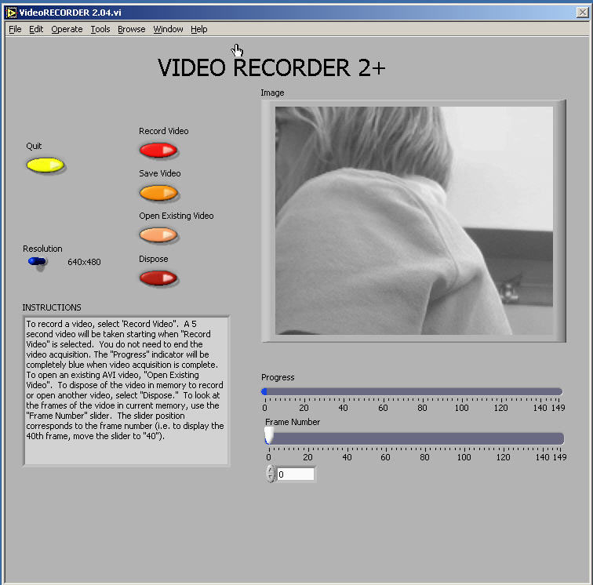

Using video to analyze motion is a two-step process. The first step is recording a video. This process uses the video software to record the images from the camera and compress the file. The second step is to analyze the video to get a kinematic description of the recorded motion.

(1) Making videos
After logging into the computer, open the video recording program by double clicking the icon on the desktop labeled VideoRECORDER. A window similar to the picture on the previous page should appear.

If the camera is working, you should see a "live" video image of whatever is in front of the camera. (See your instructor if your camera is not functioning.) By adjusting the lens on the video camera, you can alter the sharpness of the image until the picture quality is as good as possible.

The controls are fairly self-explanatory; pressing the Record Video button begins the process of recording a 5-second video. While the video is recording, the blue Progress bar beneath the video frame grows. Once you have finished recording, you can move through the video by dragging the Frame Number slider control. If you are not pleased with your video recording, delete it by pressing the Dispose button.

If fast objects appear blurry in individual frames of a recorded video, ask your instructor if you can adjust the camera’s shutter speed.

While you are recording your video, try to estimate the kinematic variables you observe, such as the initial position, velocities, and acceleration. The time with the unit of second is shown in the VideoRECORDER window, in the box below the Frame Number slider. These values prove very useful for your prediction equations. Be sure to record your estimates in your journal.

Once you have recorded a satisfactory video, save it by pressing the Save Video button. You will see a Save window, as shown on the next page.

To avoid cluttering the computer, you will only be able to save your video to certain folders on the hard disk. Check with your lab instructor for the most suitable place to save your video. In the File name box, browse for the folder in which you wish to save your video, and name the file appropriately. This name should be descriptive enough to be useful to you later (see the picture for an example). Warning: The computer may not warn you if it fails to save a video! To be absolutely sure, find the video’s file in Windows Explorer.

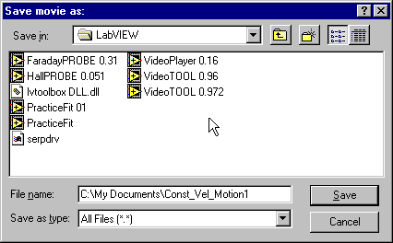

(2) analysis Basics

Open the video analysis application by clicking the icon labeled VideoTOOL, which is located on the desktop. Take a moment to identify
several elements of the program. The two most important of these are the Program Controls panel shown to the right and the Instructions box shown below. | 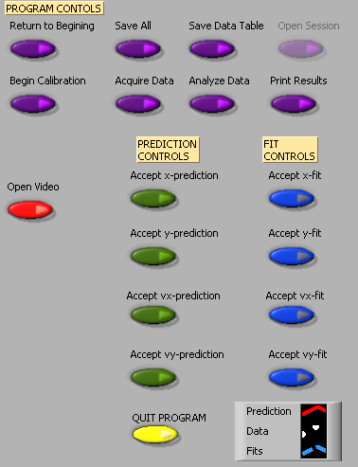
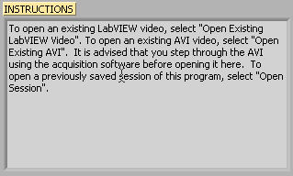

These two elements of the analysis program work in tandem. The Instructions box will give you directions and tasks to perform. It will also tell you when to select a control in the Program Controls panel. After you
select a control, it will “gray out” and the next control will become available. If you make a mistake, you cannot go backwards! You would have to quit your analysis and reopen the video to begin afresh.

You print and/or quit the video analysis from the Program Controls panel. You also have the option to save the data to continue later, or to save a data table.

Be careful not to quit without printing and saving your data! You will have to go back and analyze the data again if you fail to select Print Results before selecting Quit Program or Return to Beginning. Also be sure to save the data (Save All) and save the data table (Save Data Table).

Calibration
While the computer is very handy, it is not smart enough to identify objects or the sizes of those objects in the videos that you take and analyze. You will need to enter this information into the computer. If you are not careful in the calibration process, your analysis will not make any sense.

After you open the video that you wish to analyze and select Begin Calibration from the Program Controls panel you will be advised in the Instructions box "To begin Calibration, advance the video to a frame where the first data point will be taken. The time stamp of this frame will be used as the initial time." To advance the video to where you want time t=0 to be, you need to use the video control buttons, shown below. This action is equivalent to starting a stopwatch.



Practice with each button until you are proficient with its use. When you are ready to continue with the calibration, locate the object you wish to use to calibrate the size of the video. The best object to use is the object whose motion you are analyzing, but sometimes this is not easy. If you cannot use the object whose motion you are analyzing, you must do your best to use an object that is in the plane of motion of your object being analyzed.

Follow the direction in the Instructions box and define the length of an object that you have measured for the computer. Once this is completed, input the scale length with proper units in Calibration Controls box (shown below). Read the directions in the Instructions box carefully. Enter the scale length, and then use the arrows to select the units you are using.

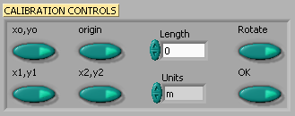

Finally, decide if you want to rotate your coordinate axes. If you choose not to rotate the axes, the computer will choose the lower left-hand corner of the video to be the origin with positive x to the right and positive y up. If you choose to rotate your axis, follow the directions in the Instructions box carefully. This option may also be used to reposition the origin of the coordinate system, should you require it.

Once you have completed this process, press "OK" in Calibration Controls.

Analysis Predictions
This video analysis relies on your graphical skills to interpret the data from the videos. Before doing your analysis, you should be familiar with both Appendix C: Graphing and Appendix B: Uncertainties.

Before analyzing the data, enter your prediction of how you expect the data to behave. This pattern of making predictions before obtaining results is the only reliable way to take data. How else can you know if something has gone wrong? This happens so often that it is given a name (Murphy’s Law). It is also a good way to make sure you have learned something, but only if you stop to think about the discrepancies or similarities between your prediction and the results.

In order to enter your prediction into the computer, you first need to decide on your coordinate axes, origin, and scale (units) for your motion. Record these in your lab journal.

Next you will need to select the generic equation, u(t), which describes the graph you expect for the motion along your x-axis seen in your video. You must choose the appropriate function that matches the predicted curve. The analysis program is equipped with several equations, which are accessible using the pull-down menu on the equation line (shown to the right).  You can change the equation to one you would like to use by clicking on the arrows to the left of the equation in the Prediction Equation command box, shown to the right. Holding down the mouse button will give you the menu also shown to the right. | 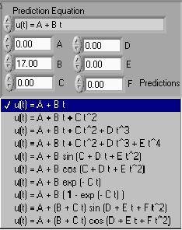

After selecting your generic equation, you next need to enter your best approximation for the parameters A and B and C and D where you need them. If you took good notes of these values during the filming of your video, inputting these values should be straightforward. You will also need to decide on the units for these constants at this time.

Once you are satisfied that the equation you selected for your motion and the values of the constants are correct, click "Predictions" in the Prediction Equation command box. Your prediction equation will then show up on the graph on the computer screen. If you wish to change your prediction simply repeat the above procedure. When you are satisfied, select the Accept x- (or y-) prediction option from the Program Controls panel. Once you have done this you cannot change your prediction except by starting over. Repeat this procedure for the Y direction.

Data Collection
To collect data, you first need to identify a very specific point on the object whose motion you are analyzing. Next move the cursor over this point and click the green Accept Data Point button in VideoPLAYER window. The computer records this position and time. The computer will automatically advance the video to the next frame leaving a mark on the point you have just selected. Then move the cursor back to the same place on the object and click Accept Data Point button again. If you always use the same point on the object, you will get reliable data from your analysis. (This can be tricky if the image is moving quickly, because of the camera’s finite shutter speed. If fast objects appear blurry, ask your instructor if you can adjust the camera’s shutter speed. If not, you must find a way to click approximately the same part of the blur in every frame.) The data will automatically appear on the appropriate graph on your computer screen each time you accept a data point. If you don’t see the data on the graph, you will need to change the scale of the axes. If you are satisfied with your data, choose Analyze Data from the Program Controls panel.

HINT: If you make a bad measurement, you need not start from scratch. Before pressing Analyze Data, return to the frame where you got the bad measurement, move the green cursor as appropriate, and press Accept Data Point. The program will ask if you’d like to replace the old data point with the new one.

Fitting your data
Deciding which equation best represents your data is the most important part of your data analysis. The actual mechanics of choosing the equation and constants is similar to what you did for your predictions. The activity in Laboratory 0 may help you refine your data fitting skills.

First you must find your data on your graphs. Usually, you can find your full data set by adjusting the scales of your X-motion and Y-motion plots. This scaling is accomplished by entering the appropriate maximum and minimum values on the vertical axis (as shown to the right) as well as adjusting the time scale. | 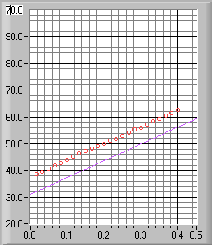

Secondly, after you find your data, you need to determine the best possible equation to describe this data. After you have decided on the appropriate equation, you need to determine the constants of this equation so that it best fits the data. Although this can be done by trial and error, it is much more efficient to think of how the behavior of the equation you have chosen depends on each parameter. Calculus can be a great help here. | 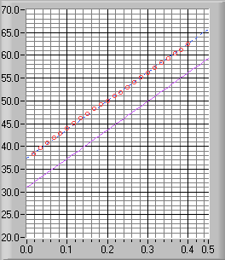

As an example of a completed determination of the equation, the X-motion plot above shows both the predicted line (down) and the line that best fits the data (through the circles). Be sure to record the values of your parameters in your journal before you go on to the next stage.

Lastly, you need to estimate the uncertainty in your fit by deciding the range of other lines that could also fit your data. This method of estimating your uncertainty is described in Appendix C. Slightly changing the values for each constant in turn will allow you to do this quickly. For example, the X-motion plots below show both the predicted line (down) and two other lines that also fit the data (near the circles).

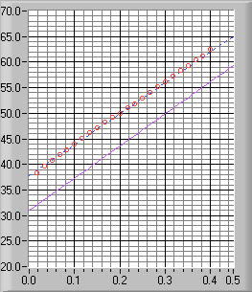 | 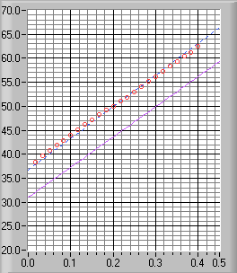
After you have found the uncertainties in your constants, return to your best-fit line and use it as your fit by selecting Accept x- (or y-) fit in the Program Controls panel.

save data table
Pressing the Save Data Table button at any time after you have made your measurement will save a text file of x-position, y-position, and time values. This can be useful for reading individual values. It can also be useful if you need to use some other program, such as Excel, to analyze data from a video.

Save session and OPEN SESSION
VideoTOOL does not include an “undo” feature. If you make a mistake, you may need to start over from scratch. However, you can partially get around that difficulty by saving your analysis at any stage you like, so that if you make a mistake later you can return to the earlier stage of the analysis (“pre-mistake”). There may also be cases in which you need to make two different analyses of the same video; in those cases, it can be helpful to save the analysis after taking the data but before committing to any fit equations.

Click the Save Session button at any time to save your analysis up to that point. Be sure to give the saved session a descriptive name, so you can figure out later what you had done up to that point!

Click the Open Session button to open a saved session.

Last Words
These directions are not meant to be exhaustive. You will discover more features of the video analysis program as you use it. Be sure to record them in your “memory on paper” (your lab journal).

Reference Guide for Ultr@ VNC version 1.0.0

Ultr@ VNC is a computer program in the physics lab rooms that gives you the power to observe student computer screens and control a student’s computer remotely via your keyboard and mouse. It is particularly useful for giving instructions about a program or displaying students’ lab data.
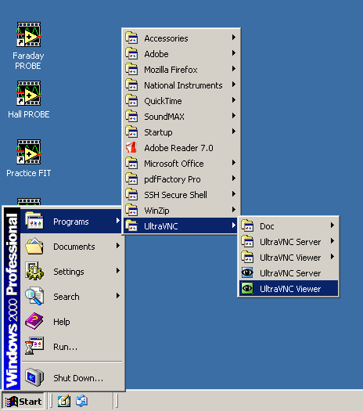
To access Ultr@ VNC, log in to a lab computer with a TA username and password (most likely your physics department ID). If you would potentially like to broadcast a screen using the digital projector, log in to the instructor computer located near the printer. (Refer to the Digital Projector Reference for more information.)
Access the program from the Start menu, Programs folder, UltraVNC, and UltraVNC Viewer. Refer to Figure 1.

You can also access the program from My Computer:
C:\Program Files\UltraVNC\UltraVNC Viewer

Fig. 1

The following pop-up window should appear, requesting the name of the display host:

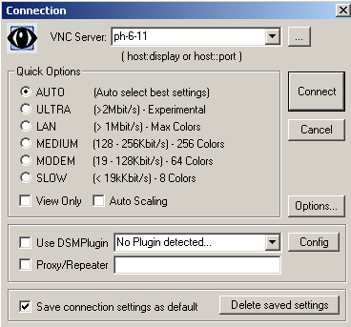
In the VNC Server drop-down field, type the number of the student’s computer that you want to observe. The numbers are printed on each computer and should be in the format ph-#-##.

If you want to change connection options, click the Options button. Another pop-up window will appear (Figure 3). Auto select best settings is the default. From this window you can change Mouse Cursor options and select Display options.

Click Connect to begin viewing the selected Desktop. An Authentication pop-up window might appear, requesting you to re-enter your username and password. Click Log On.
Fig. 2
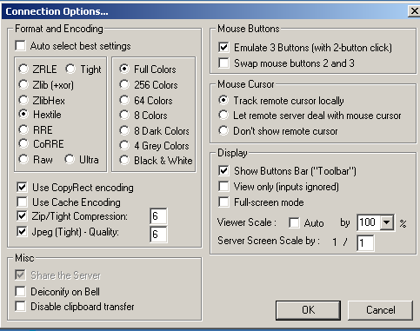
Toolbar Buttons

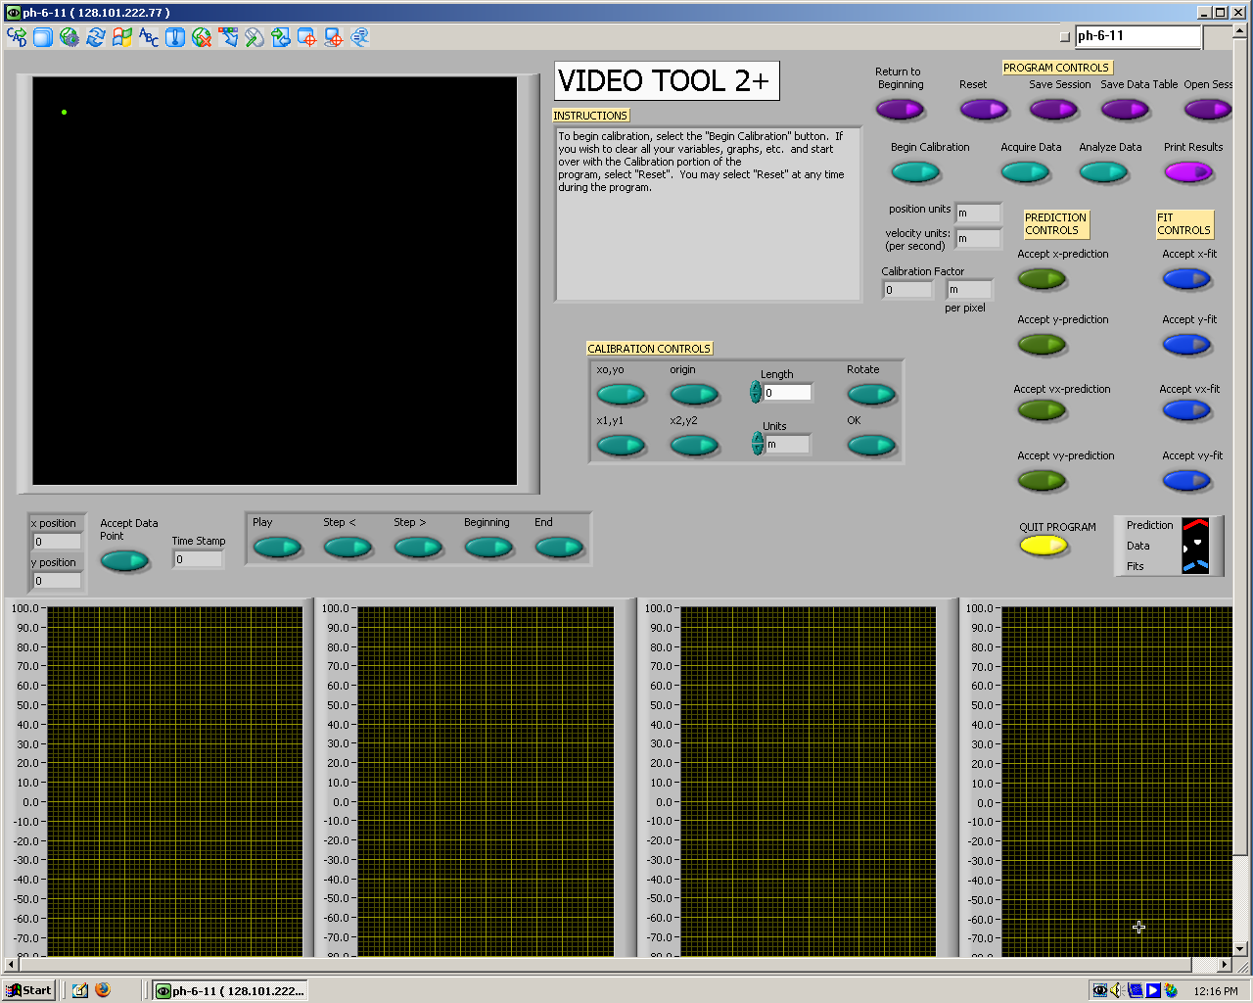
Fig. 2

Fig. 3: Connection Options

Fig. 4: Sample view of a student screen

Refer to Figure 4 for a sample view of a student screen. You can resize the window of the student screen using the arrows in the bottom right corner.

Use the toolbar buttons to navigate Ultr@VNC, as seen in Figure 5. Most buttons are self-explanatory, but selected descriptions are given on the next page.

Send Custom Key
Hide Toolbar Buttons
Select Single Window
Send Ctrl+Alt+Del to host
Show Connection Options
Show Status Window
Open
File Transfer
Select Full Desktop
Host
computer number

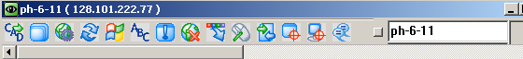

Fig. 5
Refresh Screen
Send ‘Start’ (Ctrl+Esc) to host
Close Connection
Toggle Remote Input & Remote Blank Monitor (On/Off)
Open Chat
Toggle Fullscreen mode (On/Off)

Selected Descriptions for Toolbar Buttons:
- Send Ctrl+Alt+Del to host will bring up the physics logout window on the student’s computer.
- Send ‘Start’ (Ctrl+Esc) to host will depress the start button on the student’s computer, giving you the power to access programs, etc. from the host computer.
- Show Connection Options will display the same pop-up window that is available from the Options button of the initial Connection window (Figure 3).
  - There are three options for the Mouse Cursor: Track remote cursor locally, Let remote server deal with mouse cursor, and Don’t show remote cursor.
  - The first two options appear to be a shared-control option between the student and instructor computers, with slight differences between what is seen on each screen.
- Toggle Remote Input & Remote Blank Monitor (On/Off) gives total control to the instructor by disabling the student’s computer mouse.
- Select Single Window gives you the option to select and view one window that is open on a student’s screen, providing multiple windows are opened at the same time. When this toolbar button is depressed, a crosshair appears and you can use this to click on the window to be viewed. Any remaining windows are “blacked out”. To return to the fullscreen view, click the Select Full Desktop toolbar button.

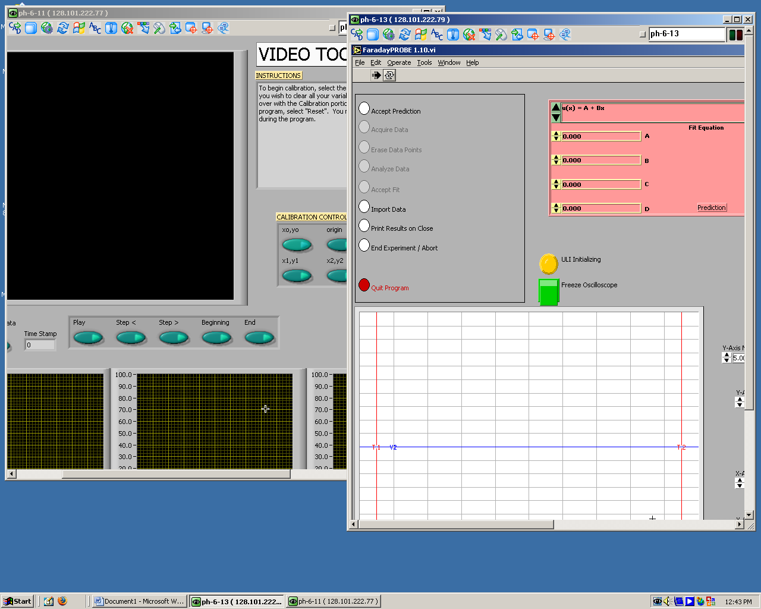

It is possible to display multiple student screens on an instructor desktop, but you must reopen the Ultr@ VNC program each time and resize the windows (or only view one screen at a time).

Fig. 6

To exit Ultr@ VNC, click Close Connection.

For more information, the software developers’ website is:
http://www.ultravnc.com/
Digital Projector Reference:

Every lab room has a Panasonic® projector fixed to the ceiling with connections to a wall unit. This is useful to project documents or programs onto a pull-down screen for easy viewing by the entire class.

To project the instructor computer, log in using either a student ID and password or a TA username and password. This computer should have a serial cable connected from Input 1 of the monitor to Local Monitor of the black Output box, and another cable from Data Display of the black Output box to Computer of the silver wall unit.

Turn on the Panasonic® projector by depressing the large Power button. You might need to use a meter stick to reach it. If the computer screen does not immediately display, cycle through the input by pressing the RGB button. Most will display on RGB 1. Turn off the projector by pressing Power twice.
Silver wall box:
Video Computer

L-Audio-R Computer
audio
Output
Local Monitor Data Display

Computer Monitor

Input 1 Black box

