Activity Book

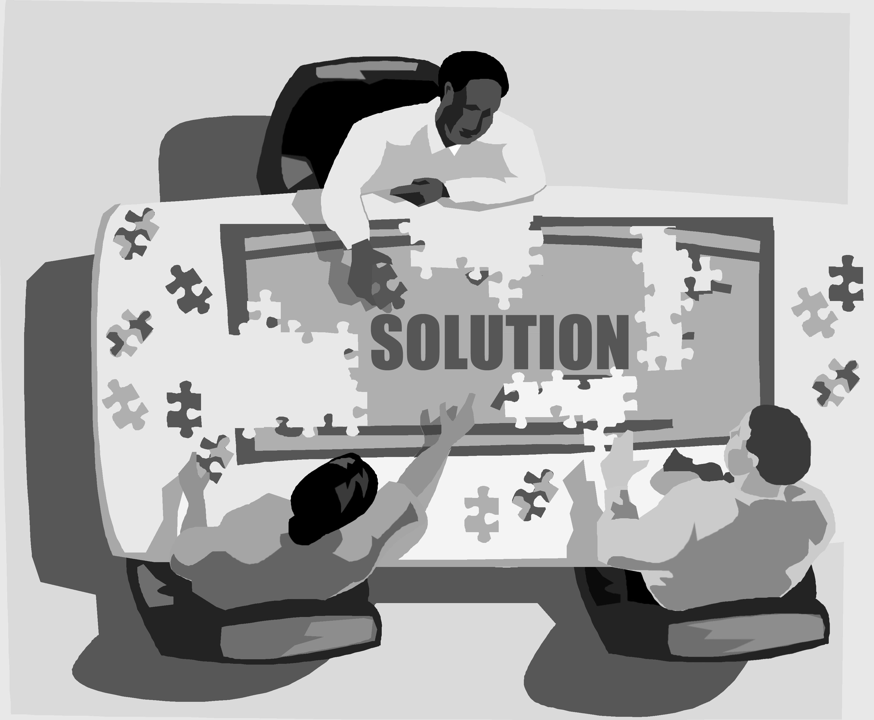

TA Orientation
School of Physics and Astronomy
University of Minnesota

Fall 2006

TABLE OF CONTENTS
FOR CLASS ACTIVITIES

Activity #1: TA Duties & Rationale for the UMn Model

Activity #2: Expert-Novice Differences in Problem Solving

Activity #3: Lab Preparation (with sample student WUQs)

Activity #4: Demonstration of a Lab Session (by mentor TAs)

Activity #5: Structure of Peer Teaching

Activity #6: Coaching during Discussion Sessions (partial student solutions)

Activity #7: Facilitating an End Discussion (complete student solutions)

Activity #8: Designing a Problem Solving Framework/Answer Sheet

Activity #9: How to Teach the First Lab and Discussion Session

Activity #10: Sexual harassment, academic honesty, diversity, & gender issues

TA Duties and Rationale for the UMn Model

Notes: _______________________________________________________________________
_____________________________________________________________________________
_____________________________________________________________________________
_____________________________________________________________________________
_____________________________________________________________________________
_____________________________________________________________________________
_____________________________________________________________________________
_____________________________________________________________________________
_____________________________________________________________________________
_____________________________________________________________________________
_____________________________________________________________________________
_____________________________________________________________________________
_____________________________________________________________________________
_____________________________________________________________________________
_____________________________________________________________________________
__________________________________________________________________________________________________________________________________________________________
_____________________________________________________________________________
_____________________________________________________________________________
_____________________________________________________________________________
_____________________________________________________________________________
_____________________________________________________________________________

Notes: _______________________________________________________________________
_____________________________________________________________________________
_____________________________________________________________________________
_____________________________________________________________________________
_____________________________________________________________________________
_____________________________________________________________________________
_____________________________________________________________________________
_____________________________________________________________________________
_____________________________________________________________________________
_____________________________________________________________________________
_____________________________________________________________________________
_____________________________________________________________________________
_____________________________________________________________________________
_____________________________________________________________________________
_____________________________________________________________________________
__________________________________________________________________________________________________________________________________________________________
_____________________________________________________________________________
_____________________________________________________________________________
_____________________________________________________________________________
_____________________________________________________________________________
_____________________________________________________________________________

The Force Concept Inventory (FCI) and Alternative Conceptions

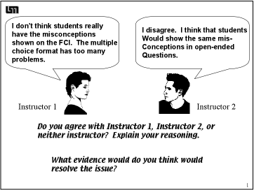

Notes: _______________________________________________________________________
_____________________________________________________________________________
_____________________________________________________________________________
_____________________________________________________________________________
_____________________________________________________________________________
_____________________________________________________________________________
_____________________________________________________________________________
_____________________________________________________________________________
_____________________________________________________________________________

Notes: _______________________________________________________________________
_____________________________________________________________________________
_____________________________________________________________________________
_____________________________________________________________________________
_____________________________________________________________________________
_____________________________________________________________________________
_____________________________________________________________________________
_____________________________________________________________________________
_____________________________________________________________________________
_____________________________________________________________________________
_____________________________________________________________________________
_____________________________________________________________________________
_____________________________________________________________________________
_____________________________________________________________________________
_____________________________________________________________________________
_____________________________________________________________________________
_____________________________________________________________________________
_____________________________________________________________________________
_____________________________________________________________________________
_____________________________________________________________________________
_____________________________________________________________________________
_____________________________________________________________________________
_____________________________________________________________________________

Differences in Expert-Novice Problem Solving

Group Tasks:

- Solve the “Cowboy Bob” exercise on the next page quickly.

- Solve (or attempt to solve) one short problem from the most recent Graduate Written Exam (choose either #1, 4, 5, 8 or 12.) Try to select a question that you don’t immediately know how to do – one that is a “real problem” for you.
- Make a list or flow chart of all the steps (major decision points and/or actions) that you took to solve a "real problem" (the Graduate Written Exam Problem).
- Make a list or flow chart of all the steps – the major decision points and/or actions - that you took to solve an "exercise" (the Cowboy Bob Problem).
5. Make a list of all the ways an expert problem solver (such as you, or a professor) solves a "real problem" differently than an "exercise."
- Compare the novice student solution to the Cowboy Bob Problem and your solution to the GWE problem. Describe what similarities and differences you notice between expert and novice approaches to solving a “real problem.”

Cooperative Group Roles:
Skeptic: Ask what other possibilities there are, keep the group from superficial analysis by not allowing the group to agree too quickly; ask questions that lead to a deeper analysis; agree when satisfied that the group has explored all possibilities.
Manager: Suggest a plan for answering the questions; make sure everyone participates and stays on task; watch the time.
Checker/Recorder: Ask others to explain their reasoning process so it is clear to all that their suggestions can be discussed; paraphrase, write down, and edit your group's answers to the questions.

Product:
Activity #2 Answer Sheet.

Below is a problem from an exam in Physics 1101 (algebra-based introductory course). Solve this problem as quickly as you can.

Cowboy Bob Problem: Because parents are concerned that children are taught incorrect science in cartoon shows, you have been hired as a technical advisor for the Cowboy Bob show. In this episode, Cowboy Bob, hero of the Old West, happens to be camped on the top of Table Rock in the Badlands. Table Rock has a flat horizontal top, vertical sides, and is 500 meters high. Cowboy Bob sees a band of outlaws at the base of Table Rock 100 meters from the side wall. The nasty outlaws are waiting to rob the Dodge City stagecoach. Cowboy Bob decides to roll a large boulder over the edge and onto the outlaws. Your boss asks you if it is possible to hit the outlaws with the boulder. Determine how fast Bob will have to roll the boulder to reach the outlaws.

Select one short problem from the most recent Graduate Written Exam (Choose either #1, 4, 5, 8, or 12.) Try to select a question that you don’t immediately know how to do – one that is a “real problem” for you.

Use the space below to solve or attempt to solve the one GWE problem you selected.
Answer Sheet for Activity #2

- Examine your solution to the Graduate Written Exam Problem. Make a flow chart of the major steps (decisions and/or actions) you took to solve the problem.

- Now compare and contrast your group solution to the Graduate Written Exam (GWE) Problem and your individual solutions to the Cowboy Bob Problem. For you, as expert problem solvers, the GWE problem was a "real problem" -- one you did not know how to solve immediately -- and the Cowboy Bob Problem was probably more like an "exercise" -- a type of problem you have solved so many times before that you immediately knew how to approach the problem.

(a) Make a flow chart of the steps (major decisions and/or actions) you took to solve the Cowboy Bob Problem.

(b) How were your solution steps different for the real problem and the exercise?
3. For students in an introductory physics class (novice problem solvers), the Cowboy Bob Problem IS A REAL PROBLEM. Compare and contrast the attached novice solution to the Cowboy Bob Problem with your group solution to the GWE Problem.

Based on your comparison of the solutions, make a list of all the ways that experts solve real problems (e.g., the GWE problem) differently than novices solve what is, for them, a real problem (e.g., the Cowboy Bob Problem).

Expert Solving Real Problem | Novice Solving a Real Problem

"Novice" Solution to Cowboy Bob Problem

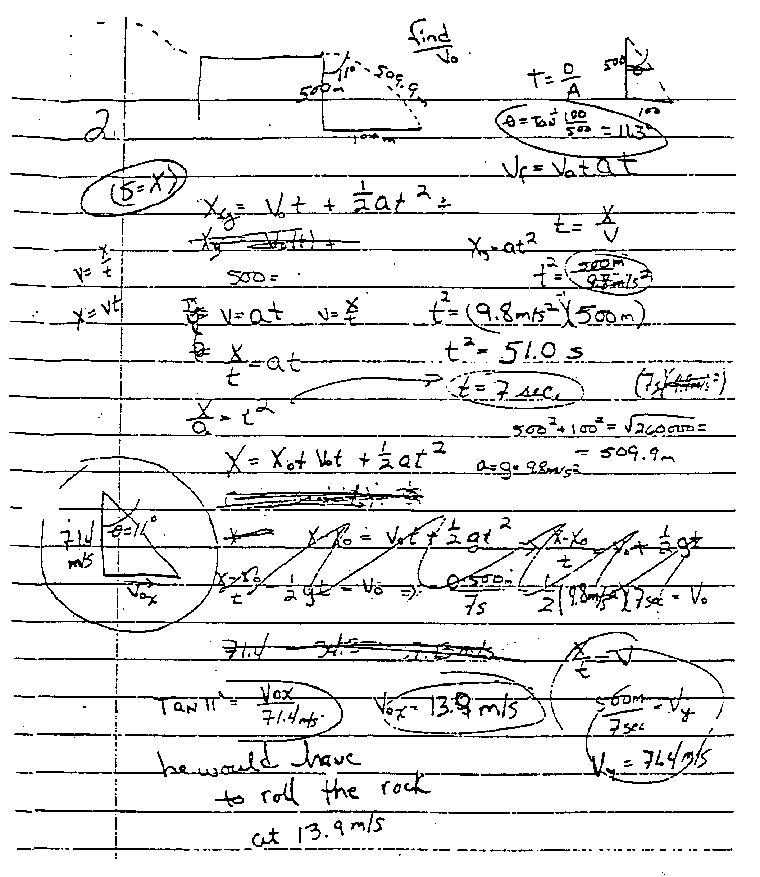

4. Optional: Shown below is a standard textbook solution to the Cowboy Bob problem. Discuss why this solution promotes continued use of a novice strategy (i.e., discourages the use of a more expert-like strategy).

"Choose a coordinate system with its origin at the point where the boulder goes off the cliff, with the x axis pointing horizontally to the right and the y axis vertically downward. The horizontal component of the initial velocity is:

Since the fastest athletes run at about this speed, it is unlikely that Cowboy Bob would be able to push a big boulder this fast."

Preparation for Teaching a Lab
The following pages contain 6 authentic student answers to the Warm-up questions for a 1301 lab problem: Force and Motion. It is the first lab that addresses the physics concept of force. This particular set of solutions was from 2004.

During the semester you will collect your students’ answers to the lab problem warm-up questions 1-2 days prior to teaching the lab. Collecting the answers in advance will help you prepare to teach the lab.

For this activity, look at the 6 student solutions to warm-up questions. Try not to spend too much time on each one – during the semester your time will be very limited! Use these student solutions to get a general idea for the students’ understanding of the lab problem. A copy of the warm-up questions is provided for you to see what students were following.

As you look through the students’ solutions, take note of which questions the students have most difficulty with. Think about how you can address their common mistakes or issues in lab. What will you ask students to write on the board at the beginning of lab? What questions will you ask students during the opening discussion?

Use the Lab Preparation sheet following the student solutions to make notes about how you would prepare for a lab session, based on the papers of these 6 students.

Warm-up Questions for 1301 Lab 3 Problem #1: Force and Motion
(2004 edition; formerly called Method Questions)

Released from rest, a cart is pulled along a level track by a hanging object as shown below:

You will be able to vary the mass of Object A (the “mass hanger”) and the Cart. They are connected together using a light string. Object A falls through a distance which is significantly shorter than the length of track. You will have a meter stick, a stopwatch, a mass hanger, a mass set, cart masses, a pulley, a pulley clamp, one piece of string and the video analysis equipment. In this experiment we ignore the friction between the cart and the track.

Prediction

Calculate the cart’s velocity after object A has hit the floor, as a function of the mass of the object A, the mass of the cart, and the distance object A falls.

Make a graph of the cart’s velocity after object A has hit the floor, as a function of the mass of object A for the same cart mass and height through which object A falls.

Make a graph of the cart’s velocity after object A has hit the floor, as a function of the mass of the cart for the same mass of object A and height through which object A falls.

Make a graph of the cart’s velocity after object A has hit the floor, as a function of the distance object A falls for the same cart mass and mass of object A.

Warm-up Questions

To test your prediction, you must determine how to calculate the velocity from the quantities you can measure in this problem. It is useful to have an organized problem-solving strategy such as the one outlined in the following questions. You might also find the Problem Solving techniques in the Competent Problem Solver useful.
1. Make a sketch of the problem situation similar to the one in the Equipment section. Draw vectors that show the direction and relative magnitude of the motion of the objects (velocity and acceleration) at the interesting times in the problem: when the cart starts from rest, just before the object A hits the floor, and just after object A hits the floor. Draw vectors to show all of the forces on object A and the cart. Assign appropriate symbols to all of the quantities describing the motion and the forces. If two quantities have the same magnitude, use the same symbol but write down your justification for doing so. For example, the cart and object A have the same magnitude of velocity when the cart is pulled by the string. Explain why. Decide on your coordinate system and draw it.
2. The “known” quantities in this problem are the mass of object A, the mass of the cart, and the height above the floor where object A is released. Assign these quantities symbols so that you can use them in algebra. The unknown quantities are the velocity of the cart and of object A just before object A hits the floor. There are other unknowns as well. List them. What is the relationship between what you really want to know (the velocity of the cart after object A hits the floor) and what you can calculate (the velocity of the cart just before object A hits the floor)?
3. Write down what principles of Physics you will use to solve the problem. Because forces determine the motion of the cart, using Newton’s 2nd Law to relate the sum of the forces on each object to its motion is a good bet. Since you need to determine forces, Newton’s 3rd Law is probably also useful. Will you need any of the principles of kinematics? Write down any assumptions you have made which are necessary to solve the problem and justified by the physical situation.
4. Draw separate free-body diagrams for object A and for the cart after they start accelerating (if you need help, see section 4-6 and section 4-7 in chapter 4 of your text book). Check to see if any of these forces are related by Newton’s 3rd Law (Third Law Pairs). For easy reference, it is useful to draw the acceleration vector for the object next to its free-body diagram. It is also useful to put the force vectors on a separate coordinate system for each object (force diagram). Remember the origin (tail) of all vectors is the origin of the coordinate system. For each force diagram (one for the cart and one for object A), write down Newton’s 2nd law along each axis of the coordinate system. It is important to make sure that all of your signs are correct. For example, if the acceleration of the cart is in the + direction, is the acceleration of object A + or -? Your answer will depend on how you define your coordinate system.
5. Since you are interested in the velocity of the cart and the distance object A falls but Newton’s 2nd Law gives you an acceleration, write down any kinematic equations which are appropriate to this situation. You will have to decide if the acceleration of each object is constant or varies during the time interval for which your calculation is valid. What is that time interval?
6. You are now ready to plan the mathematics of your solution. Write down an equation, from those you have collected in steps 4 and 5 above, which relates what you want to know (the velocity of the cart just before object A hits the ground) to a quantity you either know or can find out (the acceleration of the cart and the time from the start until just before object A hits the floor). Now you have two new unknowns (acceleration and time). Choose one of these unknowns (for example, time) and write down a new equation (again from those collected in steps 4 and 5) which relates it to another quantity you either know or can find out (distance object A falls). If you have generated no additional unknowns, go back to determine the other original unknown (acceleration). Write down a new equation that relates the acceleration of the cart to other quantities you either know or can find (forces on the cart). Continue this process until you generate no new unknowns. At that time you should have as many equations as unknowns.

You can now solve your mathematics to give the prediction.

Lab Preparation

Name: _______________________________ Date:___________

Lab Problem: __________________________ Section _________

I. Solve the problem yourself by answering the Warm-up questions. Then read the Lab Instructor’s Manual. Finally, grade the Warm-up Questions for this section.
II. Answer the following background questions.
❶ When is session scheduled? | ❷ Which session is it in the Lab topic sequence? | ❸ What is the lab problem type? | ❹ How difficult is the lab problem?
□ Early in Week  □ Later in Week | □ 1st Lab Session  □ 2nd or 3rd Lab session | □ Qualitative  □ Quantitative | □ Easy/Medium  □ Difficult
❺ Which of the WUQs did your students have the most difficulty answering? Common alternative conceptions? Which ones? |  | Warm-up Questions:
❻ Count the number of students who were able to solve the problem (even if the solution was incorrect). Is this the majority of the students? |  | ____ students solved the problem out of ____.
❼ Look at the students’ final solution (Prediction). How many students got the right answer for the wrong reasons? |  | ____ students got the right (or close to right) answer for the wrong reasons.

III. Based on the answers to these questions, make the following decisions about opening moves and the end game for the lab session.
Opening Moves
1. Which WUQs should I assign groups answer on board? | Use answer to Question ❺: | Warm-up Questions: ______________________
2. Do groups need extra time to solve the problem before they start collecting data? | Use answer to Question❻, taking into account Questions ❶ to ❹ | □ YES □ NO because:
3. If YES, then how much time extra time and how should I structure this extra time? | Use answers to Questions ❶ to ❹ | Plan:
4. What do I need to discuss/tell students about how to check their solution before they start? | Use information in Lab Instructor’s Guide and your  own experience | Discuss:

End Game
5. (Besides corrected answers to assigned WUQs), do we need to spend extra time discussing how to solve the problem? | Use answer to Question ❼ and your previous decisions 2 & 3 | □ YES □ NO because:
6. If YES, then how much time and how should I structure this extra time? |  | Plan:

IV. List some possible questions to ask groups during whole-class discussion (opening moves and/or end game) that you think would promote a discussion.

a.

b.

c.

d.

e.

f.

g.

Demonstration of Teaching a Lab Session (by the Mentor TAs)
Acceleration & Circular Motion

Today, a mentor TA will demonstrate how to teach a problem-solving laboratory session at the University of Minnesota. The goals of this activity are for you to learn:
- the structure of the problem-solving labs you will be teaching;
- the rationale for each teaching action in the lab sessions.
- how to use the video analysis of motion software (VideoTOOL & VideoRECORDER)
- how to properly install a Firewire camera
- how to use the Ultr@VNC computer screen projection application

Be sure to ask the mentor TA questions as you go through the lab.

Individual and Group Tasks:
1. Participate in the laboratory demonstration as undergraduates might.
2. Periodically, we will stop the demonstration. Discuss the reasons for each part of the lesson plan with your group. Then individually write the reasons under “Rationale” on the attached lesson plan. These reasons will then be shared and expanded upon by the class and instructors.
3. Work on the assigned laboratory problem and be prepared to discuss your results.

Cooperative Group Roles:
Skeptic: Ask what other possibilities there are, keep the group from superficial analysis by not allowing the group to agree too quickly; ask questions that lead to a deeper analysis; agree when satisfied that the group has explored all possibilities.
Manager: Suggest a plan for discussing the reasons for each part of the lesson plan; make sure everyone participates and stays on task; watch the time.
Checker/Recorder: Ask others to explain their reasoning process so it is clear to all that their suggestions can be discussed; paraphrase, your group’s rationale.

Time | Opening Moves | Comments / Rationale
10 min.  ~1 min.  5 min  2 min  5-10 min  1 min | 0 Get there early and lock door.  - Collect one piece of equipment needed for lab problems  - Write new groups/roles on board (when appropriate)  - Write which warm-up questions groups should write on board  - Open Door  1. Prepare students for group work by showing group/role assignments.  2. Prepare students for lab.  a) Focus on what students should learn. Tell students which Warm-up Question(s) they should discuss and put on the board.  b) Diagnose student difficulties. While groups discuss Warm-up Questions, circulate around the class, observe/listen to each group, and diagnose difficulties.  c) Post Group Answers. Select (randomly) one person from each group to write/draw on board answers to the Warm-up Questions.  d) Lead a class discussion. Give students a few minutes to read all the answers on the board. Ask the representatives of each group to give their reasons for each of their answers.  e) How much time. Tell class time they need to stop (usually about 30 – 40 minutes) and remind Managers to keep track of the time.

NOTES:

Time | Middle Game | Comments / Rationale
5 min  ~5 min.  variable | 3. Coach groups in problem solving (making decisions) by:  a) Diagnose initial difficulties with the problem or group functioning.  - Return equipment to groups  - Watch class from front of room:  Don’t answer questions.  Is class able to proceed?  Stop class and discuss difficulty if everyone is off task.  - Monitor groups and intervene to coach when necessary.  Monitor and diagnose :  Establish a circulation pattern around room. Listen to each group (without them knowing) at least one before answering questions.  Diagnose difficulties with physics;  Diagnose difficulties with group functioning.  Prioritize who needs the most help.  Is entire class confused on the same thing? If so, stop the class and discuss the difficulty.  Coach Groups with the Most Need.  - coach first with the group that needs the most help, and so on  - Always join a group at eye level.  - If you spend a long time with group, circulate around class again, listening briefly to each group and diagnose difficulties, before intervening again.  - Be sure groups are completing all parts of the problem  - If a group finishes early, have them start the next problem.

Time | Middle Game (continued) | Comments / Rationale
10 min  5 min | 4. Start grading lab procedures (journals).  Check to make sure that each student is recording essential observations and measurements.  5. Prepare Students for class discussion by  a) Ten-Minute Warning. Ten minutes before you want the groups to stop, tell them to find a good stopping place and clean up their area. (Make sure you are done grading journals). (If groups are new, you may want to pass out the group functioning forms.)  b) Posting Corrected Warm-up Questions and/or Results. Tell one person in each group, who is not the Recorder/Checker, to write their corrected answers (if necessary) to the warm-up questions on the board (and/or their results).

NOTES:

Time | End Game | Comments / Rationale
~10 min  5 -10 minutes  5 min | 6. Lead a class discussion. Usually, focus the discussion on the qualitative analysis of problem.  7. Optional: Discuss group functioning. Call on one group for “good” response, another group for a “problem,” and a third group for a “specific action.” Repeat until every group has spoken twice.  8. Start next problem. If there is time, have students start the next assigned lab problem. Repeat Steps 1 through 7.  9. End of Lab Session.  a) Tell students what lab problem(s) to do Warm-up Questions for next week.  b) Assign students problems to write up (if last session of lab). In each group, randomly assign each student in the group a different problem for a lab report.  c) Leaving the Lab. Leave a neat lab room for the next class.

NOTES:

Structure of Peer Teaching

As a way of preparing to teach the University of Minnesota’s problem-solving labs and discussions sessions, you will have the opportunity to practice-teach one lab session to your peers. For one afternoon (Monday), the mentor TAs will supervise the practice teaching of the lab sessions.

There are two goals for this peer teaching. One is for you to get practice “running through” a lab problem, so that you have a sense of what it feels like to keep track of time, supervise a room full of people solving a problem, and lead a discussion. The other goal is for you to become familiar and comfortable with the equipment and typical results for the problem-solving labs.

The afternoon will be structured as follows:
- The “practice teacher” for one session will teach, and the practice teachers for the other sessions will act like undergraduate students. This means that you must come to the class having read through the Warm-up Questions, and be ready to participate in discussions and take data (See the peer teaching booklet for the lab problems).
- Each practice teacher will have about 30 minutes to teach one lab problem, and there will be 10 minutes to move on to the next session. During these 10 minutes, the practice teacher will receive teaching feedback from the observer, and the next practice teacher can prepare their lab room.
- The “students” for this lab session will give each practice teacher written feedback, on the peer teaching evaluation sheets (located at the end of the peer teaching booklet.)

Tentative Schedule Format
 | 1:00-1:30 | 1:40-2:10 | 2:20-2:50 | 3:00-3:30 | 3:40-4:10 | 4:20-4:50
Group A | 1 | 2 | 3 | 4 | 5 | 6
Group B | 2 | 3 | 4 | 5 | 6 | 1
Group C | 3 | 4 | 5 | 6 | 1 | 2
Group D | 4 | 5 | 6 | 1 | 2 | 3
Problem numbering (in peer teaching booklet):
1: 1101 Lab 1 Problem #4 – Motion Up and Down an Incline
2: 1101 Lab 2 Problem #3 – Projectile Motion and Velocity
3: 1201 Lab 2 Problem #4 – Normal Force and Frictional Force
4: 1201 Lab 3 Problem #1 – Elastic and Gravitational Potential Energy
5: 1301 Lab 2 Problem #4 – Bouncing
6: 1301 Lab 3 Problem #2 – Forces in Equilibrium

Note: You will be given your group letter and peer teaching assignment (lab problem number) on Friday and a list of room locations prior to the peer teaching session.

Peer Teaching Checklist (for Observer)

What the TA Does | Observer check:
Opening Moves: | ⓪ Be at the classroom early
Opening Moves: | ① Prepare students for group work by showing group/role assignments.
Opening Moves: | ② Prepare students for lab by:  a) diagnosing difficulties while groups discuss and come to consensus on Methods Questions.
Opening Moves: | b) selecting one person from each group to write/draw on board answers to the Methods Questions.
Opening Moves: | c) leading a class discussion about the group answers.
Opening Moves: | d) telling students how much time they have to check their predictions; reminding Manager to keep track of time
Middle Game | ③ Coach groups in problem solving (making decisions) by:  a) monitoring (diagnosing) progress of all groups
Middle Game | b) helping (coaching) groups with the most need, using group roles.
Middle Game | ④ Grade Lab Procedure (journal).
Middle Game | ⑤ Prepare students for class discussion by:  a) giving students a “10-minute warning.” Pass out Group Evaluation Form (if necessary)
Middle Game | b) selecting one person from each group to put corrected methods questions and results on board.
End Game | ⑥ Lead a class discussion focusing on what you wanted students to learn from solving the problem.
End Game | ⑦ Discuss group functioning (optional) | na | na | na | n | n | na
End Game | ⑧ Start next lab problem (repeat Steps 1 – 7) if time | na | na | na | n | n | na
End Game | ⑨ End of Lab  a) Tell students what lab problems to do Methods Question for next week; if last session, assign students problems for lab report.
End Game | b) Leave a neat lab room for the next class. Do NOT let the next group of students into the classroom. Write down the comments about equipment that did not work on the lab-room sheet .
Total:
Observer Comments:

Coaching During Discussion Sessions (partial student solutions)
Individual Tasks:

On the following page is an introductory physics problem – pretend that your teaching team has decided to use this problem in the next discussion session.
- Solve this problem by yourself.
- Write down some notes about how you would prepare for this discussion session. Use the Discussion Preparation sheet as a guide.
  - What is the learning focus for this problem that you will emphasize?
  - What do you expect students to have difficulty with?
  - What questions can you ask students?
- Write up a detailed “solution” to this problem that you would hand out to your students at the end of class.

Individual & Group Tasks:

Following the problem statement are 8 partial student solutions to the problem. For this activity, you should pretend that you are in the middle of teaching a discussion session with this problem. As you circulate the room, you observe what students have written on their papers so far.

NOTE: Usually there will only be 4-5 groups in your discussion, but it is possible that students might be writing some things down individually. Pretend that students 1 & 2 are in the same group, students 3 & 4 are in the same group, 5 & 6 are in the same group, and 7 & 8 are together. The remaining members of each group have not written anything down.

- Which group would you intervene with first? (Which group do you think needs the most help?)
- How would you coach each group on problem solving?
- Are there any issues common to all student groups? (If so, then you might be able to stop the session briefly for some whole-class coaching. What could you say?)

Be prepared to share your responses to these questions with your peers during TA Orientation.

NOTE: These partial student solutions were actually taken from individual solutions to a 1201 final exam problem in Fall 2005, from two different lecture sections. The problem was chosen because it is similar to most group problems given in discussion sessions.

Problem:
Your task is to design an artificial joint to replace arthritic elbow joints in patients. After healing, the patient should be able to hold at least a gallon of milk (3.76 liters) while the lower arm is horizontal. The bicep muscle is attached to the bone at the distance 1/6 of the bone length from the elbow joint, and makes an angle of 80⁰ with the horizontal bone. For how strong of a force should you design the artificial joint? (The weight of the bone is negligible.)

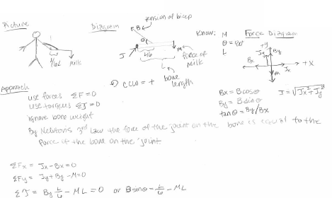
STUDENT #1:

STUDENT #2:
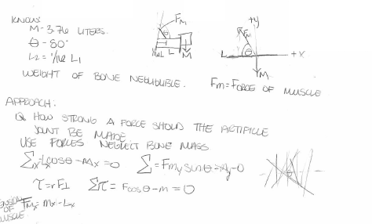

STUDENT #3:
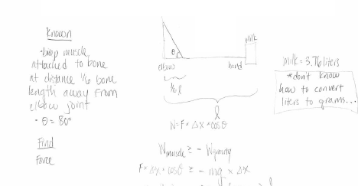

STUDENT #4:
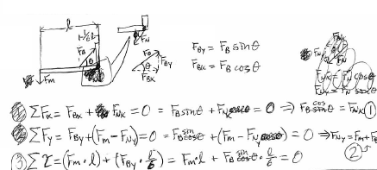
STUDENT #5:
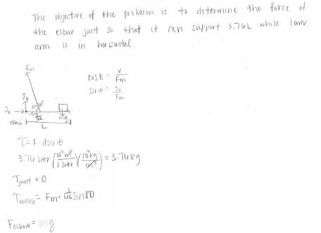

STUDENT #6:

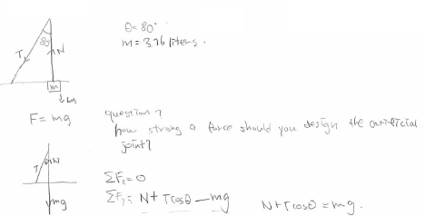
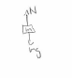
STUDENT #7:
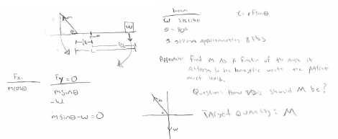

STUDENT #8:
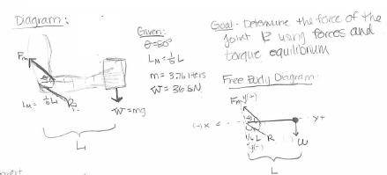

Facilitating an End Discussion (complete student solutions)
Individual Tasks:

**If you have already done the individual task from Activity #6, refer to your preparation notes from that activity.

On the following page is an introductory physics problem – pretend that your teaching team has decided to use this problem in the next discussion session.
- Solve this problem by yourself.
- Write down some notes about how you would prepare for this discussion session. Use the Discussion Preparation sheet as a guide.
  - What is the learning focus for this problem that you will emphasize?
  - What do you expect students to have difficulty with?
  - What questions can you ask students?
- Write up a detailed “solution” to this problem that you would hand out to your students at the end of class.

Individual & Group Tasks:

Following the problem statement are 8 complete student solutions to the problem. Notice that these are the same student solutions from Activity #6, but they are now longer. For this activity, you should pretend that you are approaching the end of teaching a discussion session with this problem. As you circulate the room one last time, you observe what students have written on their papers.

Choose 4 of the following 8 solutions to represent what your student groups have come to a consensus about for the problems. Ignore the other 4 solutions.

- Based on the 4 completed solutions you have chosen, what will you ask student groups to put on the board for an end discussion?
- After they put this on the board, what questions will you ask during the end-of-class discussion with all groups?

Be prepared to share your responses to these questions with your peers during TA Orientation.

NOTE: These partial student solutions were actually taken from individual solutions to a 1201 final exam problem in Fall 2005, from two different lecture sections. The problem was chosen because it is similar to most group problems given in discussion sessions.

Problem:
Your task is to design an artificial joint to replace arthritic elbow joints in patients. After healing, the patient should be able to hold at least a gallon of milk (3.76 liters) while the lower arm is horizontal. The bicep muscle is attached to the bone at the distance 1/6 of the bone length from the elbow joint, and makes an angle of 80⁰ with the horizontal bone. For how strong of a force should you design the artificial joint? (The weight of the bone is negligible.)

STUDENT #1:
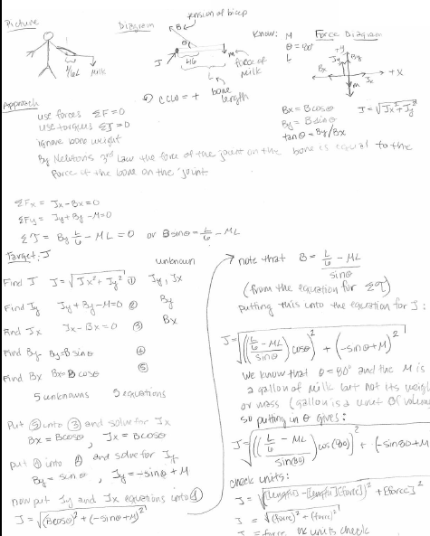
STUDENT #2:
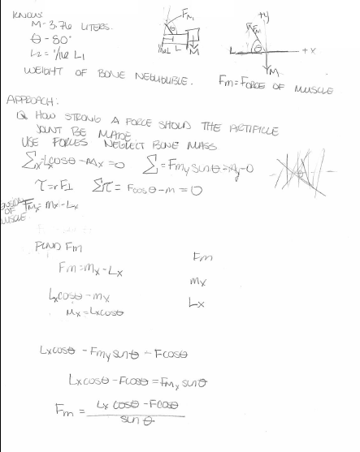
STUDENT #3:

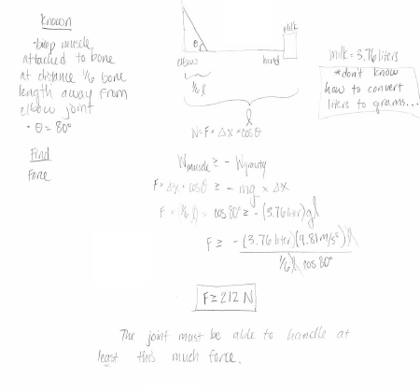
STUDENT #4:
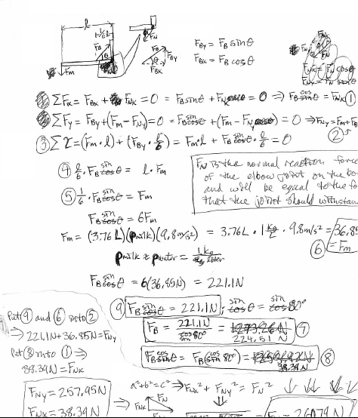

STUDENT #5:
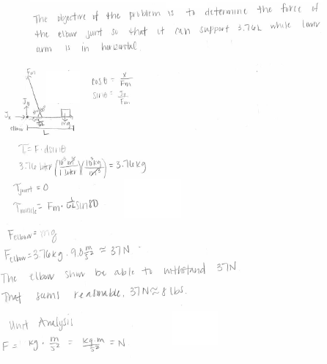

STUDENT #6:

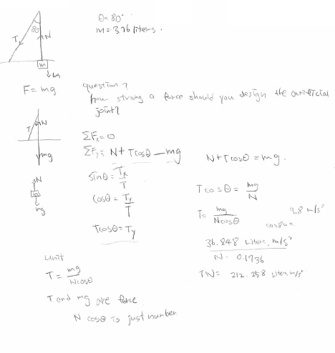

STUDENT #7:

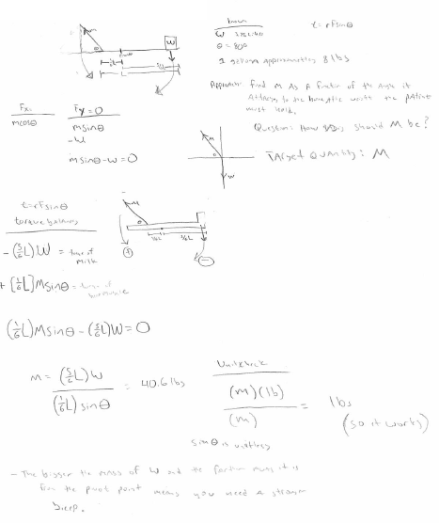

STUDENT #8:

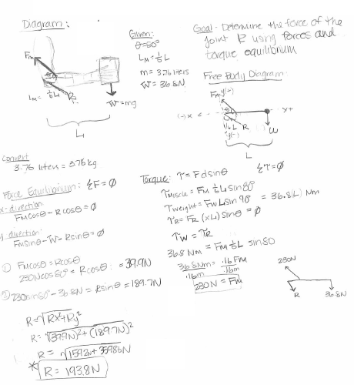

Designing a Problem-solving Framework

You learned in your reading that several research-based problem-solving frameworks for introductory physics have been developed and successfully used. These frameworks divide the important actions into a different number of steps and sub-steps, describe the same actions in different ways, and emphasize different heuristics depending on the backgrounds and needs of population of students for whom they were developed.

Group Task:

The purpose of this task is for you to design a simple, one page problem-solving flow chart that you can have your students use. The flow chart will have only three steps, and not include the last step (Check and Revise, Look Back, or Evaluate the Solution).

- Review the flow chart (expert) you made in activity 2. Also look at the problem solving steps by Fred Reif and from two textbooks (next two pages).

- Decide which actions you think students should make in each step. Describe these actions on the Activity #8 Answer Sheet.

Cooperative Group Roles:
Skeptic: Ask what other possibilities there are, keep the group from superficial analysis by not allowing the group to agree too quickly; ask questions that lead to a deeper analysis; agree when satisfied that the group has explored all possibilities.
Manager: Suggest a plan for answering the questions; make sure everyone participates and stays on task; watch the time.
Checker/Recorder: Ask others to explain their reasoning process so it is clear to all that their suggestions can be discussed; paraphrase, write down, and edit your group’s answers to the questions.

One member from your group will be randomly selected to present your group’s flow chart to the class

Product:
Activity 8 Flow Chart and Description for Students

The problem-solving framework by Frederick Reif for a calculus-based course.

- Analyze the Problem: Bring the problem into a form facilitating its subsequent solution.
  - Basic Description – clearly specify the problem by
    - describing the situation, summarizing by drawing diagram(s) accompanied by some words, and by introducing useful symbols; and
    - specifying compactly the goal(s) of the problem (wanted unknowns, symbolically or numerically.)
  - Refined Description – analyze the problem further by
    - specifying the time sequence of events (e.g., by visualizing the motion of the objects as they might be observed in successive movie frames, and identifying the time intervals where the description of the situation is distinctly different (e.g., where acceleration of the object is different); and
    - describing the situation in terms of important physics concepts (e.g., by specifying information about velocity, acceleration, forces, etc.).

- Construct a Solution: Solve simpler sub-problems repeatedly until the original problem has been solved:
  - Choose sub-problems by
    - examining the status of the problem at any stage by identifying the available known and unknown information, and the obstacles hindering a solution;
    - identifying available options for sub-problems that can help overcome the obstacles; and
    - selecting a useful sub-problem among these options.
  - If the obstacle is lack of useful information, then apply a basic relation (from general physics knowledge, such as ma = F_{TOT}, f_{k} = $μ$N, x = (1/2)a_{x}t²) to some object or system at some time (or between some times) along some direction. Eliminate the unwanted quantity by combining two (or more) relations containing this quantity.
Note: Keep track of wanted unknowns (underlined twice) and unwanted unknowns (underlined once).

- Check and Revise: A solution is rarely free of errors and should be regarded as provisional until checked and appropriately revised.
  - Goals attained? Has all wanted information been found?
  - Well-specified? Are answers expressed in terms of known quantities? Are units specified? Are both magnitudes and directions of vectors specified?
  - Self-consistent? Are units in equations consistent? Are signs (or directions) on both sides of an equation consistent?
  - Consistent with other known information? Are values sensible (e.g., consistent with known magnitudes)? Are answers consistent with special cases (e.g., with extreme or especially simple cases)? Are answers consistent with known dependence (e.g., with knowledge of how quantities increase or decrease)?
  - Optimal? Are answers and solutions as clear and simple as possible? Is answer a general algebraic expression rather than a mere number?

Problem Solving Steps from a Textbook

The following is applicable to all types of problems.

- Begin by drawing a neat diagram that includes the important features of the problem.
- Choose a convenient coordinate system and indicate it on your diagram. Show the origin and positive directions. When possible, choose the origin to be on the particle at t = 0 so that x_{o} = 0.
- Show known quantities on your diagram.
- When possible, write an equation for the quantity to be found in terms of other quantities that are known or can be found. Then proceed to find the other quantities in your equation.
- When possible, solve the problem two different ways to check your solution.
- Examine your answer to see if it is reasonable.

Problem Solving Steps from Another Textbook

Gather Information
The first thing to do when approaching a problem is to understand the situation. Carefully read the problem statement, looking for key phrases like “at rest” or “freely falling.” What information is given? Exactly what is the question asking? Don’t forget to gather information from your own experience and common sense. What should a reasonable answer look like? You wouldn’t expect to calculate the speed of an automobile to be 5 x 10⁶ m/s. Do you know what units to expect? Are there any limiting cases you should consider? What happens when an angle approaches 0º or 90º or when the mass becomes huge or goes to zero? Also make sure you carefully study any drawings that accompany the problem.

Organize Your Approach
Once you have a really good idea of what the problem is about, you need to think about what to do next. Have you seen this type of question before? Being able to classify a problem can make it easier to lay out a plan to solve it. You should almost always make a quick drawing of the situation. Label important events with circled letters. Indicate any known values, perhaps in a table or directly on the sketch.

Analyze the Problem
Because you have already categorized the problem, it should not be too difficult to select relevant equations that apply to this type of situation. Use algebra (and calculus, if necessary) to solve for the unknown variable in terms of what is given. Substitute in the appropriate numbers, calculate the result, and round to the proper number of significant figures.

Learn from Your Efforts
This is the most important part. Examine your numerical answer. Does it meet your expectations from the first step? What about the algebraic form of the result – before you plugged in numbers? Does it make sense? (Try looking at the variables within it to see whether the answer would change the answer in a physically meaningful way if they were drastically increased or decreased or even became zero.) Think about how this problem compares with others you have done. How was it similar? In what critical ways did it differ? Why was this problem assigned? You should have learned something by doing it. Can you figure out what?
Description for Students

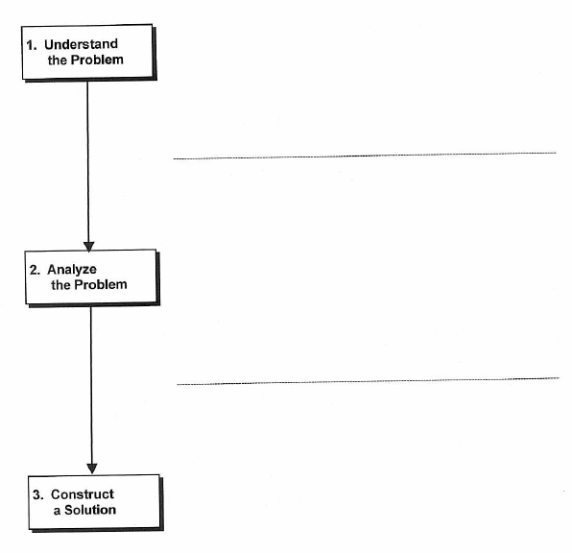

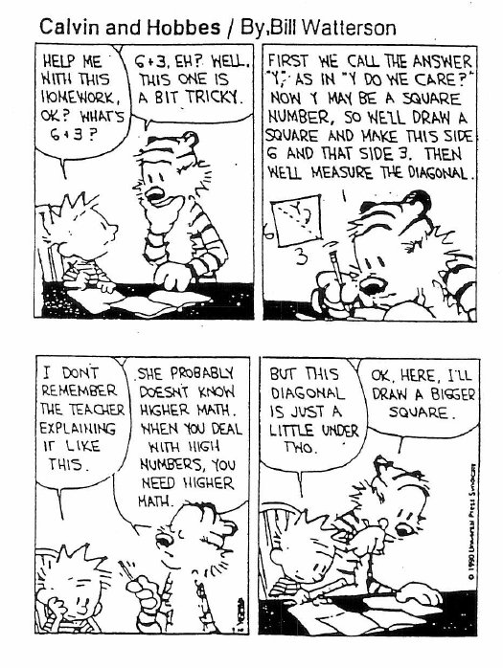

Design an Answer Sheet for your Students

You learned in the reading that it is helpful to provide students with answer sheets during the first 3-6 weeks of the course. Answer sheets provide students with cues for the major steps of your problem-solving framework.

Group Task:
- Review the answer sheets in the Competent Problem Solver.
- Decide what cues you want to provide on the answer sheets for your students. Write these cues on the Activity #9 Answer Sheet.

Cooperative Group Roles:
Skeptic: Ask what other possibilities there are, keep the group from superficial analysis by not allowing the group to agree too quickly; ask questions that lead to a deeper analysis; agree when satisfied that the group has explored all possibilities.
Manager: Suggest a plan for answering the questions; make sure everyone participates and stays on task; watch the time.
Checker/Recorder: Ask others to explain their reasoning process so it is clear to all that their suggestions can be discussed; paraphrase, write down, and edit your group’s answers to the questions.

One member from your group will be randomly selected to present your group’s answer sheet to the class

Product:
Activity 8 Answer Sheet

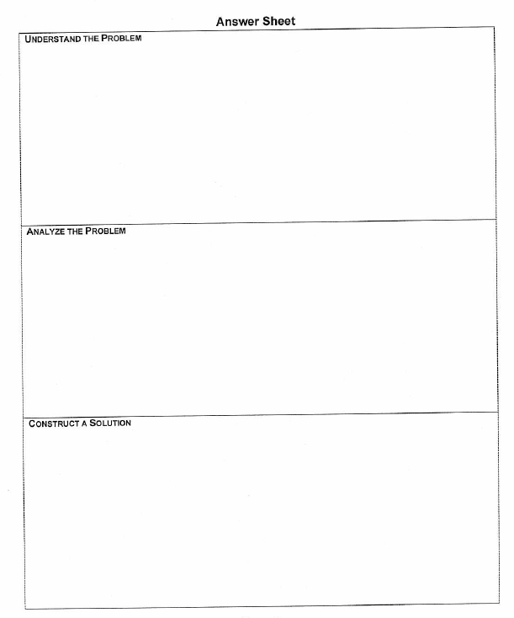

SAMPLE ANSWER SHEET:
Course:________ Section: ________
Manager:
Recorder:
Skeptic:
Skeptic:
Date: _________
UNDERSTAND THE PROBLEM
Picture and Given Information

Question:
Physics Concepts:

Approximations and Constraints:

ANALYZE THE PROBLEM
Diagram and Define Quantities

Target Quantity:

Useful Equations:

CONSTRUCT A SOLUTION
Construct specific equations, eliminate unwanted unknowns, and solve for target quantity.

Check Units:

Calculate Numerical Answer

SAMPLE ANSWER SHEET:
Picture and Given Information
FOCUS the PROBLEM

Question(s)

Approach

DESCRIBE the PHYSICS
Diagram(s) and Define Quantities

Target Quantity(ies)

Quantitative Relationships

PLAN the SOLUTION  Construct Specific Equations | EXECUTE the PLAN  Calculate Target Quantity(ies)  EVALUATE the ANSWER  Is Answer Properly Stated?  Is Answer Unreasonable?  Is Answer Complete?
Check Units | (extra space if needed)

Objectives:
• Introduce discussion sessions.
• Have the students work on solving a real problem (i.e., can’t solve in one step).

Preparation:

- Name tags and markers.  - Grade book  - Assign students to groups  - Group Roles sheets for Discussion (make copies; Instructor’s Handbook) | - Problem sheets with useful information and equations (1 per student)  - Answer Sheets (1 per group)  - Problem Solution (1 per student)

Write on Board:
• Course # and section #
• your name
• Your office hours
• Your e-mail
• groups -- names with roles
• a room map showing where each group sits in the room
• “Purpose – introduce what its like to solve a real problem in a cooperative group.”
• “Draw a picture with variables defined, and write equations you used to solve the problem”.

 | DO
Opening Moves:  (25 min)  4 min  3 min  1 min  1 min  3 min  1 min  5 min | 0. Get there early and close door. Write information on board. Wear your name tag! Arrange chairs if necessary into groups so that members face each other  • Open Door  - Greet students as they come in. SMILE ☺  - Ask them to wear a name tag  COURSE STUFF  a) Teacher introduction, office hr (if discussion session is before lab)  b) Introduce attendance rules as decided by your instructional team.  c) Introduce purpose of discussion sessions  • The purpose of these discussion sessions is to help you learn how to solve physics problems and communicate your solutions in a logical, organized fashion.  • So you will practice solving problems in cooperative groups. I will be here to coach you in the things you need to think about when you are solving physics problems.  • I will not be solving problems for you. Professor /// will demonstrate how to solve problems in the lecture, and there are many examples of solved problems in your textbook.”  d) Introduce structure of discussion session.  All discussion sessions have three parts.  1. First, you will come into the room and sit in the groups indicated on the board. I will then tell you the purpose of the practice problem and what I want each group to but on the board for a class discussion near the end of the session. For example, for today the purpose is …. and …. (point to what is written on the board).  2. Then you will have a specified time to construct a solution together as a group. Only one person will write the group solution. Each team member will sign the group solution. You may not have time to finish the mathematics of the problem. That’s OK.  3. I will randomly call on one person from each group to put their picture or diagram and equations on the board. Then we will have a class discussion about how to solve the problem. As you leave the class, I will hand out an example solution to the problem.  e) Introduce grading as decided by your instructional team.  f) Introduce Group Roles  Solving problems in cooperative groups means you discuss and construct a solution together. YOU DO NOT SOLVE THE PROBLEM SEPARATELY AND THEN COMPARE YOUR ANSWERS!  Groups work more effectively if each group member is responsible for a specific role necessary to accomplish any technical task. You will change this role responsibility every time we meet, so everyone gets the chance to practice a role several times.  • Pass out Group Roles sheets (if students do not have them already from lab). Tell your students to read the roles for discussion section, and give them time to do so.  The group roles are the Manager, the Recorder/Checker, and the Skeptic/Summarizer.  The Manager makes sure that everyone in the group contributes to solving the problem, keeps the group focused, and watches the time.  The Recorder/Checker records the group solution and makes sure that all members agree on what is written.  The Skeptic/Summarizer makes sure that alternative ideas are explored, that the group does not come to consensus too quickly, and periodically summarizes the discussion and decisions. In groups with four members, the Skeptic and Summarizer are different roles.  When you are assigned a role, it does not mean that only you can fill the role function. It simply means that you are responsible for seeing that your role is accomplished, either by you or by other group members.  Notice that everyone does physics. Cooperative groups does not mean that you stop thinking about physics or exploit your partners’ efforts. It is also true that none of the roles is that of leader. Every member of the group is responsible for its leadership and group solution.
5 min | ② Prepare Students for Group Work  a) Your group roles for today are written of the blackboard. (If this is first meeting, have all people in Group 1 raise their hand and have the students look at each other. Repeat for other groups.)  After I finish giving directions, you will get into your groups. The map on the board shows where you should sit.  • Be sure to move the chairs so you are all facing each other.  • Move all books and notebooks off your desks.  • When you are properly seated in your groups and know your roles, I will pass out the problem and the one answer sheet to the Recorder/Checker.  b) Pass out problem and answer sheets.  c) You will have 15 minutes to work on this problem. Remember, everyone in the group needs to understand the solution that your recorder writes. I will call randomly on one group member to write on the blackboard.
Middle Game  (20 min) | ③ Coach groups  a) Circulate around groups, watching and listening. You will probably need to tell some groups to get up and move their chairs so they are all facing each other. Do not intervene with any group until all groups are sitting correctly.  b) Intervene in groups that are trying to solve the problem individually. Say something like: “I notice that you are solving the problem individually, not as a group. Who is the Recorder/Checker? You should be the only person writing the solution. Manager and Skeptic/Summarizer put your pencils away and work with the Recorder/Checker to solve the problem.”  If you notice later that the group persists in solving the problem individually, then take the pencils from the Manager and Skeptic (return them at the end of class), and have the group read the green Group Role sheet again. Be sympathetic, but do not leave until they have started solving the problem together.  Intervene in groups with a loner solving problem by himself/herself. Say something like: “I notice that while two of you are working together, you (loner) appear to be solving the problem by yourself. What are each of your group roles? Why are you (loner), as the group Manager (or Skeptic /Summarizer) solving the problem by yourself?” Frequently the loner will only need a gently reminder to discuss and solve the problem with the group. Ask the Recorder/Checker to explain to the loner what they have done so far to solve the problem.
5 min | Intervene in groups with non-participant. Ask the student who is not participating to explain what the group is doing and why. If the student can do this, s/he may be a quiet student who pays attention, but does not speak as often as others. You do not need to intervene further.  ④ Prepare students for class discussion  a) Remind them when they have 5 minutes left.  b) I would like the skeptic in each group to put their group's picture and equations on the board. The other people in the group should watch their partner for errors and watch the other groups for similarities and differences.
End Game  (5 min) | ⑤ Lead a very brief discussion about differences or similarities in the pictures and/or equations they used to solve the problem.  • Collect their group solutions. Make sure that all of their names are on the solution and group functioning sheets.  ⑦ Stand at door and pass out solutions as your students leave. Say good-bye and thank them. SMILE ☺

Example of End-Game discussion for Lake Problem.

- How are the pictures of Lake Calhoun similar?
- How are the pictures different?

After the general questions, you can become more specific. For example
- Which pictures include all the information necessary to solve the problem?
- What are some advantages of drawing a picture with symbolic definitions of all the known and unknown quantities?
A good picture helps you analyze the problem -- what are the important positions and times of interest.
A good picture helps you determine relationships between the objects that are important for solving the problem -- like d = dy + dr.
Once you have drawn the picture, then you should not have to read the problem again. This makes for better time efficiency in solving the problem.

Remember to count silently up to 30, then call on a group if necessary. Always encourage an individual to get help from other group members if he or she is "stuck."
:

Group Problem

It's a sunny Sunday afternoon and you are walking around Lake Calhoun. A runner approaches you wearing a T-shirt that you try to read as he runs past. You didn’t finish reading the T-shirt, so you wonder, if the runner continues around the lake, when you will see him again.

You look at your watch and it is 3:07 p.m. You recall the lake is 3.4 miles in circumference. You estimate your average walking speed at 3 miles per hour and the runner's average speed to be about 7 miles per hour.

Possibly Useful Information: average speed = $\frac{\text{distance traveled}}{\text{time interval}}$
1 mile = 5280 ft, 1 hour = 60 minutes = 3600 seconds

Group Problem

It's a sunny Sunday afternoon and you are walking around Lake Calhoun. A runner approaches you wearing a T-shirt that you try to read as he runs past. You didn’t finish reading the T-shirt, so you wonder, if the runner continues around the lake, when you will see him again.

You look at your watch and it is 3:07 p.m. You recall the lake is 3.4 miles in circumference. You estimate your average walking speed at 3 miles per hour and the runner's average speed to be about 7 miles per hour.

Possibly Useful Information: average speed = $\frac{\text{distance traveled}}{\text{time interval}}$
1 mile = 5280 ft, 1 hour = 60 minutes = 3600 seconds

Lake Problem Solution
Picture with Definition of Symbols for Known and Unknown Quantities
First
Pass
Meet Again after time t = ?
dy = ?
dr = ?

Sy = 3mph
Sr = 7mph
d = 3.4 miles around lake
sy = 3 mph (speed of "you")
sr = 7 mph (speed of runner)
d = 3.4 miles (total distance around lake)
ts = 3:07 PM (when you & runner first pass)
dy = ? (distance "you" ran to meet runner)
dr = ? (distance runner ran to meet "you")
t = ? (time runner and "you" ran from first
pass until meet again.)

Find tf = ts + t: The clock time "you" and runner will pass again is the clock time you started plus the time it took to meet again.
Useful Equations: $s=\frac{d}{t}$; for “you” $\left(s_{y}=\frac{d_{y}}{t}\right)$ & runner $\left(s_{r}=\frac{d_{r}}{t}\right)$; and d = dy + dr
Algebraic Solution Using Defined Symbols
Find t_{f}  ① tf = ts + t  Find t  ② $s_{y}=\frac{d_{y}}{t}$  Find dy  ③ d = dy + dr  Find dr  ④ $s_{r}=\frac{d_{r}}{t}$ | Unk.  t_{f}  t  dy  dr | Kn.  ts  sy | Solve ③ for dy and substitute into ②  $$\begin{aligned}d_{y}=d−s_{r}t \\ s_{y}=\frac{d−s_{r}t}{t}\end{aligned}$$  Solve ② for t and substitute into ①  $$\begin{aligned}s_{y}t=d−s_{r}t \\ (s_{y}+s_{r})t=d \\ t=\frac{d}{s_{y}+s_{r}} \\ {\text{ So t}}_{f}=t_{s}+\frac{d}{s_{y}+s_{r}} \\ 3:\text{07}\text{ PM}+\left(\frac{3\text{.}4\text{ m}}{\text{3 m/hr+7m/hr}}\right)\left(\frac{\text{60}\text{ min}}{\text{1 hr}}\right) \\ 3:\text{07}\text{ PM +20 min} \\ t_{f}=3:\text{27}\text{ PM}\end{aligned}$$
4 equations and 4 unknowns – so can solve.

Solve ④ for dr and substitute into ③
$$\begin{aligned}s_{r}=\frac{d_{r}}{t} \\ s_{r}t=d_{r} \\ d=d_{y}+s_{r}t\end{aligned}$$
Unreasonable? No. In 20 min “you” walks 1.0 mile and the runner travels 2.4 miles
Complete? Yes -- answers question of when “you” and runner pass again.

Group Problem

You have been given a job working on a team searching for asteroids that might collide with the Earth. This search is important because current theories indicate that dinosaurs and other organisms became extinct when the Earth was struck by a large asteroid. If such a collision happens again it could cause the extinction of the current dominant species on Earth, us. The reason given for the extinction of dinosaurs is that 65 million years ago dust from an asteroid impact went into the upper atmosphere all around the globe, where it stayed for several years blocking the sunlight from reaching Earth's surface. To scan space for this danger, you need to know how large an asteroid you are looking for. A dangerous asteroid size is roughly the same as the one that wiped out the dinosaurs. You are told that about 20% of that asteroid's mass ended up as dust that was spread uniformly over Earth after eventually settling out of the upper atmosphere. Geological exploration indicates that a layer of 0.020 grams of dust, which is chemically different than the Earth's rock, covers each square centimeter of the Earth's surface on the average. Typical asteroids have a density of about 2.0 g/cm3.

Possibly Useful Information:
Surface density = Volume density =
For a right triangle: sin θ = , cos θ = , tan θ = ,
a2 + b2 = c2, sin2 θ + cos2 θ = 1
For a circle: C = 2πR , A = πR2
For a sphere: A = 4πR2, V = $\frac{4}{3}$πR3
Earth’s Radius = 6380 km, 1 km = 103 m = 105 cm

Picture with Definition of Symbols for Known and Unknown Quantities
20% of asteroid’s mass
20% of asteroid’s mass
density=2.0g/cm³

Earth
0.020 g/cm²
6380 km

What is the size of the asteroid?

Assume both the Earth and asteroid are spheres. Use definitions of surface area and density to find the mass of dust. Use mass fraction of dust to find mass of asteroid. Use definition of density to find size of asteroid.
$\begin{aligned}\text{R = 6380 km }(\text{Earth radius}) \\ \text{S = 0}\text{.}\text{020 }g/{\text{cm}}^{2} (\text{surface density of dust}) \\ \text{f = 0}\text{.}\text{20 }(\text{fraction of mass of asteroid that is dust})\end{aligned}$
R
$\begin{aligned}\text{M = ? }(\text{asteroid mass}) \\ \text{r = }?(\text{asteroid radius}) \\ \text{D = 2}\text{.}\text{0 }g/{\text{cm}}^{3}(\text{asteroid density})\end{aligned}$asteroid
r

$\text{m= ? }(\text{mass of dust})$

$V=\frac{4}{3}{pr}^{2},\text{ A=4}{pR}^{2},\text{ D=}\frac{M}{V},\text{ S=}\frac{m}{A},$Find r
$\text{and}m\text{= }fM$Useful Equations

Algebraic Solution Using Defined Symbols

Find r:  Find V:  $$\begin{aligned}D=\frac{M}{V} \\ k\text{ V=}\frac{M}{D}\end{aligned}$$  Find M:  $$\begin{aligned}m=f\text{ M} \\ l\text{ M=}\frac{m}{f}\end{aligned}$$ | Unk.  r  V  M  m | Kn.  D  f | Find m:  $$\begin{aligned}S=\frac{M}{A} \\ m\text{ m=SA}\end{aligned}$$  Find A: | Unk.  A | Kn.  S  R | Substitute into   $r=\sqrt[3]{\frac{3V}{4p}}=\sqrt[3]{\frac{3\left(\frac{S4{pR}^{2}}{\text{Df}}\right)}{4p}}=\sqrt[3]{\frac{3{\text{SR}}^{2}}{\text{Df}}}$  Check Units  $$r=\sqrt[3]{\frac{\frac{g}{{\text{cm}}^{2}}{\left(\text{km}\right)}^{2}}{\left(\frac{g}{{\text{cm}}^{3}}\right)\left(\frac{{\text{10}}^{5}\text{ cm}}{\text{km}}\right)}}=\sqrt[3]{{\text{km}}^{3}}=\text{km}\text{=OK}$$  Numerical Calculation  $$r=\sqrt[3]{\frac{3\left(\frac{0\text{.}\text{02}g}{{\text{cm}}^{2}}\right){\left(\text{6380}\text{ km}\right)}^{2}}{0\text{.}\text{20}\left(\frac{2\text{.}\text{0 g}}{{\text{cm}}^{3}}\right)\left(\frac{{\text{10}}^{5}\text{ cm}}{\text{km}}\right)}}=3\text{.}9\text{ km}$$
 | Unk.  r  V  M  m | Kn.  D  f | 5 equations & 5 unknowns, so can solve problem  Substitute  into , and  into   $M=\frac{m}{f}=\frac{S4{pR}^{2}}{f}$  Substitute into   $V=\frac{M}{D}=\frac{S4{pR}^{2}}{\text{Df}}$
Answer. The asteroid has a radius of 3.9 km (~2 miles). But an 8-km wide (~4 miles wide) asteroid seems too small to wipe out all those life forms!
Objectives:
• Have students complete Force Concept Inventory (& Math Diagnostic or Energy survey, as decided by the course instructor.)
• Have students complete background information in the test booklet.
• Acquaint students with the laboratory structure and equipment.

Preparation:
□ Photocopies: Lab Group Roles | □ Count answer sheets in room (1/person)
□ Name tags and markers. | □ Count test booklets (1/person)
□ List of groups to put on blackboard | □ Count background surveys (1/person)
□ Numbers 1-5 to put on tables | □ Scratch paper for tests
□ Grade book | □ Laboratory manual
□ Get extra pencils for answer sheets | □ Sample laboratory notebook/journal
□ Read the student’s lab manual | □ Read the instructor’s guide to the lab manual

Write on Board:
- Course # and section #
- Your name & e-mail
- Groups (numbered)
- Instructions for filling out the answer sheet.
- The physics department web site http://www.physics.umn.edu/

OPENING MOVES

0. Get there early and lock door.
a) Put a number on each table.
b) Write information on board. (your name & e-mail, course number, section number, groups, instructions for the tests and questionnaire, physics department web site)
c) Wear your name tag!
d) Read instruction sheet for tests to yourself.

1. Open Door
Greet students as they come in. SMILE ☺
a) Tell students sit with their groups – as shown on the blackboard.

2. Introductions
a) Teacher introductions (your name, your interests, where you are from). “You will be working in groups in the laboratory and the groups will change several times during the semester. Changing groups will help you meet more people in the class.

b) Have your students introduce themselves by name, major, and where they are from to the other members of their group.
3. Tell students’ agenda for the day. "We'll be doing several things today…”
a) You will be taking some tests for us that help us evaluate and improve this course.
b) Then I will tell you how this class uses the web and e-mail.
c) I will then introduce how the groups will function in this class.
d) Finally, I will introduce you to the lab manual and lab. I will discuss how the labs will be graded during the next laboratory meeting after you have read the syllabus that is posted on the class web site.

The majority of your laboratory grade will be based on a written report of one lab problem that will be done individually. I will assign which problem each person writes up at the end of all of the problems that make up a laboratory block (usually about 2-3 weeks). Since you will not know which problem you will write up until you have finished all of the problems in a given set, it is necessary to keep a good laboratory journal. Usually each member of a team will write up a different problem. You will usually have 2 days (or your instructional team’s policy) to turn in a report after it is assigned. A good laboratory journal is necessary to write a good report.”

TESTS

a) Read the first page of instructions to the students.
"You will have xx minutes to complete the basic physics test, xxxxxxx, and the questionnaire. Work as rapidly as you can. You may take a break if you finish early, but you must be back by _______.”(set time)

b) Go over the instructions on the board for filling out the answer sheet. Once the students have completed their name, ID, course number, section number, etc, on the answer sheet, then pass out the test booklet.

c) Give them xx minutes and write the ending time on the board. While they are taking the test, go around and check that they are filling out the answer sheet correctly.

d) Collect the tests and questionnaires and the answer sheet and thank your students.

FIRST-LAB INFORMATION

1. Course Stuff (depends on when your labs are during the week)

a) Use of web
This class will make extensive use of computer communication. The class web site is reached from the physics department web site on the board. Just click on the link for class web pages (on left side of the screen) and then on this course number. That will take you to the class web page. That first page will have announcements and links to other important class information such as the syllabus, office hours, and further links to such things as the reading preparation test. It is important to check this page at least once per day for important announcements.”

b) Pre-lab Quiz
“You will take a quiz on the web every week over the reading necessary to understand what you are doing in the laboratory. Since this test is on the web, you can take it from anywhere. You can use whatever help you need to pass this test (75% is passing), but reading and understanding the assigned reading should be sufficient. You may take this test as many times as necessary to pass it, but if you don’t pass it after two times, please get help from me or any other physics teaching assistant. Help is available from me by email or from other TAs in room 230.
If you do not pass this test by two hours before this laboratory (or whatever you instructional team’s policy), you will not be admitted to lab and will get a zero for that week (or whatever your instructional team’s policy). Your lab grade is part of your grade for the entire course but, since this course satisfies a University laboratory requirement, you will fail the entire course if you do not score at least a 60% in the laboratory.”

c). E-mail
“Each of you has a University email account and you need to go on the web to activate it. There are instructions of how to do this on the web under the links in Student One Stop. We will communicate important information to you and send you your grades using this email account. If you have another email account you can forward your email to that account but we are not permitted to send your information to any account other than your University account.”

2. Introduce Purpose of Labs
a) The labs in this course are very different from the labs you have done in the past. The purpose of the labs is the same as the purpose of the discussion sections -- to help you learn how to solve physics problems and communicate your solutions in a logical, organized fashion.
b) So you will practice solving problems in cooperative groups like in the discussion sections. The difference between the lab and the discussion section is that you will check your lab problem solutions by taking measurements in the lab.
c) I will be here to coach you in the things you need to think about when you are solving physics lab problems.

3. Introduce Structure of Labs
a) Please take out your lab manuals and turn to the table of contents. (pause while they do this) The instructions are divided into “labs” or topics. Each lab topic is then further divided into several problems. Each of these lab topics will take 1-3 weeks to complete. During that time, you will usually complete 1-2 problems per week. At the end of each laboratory period, I will tell you what problems to solve for the next laboratory session.
b) There are also several appendices to help you with various parts of the laboratory. Please turn to the appendices and see what information is there (pause while they do this).

c) Now turn to the beginning of Laboratory 1. You will see the motivation that is behind all of the problems in that laboratory, and the reading that is necessary to function effectively in the laboratory. This is the reading that is tested in the prelab test on the web.

d) Now turn to the beginning of Laboratory 1, Problem 1. Notice that a lab problem is similar to the problems you will solve in the discussion sessions. The difference is that instead of passing out a solution, you will test your predicted solution using laboratory equipment.
- The Warm-up Questions are suggestions and questions that guide you through a logical, organized solution to the problem, called the Prediction
- The Exploration section guides you through testing your equipment so you can decide the best way to take measurements. This section is very important and by doing it you will save a lot of time and frustration with your measurements. Usually your group decides n a measurement plan at the end of this section.
- The next sections guide you through the Measurement and Analysis of your data.
- Next, you are guided to draw a Conclusion that compares your prediction to the analysis of your measurements. All of the lab problems have this structure.”

e) Preparing for a laboratory session means that you do three things:
1. First, complete all the prerequisite textbook reading,
2. Then take and pass a test on that reading. The tests are on the web.
3. Finally, complete all the Warm-up questions to arrive at a predicted solution for each assigned lab problem.

4. Introduce Grading the Labs
a) Have students turn to the first grading sheet and look at the grading checklist. Tell students the number of points they will get for each section (from team meeting).

GRADING CHECKLIST | Points
LABORATORY JOURNAL:
WARM-UP QUESTIONS AND PREDICTIONS
(individually completed before each lab session)
LAB PROCEDURE
(measurement plan recorded in journal, tables and graphs made in journal as data is collected, observations written in journal)
PROBLEM REPORT:*
ORGANIZATION
(clear and readable; correct grammar and spelling; section headings provided; physics stated correctly)
DATA AND DATA TABLES
(clear and readable; units and assigned uncertainties clearly stated)
RESULTS
(results clearly indicated; correct, logical, and well-organized calculations with uncertainties indicated; scales, labels and uncertainties on graphs; physics stated correctly)
CONCLUSIONS
(comparison to prediction & theory discussed with physics stated correctly ; possible sources of uncertainties identified; attention called to experimental problems)
TOTAL (incorrect or missing statement of physics will result in a maximum of 60% of the total points achieved; incorrect grammar or spelling will result in a maximum of 70% of the total points achieved)
BONUS POINTS FOR TEAMWORK
(as specified by course policy)

* An "R" in the points column means to rewrite that section only and return it to your lab instructor within two days of the return of the report to you.

b) Warm-up Questions and Prediction. Tell students when and where students should turn in their journals with their Warm-up Questions and Predictions before lab. Tell students that
• The Prediction is not graded.
• The Warm-up Questions are graded for REASONABLE EFFORT, and not for the correct answers.

So what does reasonable effort mean? You will receive the maximum number of points if you:
• answer all the questions correctly;
• answer all the questions, even if some of answers are incorrect;
• answer some of the Warm-up questions, and clearly indicate where you got stuck and why.

c) Lab Procedure. While you are working through the Exploration, Measurements, Analysis, I will be grading you for how well you are keeping track of your procedure and data in your journal. In particular, you will be graded for
• a measurement plan recorded in your journal before you begin making measurements;
• you make tables and graphs made in journal as data is collected (not after all the data is collected); and
• observations are written in the journal.

d) Written Problem Report. Remind students that this course is a writing intensive course. So they will practice technical writing in this course. Tell students for which lab (decided by team) they will write a draft (turned in), edit the returned draft, and then turn in a rewritten report.

At the end of the 2 – 3 weeks of a lab topic, I will assign each member of your group a different lab problem to write up and turn in (tell students you team’s decision about how many days after lab the report is due). Since you will not know which problem you will write up until you have finished all of the problems in a given set, it is necessary to keep a good laboratory journal.

Your lab report will be graded using four criteria – Organization, Data and Data Tables, Results, and Conclusions (have students look at checklist). Read through each criterion. Notice that physics stated correctly is part of three of the four criteria.

Have students turn to the Appendix that contains the Sample Problem Report. Tell students to be sure to read through this sample before they write their own report.

END GAME OR BEGINNING IF SECOND LAB

What happens next depends on the course and section. In some courses, this could be the end of the lab. In other courses, you may start the first lab problem. Before students start working in the lab, be sure to introduce the group roles for lab, as outlined below.

Working in Cooperative Groups

We will be working in groups all semester in both lab and discussion sections. You will work in the same group in both the lab and the discussion sections. I will assign new groups after each quiz (or team’s policy).

I want to introduce how the groups will function before we get started today. Working in cooperative groups is more than sharing a table. We expect you to discuss what you should do, what this has to do with the physics the class is investigating, and how you will go about something before you act.

Pass out Group Roles sheets (if students do not already have them).

In the lab, the Recorder/Checker is the person with the primary responsibility for making sure that everyone records the data in their lab journal so they can write their own lab report. In a computer lab, the Recorder has the keyboard.

The Manager has a special responsibility in the lab. The Manager should read the instructions for each section out loud to the group before the group starts to work on that section. The manager also keeps track of the time, and make sure everyone participates.

The Skeptic/Summarizer makes sure that alternative ideas are explored, that the group does not come to consensus too quickly, and periodically summarizes the discussion and decisions. In groups with four members, the Skeptic and Summarizer are different roles.”

You will only benefit from this laboratory to the extent that you contribute to your team’s effort. By working closely together, you will help each other learn the material in this class. I will be here to guide you when I notice that you may be going astray. To be helpful I must know what YOU are thinking so I will be listening to what you say to each other and watching what you decide to do."

Scholastic Dishonesty is ...

Directions: Circle T if the statement accurately completes the above sentence; Circle F if the statement does not accurately complete the above sentence.

T / F 1. The act of passing off someone else's work as your own.
T / F 2. Extensive assistance from other people on an assignment without recognition.
T / F 3. Using sections of someone else's homework assignment.
T / F 4. Looking at another student's examination during a testing situation.
T / F 5. Conferring with fellow students during an examination period.
T / F 6. Allowing another student to copy from your examination.
T / F 7. Using notes stored on a calculator during a closed-book examination.
T / F 8. Using another person's idea without acknowledging that person.
T / F 9. Allowing another student to copy sections of your paper.
T / F 10. Signing another student's name on an attendance sheet.
T / F 11. Permitting another student to sign your name on an attendance sheet.
T / F 12. Collaborating with a fellow student on a take home exam.
T / F 13. Copying an answer to a problem line-for-line from a textbook or solution manual without identifying where it came from.
T / F 14. An act that can result in expulsion from the University.

Adapted with permission from the Teaching Enrichment Program at the University of Minnesota.
Case Studies: Diversity and Gender Issues

Group Task
This exercise uses "critical incidents" derived from encounters among and between teachers and students at the University of Minnesota. The critical incidents are, as the name implies, incidents or situations that are of importance in understanding the behavior, values, and cultural differences of those described in the incident. Case Studies #1 through #6 deal with incidents you might encounter as a graduate teaching assistant. Case Studies #7 and #8 describe encounters between people from the U.S. and international scholars. Case Studies #9 through #11 deal with incidents with fellow graduate students.
The incidents are open-ended, with no absolute right answer to be guessed or learned. In our discussion of the incidents, several explanations, alternatives, or solutions could be proposed depending on the personality, style, or culture of the individuals.
Discuss the four critical incidents assigned to your group. Use the guidelines listed under each critical incident to begin the discussion. There is no need to limit your discussion to just the questions provided.

Group Roles
Skeptic: Ask what other possibilities there are, keep the group from superficial analysis by not allowing the group to agree too quickly; ask questions that lead to a deeper analysis; agree when satisfied that the group has explored all possibilities.
Manager: Suggest a plan for discussing each incident and answering the questions; make sure everyone participates and stays on task; watch the time.
Checker/Recorder: Ask others to explain their reasoning process so it is clear to all that their suggestions can be discussed; paraphrase, write down, and edit your group's response to each incident.

Group Product
Answer Sheets for assigned Case Studies.

Case Study #1*

One of your physics students is a highly achieving undergraduate who is very bright, personable, and attractive. You enjoy working with this student, but are not otherwise interested in a relationship. Unexpectedly, the student leaves you a note, professing an interest in establishing a close relationship, along with a bouquet of flowers.

*Adapted from University-wide sexual harassment training

1. What are your responsibilities in this situation?
2. How can you maintain the kind of teaching relationship you want?

NOTES:

Case Study #2*

One day, as you are waiting for students to come in and settle down for your discussion session, you notice that one of the students enters wearing a T-shirt which is emblazoned with a sexually obscene and violent slogan. The student sits down as the bell rings for the class to begin. Just as you are about to begin your opening game, another student states loudly that he cannot sit in the class and attempt to learn if that T-shirt is allowed to stay there. The two students then engage in a shouting match.

*Taken from University-wide sexual harassment training

1. What are your responsibilities in this situation?
2. What are some possible solutions?

NOTES:

Case Study #3

You are discussing with your class the physics of sound, specifically why longer musical instruments make deeper sounds. To provide a quick demonstration, you have one male student and then one female student stand up and say "oooh." After the session, the female student goes to the professor and says that she felt singled out since she is the only woman in the class. Further, she was upset and embarrassed since saying "oooh" loudly in a room full of men seemed to her to be too sexual a thing to do.

1. What could you have done to prevent the situation?
2. What could you do to resolve the situation?
3. What could your professor have done to prevent the situation?
4. What could the professor do to resolve the situation?

NOTES:

Case Study #4

Jose, a student in your section, is in a wheelchair. His brother Pedro is in the same section, and is very protective of Jose. (Pedro registered for all the same classes as Jose on purpose so that he can help him out.) The brothers want to be in the same group, but you want to have diverse groups so that students can get to know one another. However, because of Jose's disability you give in to the brothers and put them in a group with two other people. When there is a group test problem, the brothers surprise you by speaking Spanish to one another. You ask them to speak English so that everyone in the group can understand. They tell you that they don't think they read English as well as other people in the class and are just talking to each other in Spanish to be sure that they understand the quiz problem.

1. What could you have done to prevent the situation?
2. What can you do to resolve the situation?

NOTES:

Case Study #5

You are a relaxed TA, often chatting and laughing with students in your section before you start class. One day before lab, you discover that you share an interest in racquetball with one of your students and you make an appointment to play. Soon you are meeting every Wednesday at lunch for a racquetball game with this student and becoming friends. The other students in your section know about this and are upset about it. You think it's no big deal, since it's not as though you are romantically involved with your student.

1. What are your responsibilities in this situation?
2. What can you do to resolve the situation?

NOTES:

Case Study #6

Early in the spring semester, one of your fellow team members stops by your lab section and starts chatting and visiting with one of your students during the lab. It is soon obvious that the two are in a relationship. After lab, you find out that this student was in the TA’s lab last term.

1. What are your responsibilities in this situation?
2. What can you do to resolve the situation?

NOTES:
Case Study #7*

Abdelkader, Mohammed and Naji, students from the same country, are close to completing their first semester at the University. When they first met at the new student orientation program and discovered they were all in the same engineering department, they arranged their schedules so they could take most of their classes together. Every day before their physics class they met to study each other's notes and to discuss the assigned reading and homework they had done the night before.

Their physics professor noticed that the three students made nearly the same errors in the first exam of the semester. At the time, he assumed it was because they were from the same educational background. However, when he noticed that all three students had exactly the same problems incorrect on their second test, he decided they had to be cheating. The professor called the students into his office and explained that this type of behavior was unacceptable. He told them that he was going to call the foreign-student advisor to see what action could be taken because of their cheating.

*Adapted from Florence A. Funk's "Intercultural Critical Incidents"

1. What happened? (Describe the situation.)
2. Why? (Give causes/interpretation of the situation.)
3. Alternatives/Solutions:
a. What could have been done to prevent the situation?
b. What can be done to resolve the situation?

NOTES:

Case Study #8*

Chong, a new international student at the University of Minnesota, arrived on campus two weeks before classes began so he could find housing, register for classes and become familiar with the St. Paul-Minneapolis area. During this two week period everything went well. He found an apartment to share with a U.S. student from his department, was able to register for all the classes he needed, and made the acquaintance of a few other students. Once classes began Chong discovered that he was thrilled with the discussion that took place between the students and professors in his classes, he enjoyed the company of his roommate's friends and he enjoyed the easy access to movies, shopping, and fast food establishments.

About three weeks into the term, Chong began to find the endless classroom discussions a waste of time. He was frustrated with the ridiculous antics of his roommate's friends and it seemed that everything he needed cost too much. He found that he was now seeking the company of his countrymen and that their discussions most often centered on how "screwed-up" everything was in the States. He ate lunch in a local ethnic restaurant and avoided contact with students from the U.S. unless it was required to fulfill classroom assignments.

*Taken from Florence A. Funk's "Intercultural Critical Incidents"

1. What happened? (Describe the situation.)
2. Why? (Give causes/interpretation of the situation.)
3. Alternatives/Solutions:
a. What could have been done to prevent the situation?
b. What can be done to resolve the situation?

NOTES:

Case Study #9

Boris is a first year physics graduate student from Russia. Although he speaks English with a heavy accent, he is fluent and is given his own discussion and lab sections to teach. After a few weeks he becomes puzzled by his students' behavior. Even though he can tell from their test scores that they are confused about physics, they never ask questions or come to his office hours. They come to class late and have to be asked two or three times before they will respond when he asks them to go to the board. Boris comes to you and asks what he should do.

1. What happened? (Describe the situation.)
2. Why? (Give causes/interpretation of the situation.)
3. Alternatives/Solutions:
a. What could have been done to prevent the situation?
b. What can you do to help resolve the situation?

NOTES:

Case Study #10

Mary was having some difficulty in one of her 5000-level physics classes.
She had trouble with the homework assignments and then scored below the median on the first two exams. About halfway through the term, Mary went to see the professor to ask him for help. He told Mary that she should really be ashamed at her performance in the class and that she would probably fail. He refused to help her and told her that she should drop out of school, since it was unlikely that she would ever be a physicist. After meeting with him, the student was so upset that she went to the top of a tall building and considered killing herself.

1. What happened? (Describe the situation.)
2. Why? (Give causes/interpretation of the situation.)
3. Alternatives/Solutions:
a. What could Mary have done to prevent the situation?
b. What can Mary do to resolve the situation?
c. What could the professor have done to prevent the situation?
d. What could you (as one of Mary's classmates) do to prevent or resolve the situation?

NOTES:

Case Study #11

In one of her sections Susan had a male student, Joe, who was very self-assured. During her office hours, he often sat very close to her and put his arm around the back of her chair. One day in lab, as Susan helped a group at the next table, Joe reached behind him and stroked her leg. She said, "Don't do that," and asked to speak to him after class. When the other students had gone, Susan said, "I don't know what you thought you were doing when you touched my leg in class." Joe said that it had been an accident, and Susan ended the conversation. Immediately after that, she went to see the lecturer for Joe's class and told him the whole story. The professor laughed.

1. What happened? (Describe the situation.)
2. Why? (Give causes/interpretation of the situation.)
3. Alternatives/Solutions
a. What could the TA (Susan) have done to prevent the situation?
b. What could Susan do to resolve the situation?
c. What could the professor have done to prevent the situation?
d. What could the professor do to resolve the situation?

