TA Duties and Rationale for the UMn Model

Notes: _______________________________________________________________________
_____________________________________________________________________________
_____________________________________________________________________________
_____________________________________________________________________________
_____________________________________________________________________________
_____________________________________________________________________________
_____________________________________________________________________________
_____________________________________________________________________________
_____________________________________________________________________________
_____________________________________________________________________________
_____________________________________________________________________________
_____________________________________________________________________________
_____________________________________________________________________________
_____________________________________________________________________________
_____________________________________________________________________________
__________________________________________________________________________________________________________________________________________________________
_____________________________________________________________________________
_____________________________________________________________________________
_____________________________________________________________________________
_____________________________________________________________________________
_____________________________________________________________________________

Notes: _______________________________________________________________________
_____________________________________________________________________________
_____________________________________________________________________________
_____________________________________________________________________________
_____________________________________________________________________________
_____________________________________________________________________________
_____________________________________________________________________________
_____________________________________________________________________________
_____________________________________________________________________________
_____________________________________________________________________________
_____________________________________________________________________________
_____________________________________________________________________________
_____________________________________________________________________________
_____________________________________________________________________________
_____________________________________________________________________________
__________________________________________________________________________________________________________________________________________________________
_____________________________________________________________________________
_____________________________________________________________________________
_____________________________________________________________________________
_____________________________________________________________________________
_____________________________________________________________________________

The Force Concept Inventory (FCI) and Alternative Conceptions

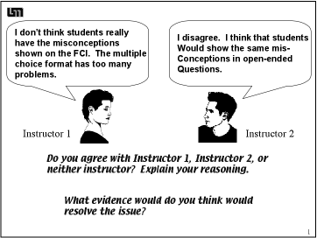

Notes: _______________________________________________________________________
_____________________________________________________________________________
_____________________________________________________________________________
_____________________________________________________________________________
_____________________________________________________________________________
_____________________________________________________________________________
_____________________________________________________________________________
_____________________________________________________________________________
_____________________________________________________________________________

Notes: _______________________________________________________________________
_____________________________________________________________________________
_____________________________________________________________________________
_____________________________________________________________________________
_____________________________________________________________________________
_____________________________________________________________________________
_____________________________________________________________________________
_____________________________________________________________________________
_____________________________________________________________________________
_____________________________________________________________________________
_____________________________________________________________________________
_____________________________________________________________________________
_____________________________________________________________________________
_____________________________________________________________________________
_____________________________________________________________________________
_____________________________________________________________________________
_____________________________________________________________________________
_____________________________________________________________________________
_____________________________________________________________________________
_____________________________________________________________________________
_____________________________________________________________________________
_____________________________________________________________________________
_____________________________________________________________________________

