Facilitating an End Discussion (complete student solutions)
Individual Tasks:

**If you have already done the individual task from Activity #6, refer to your preparation notes from that activity.

On the following page is an introductory physics problem – pretend that your teaching team has decided to use this problem in the next discussion session.
- Solve this problem by yourself.
- Write down some notes about how you would prepare for this discussion session. Use the Discussion Preparation sheet as a guide.
  - What is the learning focus for this problem that you will emphasize?
  - What do you expect students to have difficulty with?
  - What questions can you ask students?
- Write up a detailed “solution” to this problem that you would hand out to your students at the end of class.

Individual & Group Tasks:

Following the problem statement are 8 complete student solutions to the problem. Notice that these are the same student solutions from Activity #6, but they are now longer. For this activity, you should pretend that you are approaching the end of teaching a discussion session with this problem. As you circulate the room one last time, you observe what students have written on their papers.

Choose 4 of the following 8 solutions to represent what your student groups have come to a consensus about for the problems. Ignore the other 4 solutions.

- Based on the 4 completed solutions you have chosen, what will you ask student groups to put on the board for an end discussion?
- After they put this on the board, what questions will you ask during the end-of-class discussion with all groups?

Be prepared to share your responses to these questions with your peers during TA Orientation.

NOTE: These partial student solutions were actually taken from individual solutions to a 1201 final exam problem in Fall 2005, from two different lecture sections. The problem was chosen because it is similar to most group problems given in discussion sessions.

Problem:
Your task is to design an artificial joint to replace arthritic elbow joints in patients. After healing, the patient should be able to hold at least a gallon of milk (3.76 liters) while the lower arm is horizontal. The bicep muscle is attached to the bone at the distance 1/6 of the bone length from the elbow joint, and makes an angle of 80⁰ with the horizontal bone. For how strong of a force should you design the artificial joint? (The weight of the bone is negligible.)

STUDENT #1:
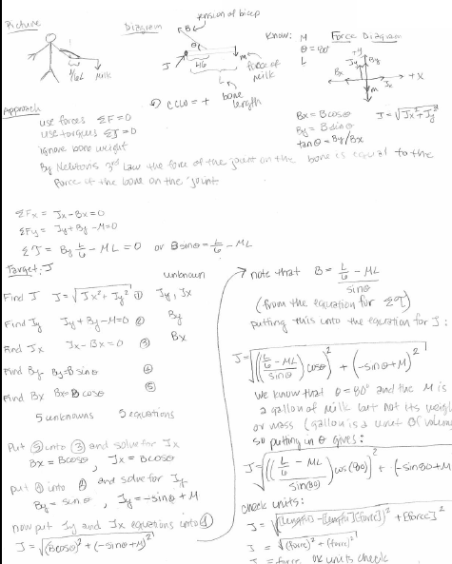
STUDENT #2:
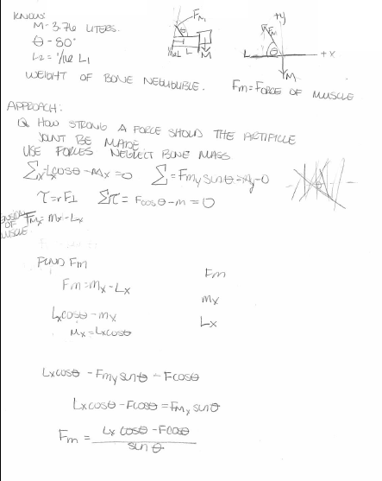
STUDENT #3:

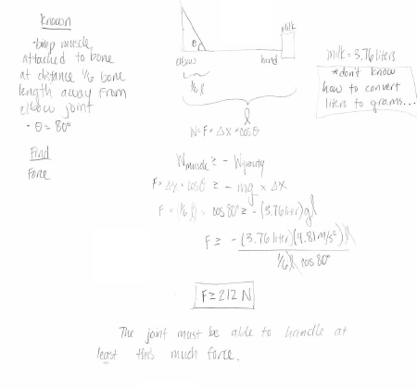
STUDENT #4:
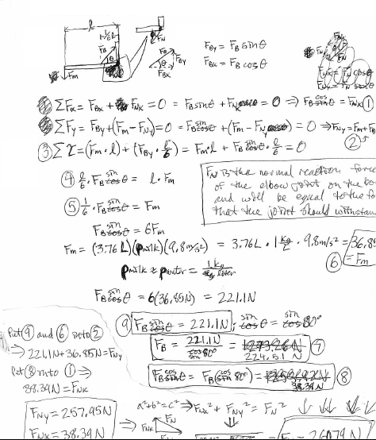

STUDENT #5:
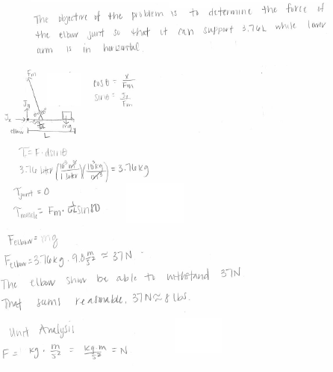

STUDENT #6:

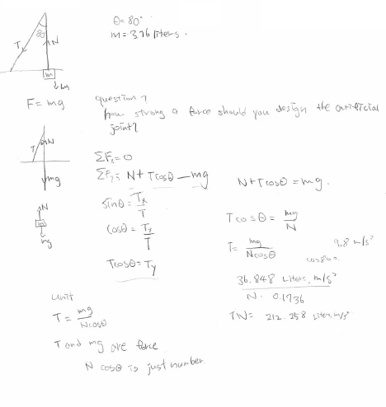

STUDENT #7:

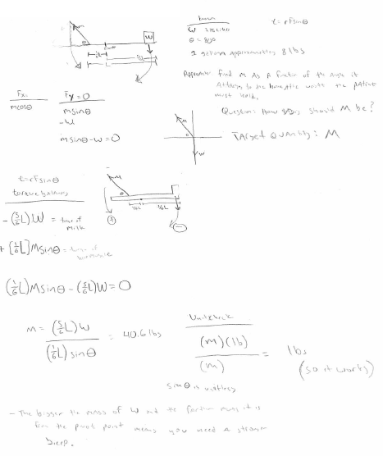

STUDENT #8:

