Grading Two Example Student Laboratory Reports

Introductory physics courses at the University of Minnesota are Writing Intensive (W-I). This means that a course grade is directly tied to the quality of the student’s writing as well as to knowledge of the subject matter, so that students cannot pass the course who do not meet minimal standards of writing competence.

In physics laboratory reports, students are provided the opportunity to learn about physics through written assignments that involve problem solving, language use, and organizational skills. Writing factors to consider in your grading include the following:

Content | Has the student included technical or scientific Content accurately & thoroughly? Does the student address accurate information such as definitions, formulas, theorems, explanations, or data?
Context | Has the student communicated in a way appropriate for the situation or Context in which the document / presentation / visual will be received? Have the requirements of the assignment been met?
Audience | Has the student addressed the Audience with appropriate language & technical content, vocabulary, level of knowledge, & register (informal or formal)?
Purpose | Has the student identified the Purpose of their communication, such as to inform, persuade, instruct, or demonstrate?
Support | Has the student included appropriate Support in the form of documentation, facts, statistics, formulas, illustration, or evidence?
Design | Does the student use effective Design, both for page design & for the integration of verbal explanation & visual illustration? Does the student display neatness & cross-references at appropriate points?
Organization | Has the student Organized the communication into logical sections, paragraphs, topic sentences, & headings?
Expression | Has the student Expressed written work clearly, efficiently, & effectively? Has the student used correct grammar & mechanics?

Individual Tasks:

- Individually read through the 2 example student laboratory reports. Mark down any and all comments on the example student laboratory reports as you do so.
- Assign points for each student laboratory report on the grading rubric, according to your teaching team’s grading policy. Group discussion about the grading will take place at the next seminar session.
- Record the time it took you to grade each student report. (How much time do you expect to spend grading an entire class of lab reports? How can you improve your grading efficiency?)
Campus Resources for Writing Support

Writing Support Network. The Writing Support Network is a web page that lists support services for students in writing classes. All writing centers home pages are listed.

See: http://www.writinghelp.umn.edu/

Center for the Interdisciplinary Studies of Writing. CISW offers workshops for TAs and faculty teaching writing-intensive courses. You can also find on their website sources for sample courses, syllabi, and assignments that are writing-intensive.

See: http://CISW.cla.umn.edu/

Writing-Intensive Resources for Scientific and Technical Disciplines. This web site provides information for faculty and students in scientific and technical disciplines. Faculty information includes suggestions for evaluating written reports, integrating writing in assignments, and incorporating revision and peer review. Student information provides a number of online handouts on writing topics such as writing and revising, editing, oral presentations, and student collaboration. Student can also find helpful links to other resources about writing such as other writing centers and sources for documentation.

See: http://www.agricola.umn.edu/writingintensive/

PHYSICS 1301 LABORATORY REPORT

Laboratory I

Name and ID#:
Date performed: Day/Time section meets:
Lab Partners' Names:
Problem # and Title:
Lab Instructor's Initials:
Grading Checklist | Points*
LABORATORY JOURNAL:
PREDICTIONS
(individual predictions and warm-up completed in journal before each lab session)
LAB PROCEDURE
(measurement plan recorded in journal, tables and graphs made in journal as data is collected, observations written in journal)
PROBLEM REPORT:
ORGANIZATION
(clear and readable; logical progression from problem statement through conclusions; pictures provided where necessary; correct grammar and spelling; section headings provided; physics stated correctly)
DATA AND DATA TABLES
(clear and readable; units and assigned uncertainties clearly stated)
RESULTS
(results clearly indicated; correct, logical, and well-organized calculations with uncertainties indicated; scales, labels and uncertainties on graphs; physics stated correctly)
CONCLUSIONS
(comparison to prediction & theory discussed with physics stated correctly ; possible sources of uncertainties identified; attention called to experimental problems)
TOTAL(incorrect or missing statement of physics will result in a maximum of 60% of the total points achieved; incorrect grammar or spelling will result in a maximum of 70% of the total points achieved)
BONUS POINTS FOR TEAMWORK
(as specified by course policy)

* An "R" in the points column means to rewrite that section only and return it to your lab instructor within two days of the return of the report to you.
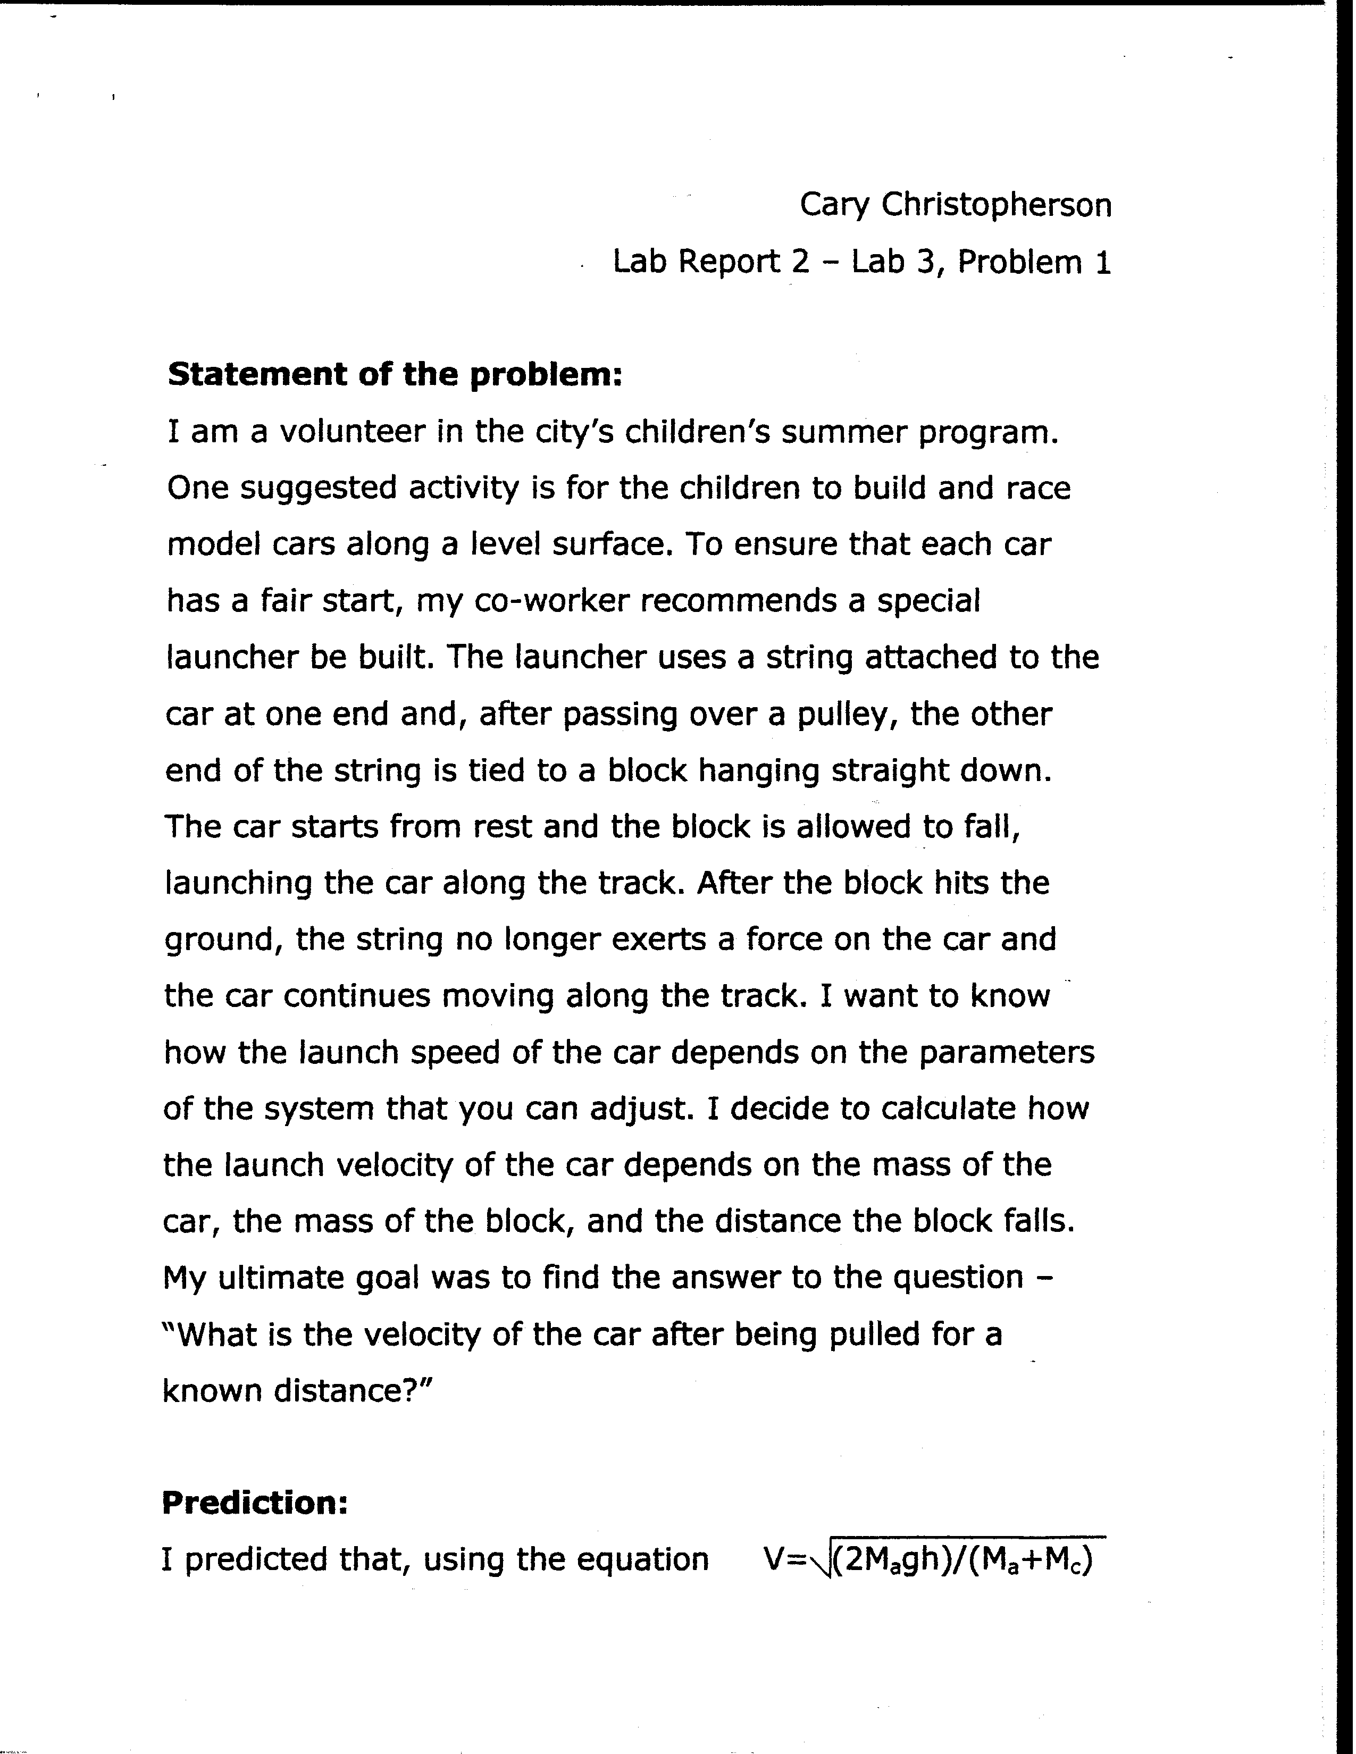

Example #1

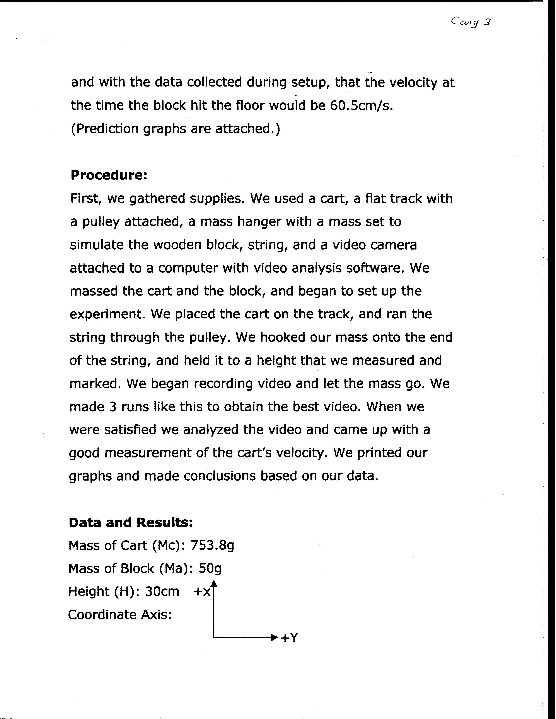
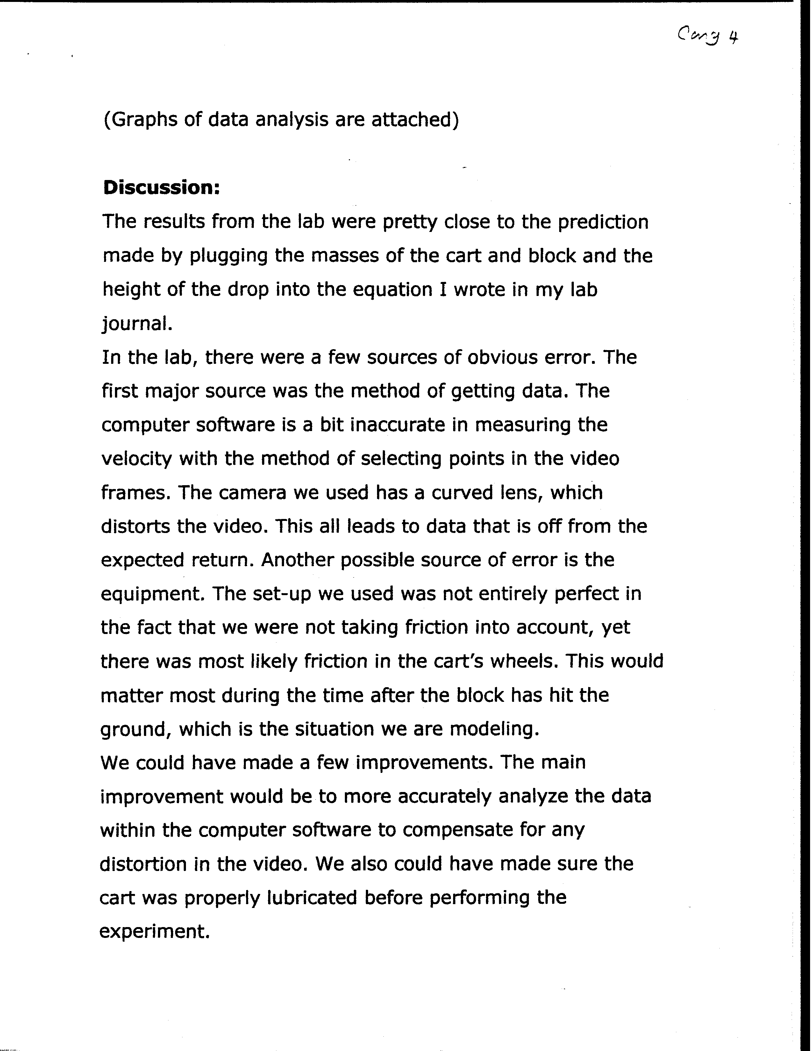
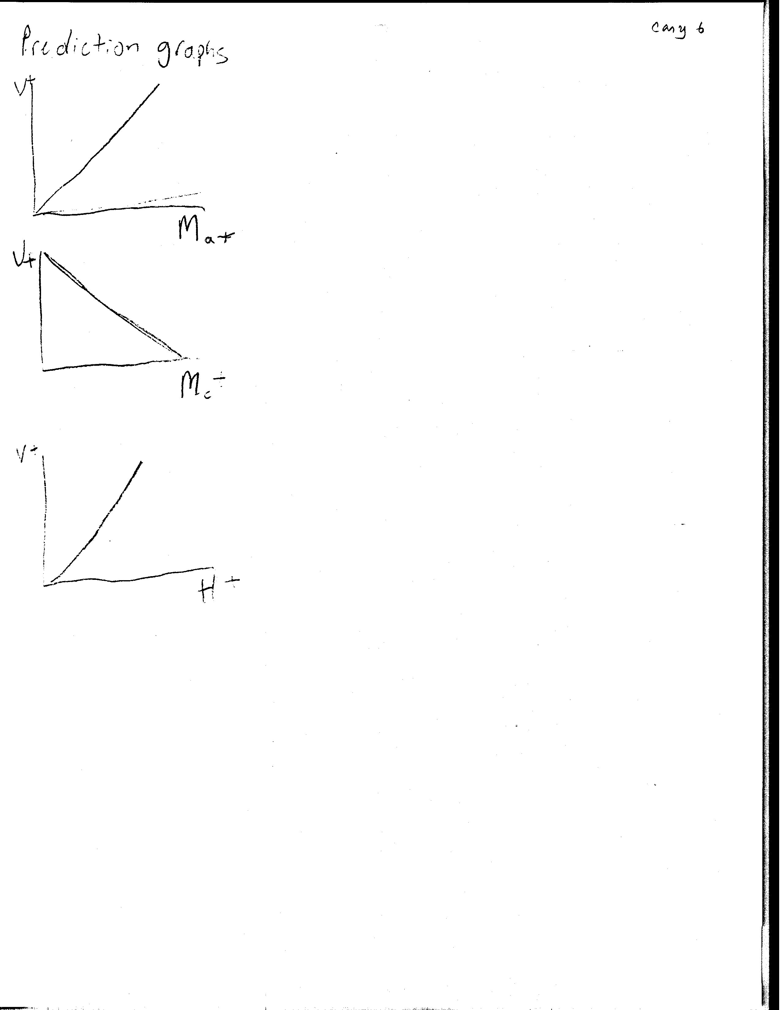
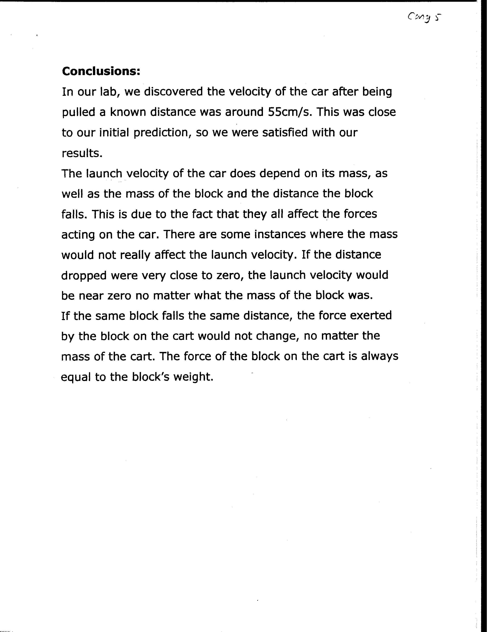

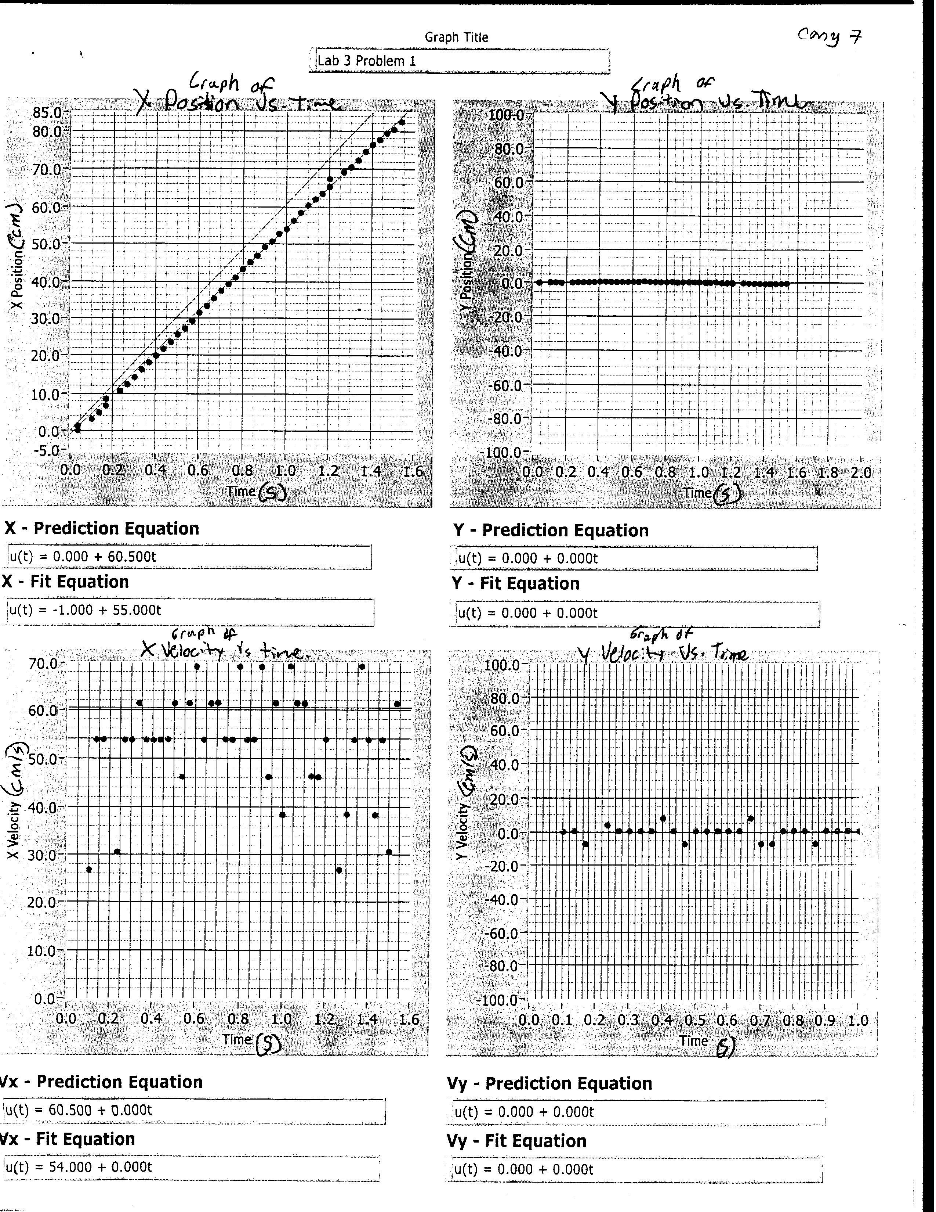

PHYSICS 1301 LABORATORY REPORT

Laboratory I

Name and ID#:
Date performed: Day/Time section meets:
Lab Partners' Names:
Problem # and Title:
Lab Instructor's Initials:
Grading Checklist | Points*
LABORATORY JOURNAL:
PREDICTIONS
(individual predictions and warm-up completed in journal before each lab session)
LAB PROCEDURE
(measurement plan recorded in journal, tables and graphs made in journal as data is collected, observations written in journal)
PROBLEM REPORT:
ORGANIZATION
(clear and readable; logical progression from problem statement through conclusions; pictures provided where necessary; correct grammar and spelling; section headings provided; physics stated correctly)
DATA AND DATA TABLES
(clear and readable; units and assigned uncertainties clearly stated)
RESULTS
(results clearly indicated; correct, logical, and well-organized calculations with uncertainties indicated; scales, labels and uncertainties on graphs; physics stated correctly)
CONCLUSIONS
(comparison to prediction & theory discussed with physics stated correctly ; possible sources of uncertainties identified; attention called to experimental problems)
TOTAL(incorrect or missing statement of physics will result in a maximum of 60% of the total points achieved; incorrect grammar or spelling will result in a maximum of 70% of the total points achieved)
BONUS POINTS FOR TEAMWORK
(as specified by course policy)

* An "R" in the points column means to rewrite that section only and return it to your lab instructor within two days of the return of the report to you.

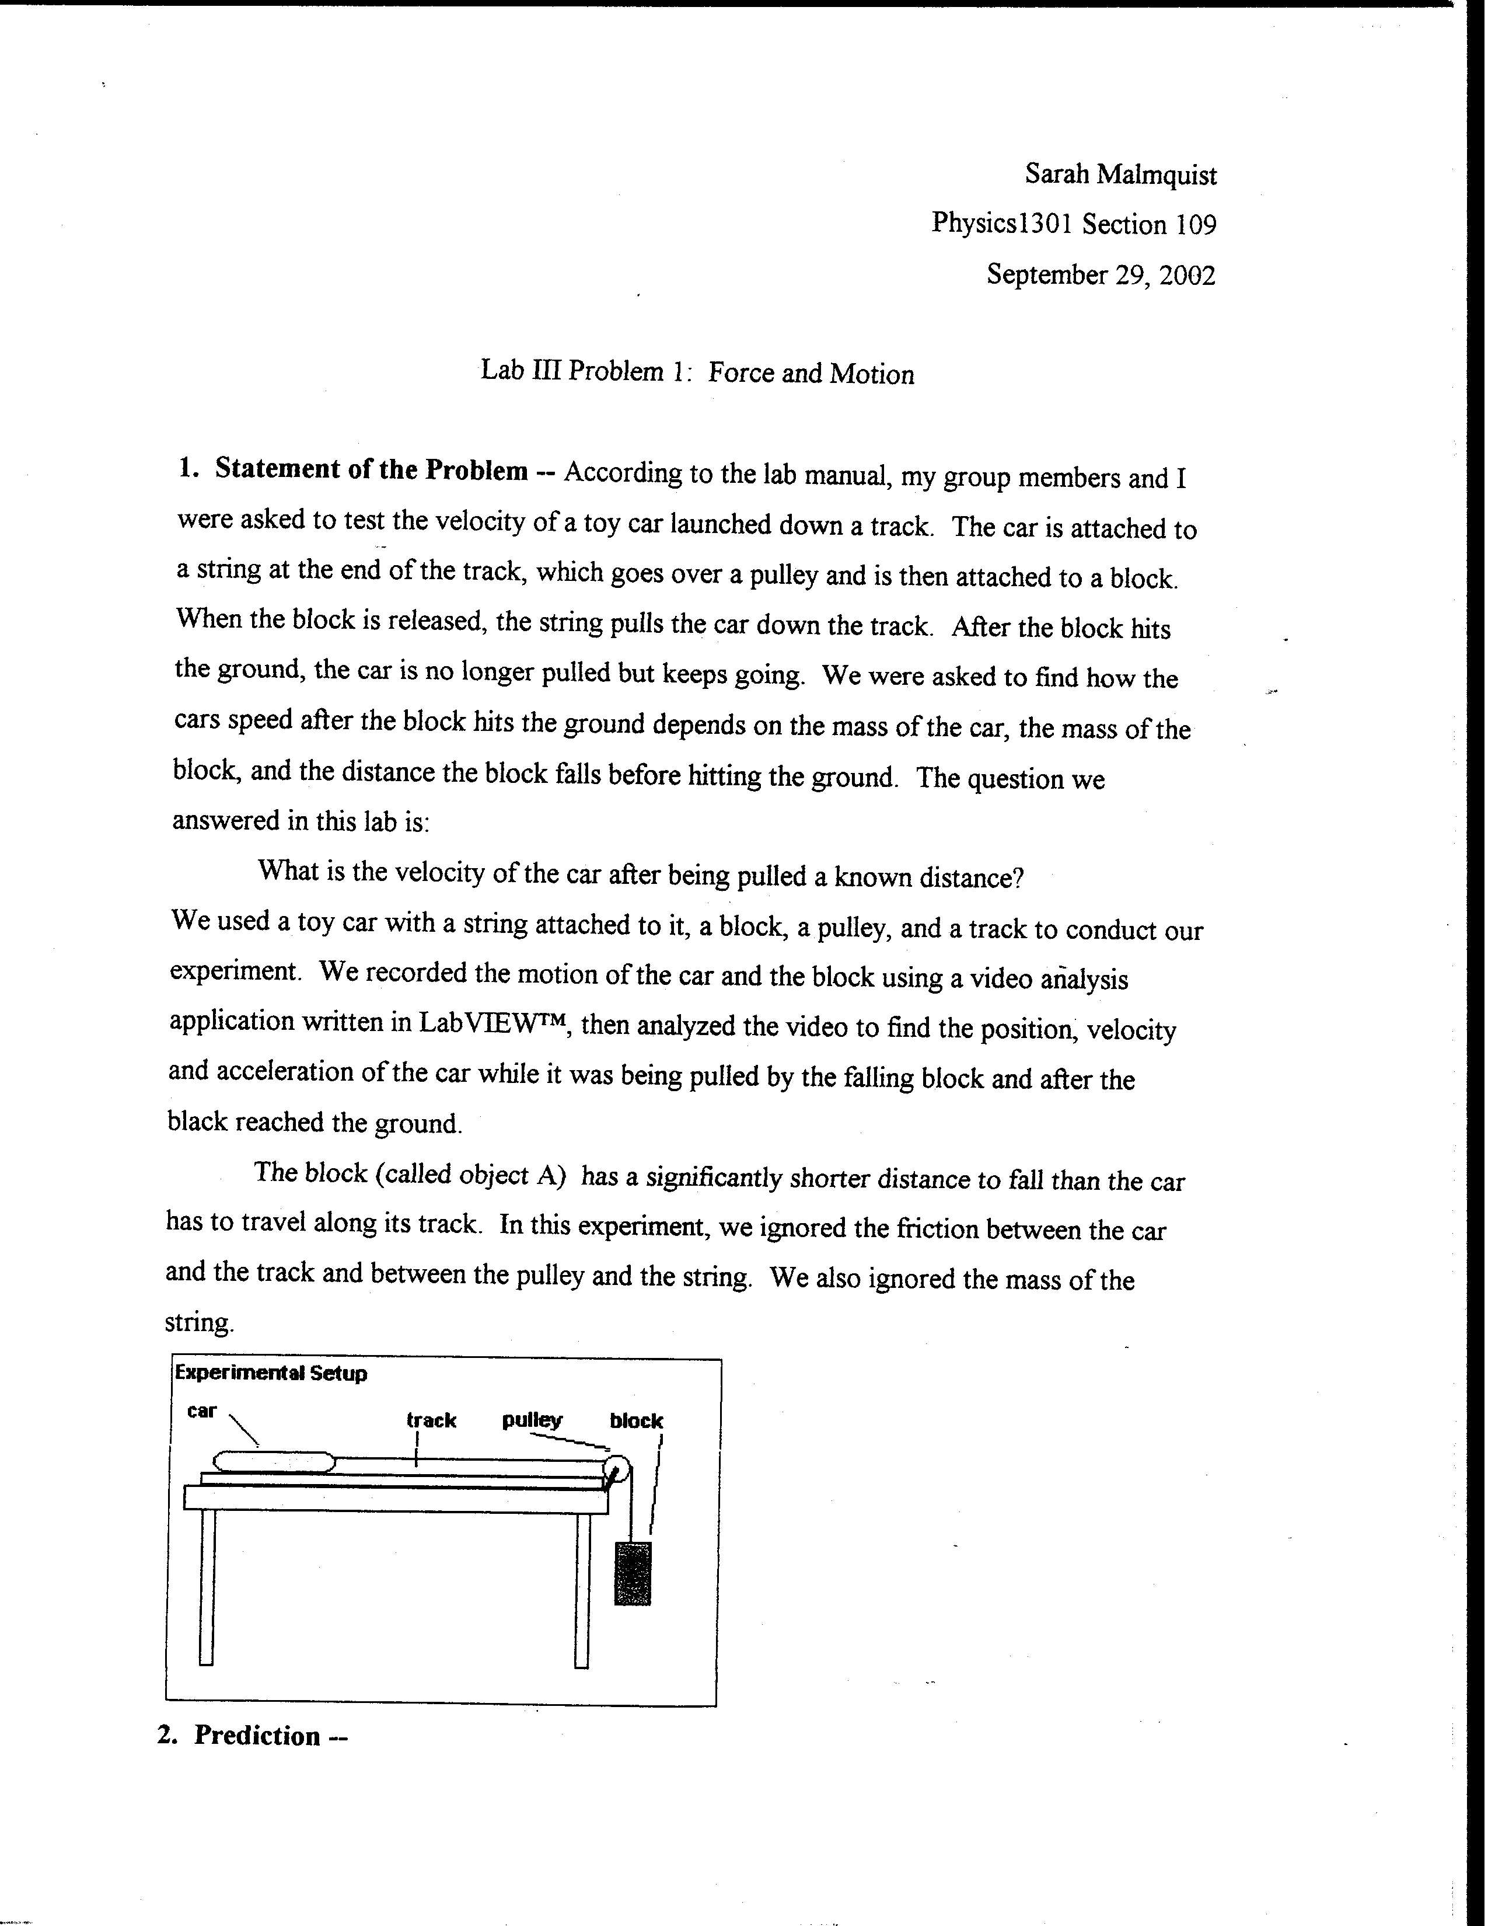

Example #2
