Peer Teaching Booklet

TA Orientation

School of Physics and Astronomy
Fall 2006

PEER TEACHING BOOKLET
TABLE OF CONTENTS

Peer Teaching a Discussion Session
Discussion Preparation Sheet 1
Discussion Problems 3

Peer Teaching a Lab Session
Laboratory Preparation Sheet 9

Laboratory Problems:
1301 Lab 2 Problem #5: Acceleration and Circular Motion 11
1101 Lab 1 Problem #4: Motion Up and Down an Incline 14
1101 Lab 2 Problem #3: Projectile Motion and Velocity 17
1201 Lab 2 Problem #4: Normal Force and Frictional Force 20
1201 Lab 3 Problem #1: Elastic and Gravitational Potential Energy 24
1301 Lab 2 Problem #4: Bouncing 26
1301 Lab 3 Problem #2: Forces in Equilibrium 30

Lab Manual Instructor’s Guide Sheets:
1301 Lab 2 Problem #5: Acceleration and Circular Motion 33
1101 Lab 1 Problem #4: Motion Up and Down an Incline 37
1101 Lab 2 Problem #3: Projectile Motion and Velocity 40
1201 Lab 2 Problem #4: Normal Force and Frictional Force 43
1201 Lab 3 Problem #1: Elastic and Gravitational Potential Energy 49
1301 Lab 2 Problem #4: Bouncing 53
1301 Lab 3 Problem #2: Forces in Equilibrium 56

Appendix
1301 Appendix D: Video Analysis of Motion 59
1301 Appendix F: Simulation Programs (LabSims) 66
Ultr@VNC Instructions 69
Digital Projector Reference 72
Firewire Camera Installation and Settings 73
Peer Teaching Evaluation Forms 75

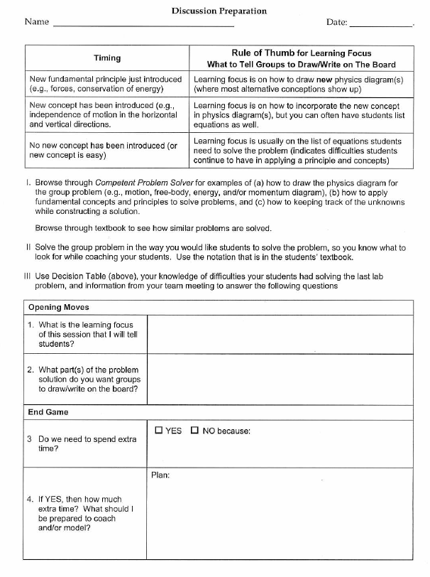

Discussion Problem #1:

In a weak moment you volunteered to be a human cannonball at an amateur charity circus. The “cannon” is actually a 3-foot diameter tube with a big stiff spring inside which is attached to the bottom of the tube. A small seat is attached to the free end of the spring. The ringmaster, one of your soon to be ex-friends, gives you your instructions. He tells you that just before you enter the mouth of the cannon, a motor will compress the spring to 1/10 its normal length and hold it in that position. You are to gracefully crawl in the tube and sit calmly in the seat without holding on to anything. The cannon will then be raised to an angle such that your speed through the air at your highest point is 10 ft/sec. When the spring is released, neither the spring nor the chair will touch the sides of the 12-foot long tube. After the drum roll, the spring is released and you will fly through the air with the appropriate sound effects and smoke. With the perfect aim of your gun crew, you will fly through the air over a 15-foot wall and land safely in a net. You are just a bit worried and decide to calculate how high above your starting position you will be at your highest point. Before the rehearsal, the cannon is taken apart for maintenance. You see the spring, which is now removed from the cannon, is hanging straight down with one end attached to the ceiling. You determine that it is 10 feet long. When you hang on its free end without touching the ground, it stretches by 2.0 ft. Is it possible for you to make it over the wall?

Discussion Problem #2:

Because of your physics background, you have been hired as a technical advisor for a new James Bond adventure movie. In the script, Bond and his latest love interest, who is 2/3 his weight (including skis, boots, clothes, and various hidden weapons), are skiing in the Swiss Alps. She skis down a slope while he stays at the top to adjust his boot. When she has skied down a vertical distance of 100 ft, she stops to wait for him and is captured by the bad guys. Bond looks up and sees what is happening. He notices that she is standing with her skis pointed downhill while she rests on her poles. To make as little noise as possible, Bond starts from rest and glides down the slope heading right at her. Just before they collide, she sees him coming and lets go of her poles. He grabs her and they both continue downhill together. At the bottom of the hill, another slope goes uphill and they continue to glide up that slope until they reach the top of the hill and are safe. The writers want you to calculate the maximum possible height that the second hill can be relative to the position where the collision took place. Both Bond and his girlfriend are using new, top-secret frictionless stealth skis developed for the British Secret Service.
Discussion Problem #3:

Because of your physics background, you have been able to get a job with a company devising stunts for an upcoming adventure movie being shot in Minnesota. In the script, the hero has been fighting the villain on the top of the locomotive of a train going down a straight horizontal track at 20 mph. He has just snuck on the train as it passed over a lake so he is wearing his rubber wet suit. During the fight, the hero slips and hangs by his fingers on the top edge of the front of the locomotive. The locomotive has a smooth steel vertical front face. Now the villain stomps on the hero’s fingers so he will be forced to let go and slip down the front of the locomotive and be crushed under its wheels. Meanwhile, the hero’s partner is at the controls of the locomotive trying to stop the train. To add to the suspense, the brakes have been locked by the villain. It will take her 10 seconds to open the lock. To her horror, she sees the hero’s fingers give way before she can get the lock off. Since she is the brains of the outfit, she immediately opens the throttle causing the train to accelerate forward. This causes the hero to stay on the front face of the locomotive without slipping down, giving her time to save the hero’s life. The movie company wants to know what minimum acceleration is necessary to perform this stunt. The hero weights 180 lbs in his wet suit. The locomotive weighs 100 tons. You look in a book giving the properties of materials and find that the coefficient of kinetic friction for rubber on steel is 0.50 and the coefficient of static friction is 0.60.

Discussion Problem #4:

While working in a University research laboratory, you are given the job of testing a new device for precisely measuring the weight of small objects. The device consists of two very light strings attached at one end to a support. An object is attached to the other end of each string. The strings are far enough apart so that objects hanging on them don’t touch. One of the objects has a very accurately known weight while the other object is the unknown. A power supply is slowly turned on to give each object an electric charge which causes the objects to slowly move away from each other (repel) because of the electric force. When the power supply is kept at its operating value, the objects come to rest at the same horizontal level. At that point, each of the strings supporting them makes a different angle with the vertical and that angle is measured. To test the device, you want to calculate the weight of an unknown sphere from the measured angles and the weight of a known sphere. You use a standard sphere with a known weight of 2.000 N supported by a string which makes an angle of 10.0º with the vertical. The unknown sphere’s string makes an angle of 20.0º with the vertical.

Discussion Problem #5:

Because of your knowledge of physics, and because your best friend is the third cousin of the director, you have been hired as the assistant technical advisor for the associate stunt coordinator on a new action movie being shot on location in Minnesota. In this exciting scene, the hero pursues the villain up to the top of a bungee-jumping apparatus. The villain appears trapped, but to create a diversion she drops a bottle filled with a deadly nerve gas on the crowd below. The script calls for the hero to quickly strap the bungee cord to his leg and dive straight down to grab the bottle while it is still in the air. Your job is to determine the length of the unstretched bungee cord needed to make the stunt work. The hero is supposed to grab the bottle before the bungee cord begins to stretch so that the stretching of the cord will stop him gently. You estimate that the hero can jump off the bungee tower with a maximum velocity of 10 ft/sec straight down by pushing off with his feet and can react to the villain’s dropping the bottle by strapping on the bungee cord and jumping in 2 seconds.

Lab Preparation

Name: _______________________________ Date:___________

Lab Problem: __________________________ Section _________

I. Solve the problem yourself by answering the Warm-up questions. Then read the Lab Instructor’s Manual. Finally, grade the Warm-up Questions for this section.
II. Answer the following background questions.
❶ When is session scheduled? | ❷ Which session is it in the Lab topic sequence? | ❸ What is the lab problem type? | ❹ How difficult is the lab problem?
□ Early in Week  □ Later in Week | □ 1st Lab Session  □ 2nd or 3rd Lab session | □ Qualitative  □ Quantitative | □ Easy/Medium  □ Difficult

❺ Which of the WUQs did your students have the most difficulty answering? Common alternative conceptions? Which ones? | Warm-up Questions:
❻ Count the number of students who were able to solve the problem (even if the solution was incorrect). Is this the majority of the students? | ____ students solved the problem out of ____.
❼ Look at the students’ final solution (Prediction). How many students got the right answer for the wrong reasons? | ____ students got the right (or close to right) answer for the wrong reasons.

III. Based on the answers to these questions, make the following decisions about opening moves and the end game for the lab session.
Opening Moves
1. Which WUQs should I assign groups answer on board? | Use answer to Question ❺: | Warm-up Questions: ______________________
2. Do groups need extra time to solve the problem before they start collecting data? | Use answer to Question❻, taking into account Questions ❶ to ❹ | □ YES □ NO because:
3. If YES, then how much time extra time and how should I structure this extra time? | Use answers to Questions ❶ to ❹ | Plan:
4. What do I need to discuss/tell students about how to check their solution before they start? | Use information in Lab Instructor’s Guide and your  own experience | Discuss:

End Game
5. (Besides corrected answers to assigned WUQs), do we need to spend extra time discussing how to solve the problem? | Use answer to Question ❼ and your previous decisions 2 & 3 | □ YES □ NO because:
6. If YES, then how much time and how should I structure this extra time? |  | Plan:

IV. List some possible questions to ask groups during whole-class discussion (opening moves and/or end game) that you think would promote a discussion.

a.

b.

c.

d.

e.

f.

g.

1301 Lab 2 Problem #5:
acceleration and circular motion

You have been appointed to a Citizen Committee investigating the safety of a proposed new ride called "The Spinner" at the Mall of America's Camp Snoopy. The ride consists of seats mounted on each end of a steel beam. For most of the ride, the beam rotates about its center in a horizontal circle at a constant speed. Several Committee members insist that a person moving in a circle at constant speed is not accelerating, so there is no need to be concerned about the ride’s safety. You disagree and sketch a diagram showing that each component of the velocity of a person on the ride changes as a function of time even though the speed is constant. Then you calculate the magnitude of a person’s acceleration. The committee is still skeptical, so you build a model to show that your calculations are correct.

Equipment

You will be using an apparatus that spins a horizontal beam on A-frame base. A top view of the device is shown to the right. You will have a stopwatch, a meter stick and the video analysis equipment.

Prediction

Calculate the time dependence of the velocity components of an object moving like the ride’s seats. Use this to calculate the object’s acceleration.

Warm Up

Read: Fishbane Chapter 3, section 3.5.

The following questions will help with your prediction and data analysis.
1. Draw the trajectory of an object moving in a horizontal circle with a constant speed. Choose a convenient origin and coordinate axes. Draw the vector that represents the position of the object at some time when it is not along an axis.
2. Write an equation for one component of the position vector as a function of the radius of the circle and the angle the vector makes with one axis of your coordinate system. Calculate how that angle depends on time and the constant angular speed of the object moving in a circle (Hint: integrate both sides of equation 3-46 with respect to time). You now have an equation that gives a component of the position as a function of time. Repeat for the component perpendicular to the first component. Make a graph of each equation. If there are constants in the equations, what do they represent? How would you determine the constants from your graph?
3. From your equations for the components of the position of the object and the definition of velocity, use calculus to write an equation for each component of the object’s velocity. Graph each equation. If there are constants in your equations, what do they represent? How would you determine these constants? Compare these graphs to those for the components of the object’s position.
4. From your equations for the components of the object’s velocity, calculate its speed. Does the speed change with time or is it constant?
5. From your equations for the components of the object’s velocity and the definition of acceleration, use calculus to write down the equation for each component of the object’s acceleration. Graph each equation. If there are constants in your equations, what do they represent? How would you determine these constants from your graphs? Compare these graphs to those for the components of the object’s position.
6. From your equations for the components of the acceleration of the object, calculate the magnitude of the object’s acceleration. Is it a function of time or is it constant?

Exploration

Practice spinning the beam at different speeds. How many rotations does the beam make before it slows down appreciably? Use the stopwatch to determine which spin gives the closest approximation to constant speed. At that speed, how many video frames will you get for one rotation? Will this be enough to determine the characteristics of the motion?

Check to see if the spinning beam is level.

Move the apparatus to the floor and adjust the camera tripod so that the camera is directly above the middle of the spinning beam. Practice taking some videos. How will you make sure that you always click on the same position on the beam?

Decide how to calibrate your video.

Measurement

Acquire the position of a fixed point on the beam in enough frames of the video so that you have sufficient data to accomplish your analysis -- at least two complete rotations. Set the scale for the axes of your graph so that you can see the data points as you take them. Use your measurements of total distance the object travels and total time to determine the maximum and minimum value for each axis before taking data.

Analysis

Analyze your video by digitizing a single point on the beam for at least two complete revolutions.

Choose a function to represent the graph of horizontal position vs. time and another for the graph of vertical position vs. time. How can you estimate the values of the constants in the functions? You can waste a lot of time if you just try to guess the constants. What kinematic quantities do these constants represent? Which are the same for both components? How can you tell from the graph when a complete rotation occurred?

Choose a function to represent the velocity vs. time graph for each component of the velocity. How can you calculate the values of the constants of these functions from the functions representing the position vs. time graphs? Check how well this works. You can also estimate the values of the constants from the graph. Just trying to guess the constants can waste a lot of your time. What kinematic quantities do these constants represent? Which are the same for both components? How can you tell when a complete rotation occurred from each graph?

Use the equations for the velocity components to calculate the speed of the object. Is the speed constant? How does it compare with your measurements using a stopwatch and meter stick?

Use the equations for the velocity components to calculate the equations that represent the components of the acceleration of the object. Use these components to calculate the magnitude of the total acceleration of the object as a function of time. Is the magnitude of the acceleration a constant? What is the relationship between the acceleration and the speed?

Conclusion

How do your graphs compare to your predictions and warm up questions? What are the limitations on the accuracy of your measurements and analysis?

Is it true that the velocity of the object changes with time while the speed remains constant?

Is the instantaneous speed of the object that you calculate from your measurements the same as its average speed that you measure with a stopwatch and meter stick?

Have you shown that an object moving in a circle with a constant speed is always accelerating? Explain.

Compare the magnitude of the acceleration of the object that you calculate from your measurements to the “centripetal acceleration” that you can calculate from the speed and the radius of the object.

1101 LAB 1 PROBLEM #4:
MOTION UP AND DOWN AN INCLINE

A proposed ride at the Valley Fair amusement park launches a roller coaster car up an inclined track. Near the top of the track, the car reverses direction and rolls backwards into the station. As a member of the safety committee, you have been asked to compute the acceleration of the car throughout the ride and determine if the acceleration of an object moving up a ramp is different from that of an object moving down the same ramp. To check your results, you decide to build a laboratory model of the ride.

Equipment

You will have a stopwatch, meter stick, an end stop, a wood block, a video camera, and a computer with video analysis applications written in LabVIEWTM (VideoRECORDER and VideoTOOL). You will also have a PASCO cart to roll on an inclined aluminum track.

Remember that if you have broken or missing equipment, submit a problem report using the icon on the lab computer desktop.

Prediction

Make a rough sketch of the acceleration vs. time graph for the cart moving down the inclined track. On the same graph, sketch how you think the acceleration vs. time graph will look for the cart moving up the track at the same angle.

Do you think the magnitude of the cart’s acceleration as it moves up an inclined track will increase, decrease, or stay the same? What about the magnitude of the cart’s acceleration as it moves down a track inclined at the same angle? Explain your reasoning. Does the direction of the cart’s acceleration change throughout its motion, or stay the same?

Warm-up

Read: Serway & Vuille Chapter 2, Sections 2.1 to 2.5

- Draw a picture of the cart rolling up the ramp. Draw arrows above the cart to show the direction of the velocity and the direction of the acceleration. Choose a coordinate system and include this in your picture.
- Draw a new picture of the cart rolling down the ramp. Draw arrows above the cart to show the direction of the velocity and the direction of the acceleration. Label your coordinate system.
- Sketch a graph of the instantaneous acceleration vs. time for the entire motion of the cart as it rolls up and then back down the track after an initial push. Label the instant where the cart reverses its motion near the top of the track. Explain your reasoning. Write down the equation(s) that best represents this graph. If there are constants in your equation, what kinematic quantities do they represent? How would you determine these constants from your graph?
- From your acceleration vs. time graph, answer Warm-up question 3. for instantaneous velocity vs. time instead. Hint: Be sure to consider both the direction and the magnitude of the velocity as the cart rolls up and down the track. Use the same scale for your time axes. Can any of the constants in the velocity equation(s) be determined from the constants in the acceleration equation(s)?
- Now do the same for position vs. time.
- Use the simulation “Lab1Sim” to approximate the conditions of the cart’s motion. (See Appendix F for a brief explanation of how to use the simulations.) Look at the graphs produced by the simulation. If you believe friction or air resistance may affect your results, explore the effects of each with the simulation. If you believe that uncertainty in position measurements may affect your results, use the simulation to compare the results with and without error. Note the difference in the effect in the position vs. time and velocity vs. time graph. Remember to check for the effects of measurement uncertainty in your VideoTOOL measurements later in lab.

Exploration

What is the best way to change the angle of the inclined track in a reproducible way? How are you going to measure this angle with respect to the table? Hint: Think about trigonometry. How steep of an incline do you want to use?

Start the cart up the track with a gentle push. BE SURE TO CATCH THE CART BEFORE IT HITS THE END STOP ON ITS WAY DOWN! Observe the cart as it moves up the inclined track. At the instant the cart reverses direction, what is its velocity? Its acceleration? Observe the cart as it moves down the inclined track. Do your observations agree with your prediction? If not, this is a good time to discuss with your group and modify your prediction.

When placing the camera, consider which part of the motion you wish to capture. Try different camera positions until you get the best possible video. Hint: Your video may be easier to analyze if the motion on the video screen is purely horizontal. Why? It could be useful to rotate the camera!

Try several different angles. If the angle is too large, the cart may not go up very far and give you too few video frames for the measurement. If the angle is too small it will be difficult to measure the acceleration. Determine the useful range of angles for your track. Take a few practice videos and play them back to make sure you have captured the motion you want.

What is the total distance through which the cart rolls? How much time does it take? These measurements will help you set up the graphs for your computer data taking. Write down your measurement plan.

Measurement

Follow your measurement plan from the Exploration section to make a video of the cart moving up and then down the track at your chosen angle. Make sure you get enough points for each part of the motion to determine the behavior of the acceleration. Record the time duration of the cart’s trip, and the distance traveled. Don't forget to measure and record the angle (with estimated uncertainty).

Choose an object in your picture for calibration. Choose your coordinate system. Is a rotated coordinate system the easiest to use in this case?

Why is it important to click on the same point on the car’s image to record its position? Estimate your accuracy in doing so.

Make sure you set the scale for the axes of your graph so that you can see the data points as you take them. Use your measurements of total distance the cart travels and total time to determine the maximum and minimum value for each axis before taking data.

Analysis

From the time given by the stopwatch (or the time stamp on the video) and the distance traveled by the cart, calculate the average acceleration. Estimate the uncertainty.

Using VideoTOOL, determine the fit functions that best represent the position vs. time graphs in the x and y directions. How can you estimate the values of the constants of the function from the graph? You can waste a lot of time if you just try to guess the constants. What kinematic quantities do these constants represent? Can you tell from your graph where the cart reaches its highest point?

Do the same for the velocity vs. time graphs in the x and y directions. Compare these functions with the position vs. time functions. What was the velocity when the cart reached its maximum height on the track? How do you know?

Determine the acceleration as a function of time as the cart goes up and then down the ramp. Make a graph of the acceleration vs. time. Can you tell from your graph where the cart reaches its highest point? Is the average acceleration of the cart equal to its instantaneous acceleration in this case?

As you analyze your video, make sure everyone in your group gets the chance to operate the computer.

Compare the acceleration function you just graphed with the average acceleration you calculated from the time and the distance the cart traveled.

Conclusions

How do your position vs. time and velocity vs. time graphs compare with your answers to the warm-up and the prediction? What are the limitations on the accuracy of your measurements and analysis?

How did the acceleration of the cart up the track compare to the acceleration down the track? Did the acceleration change magnitude or direction at any time during its motion? Was the acceleration zero, or nonzero at the maximum height of its motion? Explain how you reached your conclusions about the cart’s motion.

1101 Lab 2 Problem #3:
Projectile Motion and Velocity

In medieval warfare, probably the greatest technological advancement was the trebuchet, which slings rocks into castles. You are asked to study the motion of such a projectile for a group of local enthusiast planning a war reenactment. Unfortunately an actual trebuchet had not been built yet, so you decide to first look at the motion of a thrown ball as a model of rocks thrown by a trebuchet. Specifically, you are interested in how the horizontal and the vertical components of the velocity for a thrown object change with time.

Equipment

For this problem you will have a ball, a stopwatch, a meter stick, a video camera, and a computer with video analysis applications written in LabVIEW™ (VideoRECORDER and VideoTOOL).

Prediction

1. Make a rough sketch of how you expect the graph of the horizontal velocity vs. time to look for the thrown object. Do you think the horizontal component of the object's velocity changes during its flight? If so, how does it change? Or do you think it is constant? Explain your reasoning.

2. Make a rough sketch of how you expect the graph of the vertical velocity vs. time to look for the object. Do you think the vertical component of the object's velocity changes during its flight? If so, how does it change? Or do you think it is constant? Explain your reasoning.

Warm-up

Read: Serway & Vuille Chapter 3, Sections 3.1 to 3.4
- Make a large (about one-half page) rough sketch of the trajectory of the ball after it has been thrown. Draw the ball in at least five different positions; two when the ball is going up, two when it is going down, and one at its maximum height. Label the horizontal and vertical axes of your coordinate system.
- On your sketch, draw and label the expected acceleration vectors of the ball (relative sizes and directions) for the five different positions. Decompose each acceleration vector into its vertical and horizontal components.
- On your sketch, draw and label the velocity vectors of the object at the same positions you chose to draw your acceleration vectors. Decomposes each velocity vector into its vertical and horizontal components. Check to see that the changes in the velocity vector are consistent with the acceleration vectors.
- Looking at your sketch, how do you expect the ball’s horizontal acceleration to change with time? Write an equation giving the ball’s horizontal acceleration as a function of time. Graph this equation. If there are constants in your equation, what kinematic quantities do they represent? How would you determine these constants from your graph?
- Looking at your sketch, how do you expect the ball’s horizontal velocity to change with time? Is it consistent with your statements about the ball’s acceleration from the previous question? Write an equation for the ball’s horizontal velocity as a function of time. Graph this equation. If there are constants in your equation, what kinematic quantities do they represent? How would you determine these constants from your graph?
- Write an equation for the ball’s horizontal position as a function of time. Graph this equation. If there are constants in your equation, what kinematic quantities do they represent? How would you determine these constants from your graph? Are any of these constants related to the equations for horizontal velocity or acceleration?
- Repeat Warm-up questions 4-6 for the vertical component of the acceleration, velocity, and position. How are the constants for the acceleration, velocity and position equations related?
- Use the simulation “Lab2Sim” to simulate the projectile motion in this problem. Note that in this case the initial velocity should have non-zero horizontal and vertical components.

Exploration

Review your lab journal from the problems in Lab 1.

Position the camera and adjust it for optimal performance. Make sure everyone in your group gets the chance to operate the camera and the computer.

Practice throwing the ball until you can get the ball's motion to fill the video screen (or at least the undistorted part of the video screen) after it leaves your hand. Determine how much time it takes for the ball to travel and estimate the number of video points you will get in that time. Is that enough points to make the measurement? Adjust the camera position to give you enough data points.

Although the ball is the best item to use to calibrate the video, the image quality due to its motion might make this difficult. Instead, you might need to place an object of known length in the plane of motion of the ball, near the center of the ball’s trajectory, for calibration purposes. Where you place your reference object does make a difference in your results. Check your video image when you put the reference object close to the camera and then further away. What do you notice about the size of the reference object? Determine the best place to put the reference object for calibration.

Step through the video and determine which part of the ball is easiest to consistently determine. When the ball moves rapidly you may see a blurred image of the ball due to the camera’s finite shutter speed. If you cannot make the shutter speed faster, devise a plan to measure the position of the same part of the “blur” in each video frame.

Write down your measurement plan.

Measurement

Measure the total distance the ball travels and total time to determine the maximum and minimum value for each position axis before taking data with the computer.

Make a video of the ball being tossed. Make sure you can see the ball in every frame of the video.

Digitize the position of the ball in enough frames of the video so that you have sufficient data to accomplish your analysis. Set the scale for the axes of your graph so that you can see the data points as you take them.

Analysis

Using VideoTOOL, determine the fit functions that best represent the position vs. time graphs in the x and y directions. How can you estimate the values of the constants of each function from the graph? You can waste a lot of time if you just try to guess the constants. What kinematic quantities do these constants represent?

Do the same for the velocity vs. time graphs in the x and y directions. Compare these functions with the position vs. time functions. How can you calculate the values of the constants of these functions from the functions representing the position vs. time graphs? You can also estimate the value of the constants from the graph. What kinematics quantities do these constants represent?

From the velocity vs. time graph(s) determine the acceleration of the ball independently for each component of the motion as a function of time. What is the acceleration of the ball just after it is thrown, and just before it is caught? What is the magnitude of the ball’s acceleration at its highest point? Is this value reasonable?

Determine the launch velocity of the ball from the velocity vs. time graphs in the x and y directions. Is this value reasonable? Determine the velocity of the ball at its highest point. Is this value reasonable?

Conclusion

Did your measurements agree with your initial predictions? Why or why not? If they do not agree, are there any assumptions that you have made, that might not be correct? What are the limitations on the accuracy of your measurements and analysis?

How does the horizontal velocity component of a launched rock depend on time? How does the vertical velocity component of depend on time? State your results in the most general terms supported by your analysis. At what position does the ball have the minimum velocity? Maximum velocity?

If your results did not completely match your expectations, you shoud go back and use the simulation “Lab2Sim” again.

1201 Lab 2 problem #4:
normal force and frictional force

You are working in a biotech company investigating substances that organisms produce to cope with their environment. Some of these substances could be synthesized and be useful to humans. For example, some fish have a substance on their scales that reduces the friction between them and the water. This substance might be a replacement for oil based lubricants in some types of machinery. To test the effectiveness of such substances, you decide to measure its coefficient of kinetic friction when used between an object moving down a ramp and the ramp.

First you need to determine how well the approximate expression relating the frictional force to the normal force and the coefficient of kinetic friction works under laboratory conditions. To perform this check you decide to calculate the frictional force when a block of wood slides down an aluminum ramp using conservation of energy. Then you calculate the normal force using Newton’s second law. Assuming the usual expression for the frictional force is approximately correct in this situation you make a sketch of the graph that should result from plotting frictional force determined by conservation of energy versus normal force determined by Newton’s second law. This is what you will test in the laboratory.

Equipment

For this problem you will have an aluminum track, a stopwatch, a meter stick, a balance, wood blocks, weights, a video camera, and a computer with video analysis applications written in LabVIEW™ (VideoRECORDER and VideoTOOL).

Predictions

Restate the problem in terms of quantities you know or can measure. Beginning with basic physics principles, show how you get the two equations that each give one of the forces you need to solve the problem. Make sure that you state any approximations or assumptions that you are making. Make sure that in each case the force is given in terms of quantities you know or can measure. Write down the approximate expression for friction that you are testing and sketch a graph of frictional force as a function of normal force for that equation.

What assumptions are you making to solve this problem?

Warm-up Questions

Read Serway & Jewett: sections 1.10, 2.2, 4.5, 4.6, 5.1, 6.1, 6.2, 6.5, and 6.6.
1. Make a drawing of the problem situation including labeled vectors to represent the motion of the block as well as the forces on it. What measurements can you make with a meter stick to determine the angle of incline?
2. Draw a free-body diagram of the block as it slides down the track. Choose a coordinate system that will make calculations of energy transfer to and from the block easiest. What is your reason for choosing that coordinate system?
3. Transfer the force vectors to your coordinate system. What angles between your force vectors and your coordinate axes are the same as the angle between the track and the table?
4. In the coordinate system you have chosen, is there a component of the block’s motion that can be considered as in equilibrium? Use Newton’s second law in that direction to get an equation for the normal force in terms of quantities you know or can measure. Does the normal force increase, decrease, or stay the same as the ramp angle increases?
5. Write down the energy transfer to or from the block caused by each of the forces acting on the block when the block has slid some distance. Which forces give an energy input and which an output? Write down an equation that expresses conservation of energy for this situation. Determine the kinetic frictional force from this equation.
6. Sketch a graph of the frictional force as a function of the normal force if the approximate relationship between them is good in this situation. How would you determine the coefficient of kinetic friction from this graph?

Exploration

The frictional force is usually very complicated but you need to find a range of situations where its behavior is simple. To do this, try different angles until you find one for which the wooden block slides smoothly down the aluminum track every time you try it. Make sure this is also true for the range of weights you will add to the wooden block.

You can change the normal force on the block either by changing the weight of the block and keeping the angle of the track the same or by changing the angle of the track and keeping the weight of the block the same.

Select an angle and determine a series of masses that always give you smooth sliding. Select a block mass and determine a series of track angles that always give you smooth sliding. Determine which procedure will give you the largest range of normal forces for your measurement.

Write down your measurement plan.

Measurement

Follow your measurement plan. Make sure you measure and record the angles and weights that you use.

Collect enough data to convince yourself and others of your conclusion about how the kinetic frictional force on the wooden block depends on the normal force on the wooden block.

Analysis

From your video analysis and other measurements, calculate the magnitude of the kinetic frictional force. Also determine the normal force on the block.

Graph the magnitude of the kinetic frictional force against the magnitude of the normal force. On the same graph, show the relationship predicted by the approximation for kinetic friction.

Conclusion

Is the approximation that kinetic frictional force is proportional to the normal force useful for the situation you measured? Justify your conclusion. What is the coefficient of kinetic friction for wood on aluminum? How does this compare to values you can look up in a table such as the one is given at the end of this lab?

What are the limitations on the accuracy of your measurements and analysis? Over what range of values does the measured graph match the predicted graph best? Where do the two curves start to diverge from one another? What does this tell you?

Table of Friction Coefficients

Surfaces | static | kinetic
Steel on steel | 0.74 | 0.57
Aluminum on steel | 0.61 | 0.47
Copper on steel | 0.53 | 0.36
Steel on lead | 0.9 | 0.9
Copper on cast iron | 1.1 | 0.3
Copper on glass | 0.7 | 0.5
Wood on wood | 0.25 - 0.5 | 0.2
Glass on glass | 0.94 | 0.4
Metal on metal (lubricated) | 0.15 | 0.07
Teflon on Teflon | 0.04 | 0.04
Rubber on concrete | 1.0 | 0.8
Ice on ice | 0.1 | 0.03
Wood on Aluminum |  | 0.25-0.3
1201 Lab 3 problem #1:
elastic and gravitational potential energy

You are working in a research group investigating the structure of coiled proteins. These proteins behave to some extent like a spring. Your group intends to fasten one end of the protein to a stationary base while it attaches an electrically charged bead to the other end. The bead will be attracted by an electrostatic force. From the motion of the bead under the influence of this electrostatic force, your group will determine the mechanical properties of the protein. Before setting up this experiment, you decide to test the ideas using a physical model in the lab. You decide to model you system using a cart attached by a spring to the top of an inclined track. Instead of an electrostatic force, you will use the gravitational force. You can’t change the gravitational force but you can change its effect on the cart by changing the angle of the track. You intend to release the cart from the top of the track where the spring is unstretched and measure its motion. To characterize the motion, you have been asked to calculate what will be the maximum extension of the spring and where the cart will have its maximum speed as a function of the properties of the cart and the spring and the angle of the track.

Equipment

For this problem you will have an aluminum track, a cart, weights, springs, a balance, a meter stick, a video camera and a computer with a video analysis application written in LabVIEW™.

Prediction

Restate the problem in terms of quantities you know or can measure. Beginning with basic physics principles, show how you get the two equations that give the solutions to the problem. Make sure that you state any approximations or assumptions that you are making.

Warm-up Questions

Read Serway & Jewett: sections 7.1-7.3.

1. Draw a picture of the situation at each of the three different times described in the problem. Label all relevant quantities on the diagram for each time.
2. Define the system of interest so that you can use both gravitational potential energy and spring potential energy. Write the energy conservation equation for the system that relates its initial energy to its energy when the cart’s speed is maximum. Are there any interactions of your system with other objects that give energy transfer terms?
3. Solve your conservation of energy equation for the velocity of the cart and determine the position when it is maximum. Write down the calculus expression that velocity is maximum and use that in your equation. Make a graph of velocity as a function of position and verify that your calculus does give you the maximum.
4. Write the energy conservation equation for the system that relates its initial energy to its energy when the spring has its maximum extension. What is the value of the velocity of the cart at that time?

Exploration

Choose an angle of incline for the track and a range of weights to place on the cart such that the elongations of the spring are distinct, significant and do not exceed the elastic limit of the spring which is about 60 cm. Try different track angles to get a good range of motion for the video.

Use a meter stick to get approximate values for the maximum displacement and the position when the velocity is maximum.

Decide how you will measure the spring constant and the angle of the track. Decide how you will measure the cart’s maximum speed and displacement from each video, and how you will adjust the camera for maximum convenience and accuracy. Decide on how many angles and cart weights you will need to test your equations. Write down a measurement plan.

Measurement

Carry out your measurement plan. Remember to measure the dimensions necessary to determine the slope or angle of the inclined track, and the spring constant.

Analysis

Analyze the video for the position and velocity of the cart as a function of time. Use both graphs to determine the position of the cart when it has maximum velocity. Also indicate how you would determine the position of maximum velocity from the just the graph of position vs. time.

Conclusion

Do your measurements match your predictions? Why or why not?
1301 Lab 2 Problem #4:
Bouncing

You work for NASA designing a low-cost landing system for a Mars mission. The payload will be surrounded by padding and dropped onto the surface. When it reaches the surface, it will bounce. The height and the distance of the bounces will get smaller with each bounce so that it finally comes to rest on the surface. Your boss asks you to determine how the ratio of the horizontal distance covered by two successive bounces depends on the ratio of the heights of the two bounces and the ratio of the horizontal components of the initial velocity of the two bounces. After making the calculation you decide to check it in your laboratory on Earth.

Equipment

You will have a ball, a stopwatch, a meter stick, and a computer with a video camera and an analysis application written in LabVIEW™ (VideoRECORDER and VideoTOOL applications.)

Prediction

Note: for this problem, you should complete the Warm up questions to help formulate a prediction.

Calculate the ratio asked for by your boss. (Assume that you know the ratio of the heights of the two bounces and the ratio of the horizontal components of the initial velocity for the two bounces.)

Be sure to state your assumptions so your boss can decide if they are reasonable for the Mars mission.

Warm Up

Read: Fishbane Chapter 3. Sections 3.1-3.4.

The following questions will help you make the prediction.
1. Draw a sketch of the situation, including velocity and acceleration vectors at all relevant times. Decide on a coordinate system. Define the positive and negative directions. During what time interval does the ball have motion that is easiest to calculate? Is the acceleration of the ball during that time interval constant or is it changing? Why? Are the time durations of two successive bounces equal? Why or why not? Label the horizontal distances and the maximum heights for each of the first two bounces. What reasonable assumptions will you probably need to make to solve this problem? How will you check these assumptions with your data?
2. Write down the basic kinematics equations that apply to the time intervals you selected, under the assumptions you have made. Clearly distinguish the equations describing horizontal motion from those describing vertical motion.
3. Write an equation for the horizontal distance the ball travels in the air during the first bounce, in terms of the initial horizontal velocity of the ball, its horizontal acceleration, and the time it stays in the air before reaching the ground again.
4. The equation you just wrote contains the time of flight, which must be re-written in terms of other quantities. Determine it from the vertical motion of the ball. First, select an equation that gives the ball’s vertical position during a bounce as a function of its initial vertical velocity, its vertical acceleration, and the time elapsed since it last touched the ground.
5. The equation in the previous step involves two unknowns, which can both be related to the time of flight. How is the ball’s vertical position when it touches the ground at the end of its first bounce related to its vertical position when it touched the ground at the beginning of its first bounce? Use this relationship and the equation from step 4 to write one equation involving the time of flight. How is the time of flight related to the time it takes for the ball to reach its maximum height for the bounce? Use this relationship and the equation from step 4 to write another equation involving the time of flight. Solve these two equations to get an equation expressing the time of flight as a function of the height of the bounce and the vertical acceleration.
6. Combine the previous steps to get an equation for the horizontal distance of a bounce in terms of the ball’s horizontal velocity, the height of the bounce, and the ball’s vertical acceleration.
7. Repeat the above process for the next bounce; take the ratio of horizontal distances to get your prediction equation.
8. Use the simulation “Lab2Sim” to simulate the lab as best as possible. You will need to trial different initial conditions and possibly use more frames than generally used.

Exploration

Review your lab journal from any previous problem requiring analyzing a video of a falling ball.

Position the camera and adjust it for optimal performance. Make sure everyone in your group gets the chance to operate the camera and the computer.

Practice bouncing the ball without spin until you can get at least two full bounces to fill the video screen. Three is better so you can check your results. It will take practice and skill to get a good set of bounces. Everyone in the group should try to determine who is best at throwing the ball.

Determine how much time it takes for the ball to have the number of bounces you will video and estimate the number of video points you will get in that time. Is that enough points to make the measurement? Adjust the camera position to get enough data points.

Although the ball is the best item to use to calibrate the video, the image quality due to its motion might make this difficult. Instead, you might need to place an object of known length in the plane of motion of the ball, near the center of the ball’s trajectory, for calibration purposes. Where you place your reference object does make a difference to your results. Determine the best place to put the reference object for calibration.

Step through the video and determine which part of the ball is easiest to consistently determine. When the ball moves rapidly you may see a blurred image due to the camera’s finite shutter speed. If you cannot make the shutter speed faster, devise a plan to measure the position of the same part of the “blur” in each video frame.

Write down your measurement plan.

Measurement

Make a video of the ball being tossed. Make sure you have enough frames to complete a useful analysis.

Digitize the position of the ball in enough frames of the video so that you have the sufficient data to accomplish your analysis. Make sure you set the scale for the axes of your graph so that you can see the data points as you take them. Use your measurements of total distance the ball travels and total time to determine the maximum and minimum value for each axis before taking data.

Analysis

Analyze the video to get the horizontal distance of two successive bounces, the height of the two bounces, and the horizontal components of the ball’s velocity for each bounce. You may wish to calibrate the video independently for each bounce so you can begin your time as close as possible to when the ball leaves the ground. (Alternatively, you may wish to avoid repeating some work with the “Save Session” and “Open Session” commands.) The point where the bounce occurs will usually not correspond to a video frame taken by the camera so some estimation will be necessary to determine this position. (Can you use the “Save Data Table” command to help with this estimation?)

Choose a function to represent the horizontal position vs. time graph and another for the vertical position graph for the first bounce. How can you estimate the values of the constants of the functions? You can waste a lot of time if you just try to guess the constants. What kinematic quantities do these constants represent? How can you tell where the bounce occurred from each graph? Determine the height and horizontal distance for the first bounce.

Choose a function to represent the velocity vs. time graph for each component of the velocity for the first bounce. How can you calculate the values of the constants of these functions from the functions representing the position vs. time graphs? Check how well this works. You can also estimate the values of the constants from the graph. Just trying to guess the constants can waste a lot of your time. What kinematic quantities do these constants represent? How can you tell where the bounce occurred from each graph? Determine the initial horizontal velocity of the ball for the first bounce. What is the horizontal and vertical acceleration of the ball between bounces? Does this agree with your expectations?

Repeat this analysis for the second bounce, and the third bounce if possible.

What kinematics quantities are approximately the same for each bounce? How does that simplify your prediction equation?

Conclusion

How do your graphs compare to your predictions and warm up questions? What are the limitations on the accuracy of your measurements and analysis?

Will the ratio you calculated be the same on Mars as on Earth? Why?

What additional kinematic quantity, whose value you know, can be determined with the data you have taken to give you some indication of the precision of your measurement? How close is this quantity to its known value?

SIMULATION
If your results did not completely match your expectations, you should again use the simulation “Lab2Sim” See Appendix F for a brief explanation of how to use the simulations, and see Problem 2 in this laboratory for suggestions of how you could use the simulation here.
1301 Lab 3 pROBLEM #2:
fORCES IN EQUILIBRIUM

You have a summer job with a research group studying the ecology of a rain forest in South America. To avoid walking on the delicate rain forest floor, the team members walk along a rope walkway that the local inhabitants have strung from tree to tree through the forest canopy. Your supervisor is concerned about the maximum amount of equipment each team member should carry to safely walk from tree to tree. If the walkway sags too much, the team member could be in danger, not to mention possible damage to the rain forest floor. You are assigned to set the load standards.

Each end of the rope supporting the walkway goes over a branch and then is attached to a large weight hanging down. You need to determine how the sag of the walkway is related to the mass of a team member plus equipment when they are at the center of the walkway between two trees. To check your calculation, you decide to model the situation using the equipment shown below.

Equipment

The system consists of a central object B (mass M), suspended halfway between two pulleys by a string. The whole system is in equilibrium. The picture below is similar to the situation with which you will work. The objects A and C, which have the same mass (m), allow you to determine the force exerted on the central object by the string.
You need to make some assumptions about what you can neglect. For this investigation, you will need a meter stick, two pulleys and two pulley clamps, three mass hangers and a mass set to vary the mass of object B.

Prediction

Write an equation for the vertical displacement of the central object B in terms of the horizontal distance between the two pulleys (L), the mass of object B (M), and the mass (m) of objects A and C.

Warm up

Read: Fishbane Chapter 4. Read carefully Section 4-6 and Example 4-12.

To solve this problem it is useful to have an organized problem-solving strategy such as the one outlined in the following questions. You should use a technique similar to that used in Problem 1 (where a more detailed set of Warm up questions is provided) to solve this problem.
1. Draw a sketch similar to the one in the Equipment section. Draw vectors that represent the forces on objects A, B, C, and point P. Use trigonometry to show how the vertical displacement of object B is related to the horizontal distance between the two pulleys and the angle that the string between the two pulleys sags below the horizontal.
2. The "known" (measurable) quantities in this problem are L, m and M; the unknown quantity is the vertical displacement of object B.
3. Write down the acceleration for each object. Draw separate force diagrams for objects A, B, C and for point P (if you need help, see your text). Use Newton’s third law to identify pairs of forces with equal magnitude. What assumptions are you making?
Which angles between your force vectors and your horizontal coordinate axis are the same as the angle between the strings and the horizontal?
4. For each force diagram, write Newton's second law along each coordinate axis.
5. Solve your equations to predict how the vertical displacement of object B depends on its mass (M), the mass (m) of objects A and C, and the horizontal distance between the two pulleys (L). Use this resulting equation to make a graph of how the vertical displacement changes as a function of the mass of object B.
6. From your resulting equation, analyze what is the limit of mass (M) of object B corresponding to the fixed mass (m) of object A and C. What will happen if M>2m?

Exploration

Start with just the string suspended between the pulleys (no central object), so that the string looks horizontal. Attach a central object and observe how the string sags. Decide on the origin from which you will measure the vertical position of the object.

Try changing the mass of objects A and C (keep them equal for the measurements but you will want to explore the case where they are not equal).

Do the pulleys behave in a frictionless way for the entire range of weights you will use? How can you determine if the assumption of frictionless pulleys is a good one? Add mass to the central object to decide what increments of mass will give a good range of values for the measurement. Decide how measurements you will need to make.

Measurement

Measure the vertical position of the central object as you increase its mass. Make a table and record your measurements with uncertainties.

Analysis

Graph the measured vertical displacement of the central object as a function of its mass. On the same graph, plot the predicted vertical displacement.

Where do the two curves match? Are there places where the two curves start to diverge from one another? What does this tell you about the system?

What are the limitations on the accuracy of your measurements and analysis?

Conclusion

What will you report to your supervisor? How does the vertical displacement of an object suspended on a string between two pulleys depend on the mass of that object? Did your measurements of the vertical displacement of object B agree with your predictions? If not, why? State your result in the most general terms supported by your analysis.

What information would you need to apply your calculation to the walkway through the rain forest?

Estimate reasonable values for the information you need, and solve the problem for the walkway over the rain forest.

1301 Lab 2 Problem #5: Acceleration and Circular Motion

Purpose:
- To show students that objects with constant speed can be accelerating. To give an example of 2-D motion with non-constant acceleration.

Equipment Setup:
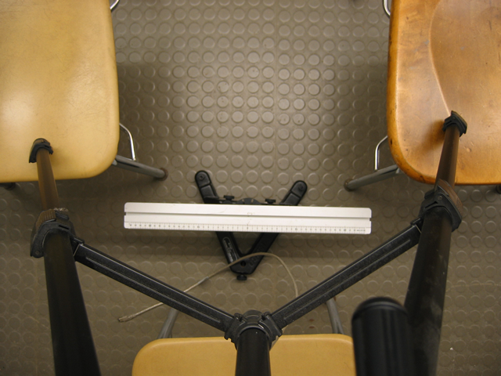

Teaching Tips:
- Your students will find these problems challenging since most students do not yet understand vectors or kinematics well. Try to let them work on it on their own before stepping in to help. They generally just assume that the velocity is tangent to the circle, because the book says so. They do not appreciate that they can understand this “complicated” motion using just the definitions of velocity and acceleration.

- To convince the students that the velocity vectors are tangent to the circle, they must first recognize that the position vectors are the radius vectors. The difference in position gives the direction of the average velocity between the two position vectors. A limiting process of bringing those two position vectors closer together gives the direction of the instantaneous velocity.

- Below is a frame of a “good movie.” Notice that the camera is mounted directly above the center of the spinning apparatus. There is very little clutter, the picture is clear, and the contrast is about right. If you could see the entire movie, you would find that the arm is visible at all points of the movie, thus we will not lose any data points due to blocking of the picture by the tripod or other objects.
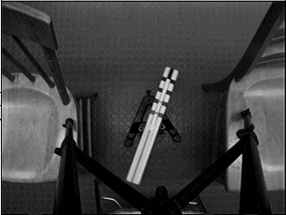

- To get these problems to work properly the students MUST use the arm of the spinning apparatus to calibrate their movie. When we analyzed the movie (a frame of which is shown on the previous page) we found that when we used the base of the apparatus for calibration our best fit was $y(t)=\text{78}\text{.}1+\text{12}\text{.}8\text{sin}(2\text{.}7t+1\text{.}\text{89})$. When we used the arm for calibration the best fit was $y(t)=\text{62}\text{.}9+\text{10}\text{.}2\text{sin}(2\text{.}7t+1\text{.}\text{89})$. The radius at which we did the analysis was supposed to be 10 cm. Obviously using the arm gave us a much better results for the radius! When moving on to the v-versus-t graph (using the movie calibrated with the arm) we found that the amplitude (in cm/s) was indeed 27.5 ($±$0.5). When analyzing the movie calibrated with the base the amplitude of the v versus t graph was about 39, NOT 34.6. Therefore the students are sure to be confused about how to predict the behavior of rotational motion if they do not calibrate their movies correctly.

Difficulties and Alternative Conceptions:
Students do not believe that an object moving at a constant speed can be accelerating especially toward the center of the circle. Again, you will come up against the misconception that the acceleration must be in the direction that the object is moving. If they have read the book (or remember high school physics) they might believe that the acceleration points inward as a matter of faith. They don't understand that the same definitions they used for linear motion will get them to this result when the magnitude of the velocity isn't changing but the direction is. Students also may believe there is an outward acceleration, based on their personal experience with circular motion.

Predictions and Warm up questions:
Problem #5:
$x=x_{c}+r\text{sin}(ωt+θ_{0})$, $y=y_{c}+r\text{cos}(ωt+θ_{0})$,
$v_{x}(t)=ωr\text{cos}(ωt+θ_{0})$, $v_{y}(t)=−ωr\text{sin}(ωt+θ_{0})$,
$a_{x}(t)=−ω^{2}r\text{sin}(ωt+θ_{0})$, $a_{y}(t)=−ω^{2}r\text{cos}(ωt+θ_{0})$,
$a=ω^{2}r$,

Sample Data:
The printouts for all measurements are included at the end of following sample data.

Problem #5
Measured angular speed: 2.93 (rad/s),
Measured radius of rotation: 12.2 (cm),
Acceleration : $a=\text{104}\text{.}6$(cm/s²)

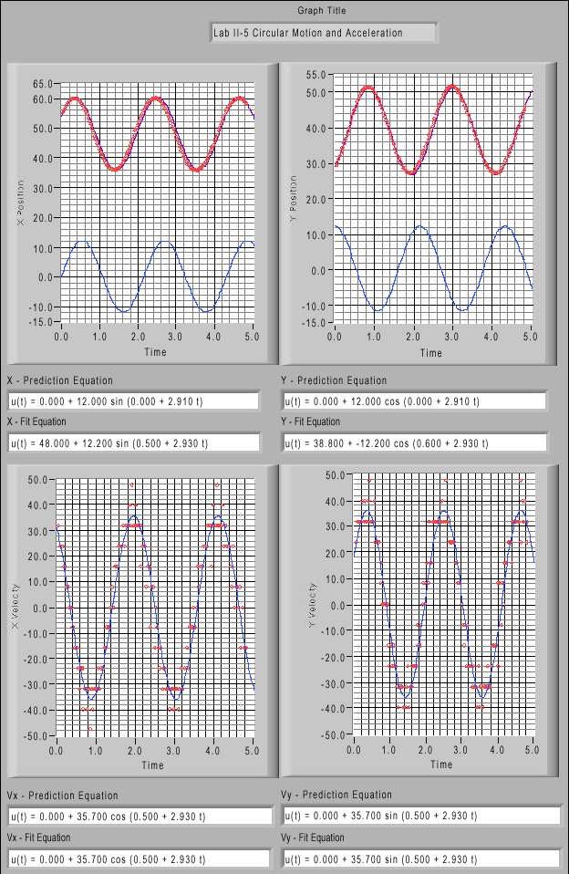

1101 Lab 1 Problem 4: Motion Up and Down an Incline

Purposes:
- To show students that the acceleration up an incline is the same as the acceleration down an incline - same in magnitude and direction.

Experiment Set Up:

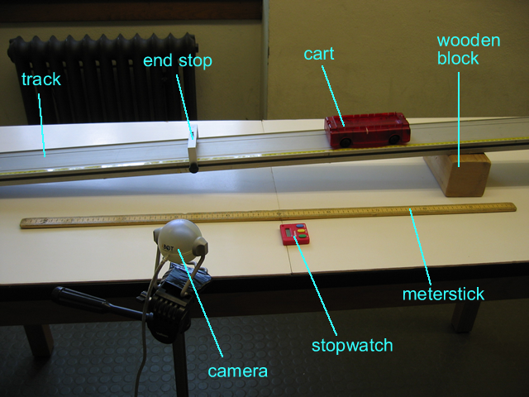

Teaching Tips:
- Have the students compare the results of the motion of the cart up and down the incline. Watch for students who show that the acceleration changes direction for the two cases. The graphical analysis is very useful here if the students understand the meaning of the slope of the velocity-versus-time graph. If a group is having trouble, it is useful to ask the direction of the change of velocity as the cart goes up the ramp, comes down the ramp, and is at its highest point on the ramp. Point out the connection between the direction of an object’s change of velocity and the direction of its acceleration.

Difficulties and Alternative Conceptions: It is very common for students to think that acceleration is pointed up the incline, or that acceleration drops to zero when the velocity drops to zero. Beware of these misconceptions. Think of added experiments you can do to break them.

Prediction and Warm-up Questions:

The prediction and Warm-up questions are straightforward and the prediction does not require any derived equation.

Possible Discussion Questions:
- What is the direction of acceleration in this problem?
- What does the term "deceleration" tell us about the relative directions of acceleration and velocity?
- How does the videos compare between motion up an incline and motion down an incline?

Sample Data:

Inclined angle: sin⁻¹(8.7/220.5);
Acceleration: a = 40cm/s².

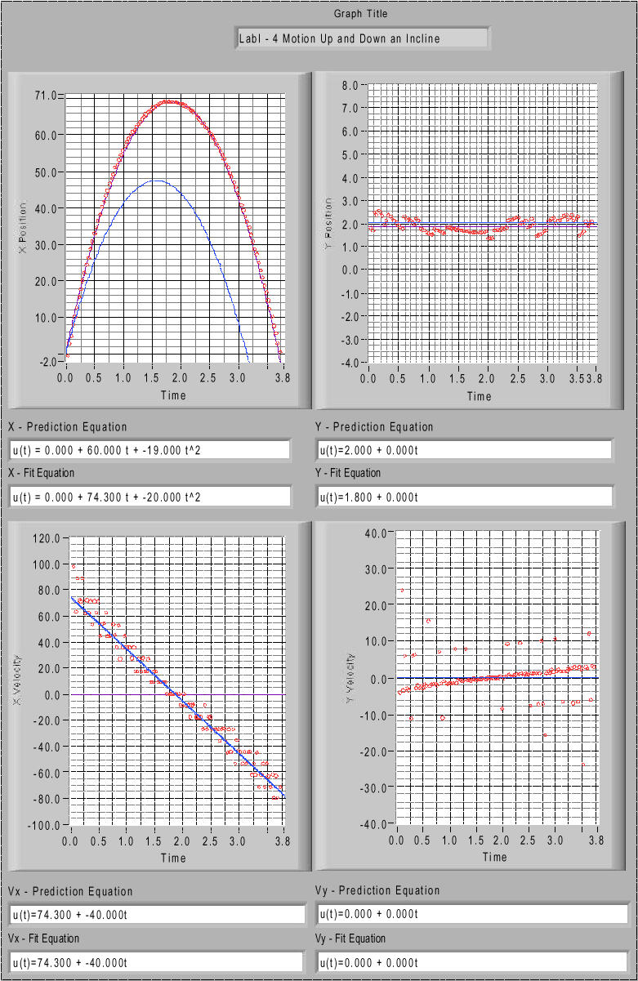
1101 Lab 2 Problem 3: Projectile Motion and Velocity

Purpose:
- To demonstrate that two-dimensional motion can be analyzed as a combination of one-dimensional motions.

Experiment Set Up:
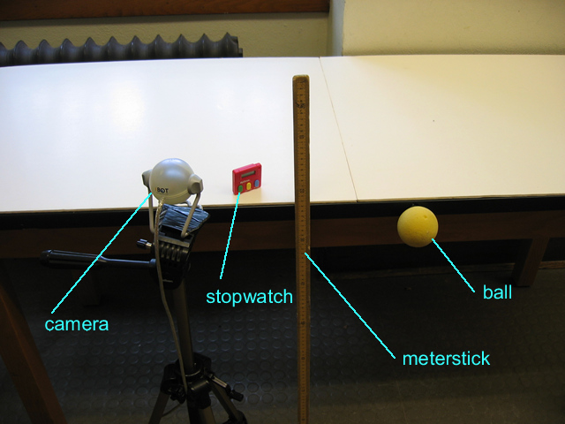
Teaching Tips:
- This is a great lab for the students to practice decomposing vectors. This is difficult for most of them to accept intellectually and they need the practice.
- Stress vectors with this lab. Break the velocity into horizontal and vertical components and watch how the vectors change.
- Parallax does influence the outcome of the movie analysis. It can skew the results by 10%, or even more if the students are not thoughtful about their movie making. The parallax issue is why the students are asked to use the object in motion to calibrate their computers. Shadows and image resolution may prevent an accurate calibration from the balls in flight. In this case, the students should put an object of known length in the plane of motion. Watch out for students having trouble because of image splitting due to video interlacing.
- The students’ lab manual tells them to “make a video of a ball thrown in a manner appropriate to juggling.” You may want to make this clearer by pointing out that we just want them to toss it to a lab partner, hopefully with a rather high arc to make the analysis more interesting. We certainly don’t envision the students analyzing an actual juggled ball!

Difficulties and Alternative Conceptions:
Students tend to confuse the mathematics behind two-dimensional motion. Stress that the horizontal and vertical motions can be analyzed independently. Students also have difficulty understanding that vertical motion can be negative. Look out for V-shaped velocity versus time graphs instead of graphs that extend straight below the axis as they should.

Prediction, Warm-up Questions:

The prediction and Warm-up questions are straightforward and the prediction does not require any derived equation.

Possible Discussion Questions:
1) Is the vertical acceleration the same as the acceleration you found in problem 1?
2) Where in the path of trajectory is the speed the greatest? The least?

Sample Data:

The motion along X (horizontal) axis is a constant velocity motion with velocity 177 cm/s, and the motion along Y (vertical) axis is a constant acceleration motion with acceleration 981 cm/s², with the defined positive directions for both axes.
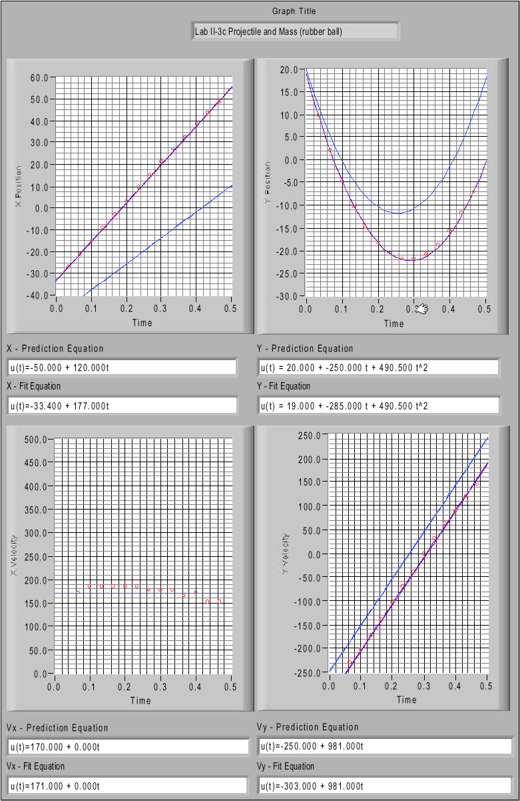
1201 Lab 2 Problem #4: Normal Force and Frictional Force

Problem: Calculate the frictional force on an object sliding down a ramp, given the distance the object has traveled, the speed of the object after covering this distance, the angle of the ramp, and the weight of the block. Based on that information, calculate the coefficient of kinetic friction for wood on aluminum. Sketch a graph of the kinetic frictional force on the block as a function of the normal force on the block.

Purpose:
- Another lab problem involving motion under a constant force in which components have to be resolved non-trivially. A new ingredient is the retarding force due to friction, which shows up as a form of energy loss. This problem is meant to be studied using the work-kinetic energy relation to relate the velocity to the height the object is dropped from, as Newton’ second law and acceleration may not have been introduced at this point.
- To learn a way to measure a frictional coefficient.

Equipment Setup: … also masking tape
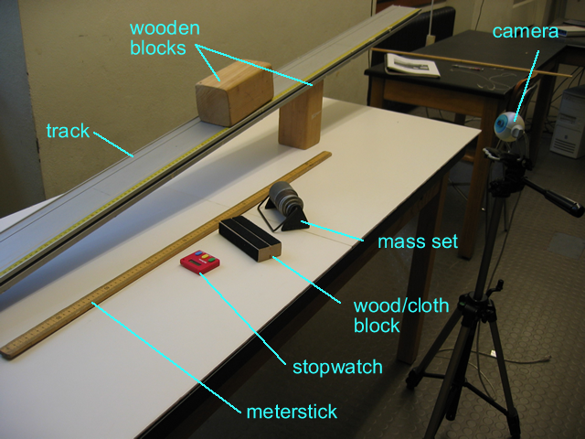
Teaching Tip:
- Be sure the block doesn’t slide along the yellow ruler tape.
- Don’t let the block crash into the end stop. Be sure to remove the end stops before sliding the blocks down the track.
- It is important that the wooden block accelerate smoothly down the ramp, otherwise the friction force will not be constant. Increasing the angle of incline will help solve this problem.

Difficulties and Alternative Conceptions:
The normal force is difficult for the students. Students generally believe that the normal force is always either a constant or equal to the weight of an object. They do not associate the normal force with a physical interaction with another object. These students believe that there is always a normal force, even if there is nothing touching the object. The students often have difficulty relating the angle of the incline to the direction of the normal force.

Prediction and Warm-up Questions:
$N=\text{mg}\text{cos}θ$,
$f_{k}=\text{mg}\text{sin}θ−\text{ma}$,
$$f_{k}d=\text{mg}\text{sin}θd−\frac{1}{2}{\text{mv}}^{2}$$
where $θ$ is the angle of incline of the track to the horizontal, $m$is the mass of the wooden block, $a$ is the acceleration of the wooden block moving down along the inclined track, $d$ is the distance traveled by the block.
The graph of f_{k}-N is a slope line, which indicates f_{k} is proportional to N.

Sample Data:
Inclined angle sin⁻¹(76.5/185.2)=24.40 degree
$m$(g) | 557.58 | 856.88 | 1157.70 | 1457.80
$a$(cm/s²) | 103.6 | 50.0 | 156.0 | 108.0
Normal force $N$(N) | 4.98 | 7.65 | 10.33 | 13.01
Frictional force. $f_{k}$(N) | 1.67 | 3.04 | 2.88 | 4.33

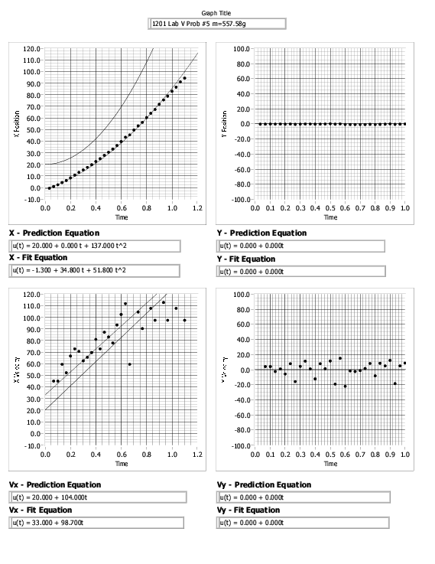

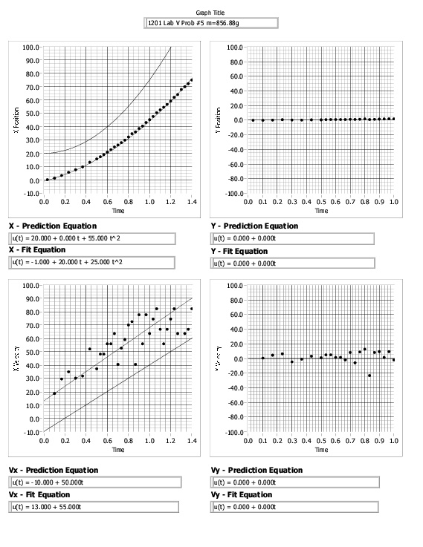
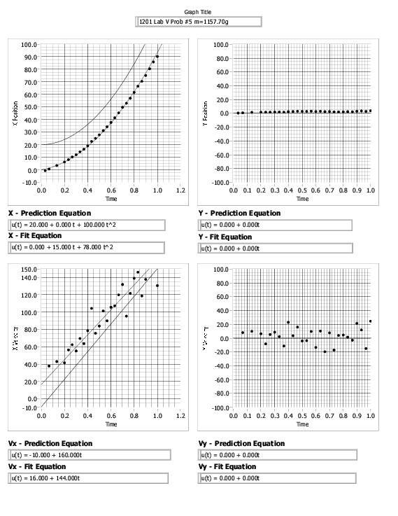
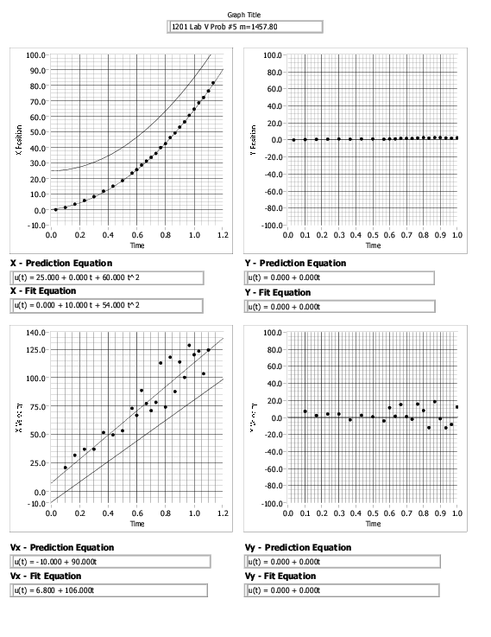

1201 Lab 3 Problem #1: Elastic and Gravitational Potential Energy

Purpose:
- To give students an example of a problem conveniently described by conservation of energy involving kinetic, elastic and gravitational potential energy.
- To give students more exposure to filming motion and constructing, analyzing and interpreting graphs.

Note:
This laboratory exercise was developed during summer 2004, and may need improvement. Your feedback is crucial.

Question:
Determine the maximum elongation of the spring after the cart is released from rest along an inclined track. Compare the maximum elongation to the amount the spring stretches to support a stationary cart. Determine the maximum velocity of the cart and the position of the cart at the instant the maximum velocity is reached.

Prediction:
$$\begin{aligned}\frac{1}{2}{\text{mv}}^{2}+(\text{mg}\text{sin}θ)(x_{\text{max}}−x)+\frac{1}{2}{\text{kx}}^{2}=E=\text{const} \\ (\text{mg}\text{sin}θ)x_{\text{max}}={{\text{kx}}_{\text{max}}^{2}}/2 \\ −\text{mg}\text{sin}θ+{\text{kx}}_{\text{equil}}=0→v_{\text{max}}^{2}=(g\text{sin}θ)x_{\text{equil}}\end{aligned}$$
Here x is the displacement of the cart from its initial position with the spring unstretched. The maximum displacement is linearly related to the mass of the cart. The equilibrium displacement is half the maximum displacement and is also the displacement at which the maximum velocity occurs, as can be verified using the simple calculus of extremas.

Equipment:
Cart track, cart, weight set, springs, balance, meter stick, camera and computer with video analysis software.

Sample Experiment:
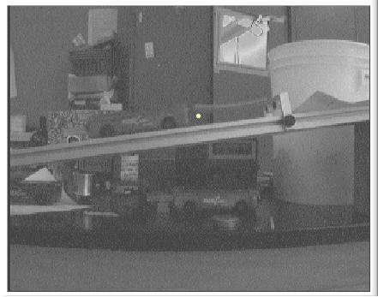
Slope of incline: 27cm/(227-77)cm=0.18.
Angle : 10.4 degrees.
The ‘fat’ spring has about k=2.7N/m.
experiment |  |  |  |  | prediction
Mass(g) | maximum x(cm) |  | equilbrium x |  | x in kx=2*mg*sin(theta) |  |  | x in kx=mg*sin(theta)
253 | 21.5 |  | 11 |  | 25.73853 |  |  | 12.86927
303 | 27 |  | 13.8 |  | 30.8252 |  |  | 15.4126
353 | 32.5 |  | 16.5 |  | 35.91187 |  |  | 17.95593
403 | 37.5 |  | 19.5 |  | 40.99853 |  |  | 20.49927

Agreement is good. Maximum displacement is about twice the equilibrium displacement. The measured displacements are consistently smaller than the predictions, perhaps indicating the effect of friction (or that the spring doesn’t extend at all until it exerts some small but non-zero force … perhaps better to compare a measured slope for differences in displacements with different masses vs. a predicted slope of the same thing? ). A measurement was done with a smaller angle of incline (about 8 degrees) and the agreement between experiment and theory was worse, although the slope of the lines agree.

The first image below gives the position (cm) versus time (sec) while the second image gives the velocity (cm/s) along the incline versus time. The position at which the maximum velocity occurs is located at the point of inflection of the graph. The slope of the line (40cm/s) gives the velocity. The predicted value is sqrt((981)*(0.18)*(11))cm/s=44cm/s.

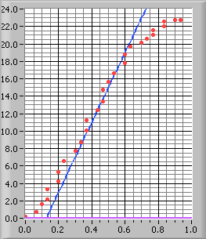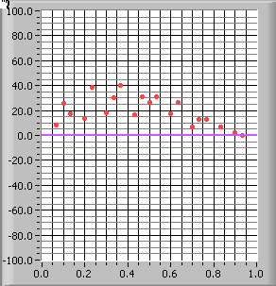

1301 Lab 2 Problem #4: Bouncing

Purpose:
- This is the first of the true problem-solving labs. Point out the difference to your students. Tell them of the new and higher expectations involved in getting the equations for their predictions as opposed to using an “educated guess” to predict the relevant physics quantity.

Equipment Setup:

Teaching Tips:
1. This is a very difficult lab. If the students are not careful about how they do their analysis, they can very easily get incorrect results. However, if they are careful, it works out very nicely.

2. The object being used to calibrate the movie MUST be in the plane of the bouncing ball. (We placed a box of known length on the floor in the center of the screen.) If the ball bounces in front of or behind this plane, their results will not come out correct to within 10%. Tell the students to practice bouncing the ball and be patient about getting a good movie. While developing the lab, we found that we had to take several movies before we got one that was acceptable.

3. Again, it is very important that all bounces that are recorded are in the same plane of motion within a movie. The balls have a tendency to move a bit towards or away from the camera after each bounce. The camera CANNOT take the third dimension into account, so the students’ results will not be correct.

4. It is also quite important that the students click on the same point of the ball throughout the entire movie (as is the case in all of the problems!). If they click on the bottom of the ball at the top of the motion, and the top of the ball right before it bounces, the height they measure could be off by as much as a few centimeters. Make sure that they are consistent.

5. Make sure that the students capture all of the motion of the ball within the area of the screen, including the bounces. The students should be especially concerned with where their origin is, to ensure that they are measuring the correct height and horizontal distance. We found the data tables useful for finding the height of the bouncing ball.

6. It works well to analyze both bounces at once. Then it is quite clear that the initial horizontal velocity remains constant throughout the bouncing. However, the students will have to be careful about where the origin is, as mentioned above.

7. This is a good lab to help the students think about the uncertainty in position in their movies. The equation that they will use is not that difficult, so this is a good opportunity to check that they understand how to propagate uncertainty through equations according to Appendix B.

Difficulties and Alternative Conceptions:
The alternative conceptions of students are the same as in Problem #3. Students need a lot of repetition emphasizing the independence of perpendicular components of motion.

Prediction and Warm up questions:

$\frac{x_{0}}{x_{1}}=\frac{v_{\text{ox}}}{v_{1x}}\sqrt{\frac{h_{o}}{h_{1}}}$,

where $h_{o}$ is the height of the first bounce, $h_{1}$ is the height of the second bounce, $x_{o}$ is the horizontal distance of the first bounce,$x_{1}$ is the horizontal distance of the second bounce, $v_{\text{ox}}$ is the initial horizontal velocity during the first bounce and $v_{1x}$ is the initial horizontal velocity during the second bounce. Your students should find in their analysis that $v_{\text{ox}}$=$v_{1x}$, thus they cancel out of the above equation. This is a very interesting and surprising result, which they should wonder about. [Refer to this again when they study forces and Newton’s second law. During the bounce, the force on the ball caused by the floor is vertical so only the vertical component of velocity can change. DO NOT, however, lecture them about it at this time.]

Sample Data:
The printouts for the measurements of all distances and velocities are included at the end of following sample data.

$v_{0x}=v_{1x}=\text{121}$(cm/s),
$x_{0}=\text{58}\text{.}5$(cm), $x_{1}=\text{44}\text{.}5$(cm),
$h_{0}=\text{29}\text{.}8$(cm), $h_{1}=\text{16}\text{.}2$(cm),

Predicted $\frac{x_{0}}{x_{1}}$=1.356,
Measured $\frac{x_{0}}{x_{1}}$=1.315.

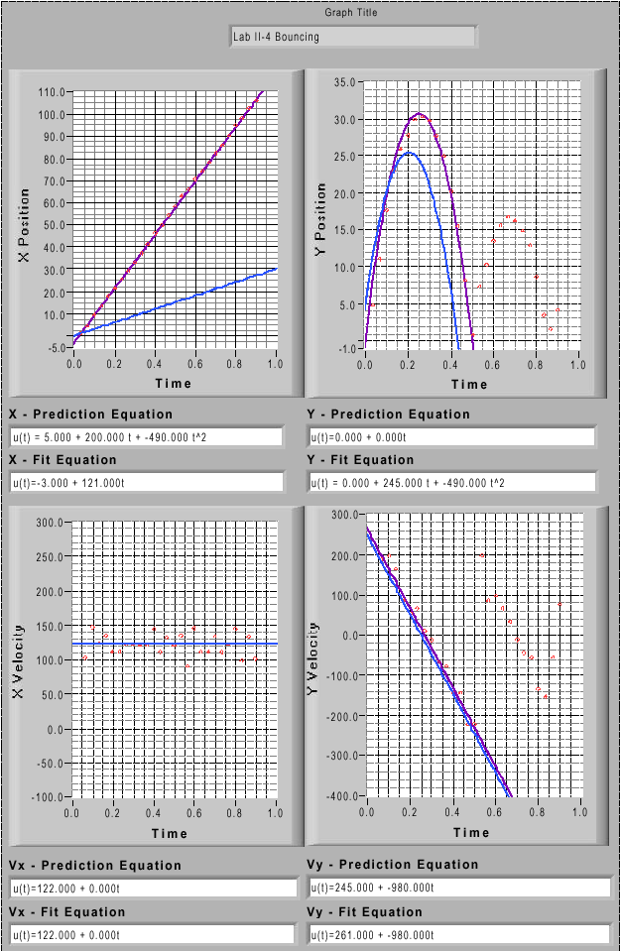

1301 Lab 3 Problem #2: Forces in Equilibrium

Purpose:
- To have students use Newton's second law in a situation which requires the use of force components and the knowledge of the relationship of the direction of the forces to the geometry of the situation.

Equipment Setup:

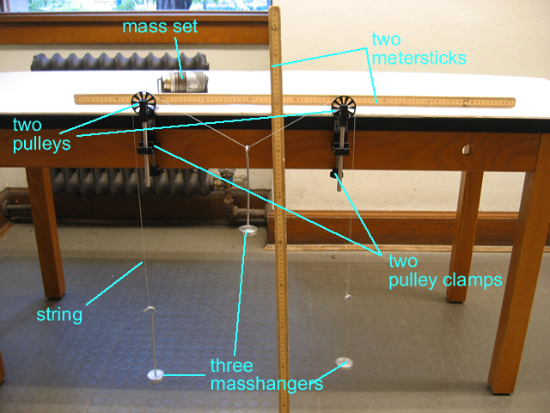

Teaching Tips:
1. It is a good idea to tell your students, before they come to lab, that the algebra is messy. Students often think that they are doing something wrong if the algebra isn't simple. It is interesting to point out to your students that the equation is not simple even though the system is not particularly complicated. This is a good example of how quickly the mathematics can become complicated in the real world yet the problem remains soluble.

2. Students will have trouble with the predictions. You should insist they do them before they arrive, but be prepared to dedicate class time to letting the students work on their predictions again after you compare group predictions in class. Lead a class discussion to highlight the difficulties that students are having and suggest solutions to those difficulties.

3. Resist the urge to do the problem for the class. The students can do this problem if you have confidence in them. Let them try.

4. Often students leave such quantities as $θ$ in their equation. If another group does not point out that $θ$ can be determined by measuring lengths, make sure you do so.

5. This is a good opportunity to encourage your students to use extreme cases to check their results. Ask them to determine what happens when M 0, $∞$. A discussion of taking limits is probably best done in the closing discussion after all measurements have been made.

6. The students need a large enough mass range to show them that the curve is not linear. If the students aren't using a large enough range of masses, remind them to look at how the deflection depends on other quantities. They can bring the pulleys together or add masses to the outside weights to increase the range of the central mass before it hits the floor.

7. For the sake of the analysis, assume no error on the masses. They can check this assumption with a balance.

8. Encourage the students to explore both mass ranges 0<M<m and M>m.

9. An interesting test of the frictionless pulley assumption is to put unequal masses on each side (A and C) and find the maximum difference between A and C that causes the masses to move.

Difficulties and Alternative Conceptions:
Many students do not connect the concept of a force with a physical interaction. They cannot determine the direction of a force from the physical connections of real objects. Some students still confuse the components of a force with the entire force.

Question:
How does the vertical displacement of an object suspended on a string halfway between two branches, depend on the mass of that object?

Prediction and Warm up questions:
,

where M is the mass of object B, m is the mass of each of the objects A and C, L is the separation of the pulleys, and h is the vertical displacement of object B.

[$\text{sin}θ=\frac{M}{2m}⇒\text{tan}θ=\frac{M}{\sqrt{(2m)^{2}−M^{2}}}$.]

Sample Data:

m_{A} = 119.12g; m_{C} = 119.21g
Distance between two pulleys: L = 40.0cm

Mass of the suspended object M (g) | Predicted vertical displacement h (cm) | Measured vertical displacement h (cm)
49.48 | 4.2 | 4.2
68.85 | 6.0 | 6.0
77.92 | 6.9 | 6.9

In the calculation of the predicted vertical displacement the average value of m_{A} and m_{C} was used for m.

1301 Appendix D: Video Analysis of Motion
Analyzing pictures (movies or videos) is a powerful tool for understanding how objects move. Like most forms of data, video is most easily analyzed using a computer and data acquisition software. This appendix will guide a person somewhat familiar with WindowsNT through the use of one such program: the video analysis application written in LabVIEW™. LabVIEW™ is a general-purpose data acquisition programming system. It is widely used in academic research and industry. We will also use LabVIEW™ to acquire data from other instruments throughout the year.

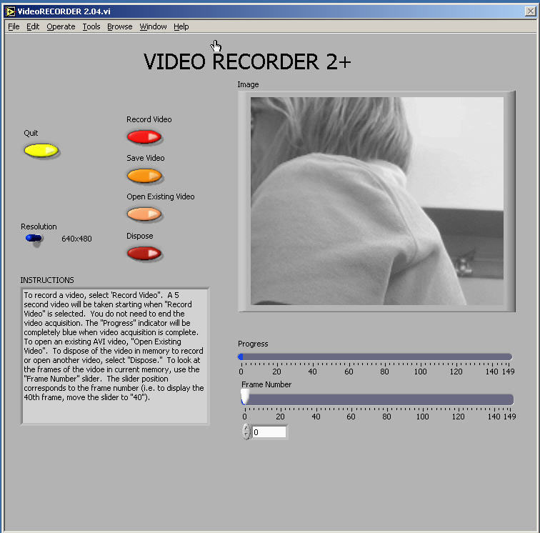

Using video to analyze motion is a two-step process. The first step is recording a video. This process uses the video software to record the images from the camera and compress the file. The second step is to analyze the video to get a kinematic description of the recorded motion.

(1) Making videos
After logging into the computer, open the video recording program by double clicking the icon on the desktop labeled VideoRECORDER. A window similar to the picture on the previous page should appear.

If the camera is working, you should see a "live" video image of whatever is in front of the camera. (See your instructor if your camera is not functioning and you are sure you turned it on.) By adjusting the lens on the video camera, you can alter both the magnification and the sharpness of the image until the picture quality is as good as possible.

The controls are fairly self-explanatory; pressing the Record Video button begins the process of recording a 5-second video image. While the video is recording, the blue Progress bar beneath the video frame grows. Once you have finished recording, you can move through the video by dragging the Frame Number slider control. If you are not pleased with your video recording, delete it by pressing the Dispose button.

You may notice that the computer sometimes skips frames. You can identify the dropped frame by playing the video back frame by frame. If the recorded motion does not appear smooth or if the object moves irregularly from frame to frame, then frames are probably missing. If the computer is skipping frames, speak with your instructor.

While you are recording your video, you should try to estimate the kinematic variables you observe, such as the initial position, velocities, and acceleration. The time with the unit of second is shown in the VideoRECORDER window, in the box below the Frame Number slider. These values prove very useful for your prediction equations. Be sure to record your estimates in your journal.

Once you have recorded a satisfactory video, save it by pressing the Save Video button. You will see a Save window, as shown on the next page.

To avoid cluttering the computer, you will only be able to save your video to certain folders on the hard disk. One such folder is the My Documents folder located on the C drive. You should check with your lab instructor for the most suitable place to save your video. In the File name box, you should enter the location of the folder in which you wish to save your video followed by the name that you wish to give to your video. This name should be descriptive enough to be useful to you later (see the picture for an example).

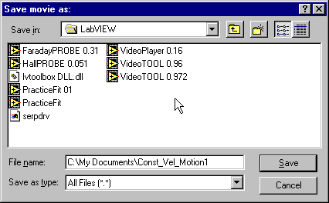

(2) analysis Basics

Open the video analysis application by clicking the icon labeled VideoTOOL, which is located on the desktop. You should now take a moment to identify several elements of the program.
The two most important of these are the Program Controls panel shown to the right and the Instructions box shown below. | 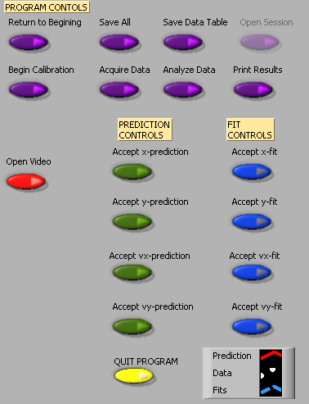
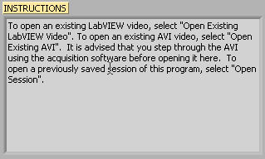

These two elements of the analysis program work in tandem. The Instructions box will give you directions and tasks to perform. It will also tell you when to select a control in the Program Controls panel. After you select a control, it will “gray out” and the next control will become available. If you make a mistake, you cannot go backwards!
You would have to quit your analysis and reopen the video to begin afresh.

You print and/or quit the video analysis from the Program Controls panel. You also have the option to save the data to continue later, or to save a data table.

Be careful not to quit without printing and saving your data! You will have to go back and analyze the data again if you fail to select Print Results before selecting Quit Program or Return to Beginning. Also be sure to save the data (Save All) and save the data table (Save Data Table).

Calibration
While the computer is a very handy tool, it is not smart enough to identify objects or the sizes of those objects in the videos that you take and analyze. For this reason, you will need to enter this information into the computer. If you are not careful in the calibration process, your analysis will not make any sense.

After you open the video that you wish to analyze and select Begin Calibration from the Program Controls panel you will be advised in the Instructions box "To begin Calibration, advance the video to a frame where the first data point will be taken. The time stamp of this frame will be used as the initial time." To advance the video to where you want time t=0 to be, you need to use the video control buttons, shown below. This action is equivalent to starting a stopwatch.



Practice with each button until you are proficient with its use. When you are ready to continue with the calibration, locate the object you wish to use to calibrate the size of the video. The best object to use is the object whose motion you are analyzing, but sometimes this is not easy. If you cannot use the object whose motion you are analyzing, you must do your best to use an object that is in the plane of motion of your object being analyzed.

Follow the direction in the Instructions box and define the length of an object that you have measured for the computer. Once this is completed, input the scale length with proper units in Calibration Controls box (shown below). Read the directions in the Instructions box carefully. Enter the scale length, and then use the arrows to select the units you are using.

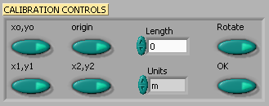

Lastly, decide if you want to rotate your coordinate axes. If you choose not to rotate the axes, the computer will choose the lower left-hand corner of the video to be the origin with positive x to the right and positive y up. If you choose to rotate your axis, follow the directions in the Instructions box carefully. Your chosen axes will appear under the Calibration Controls box. This option may also be used to reposition the origin of the coordinate system, should you require it.

Once you have completed this process, select "OK" from the Calibration Controls box.

Analysis Predictions
This video analysis relies on your graphical skills to interpret the data from the videos. Before doing your analysis, you should be familiar with both Appendix C: Graphing and Appendix B: Uncertainties.

Before analyzing the data, enter your prediction of how you expect the data to behave. This pattern of making predictions before obtaining results is the only reliable way to take data. How else can you know if something has gone wrong? This happens so often that it is given a name (Murphy’s Law). It is also a good way to make sure you have learned something, but only if you stop to think about the discrepancies or similarities between your prediction and the results.

In order to enter your prediction into the computer, you first need to decide on your coordinate axes, origin, and scale (units) for your motion. Record these in your lab journal.

Next you will need to select the generic equation, u(t), which describes the graph you expect for the motion along your x-axis seen in your video. You must choose the appropriate function that matches the predicted curve. The analysis program is equipped with several equations, which are accessible using the pull-down menu on the equation line (shown to the right).  You can change the equation to one you would like to use by clicking on the arrows to the left of the equation in the Prediction Equation command box, shown to the right. Holding down the mouse button will give you the menu also shown to the right.  After selecting your generic equation, you next need to enter your best approximation for the parameters A and B and C and D where you need them. If you took good notes of these values during the filming of your video, inputting these values should be straightforward. You will also need to decide on the units for these constants at this time. | 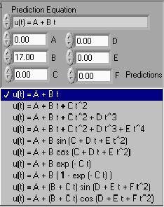

Once you are satisfied that the equation you selected for your motion and the values of the constants are correct, click "Predictions" in the Prediction Equation command box. Your prediction equation will then show up on the graph on the computer screen. If you wish to change your prediction simply repeat the above procedure. When you are satisfied, select the Accept x- (or y-) prediction option from the Program Controls panel. Once you have done this you cannot change your prediction except by starting over. Repeat this procedure for the Y direction.

Data Collection

To collect data, you first need to identify a very specific point on the object whose motion you are analyzing. Next move the cursor over this point and click the green Accept Data Point button in VideoPLAYER window. The computer records this position and time. The computer will automatically advance the video to the next frame leaving a mark on the point you have just selected. Then move the cursor back to the same place on the object and click Accept Data Point button again. So long as you always use the same point on the object, you will get reliable data from your analysis. This process is not always so easy especially if the object is moving rapidly. Because the camera has an interlaced scan of the image, it actually gives you two images. For a rapidly moving object, these images split apart. You need to keep track of which image you are measuring for each picture frame. The data will automatically appear on the appropriate graph on your computer screen each time you accept a data point. If you don’t see the data on the graph, you will need to change the scale of the axes. If you are satisfied with your data, choose Analyze Data from the Program Controls panel.

Fitting your data

Deciding which equation best represents your data is the most important part of your data analysis. The actual mechanics of choosing the equation and constants is similar to what you did for your predictions.

First you must find your data on your graphs. Usually, you can find your full data set by adjusting the scales of your X-motion and Y-motion plots. This scaling is accomplished by entering the appropriate maximum and minimum values on the vertical axis (as shown to the right) as well as adjusting the time scale. | 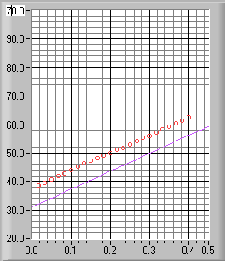

Secondly, after you find your data, you need to determine the best possible equation to describe this data. After you have decided on the appropriate equation, you need to determine the constants of this equation so that it best fits the data. Although this can be done by trial and error, it is much more efficient to think of how the behavior of the equation you have chosen depends on each parameter. Calculus can be a great help here. | 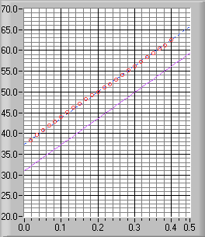
As an example of a completed determination of the equation, the X-motion plot above shows both the predicted line (down) and the line that best fits the data (through the circles). Be sure to record the values of your parameters in your journal before you go on to the next stage.

Lastly, you need to estimate the uncertainty in your fit by deciding the range of other lines that could also fit your data. This method of estimating your uncertainty is described in Appendix C. Slightly changing the values for each constant in turn will allow you to do this quickly. For example, the X-motion plots below show both the predicted line (down) and two other lines that also fit the data (near the circles).
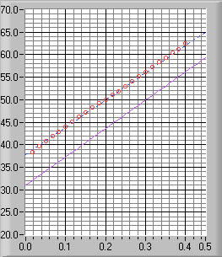 | 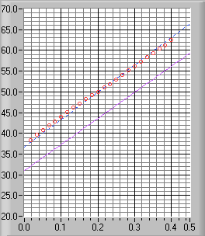
After you have found the uncertainties in your constants, return to your best-fit line and use it as your fit by selecting Accept x- (or y-) fit in the Program Controls panel.

Last Words
These directions are not meant to be exhaustive. You will discover more features of the video analysis program as you use it. Be sure to record these features in your lab journal.

1301 Appendix F: Simulation Programs (LabSims)
Note: Up-to-date information on using the LabSims can be found by pressing the “Sim Help” button at the lower left corner of a simulation window.

A LabSim program is a computer simulation of some of the situations you encounter in the lab. Simulations let you do things you can't do in the real world, in order to see what happens in those circumstances. That may sound silly (why would anyone care about what happens in an unreal world), but is actually very useful. If your data doesn't match your predictions, a simulation can help you find out what is causing the difference by letting you look at the consequences of different potential causes, and seeing what effects they make in isolation, without getting confused with something else.

The LabSims are meant to let you “explore the experiment”, and to see the effects of different physical interactions. For example, suppose you thought your real experiment didn't match your predictions because of air resistance (which is present in the real world, but not in your predictions). A simulation lets you investigate the effects of air resistance by itself, without getting confused with other kinds of friction. Simulations also let you “turn up” air resistance to ridiculous levels, so you can see the form of its effects very clearly. If simulated air resistance does reproduce the problems you see in your data, then it might be the cause; if it fails to reproduce them, you should look elsewhere.

Using the LabSims

Once you get a LabSim program going, the easiest way to see what it does is to push the Run button, which is right under the 3D window (it's the black button with the “>” label). “Run” makes the LabSim go, using the values in the yellow windows to the left. You can change the length of a run by changing the number of frames (the current frame number is shown to the right of the run button). The “|<” button is a “Rewind”, which places all objects in their initial positions. The “||” button is “Pause”, which stops everything. The buttons are meant to look like those on a DVD player or VCR.

3D NAVIGATION
You can “walk” around in the 3D window by using the arrow keys (but first you MUST put the mouse in the 3D window). The arrows move you around rather like in a video game, with which you may have experience. Holding down ALT while you push the arrows lets you move up and down or back and forth (gamers call it a “strafe” button) and CTRL lets you tip up and down. Experiment with these.

WHEN YOU GET LOST
If you get lost in the 3D space, click the “Horiz View”, “Vert View” or “Reset All” buttons. Horiz View brings you back to your starting point, Vert View puts you over the table looking down, and Reset All resets everything to where it was when the program started.

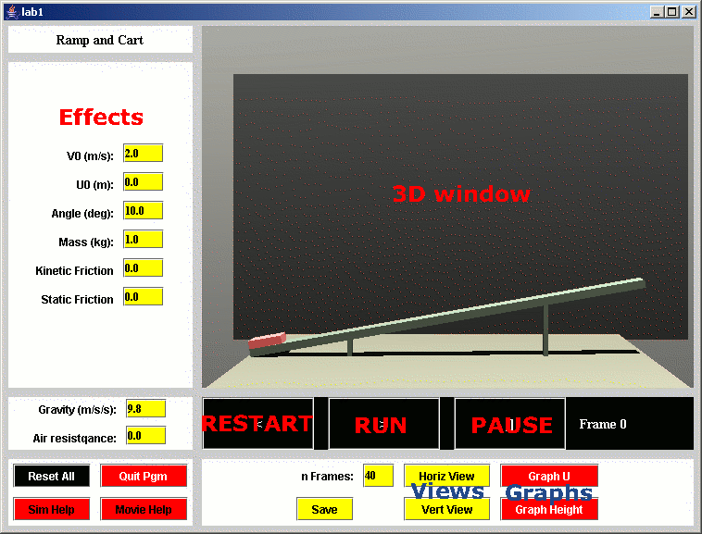

PARAMETERS
The panel to the left of the 3D view has names and values of all the things you can vary in the experiment. For example, in the simulation pictured below you can adjust the cart’s initial speed or position, change the ramp angle, change the cart’s mass, or create friction,. You change them by typing in new values, then see what happens by pushing Rewind and then Run. If you change so many things you don't know where you are anymore, and you just want to get back to some reasonable defaults, click on “Reset All.” in the lower left panel.

Graphs

A Powerful way to visualize motion using the LabSims is with real time graphs. If you push one of the red graph buttons at the bottom right, a separate window will pop up. The new window will be rather empty until you do a run in the 3D window, after which it will have graphs of position and speed. The top graph is the position, and the bottom one is speed (which component of position and speed depends on the button). You can change the limits on the graphs, redraw the plot and so on with the boxes on the left side of the graph window.

Sometimes a Graph window may appear to lose part of its information. Press the Redraw button to fix the problem.

Graphs are extremely useful for comparing different runs and checking for differences. Explore this by doing one run, then changing something and doing it again (click on the new color button after the first run).

Graphs also let you simulate the effects of MEASUREMENT UNCERTAINTY. You can never get perfect data in the laboratory. With the simulations you can see the difference between “perfect” data and what you get with imprecise “position clicks” in VideoTOOL. You may discover that it is worth your time to take VideoTOOL data very carefully.

To see the effect of measurement uncertainty, do a run. Then simulate uncertainty on the graph by pressing the “Add error” button in the graph window. This adds randomly distributed errors to the position measurements. Experiment with different measurement uncertainties by changing the “error” parameter in the pink box, or by adding error several times (just press Add Error several times). The velocity values are recalculated when you add error to the positions, so you can see what happens to velocity if position measurements are not made precisely.

To compare the effects of measurement uncertainty to other effects (air resistance, for example) go through the process of adding error to a clean run. Change Color on the graph, and then do another run with the other effect (air resistance, for example). Now you have two sets of graphs to compare.

MAKING MOVIES

Click the “Movie Help” button in any simulation for up-to-date information on this function.

Possibly the most useful, but currently the slowest, way to use the LabSims is to make a movie with them, and then to analyze the simulation movie in the same way you analyze real video data.

To make a movie, first you should clean out any old frames by clicking the “Cleanup” button on the computer desktop. Then you should play around with the LabSim until you have a run and a camera position you like. Click on the yellow “Save” button, which writes a little file to disk with the positions of the apparatus in every frame. Now click on the “Make Frames for Lab x” button on the desktop, which will start up a program called PoVRay. PoVRay makes high quality movie frames of the experiment (it will take a couple minutes). Finally you can turn the frames into a movie (which will be in c:\labSim\frames\simMovie.avi) by clicking on the “Make movie from frames” button. Then you can read the movie into VideoTOOL and analyze it with that.

Reference Guide for Ultr@ VNC version 1.0.0

Ultr@ VNC is a computer program in the physics lab rooms that gives you the power to observe student computer screens and control a student’s computer remotely via your keyboard and mouse. It is particularly useful for giving instructions about a program or displaying students’ lab data.
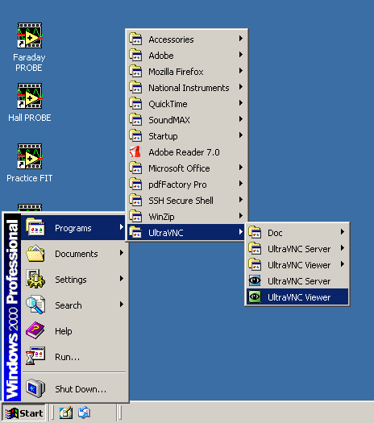
To access Ultr@ VNC, log in to a lab computer with a TA username and password (most likely your physics department ID). If you would potentially like to broadcast a screen using the digital projector, log in to the instructor computer located near the printer. (Refer to the Digital Projector Reference for more information.)
Access the program from the Start menu, Programs folder, UltraVNC, and UltraVNC Viewer. Refer to Figure 1.

You can also access the program from My Computer:
C:\Program Files\UltraVNC\UltraVNC Viewer

Fig. 1

The following pop-up window should appear, requesting the name of the display host:

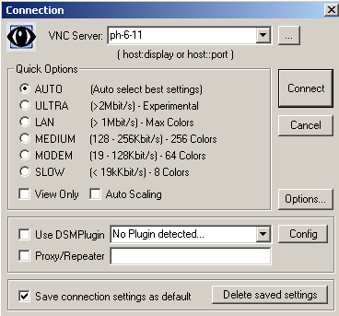
In the VNC Server drop-down field, type the number of the student’s computer that you want to observe. The numbers are printed on each computer and should be in the format ph-#-##.

If you want to change connection options, click the Options button. Another pop-up window will appear (Figure 3). Auto select best settings is the default. From this window you can change Mouse Cursor options and select Display options.

Click Connect to begin viewing the selected Desktop. An Authentication pop-up window will appear, requesting you to enter a username and password. Type in “vnc” and “labvnc”. Click Log On.
Fig. 2
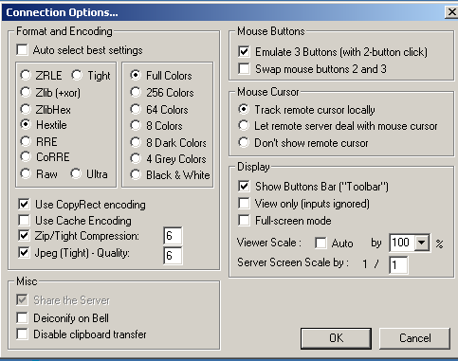
Toolbar Buttons

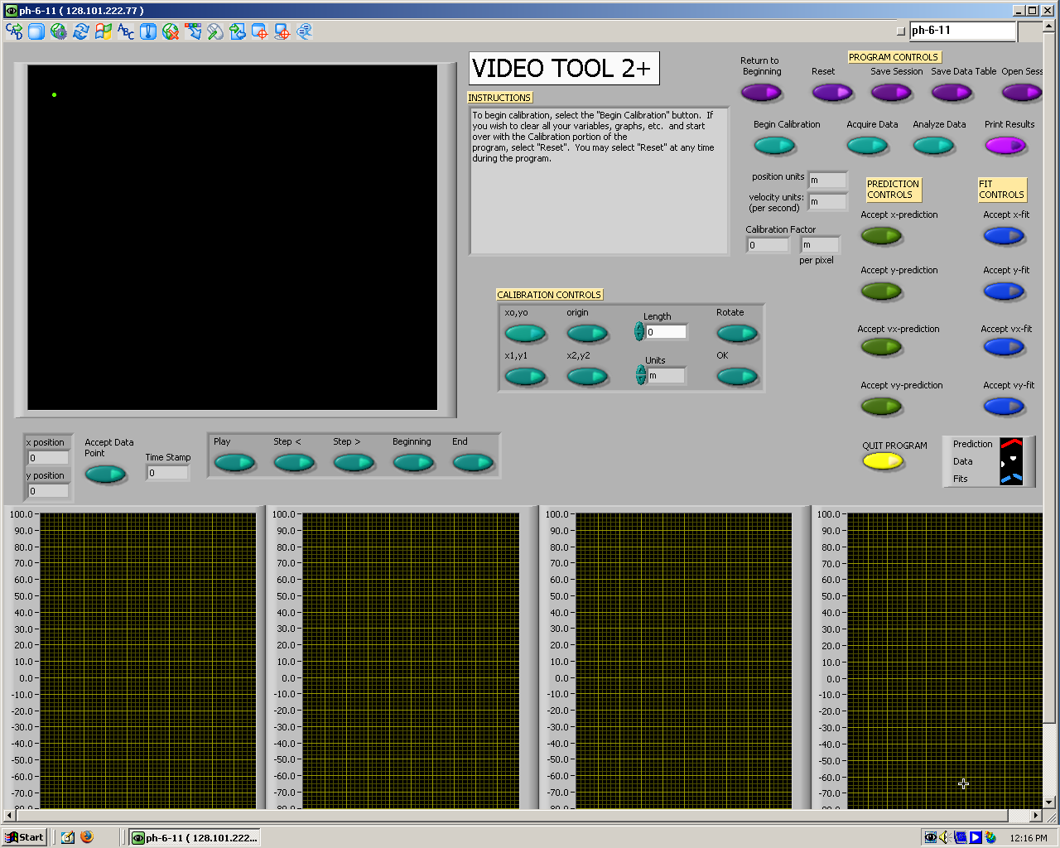
Fig. 2

Fig. 3: Connection Options

Fig. 4: Sample view of a student screen

Refer to Figure 4 for a sample view of a student screen. You can resize the window of the student screen using the arrows in the bottom right corner.

Use the toolbar buttons to navigate Ultr@VNC, as seen in Figure 5. Most buttons are self-explanatory, but selected descriptions are given on the next page.

Send Custom Key
Hide Toolbar Buttons
Select Single Window
Send Ctrl+Alt+Del to host
Show Connection Options
Show Status Window
Open
File Transfer
Select Full Desktop
Host
computer number



Fig. 5
Refresh Screen
Send ‘Start’ (Ctrl+Esc) to host
Close Connection
Toggle Remote Input & Remote Blank Monitor (On/Off)
Open Chat
Toggle Fullscreen mode (On/Off)

Selected Descriptions for Toolbar Buttons:
- Send Ctrl+Alt+Del to host will bring up the physics logout window on the student’s computer.
- Send ‘Start’ (Ctrl+Esc) to host will depress the start button on the student’s computer, giving you the power to access programs, etc. from the host computer.
- Show Connection Options will display the same pop-up window that is available from the Options button of the initial Connection window (Figure 3).
  - There are three options for the Mouse Cursor: Track remote cursor locally, Let remote server deal with mouse cursor, and Don’t show remote cursor.
  - The first two options appear to be a shared-control option between the student and instructor computers, with slight differences between what is seen on each screen.
- Toggle Remote Input & Remote Blank Monitor (On/Off) gives total control to the instructor by disabling the student’s computer mouse.
- Select Single Window gives you the option to select and view one window that is open on a student’s screen, providing multiple windows are opened at the same time. When this toolbar button is depressed, a crosshair appears and you can use this to click on the window to be viewed. Any remaining windows are “blacked out”. To return to the fullscreen view, click the Select Full Desktop toolbar button.

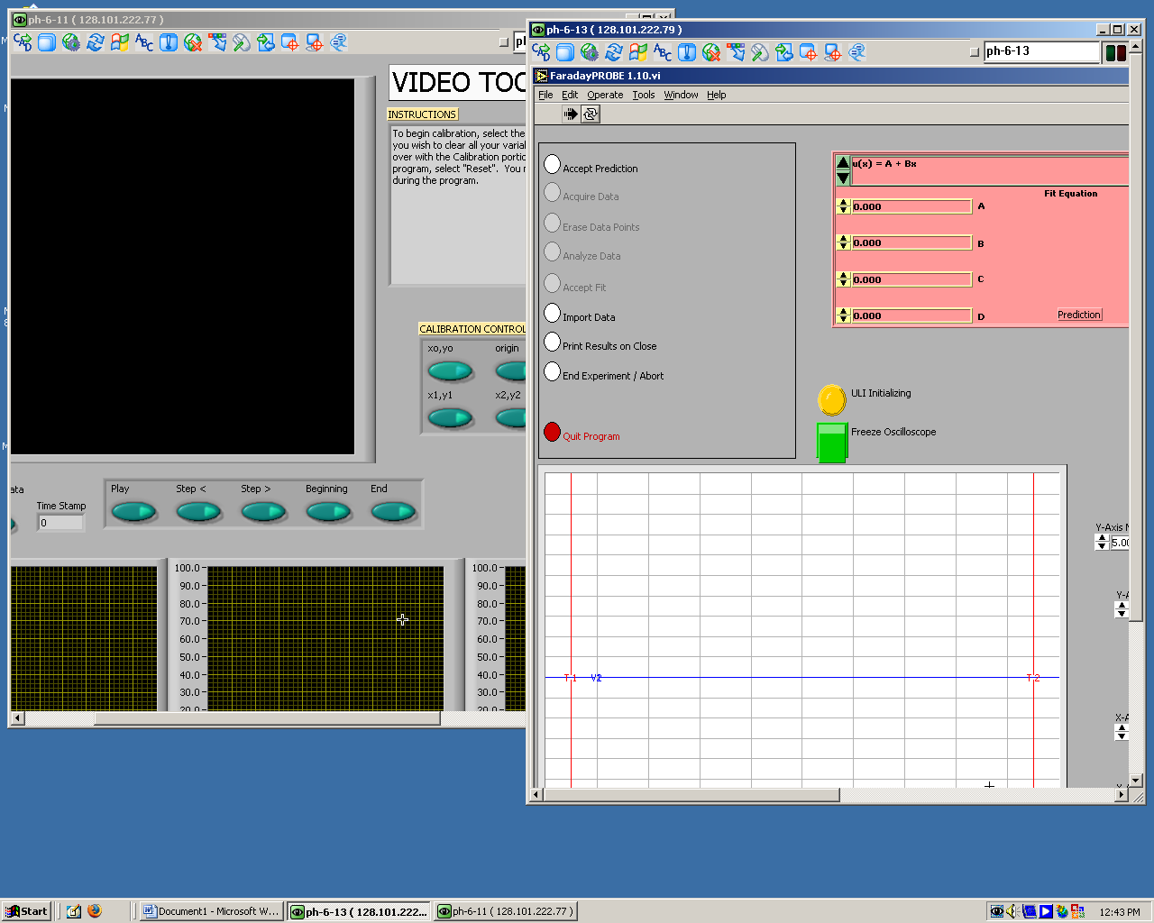

It is possible to display multiple student screens on an instructor desktop, but you must reopen the Ultr@ VNC program each time and resize the windows (or only view one screen at a time).

Fig. 6

To exit Ultr@ VNC, click Close Connection.

For more information, the software developers’ website is:
http://www.ultravnc.com/
Digital Projector Reference:

Every lab room has a Panasonic® projector fixed to the ceiling with connections to a wall unit. This is useful to project documents or programs onto a pull-down screen for easy viewing by the entire class.

To project the instructor computer, log in using either a student ID and password or a TA username and password. This computer should have a serial cable connected from Input 1 of the monitor to Local Monitor of the black Output box, and another cable from Data Display of the black Output box to Computer of the silver wall unit.

Turn on the Panasonic® projector by depressing the large Power button. You might need to use a meter stick to reach it. If the computer screen does not immediately display, cycle through the input by pressing the RGB button. Most will display on RGB 1. Turn off the projector by pressing Power twice.
Silver wall box:
Video Computer

L-Audio-R Computer
audio
Output
Local Monitor Data Display

Computer Monitor

Input 1 Black box

To install a camera:
1. Hook up new camera to firewire cable.
- Launch the “Measurement & Automation” application (icon on desktop)
- On the left-hand panel (shown below), expand “Devices and Interfaces”
- On the same panel, expand “NI-IMAQ IEEE 1394 Devices”
MAX has a generic camera setup initially; this needs to be switched to the Unibrain camera by right clicking on the device and selecting the NI-IMAQ driver using the menu. If a device does not appear, you likely have a bad camera (see next page.)
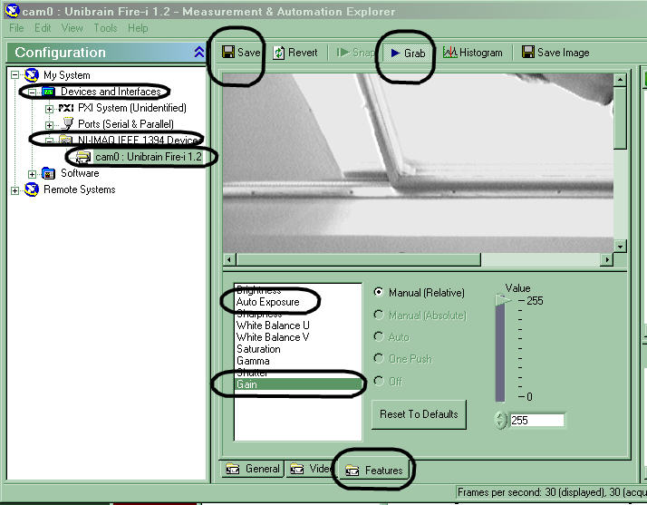
- On the same panel, click the icon for the camera (“Unibrain cam0:…”)
- Click GRAB (along the top, shown above) to see what the camera sees
- Click the Video tab (along the bottom, next to the circled features tab)
- Change Video Mode by selecting the last option in the pull down menu (640x480 Y (Mono8)(30fps))
To help your students get useful data from the video camera, it may be necessary for you to adjust additional camera settings. (These settings should be stable, but may change when a camera is unplugged from its computer.)
- Click the FEATURES tab (along the bottom, shown above)
In the picture below, “gain” is selected, and is set to its maximum value of 255.
- Set GAIN to its MAXimum value (this may cause a “washed-out” image).
- Set AUTO EXPOSURE to the MINimum value that shows a useful image (depending on camera and lighting, 180 or below may be possible).
- Click SAVE (top left) to save the settings.
- Exit the “Measurement & Automation” application.
“Good” camera settings  - short Exposure time  - high amplification (Gain)  Motionless objects may look grainy; objects in motion have well-defined edges (The ball below has fallen through the entire frame). | “Bad” camera settings (factory default)  - long Exposure time  - low amplification (Gain)  Motionless objects look nice; motion causes blur (The blurred ball below has fallen only a short distance).
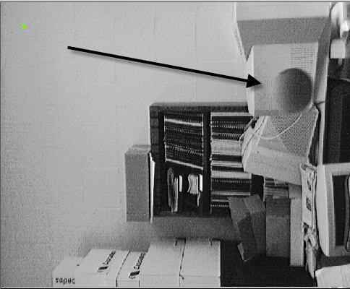 | 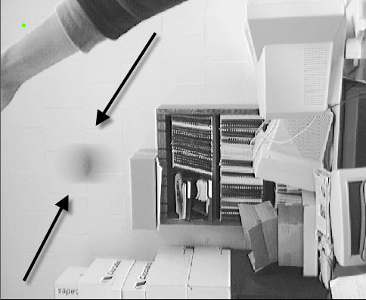

To check to see if a camera is bad:
1. Hook up camera to firewire cable.
- Launch the “Measurement & Automation” application (icon on desktop)
- On the left-hand panel, expand “Devices and Interfaces”
- On the same panel, expand “NI-IMAQ IEEE 1394 Devices”
If a device (camera) does not appear, you have a bad camera, cable or firewire card. Check the cable, making sure the connectors are intact and not plugged by debris. Look at the firewire card in the back of the computer - try to use the port that looks best. If the camera still does not work, get a new camera and start over. If the new camera doesn’t work, reboot the computer and try again, possibly with a third camera. You can also use the TA computer and see if the camera will work on that machine. Remember to submit an electronic lab problem report form about any unresolved problems and bad cameras.

Peer Teaching Feedback Sheet

Peer Teacher Name:

List 2 things that the TA did well.

List one thing that the TA could do to improve his/her teaching.

Additional Comments:

Peer Teaching Feedback Sheet

Peer Teacher Name:

List 2 things that the TA did well.

List one thing that the TA could do to improve his/her teaching.

Additional Comments:

Peer Teaching Feedback Sheet

Peer Teacher Name:

List 2 things that the TA did well.

List one thing that the TA could do to improve his/her teaching.

Additional Comments:

Peer Teaching Feedback Sheet

Peer Teacher Name:

List 2 things that the TA did well.

List one thing that the TA could do to improve his/her teaching.

Additional Comments:

Peer Teaching Feedback Sheet

Peer Teacher Name:

List 2 things that the TA did well.

List one thing that the TA could do to improve his/her teaching.

Additional Comments:

Peer Teaching Feedback Sheet

Peer Teacher Name:

List 2 things that the TA did well.

List one thing that the TA could do to improve his/her teaching.

Additional Comments:

