TA Orientation 2006 Selected Reading

Table of Contents

Section 1. Annotations for Readings from Book by Edward F. Redish (2003), Teaching Physics with the Physics Suite, Wiley.

Section 2. Alternative Conceptions
- McDermott, L.C. - Research on Conceptual Understanding in Mechanics
- Hughes, M. J. - How I Misunderstood Newton’s Third Law
- Lane, B. - Why Can’t Physicists Draw FBD’s?
- Arons, A.B. - A Guide to Introductory Physics Teaching, Chapter 3 Elementary Dynamics

Section 3. Problem Solving and Cooperative Problem Solving (CPS)
- Martinez, M. - What is Problem Solving?
- Heller, P. & Heller, K. - What is Cooperative Problem Solving?
- Larkin, J. - Processing Information for Effective Problem Solving
- Heller, P. & Heller, K. - How Do Beginning Students Solve Problems?
Additional Reading (Optional):
- Heller, Keith, & Anderson – Teaching Problem Solving Through Cooperative Grouping Part 1: Group Versus Individual Problem Solving
- Heller & Hollabaugh – Teaching Problem Solving Through Cooperative Grouping Part 2: Designing Problems and Structuring Groups
- Brown, Collins, & Duguid – Situated Cognition and the Culture of Learning

Section 4. Sexual Harassment, Ethics, and Equal Opportunity
- Shymansky & Penick - Do laboratory teaching assistants exhibit sex bias?
- Seymour - Gender Differences in Attrition Rates
- Equal Opportunity and Affirmative Action at UMn
- Minnesota Daily Article - Orientation Leaders Fired
- UMn Board of Regents Policy – Student Conduct Code

Annotations for Reading
from the Book:

Teaching Physics with
the Physics Suite

by
Edward F. Redish

Redish, E. F. (2003), Teaching Physics with the Physics Suite, Wiley.
Annotations for Chapter 1

Chapter 1, pp 5 – 14 (8 pages)

This chapter discusses the goals, methods, and objectives of physics education. If the goals of physics education are not being met, how should the community chart a new path?

In order to understand the rest of Teaching Physics with the Physics Suite, consider the following questions.

1. According to Redish, what are the goals of physics education? Are these goals being met with traditional instruction?

2. What are the goals of physics education research?

3. What aspects of the scientific method does physics education research utilize? Why do you think Redish emphasizes this?

Redish, E. F. (2003), Teaching Physics with the Physics Suite, Wiley.
Annotations for Chapter 2

This is a lengthy chapter on cognitive psychology as much as education. Many educators do not spend much time thinking about how their students learn; the implicit model is that of a computer receiving programming or knowledge being poured into an empty head. Extensive research shows that students learn in a more complex way. Redish then lists some principles based on the psychology of learning. Keep in mind that these apply to the average student; as someone who chose to specialize in physics, there are ways in which you deviate from average. | 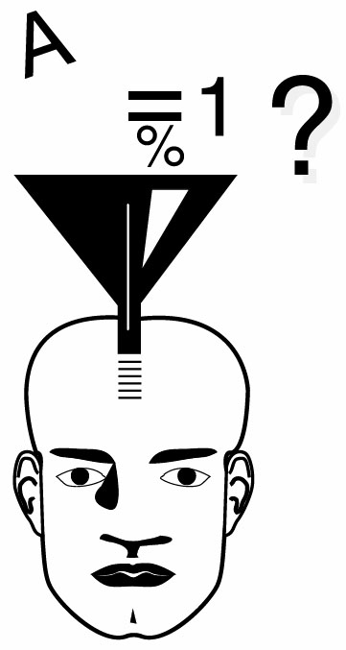

You will read chapter 2 in two parts.

Chapter 2, pp 17- 30 (13 pages)

The following questions may help guide your reading: Be prepared to discuss some of these questions in class.

1. What is a “chunk”? Can you think of ways that you use chunks to help yourself learn, or to solve problems?

2. What is a “schema”? How is a schema related to mental model?

3. How are schemas related to alternative conceptions (common naive conceptions, preconceptions, misconceptions)?

4. What are two reasons why it is important for us (teachers) to understand the knowledge and reasoning about the physical world that students bring with them to our classes.

(continued on next page)
Chapter 2, pp 30 – 47 (17.5 pages)

The following questions may help guide your reading: Be prepared to discuss some of these questions in class.

Implications of the Cognitive Model for Instruction: Five Foothold Principles

5. The table on the next two pages list five principles from cognitive psychology that help us understand what happens in a traditional physics classroom. In the second column, give examples of how traditional instruction usually fails to take into account each principle of learning.

6. Principle 3 Corollary 4.3 is:: Our own personal experiences may be a very poor guide for telling us the best way to teach our students. Have you experienced this as a student or instructor?

Some General Instructional Methods Derived from the Cognitive Models

7. What is the cognitive conflict model?

8. What is the bridging model?

9. What is the multiple representation model? What role does restricting the frame play in this model?

(continued on next page)
Five Principles of learning  from Cognitive Psychology | How does traditional instruction  fail to utilize this principle?
The Constructivism Principle 1: Individuals build their knowledge by making connections to existing knowledge; they use this knowledge by productively creating a response to the information they receive.
Corollary 1.1 • Learning is a growth, not a transfer. It takes repetition, reflection, and integration to build robust, functional knowledge.
Corollary 1.2 • Building functional scientific mental models does not occur spontaneously for most students. Repeated and varied activities that help build coherence are important.
The Context Principle 2: What people construct depends on the context – including their mental states.

The Change Principle 3: It is reasonably easy to learn something that matches or extends an existing schema, but changing a well-established schema substantially is difficult.
Corollary 3.1 • It's hard to learn something we don't almost already know.
Corollary 3.2 • Much of our learning is done by analogy.
Corollary 3.3 • “Touchstone” problems and examples are very important.
Corollary: 3.4 • It is very difficult to change an established mental model.

The Individuality Principle 4: Since each individual constructs his or her own mental structures, different students have different mental responses and different approaches to learning. Any population of students will show a significant variation in a large number of cognitive variables.
Corollary 4.1: People have different styles of learning.
Corollary 4.2: There is no unique answer to the question: What is the best way to teach a particular subject?
Corollary 4.3: Our own personal experiences may be a very poor guide for telling us the best way to teach our students.
Corollary 4.4: The information about the state of our students’ knowledge is contained within them. If we want to know what they know, we not only have to ask, we have to listen!

The Social Learning Principle 5: For most individuals, learning is most effectively carried out via social interactions.

Redish, E. F. (2003), Teaching Physics with the Physics Suite, Wiley.
Annotations for Chapter 3 and one section of Chapter 5

Students bring to the classroom ideas and schemas about the nature of learning, the nature of science, and what it is they think they are expected to do in class. In addition, they have their own motivations for success. Redish describes this set of “expectations” of our students .

You will read this chapter in two parts

Chapter 3, pp 62 – 68 (6 pages)

The following questions may help guide your reading: Be prepared to discuss some of these questions in class.

1. What is metacognition?

2. How difficult do you think it would be for you to implement Schoenfeld’s method for helping students become more metacognitive in a physics class? Why?

(continued on next page)
Chapter 3 (pp 51 - 62) and one section of Chapter 5

Chapter 3, pp 51- 62 (11 pages)

The following questions may help guide your reading: Be prepared to discuss some of these questions in class.

1. What is the second level of cognition?

2. What are the three stages of evolution of college students’ expectations of their subjects (especially in their attitudes about knowledge)? What stage do you think you are in with regard to your knowledge about teaching physics? Explain.

One Section of Chapter 5, pp 105 – 111 (~6 pages)

Chapter 5: This short reading is about the development of a tool to measure what we want students to ask themselves -- What do I expect to have to do in order to succeed in this physics class?. Read the bottom of page 105 through page107 (~2 pages). Skim the next sub-section (Analyzing the MPEX). Read the next sub-section (Getting improvements on the MPEX, 2 pages).

The following questions may help guide your reading: Be prepared to discuss some of these questions in class.

1. What happens to the overall scores of college students on the MPEX after one semester of a physics course

2. What three things did Redish do in his lecture class to obtain gains in the students’ MPEX scores?

3. Look at the description of Context –based reasoning problems (pp 83-84). How do you think these problems could contribute to improving students’ MPEX scores MPEX

Redish, E. F. (2003), Teaching Physics with the Physics Suite, Wiley.
Annotations for Chapter 6

Chapter 6, pp 161-169 (8 Pages)

This short chapter describes the difference between instructor-centered and student-centered classrooms. Each model produces a different set of results that flow naturally from the methods of instruction.

The following questions may help guide your reading:

1. What are the characteristics of an instructor-centered classroom environment? What do you think are the specific skills acquired from instruction in this environment?

2. What are the characteristics of a student-centered classroom environment? What do you think are the specific skills acquired from instruction in this environment?

3. Do you agree with the skills that Redish states are desirable? Are there any that you would add or subtract? Which environment is most conducive to developing these skills?

Redish, E. F. (2003), Teaching Physics with the Physics Suite, Wiley.
Annotations for Chapter 8

This chapter describes different methods of running a recitation and laboratory. Redish lists the characteristics of the traditional method of each. He also describes some activities that utilize the learning principles from Chapter 2.

You will read this chapter in two parts. You will read about the laboratory first, then about recitations.

Chapter 8, pp 161-169 (8 Pages), The Laboratory

The following questions may help guide your reading:

1. What are the goals and characteristics of traditional laboratories?

2. What are Redish’s guidelines for making a laboratory more interactive?

(continued on next page)
Chapter 8, pp 142 - 169 (17 Pages), The Recitation

The following questions may help guide your reading:

1. What are the goals and characteristics of traditional recitations?

2. What are Redish’s guidelines for making a recitation more interactive?

3. How is Redish’s description of Cooperative Problem Solving (CPS) compare with what you have heard in class?

4. How are Tutorials different from Cooperative Problem Solving (CPS)?

5. Challenge Question. The graph in Figure 5.3 shows that Tutorials and CPS are equally effective in improving students’ conceptual understanding of mechanics s as measured by the FCI and FMCE. He notes that: “This is interesting since CPS focuses on quantitative rather than qualitative problem solving.” Why do you think that a method that focuses on quantitative problem solving can produce the same improvement in conceptual understanding as a method that focuses on qualitative (conceptual) understanding?

Annotations for
Articles About

Alternative Conceptions

McDermott, L,C. (1984). Research on conceptual understanding in mechanics. Physics Today, 37: 24-32.

This article summarizes many research studies conducted to determine common alternative conceptions of students in introductory physics classes.

The following questions may help guide your reading:

1. What are some alternative conceptions students have about passive forces?
2. What are some alternative conceptions students have about the gravitational force?
3. What are some alternative conceptions students have about velocity, acceleration, and motion in two dimensions?
4. What are some alternative conceptions students have about force and motion
5. What are some of implications for instruction of this research?

Write your answers for specific alternative conceptions in the tables on this page (for Motion) and the next page (for Forces and Motion). You will use this table in class.

Alternative Conceptions About Motion
Velocity

Acceleration

Motion in Two Dimensions

(continued on next page)

Alternative Conceptions About Forces and Motion
Forces
Passive Forces:

Tension:

Normal:

Friction:

Gravitational Force

Forces and Motion (Newton’s 1st and 2nd Laws)

Newton’s 3rd Law

Hughes, M. J. (2002). How I misunderstood Newton’s Third Law, The Physics Teacher, 40: 381-382.

This short article describes how a high school physics teacher. came to realize his alternative conception about Newton’s third Law, The article also is a good description of a teacher “coaching” his students with a series of examples and questions.

The following questions may help guide your reading:

1. What is the alternative conception this teacher had about Newton’s Third Law?

2. What remedy did this teacher adopt that helps students (a) find the “action and reaction forces (3rd Law pairs), and (2) is useful in eliminating pseudo-forces such as inertia and the force of the hand?”

Lane, B. (1993). Why can’t physicists draw FBD’s? The Physics Teacher, 31: 216 – 217.

This short article compares the free-body diagrams (FBD’s) that engineers draw with the FBD’s found in typical physics texts. [You definitely get the feeling he thinks physicists are, at best, careless!] He describes guidelines and a special notation for representing the location of the forces different types of forces acting on an object.

The following questions may help guide your reading:

1. What is the difference between an engineer’s FBD and a physicist’s FBD? What does the author think is wrong with the way physicists draw FBD’s?

2. What does the author think is wrong with the way physicists draw FBD’s? Which way do you think would be most helpful for students learning about forces? Why?

Arons, A.B. (1990). A guide to introductory physics teaching, Chapter 3, Elementary Dynamics (pp 49-85), Wiley

This book was written for teachers of introductory physics courses. Arons does not use the same language as the authors of research articles (although his language is very academic). Instead, he emphasizes students’ underlying problems in learning and understanding different topics in physics, and suggests ways to help students with their problems.

Chapter 3 is very long, and the content overlaps the other readings in alternative conceptions. Read only the following sections at this time: Section 3.11 (starting on page 63) through page 72 of Section 3.16; and Sections 3.19 through 3.21.

The following questions may help guide your reading:

1. As you read through the sections, add new information or insights to the tables you made for the McDermott reading

2. In Section 3.12 (page 66), Arons states that many students “…persist in showing (on their free-body diagrams) the two equal and opposite forces of the Third Law acting on the same body. How do textbook drawings, like this one, reinforce this alternative conception?  Hint: How easy is it to tell what object is applying a force to another object? For example, can you tell whether FEB (gravitational pull of the earth on the block) is a force acting on the block or a force acting on the floor? Is FEB (normal force) a push of a ? | 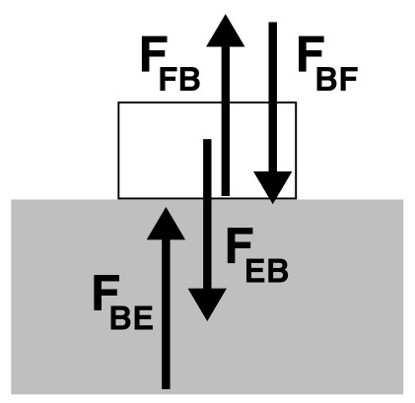

Annotations for
Articles About

Problem Solving and CPS

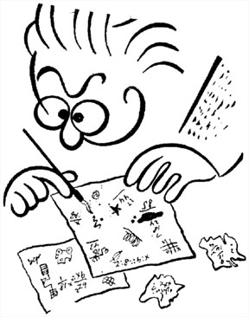

Martinez, M. What is Problem Solving? Phi Delta Kappan (April 1998)

There are many articles about the question “What is problem solving?” This article was selected because it is easier to read (uses fewer definitions) than most. Although this article was written for K-12 educators, the same ideas apply for educators of college freshman and sophomores (grades 13 and 14.)

The following questions may guide your reading:

- According to Martinez, what is problem solving? What is your view of what problem solving is?

- What did you learn from this article?

- What points in this article do you agree with? What do you disagree with?

- Are there any statements in this article that you do not trust (not “scientific”?)

- Was there anything about the article that you did not understand?

- Based on this article, come up with a list of skills that one needs to acquire if one were to be a good problem solver. Which ones do you agree or disagree with?

Before the next class, be prepared to express your ideas about the following topics in a class discussion:
- Your view on the appropriateness of our goal for our Introductory Physics classes: to learn physics through problem solving
- what you think is meant by “learning physics,” and “problem solving”
- your experience with group learning
- negative as well as positive aspects of group learning.

Heller, P. & Heller, K. (in press). Cooperative Problem Solving in the College Physics Classroom.

What is Cooperative Problem Solving?

The following questions may help guide your reading:

1. What are five ways that cooperative problems solving is different from traditional group work?

2. What are the five elements of cooperative problem solving?

3. How does the problem solving performance of a cooperative group compare to the performance of a traditional group ?

4. Read the example in the middle of page 158 in the book by Redish. How does this example support the research results comparing cooperative, competitive, and individual learning environments?

Larkin, J.H. (1979). Processing information for effective problem solving. Engineering Education (December), 285-288.

Jill Larkin and her associates at Carnegie Mellon University did much of the early work in physics problem solving. Her articles are referenced in almost everything written about problem solving in physics. This article is one of her earlier, shorter, and easy –to-read articles. Her conclusions from this article have since been confirmed by other research studies using a wide variety of different methods of collecting data.

1. Larkin states that an expert and a novice problem solver can have the same amount of knowledge, but this knowledge is organized differently in their memories. What is this difference in the knowledge organization of expert's and novices?

2. On the table below, summarize three differences in the approach an expert and novice take when solving a physics problem.

 | Expert | Novice
1.

2.

3.

3. What does Larkin recommend be done to help students become more effective problem solvers? How should this be done? What do you think of this idea?

Heller, P. & Heller, K. (in press). Cooperative Problem Solving in the College Physics Classroom.

Research Review: How Do Beginning Students Solve Problems?

The following questions may help guide your reading:

1. What is a problem?

2. How is the plug-and chug-strategy different from the pattern-matching strategy?

3. How is the knowledge base of a beginning student different from the knowledge structure of an expert problem solver?

Heller, P., Keith, R., & Anderson, S. (1992). Teaching problem solving through cooperative grouping. Part 1: Group versus individual problem solving. American Journal of Physics, 60(7), 627-636.
This is the first part of a two-part article that describes some of the research that Pat Heller and her colleagues completed at the University of Minnesota. In this paper the authors discuss a study of the problem solving of students in the algebra-based introductory physics course.
The following questions may help guide your reading:
Pages 628-630: Description of the Course with Prescribed Problem-Solving Strategy
- Steps 1 and 2 of the prescribed problem-solving strategy require students to do something that expert problem solvers do, but novice problem-solvers rarely do (see Larkin, 1979). What is it?
- At the end of Step 1, students are required to identify their general approach to take to solve the problem (e.g., Kinematics, Newton’s Laws of Motion, Conservation of Energy). How is this related to what experts do, but novices rarely do, when solving problems (see Larkin, 1979)?
- Examine how Steps 1 and 2 are executed in Figure 1. Which heuristic (see Martinez, 1998) are students explicitly taught to apply?
- In Step 3, Plan a Solution, students translate their physics description into a mathematical representation of the problem and determine if they have enough information to solve the problem. Examine how Step 3 is executed in Figure 1. Which heuristic (see Martinez, 1998) are students explicitly taught to use to plan a mathematical solution?
- In Step 5, students are given explicit questions and strategies for checking and evaluating their solution. How is this step related to explicitly teaching metacognition (see Martinez, 1998)?
- Did the grading for test problems follow the recommendation of Martinez (1998, page 609)?
Pages 627 and 630-636: Experiment and Results
- Do individuals or groups solve problems better? Why?
- What parts of problem solving do groups do better than individuals?
- Did student problem solving performance improve over time?
- Are students who use the explicit problem solving strategy better problem solvers than those who do not use the strategy? Using what criteria?
- How are these results (#9 above) similar to those of Larkin (1979)?

Heller, P., Hollabaugh, M. (1992). Teaching problem solving through cooperative grouping. Part 2: Designing problems and structuring groups. American Journal of Physics, 60(7), 637-644.
This is the second part of a two-part article that describes some of the research that Pat Heller and her colleagues have done at the University of Minnesota. In this part, Heller and Hollabaugh discuss the types of problems that work best and how to form and maintain well-functioning cooperative groups.
The following questions may help guide your reading:
Pages 637-640: Designing Physics problems to Promote Effective Problem Solving
- Why are standard textbook problems NOT effective in helping students use a more effective problem-solving strategy (heuristics) than their novice strategy of immediately plugging numbers into formulas?
- How does the use of context-rich problems in an introductory physics course relate to McDermott’s (1993) fifth generalization (E) about the failure of traditional instruction?
- How does the use of context-rich problems help promote students’ use of a more effective problem-solving strategy (heuristics)?
- In what ways is cooperative-group problem solving of context-rich problems (part of the Minnesota Model for teaching introductory physics courses) similar to cognitive apprenticeship methods (Brown, Collins, and Duguid, 1989)? In what ways is it different? (Hint: See also Heller, Keith, and Anderson, 1992.)
  - Where is the “modeling” of problem solving done?
  - Where and how does the “coaching” of problem solving occur?
Pages 640-643: Forming and Maintaining Well-Functioning Cooperative Groups (Optional)
- What is the “optimal” group size for physics problem solving?
- What ability and gender composition of groups results in the best problem-solving performance?
- How can problems of dominance by one student and conflict avoidance within a group be addressed?
- How can groups be structured so students are concerned about the performance of all group members, as well as their own?

Brown, J.S., Collins, A., & Duguid, P. (1989). Situated cognition and the culture of learning. Educational Researcher, 18(1), 32-42.
The Minnesota Model for teaching large introductory physics courses is based, in part, on cognitive apprenticeship (situated cognition). The article discusses several examples of cognitive apprenticeship in the classroom. It was written for people with a background in theories of learning and educational psychology, so the terminology is sometimes difficult to follow. You may need to use the dictionary and read some sentences several times to “unchunk” what they mean. (Note: Your experience reading this article is like that of a non-science major reading a physics article in Scientific American…)
You should read the first half-Page introduction, and pages 37-42.
In this reading, JPF behavior refers to the behavior of “Just Plain Folks”. Several studies show that the way JPF learn is very different from what we usually ask students to do in school.
The following may help guide reading:
- In your own words, what is cognitive apprenticeship? (Hint: See page 39.)

- According to the authors, what are the four “salient features” of collaborative learning? Describe them briefly.

- Can you think of experiences in your undergraduate career that you consider to be, at least in part, cognitive apprenticeship?

- Does cognitive apprenticeship have any value over traditional instruction? If so, what?

Annotations for
Articles About

Sexual Harassment,
Ethics, and Equal
Opportunity

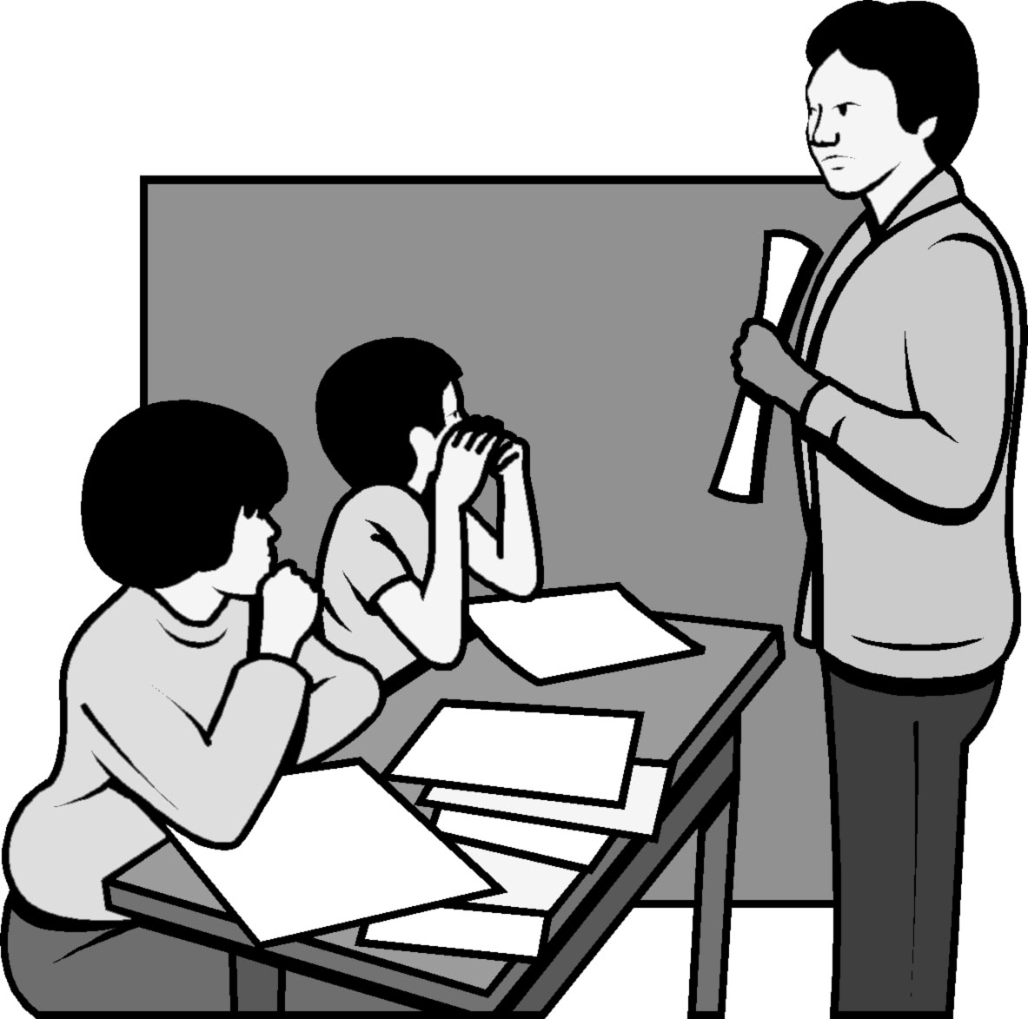

Equal Opportunity and Affirmative Action Brochure, University of Minnesota

This booklet is published by the University for all the faculty, staff, and students and visitors. It is intended to clarify any misunderstanding and fear that people might have about the University’s policy. It is very important that you understand the policy and how it will affect you as a student and as a teacher.

The following questions may help guide your reading:
(Section 5 – Discrimination: Gender and Sexual Harassment)

1. Why is there a sexual harassment policy at the University of Minnesota?

2. Have you ever seen or heard about the behavior in any of the examples?

3. Do you agree with the booklet’s definition of sexual harassment? Why or why not?

4. What will you do if you feel sexually harassed by a faculty member? A staff member? Another graduate student? One of your students??

Shymansky, J.A. and Penick, J.E. (1979). Do laboratory teaching assistants exhibit sex bias? Journal of College Science Teaching, 8: 223-225

This is a short paper on a study done at the University of Iowa, where the researchers asked the question of whether the behavior of lab instructors with students depends on the sex of the students.

The following questions may help guide your reading:

1. Do you think there is enough evidence to support the two “basic assumptions” on page 223?

2. What do you think is the most interesting result of this study?

Seymour, E. (1992). Undergraduate problems with teaching and advising in SME majors explaining gender differences in attrition rates, Journal of College Science teaching, 21:284-292.

There are high dropout rates from science, math, and engineering (SME) majors of both sexes. This article describes a study done on the reasons people drop out of SME majors, some of which are gender specific.

The following questions may help guide your reading:

1. What are some of the reasons people drop out of SME majors? Were these factors at the school where you got your undergraduate degree? Do you expect that they are a factor at the University of Minnesota?

2. What are some gender differences in the reasons given for dropping out of SME majors?

3. What are the differences in what women and men describe as good teaching?

